Lab Assignment 17.5
2403A52L10-B50
A.Tharun
Task1:
Code and prompt:
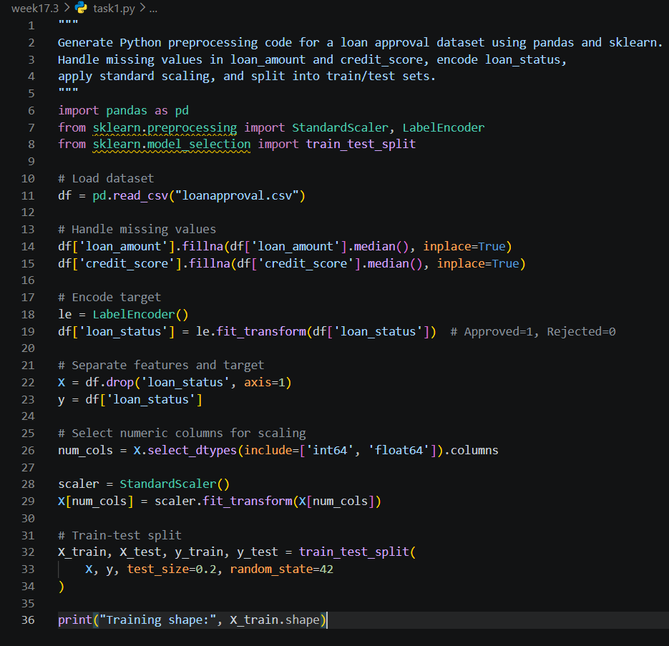

Task2:
Code and prompt:
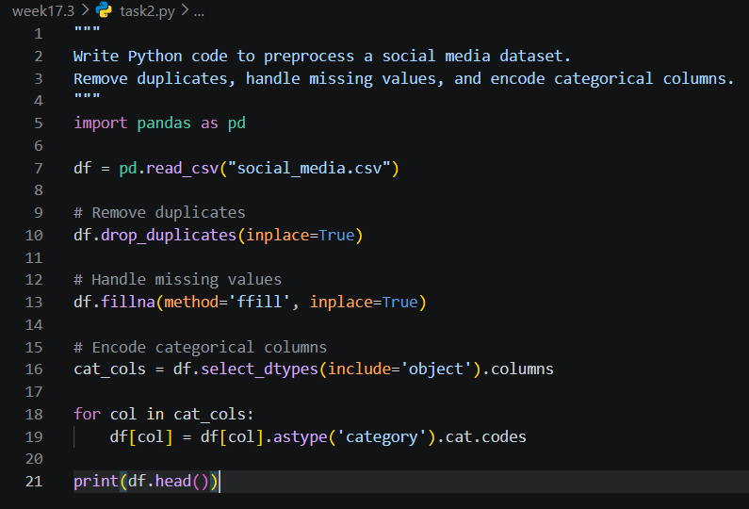
Task3:
Code and prompt:
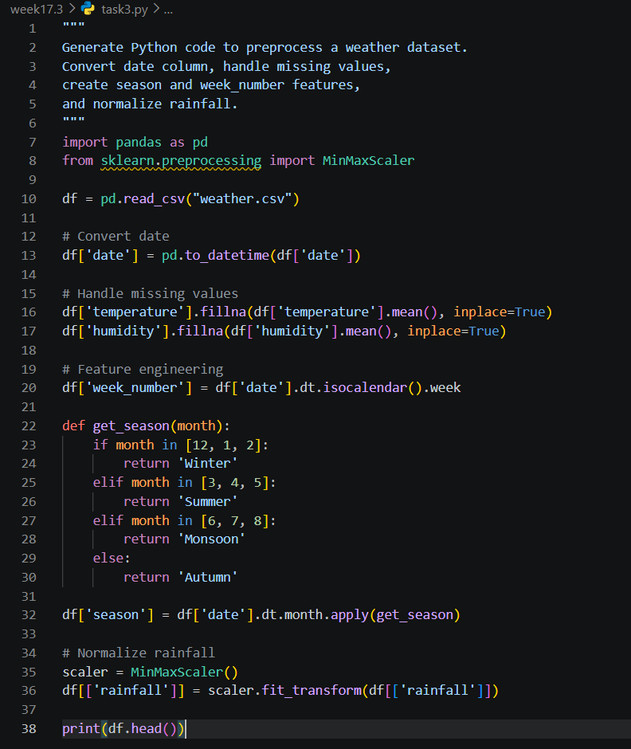
Task4:
Code and prompt:
