Lab Assignment 18.3
240A52L10-B50
A.Tharun

Task1:
Code and prompt:
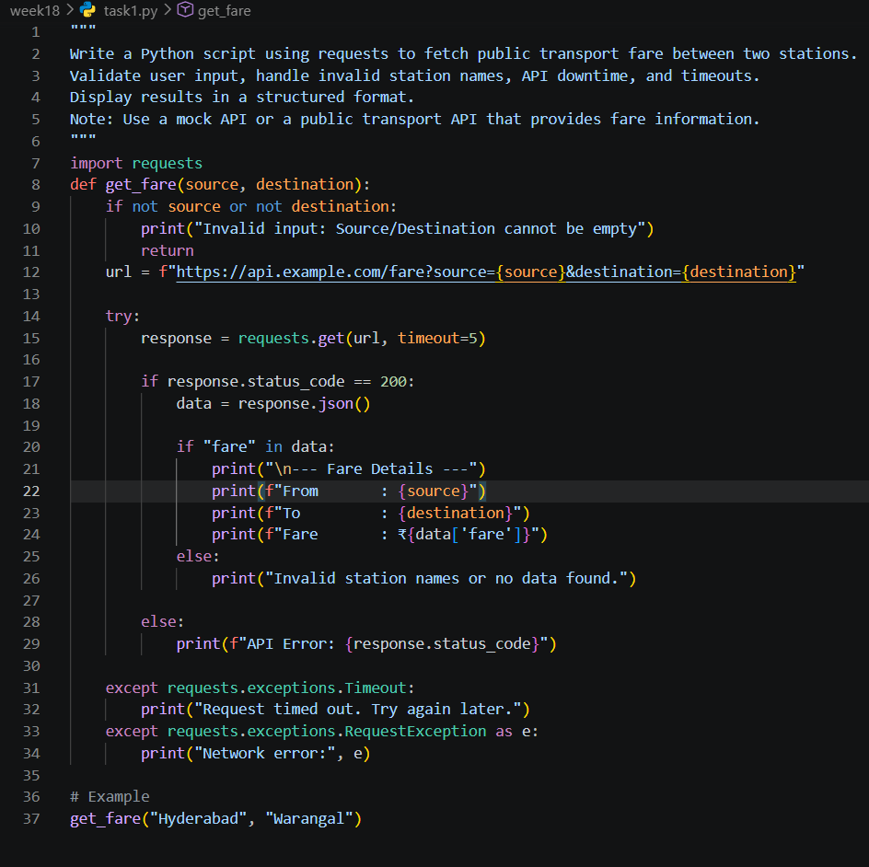

Task2:
Code and prompt:
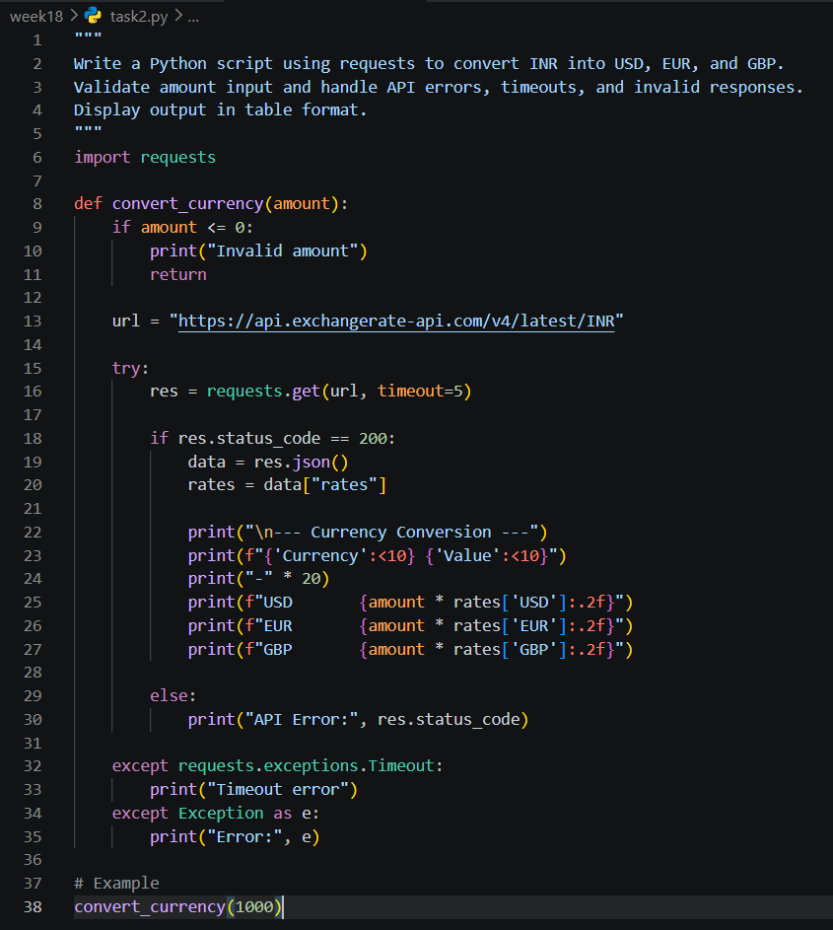

Task3:
Code and prompt:
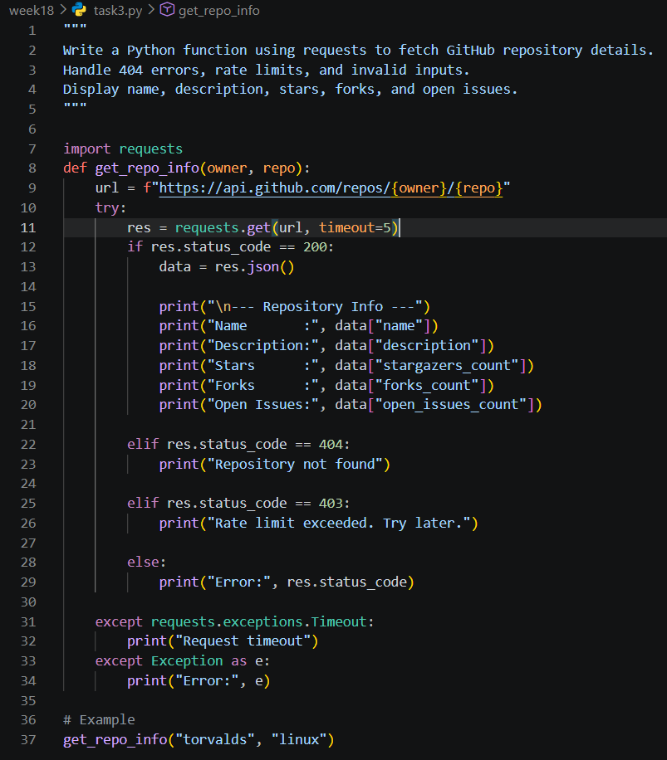

Task4:
Code and prompt:
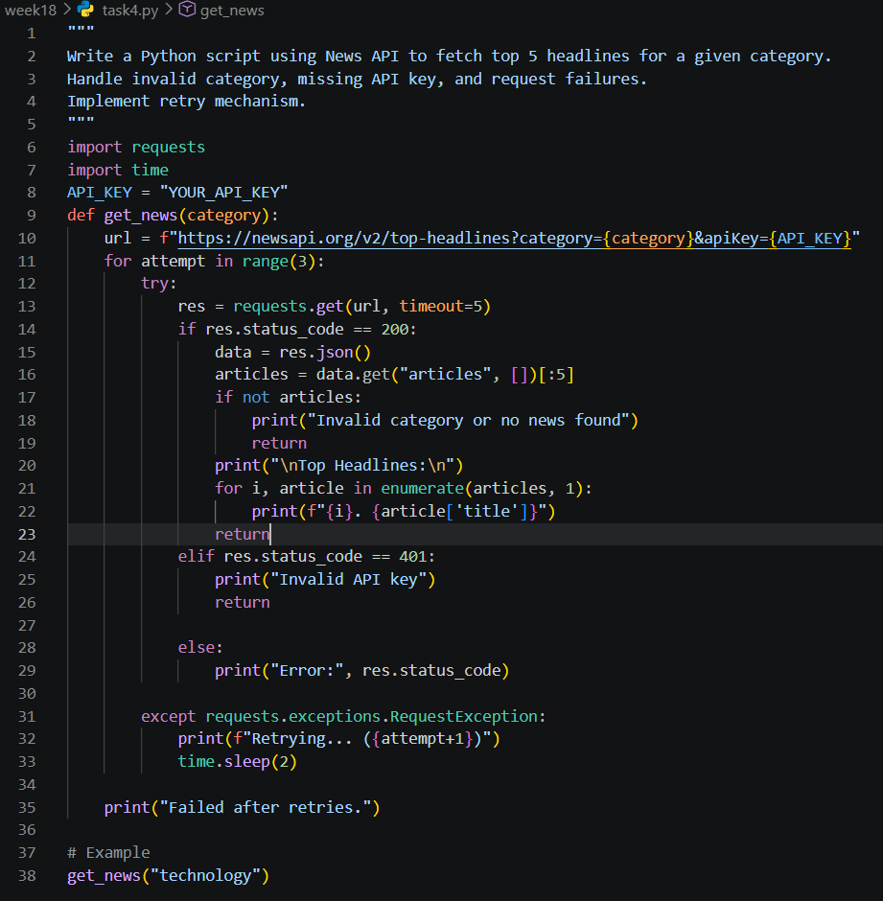

Task5:
Code and prompt:
