SCHOOL OF COMPUTER SCIENCE AND ARTIFICIAL INTELLIGENCE |  |  |  |  | DEPARTMENT OF COMPUTER SCIENCE ENGINEERING
ProgramName:B. Tech |  |  |  | Assignment Type: Lab |  |  | AcademicYear:2025-2026
CourseCoordinatorName |  |  |  | Venkataramana Veeramsetty
Instructor(s)Name |  |  |  | Dr. V. Venkataramana (Co-ordinator)  Dr. T. Sampath Kumar  Dr. Pramoda Patro  Dr. Brij Kishor Tiwari  Dr.J.Ravichander  Dr. Mohammand Ali Shaik  Dr. Anirodh Kumar  Mr. S.Naresh Kumar  Dr. RAJESH VELPULA  Mr. Kundhan Kumar  Ms. Ch.Rajitha  Mr. M Prakash  Mr. B.Raju  Intern 1 (Dharma teja)  Intern 2 (Sai Prasad)  Intern 3 (Sowmya)  NS_2 ( Mounika)
CourseCode |  |  | 24CS002PC215 | CourseTitle |  | AI Assisted Coding
Year/Sem |  |  | II/I | Regulation |  | R24
Date and Day  of Assignment |  |  | Week3 - Thursday | Time(s)
Duration |  |  | 2 Hours | Applicableto  Batches
AssignmentNumber:6.4(Present assignment number)/24(Total number of assignments)
 | Q.No. | Question |  |  |  |  |  | ExpectedTime  to complete
 | 1 | Lab 6: AI-Based Code Completion – Classes, Loops, and Conditionals  Lab Objectives:  - To explore AI-powered auto-completion features for core Python constructs.  - To analyze how AI suggests logic for class definitions, loops, and conditionals.  - To evaluate the completeness and correctness of code generated by AI assistants.  Lab Outcomes (LOs):  After completing this lab, students will be able to:  - Use AI tools to generate and complete class definitions and methods.  - Understand and assess AI-suggested loops for iterative tasks.  - Generate conditional statements through prompt-driven suggestions.  - Critically evaluate AI-assisted code for correctness and clarity.  Task Description #1:  • Start a Python class named Student with attributes name, roll_number, and marks. Prompt GitHub Copilot to complete methods for displaying details and checking if marks are above average.  Expected Outcome #1:  • Completed class with Copilot-generated methods like display_details() and is_passed(), demonstrating use of if-else conditions.  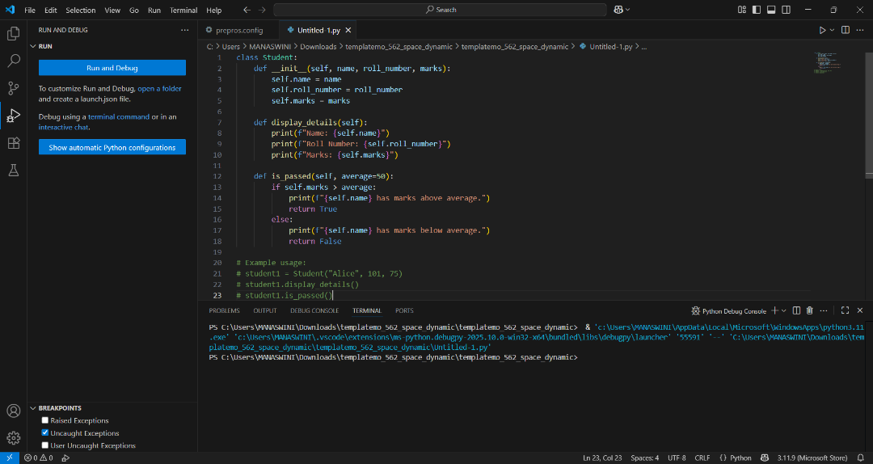  Task Description #2:  • Write the first two lines of a for loop to iterate through a list of numbers. Use a comment prompt to let Copilot suggest how to calculate and print the square of even numbers only.  Expected Outcome #2:  • A complete loop generated by Copilot with conditional logic (if number % 2 == 0) and appropriate output.  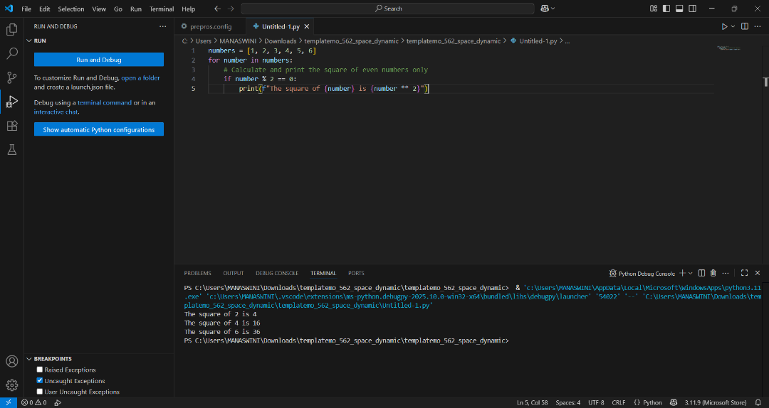  Task Description #3:  • Create a class called BankAccount with attributes account_holder and balance. Use Copilot to complete methods for deposit(), withdraw(), and check for insufficient balance.  Expected Outcome #3:  • Functional class with complete method definitions using if conditions and self attributes. Code should prevent overdrawing.  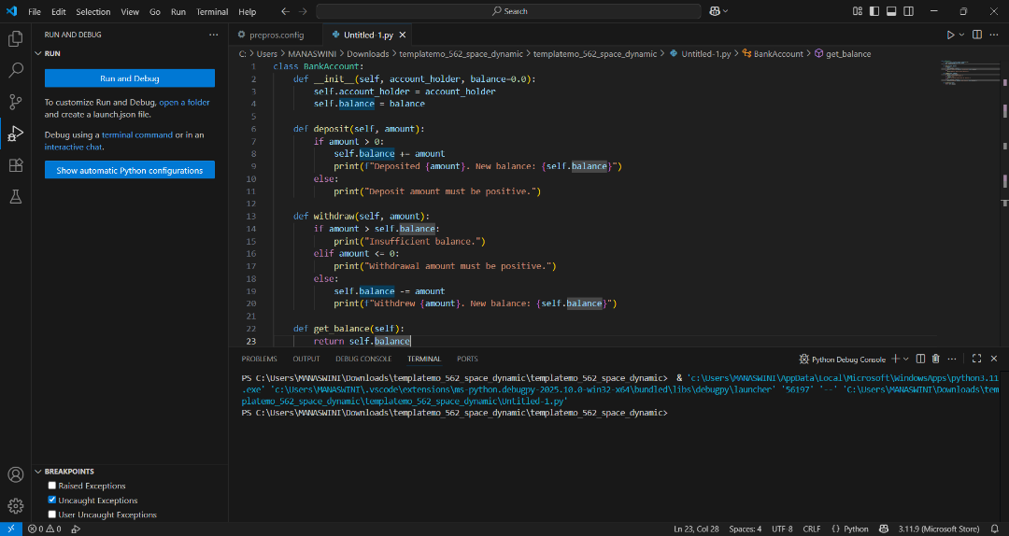  Task Description #4:  • Define a list of student dictionaries with keys name and score. Ask Copilot to write a while loop to print the names of students who scored more than 75.  Expected Outcome #4:  • A complete while loop generated by Copilot with proper condition checks and formatted output.  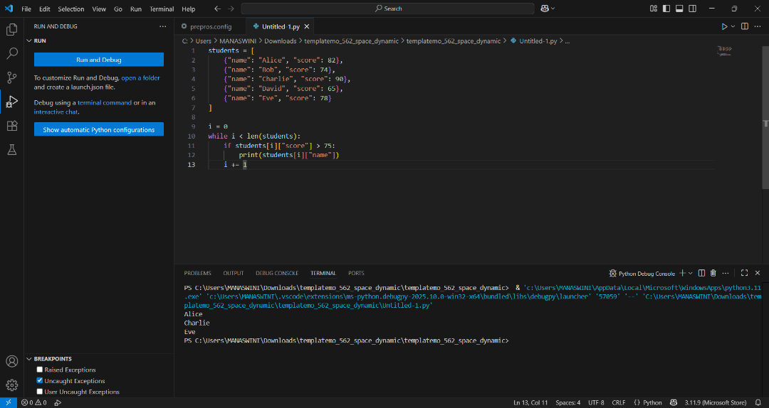  Task Description #5:  • Begin writing a class ShoppingCart with an empty items list. Prompt Copilot to generate methods to add_item, remove_item, and use a loop to calculate the total bill using conditional discounts.  Expected Outcome #5:  • A fully implemented ShoppingCart class with Copilot-generated loops and if-else statements handling item management and discount logic.  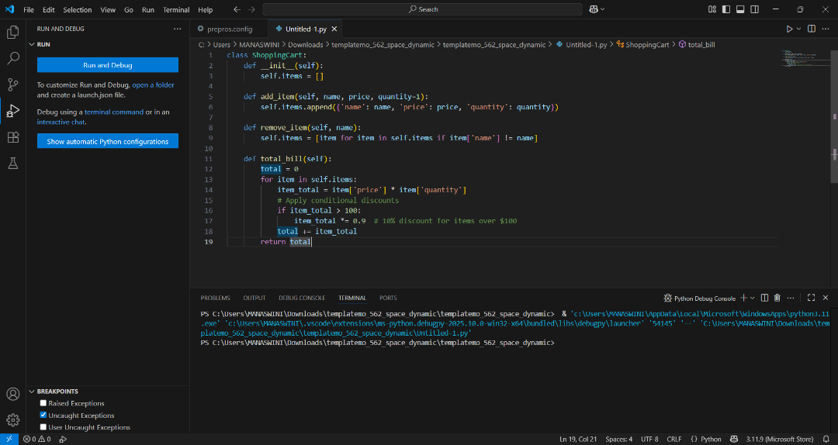  Note: Report should be submitted a word document for all tasks in a single document with prompts, comments & code explanation, and output and if required, screenshots  Evaluation Criteria:  Criteria Max Marks  Class 1  Loop 1  condition 0.5  Total 2.5 Marks |  |  |  |  |  | Week3 - Thursday

