AI LAB-4
SET-A

Q2.
Use AI to generate a Python script that:
• Randomly creates a numeric dataset representing daily website traffic
• Identifies and removes outliers using the IQR (Interquartile Range) method
• Exports both the original and cleaned datasets to two separate CSV files

Prompt:
generate a Python script that:
• Randomly creates a numeric dataset representing daily website traffic
• Identifies and removes outliers using the IQR (Interquartile Range) method
• Exports both the original and cleaned datasets to two separate CSV files

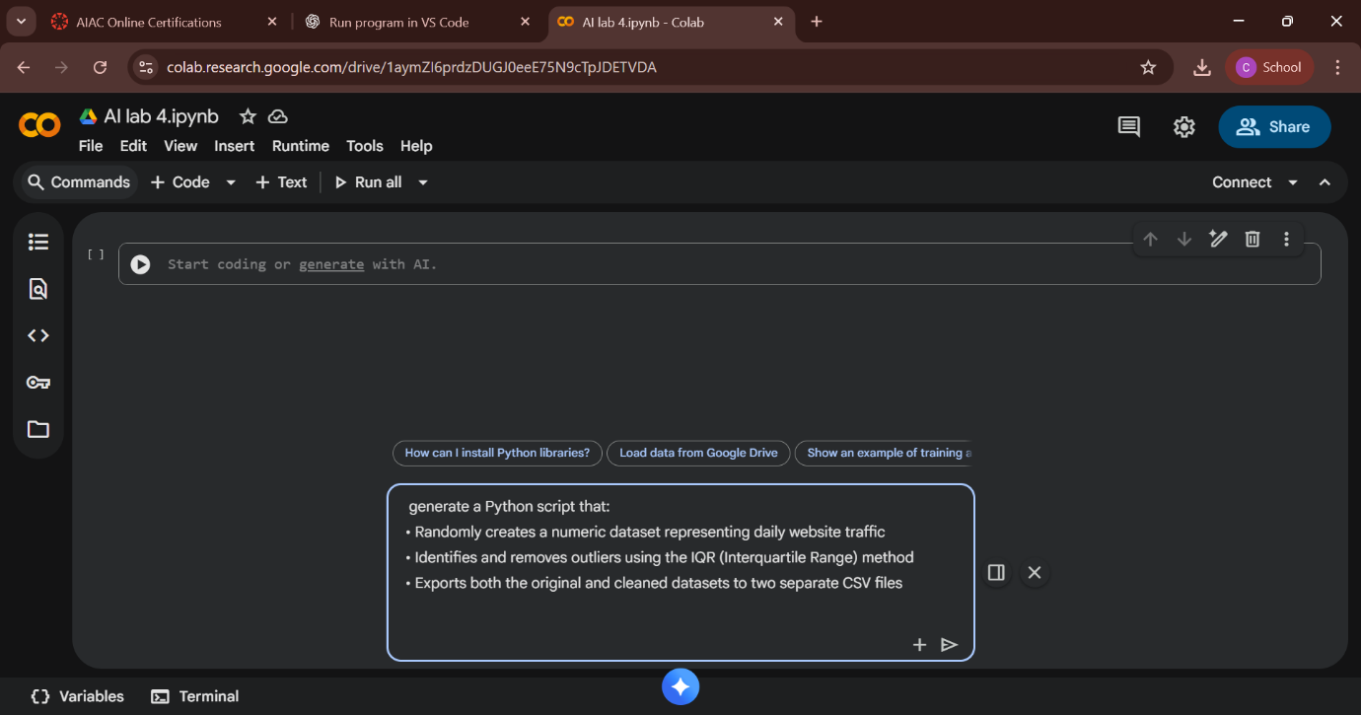
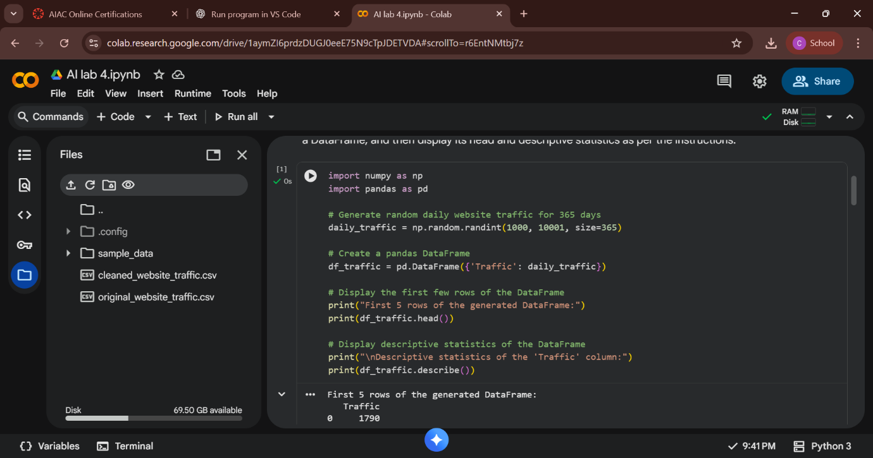

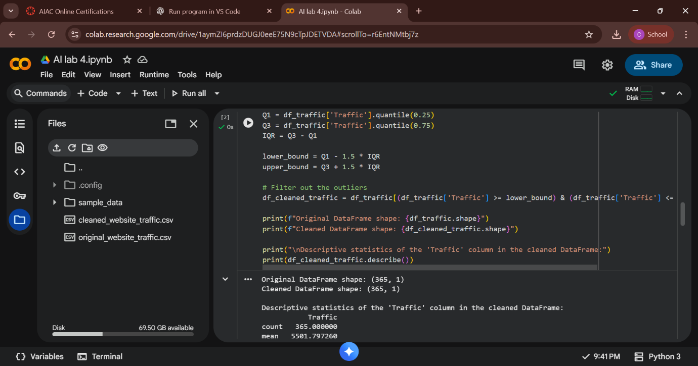

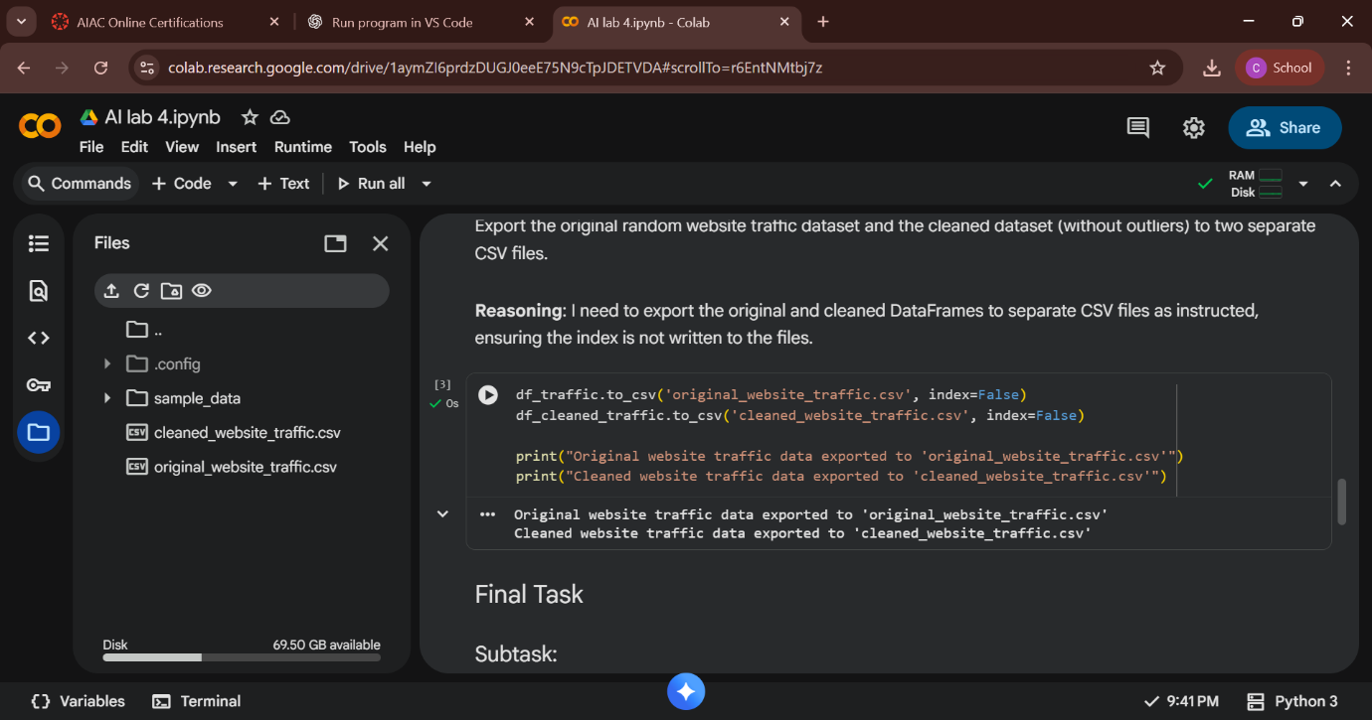

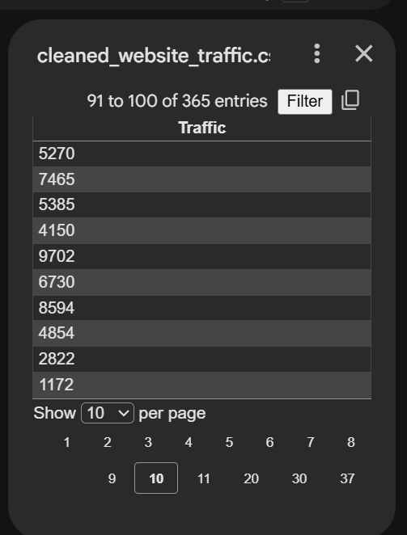
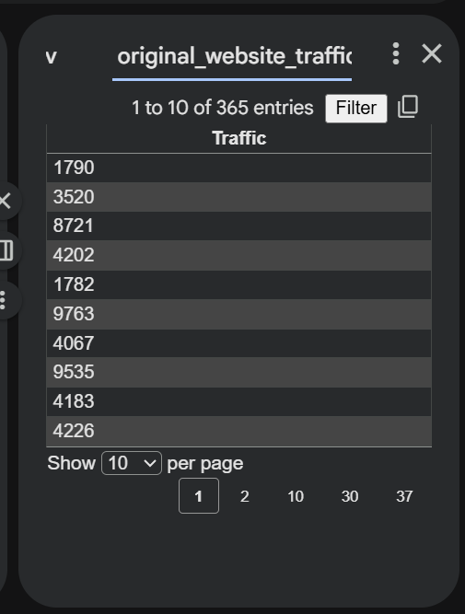

Q1.
Using AI assistance, design a Travel Agency Reservation Database.
• Create tables: Clients, Tours, Reservations
• Populate each table with sample entries
• Write an SQL query to list all tours that do NOT have any booking between two given dates
Prompt:
create tables on client tour and reservations
and insert the sample data to load in to the tables also write an sql query that lists all the tours that are not reserved between 2 dates

