SCHOOL OF COMPUTER SCIENCE AND ARTIFICIAL INTELLIGENCE |  |  |  |  | DEPARTMENT OF COMPUTER SCIENCE ENGINEERING
Program Name: B. Tech |  |  |  | Assignment Type: Lab |  |  | Academic Year:2025-2026
Course Coordinator Name |  |  |  | Venkataramana Veeramsetty
Instructor(s) Name |  |  |  | Dr. V. Venkataramana (Co-ordinator)  Dr. T. Sampath Kumar  Dr. Pramoda Patro  Dr. Brij Kishor Tiwari  Dr.J.Ravichander  Dr. Mohammand Ali Shaik  Dr. Anirodh Kumar  Mr. S.Naresh Kumar  Dr. RAJESH VELPULA  Mr. Kundhan Kumar  Ms. Ch.Rajitha  Mr. M Prakash  Mr. B.Raju  Intern 1 (Dharma teja)  Intern 2 (Sai Prasad)  Intern 3 (Sowmya)  NS_2 ( Mounika)
Course Code |  |  | 24CS002PC215 | Course Title |  | AI Assisted Coding
Year/Sem |  |  | II/I | Regulation |  | R24
Date and Day  of Assignment |  |  | Week5 - Monday | Time(s)
Duration |  |  | 2 Hours | Applicable to  Batches
AssignmentNumber: 9.1(Present assignment number)/24(Total number of assignments)
 | Q.No. | Question |  |  |  |  |  | Expected Time  to complete
 | 1 | Lab 17– AI for Data Processing: Data cleaning and preprocessing scripts  The objective of this lab is to enable students to understand and apply AI-assisted coding tools for automating and enhancing data preprocessing tasks. Students will:  - Gain practical experience in cleaning, transforming, and standardizing real-world datasets with issues such as missing values, duplicates, outliers, inconsistent formats, and noisy text.  - Learn to leverage AI coding assistants to generate preprocessing scripts, while critically evaluating and refining the AI-generated code for accuracy, efficiency, and best practices.  - Develop the ability to design end-to-end preprocessing pipelines that prepare raw data for downstream machine learning and analytics applications.  - Build confidence in combining human expertise with AI assistance, ensuring data quality and integrity in diverse domains such as customer feedback, healthcare, and finance.  Lab Question 1: Customer Feedback Dataset  You are given a CSV file containing customer feedback collected from an e-commerce website. The dataset includes columns: customer_id, feedback_text, rating, and date. However, the file has many missing values, typos, and inconsistent date formats.  - Task 1: Use an AI-assisted coding tool to generate a script that detects and fills missing rating values with the column’s median and standardizes the date column into YYYY-MM-DD format  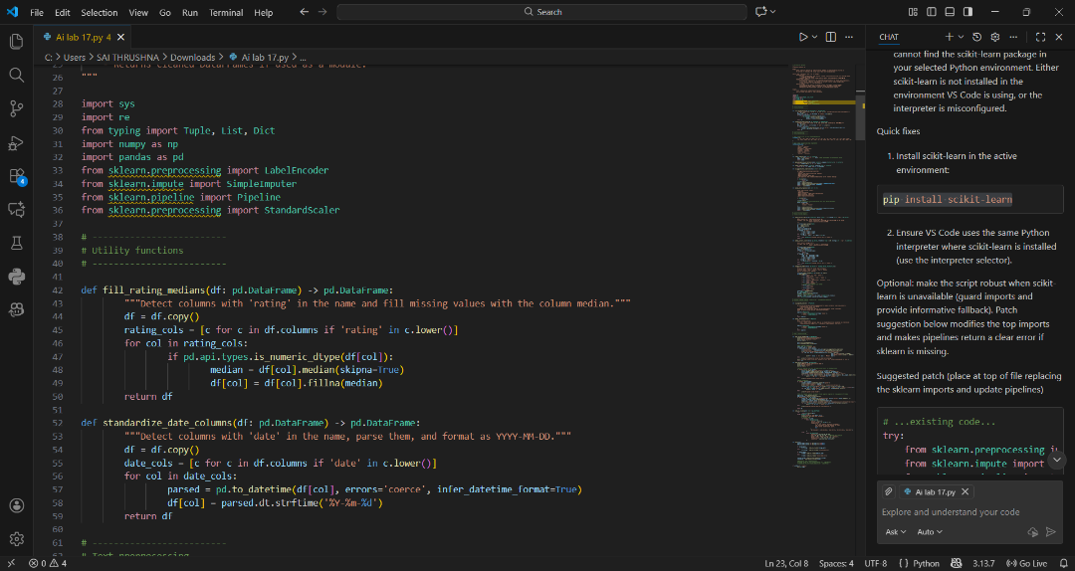.  - Task 2: Clean the feedback_text column by removing stopwords, correcting common spelling mistakes, and converting text to lowercase using AI suggestions. Compare the AI-generated preprocessing code with your manually written version.  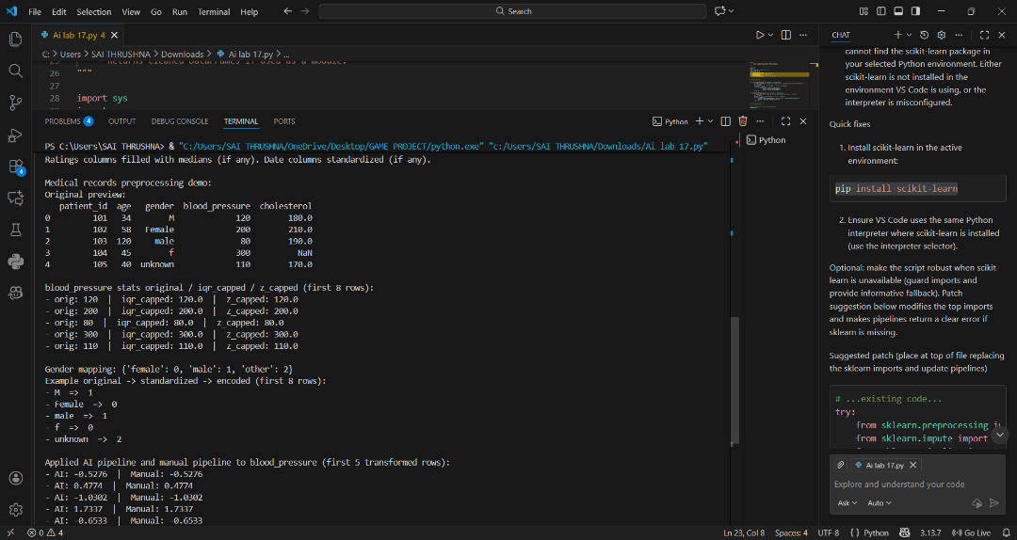  Lab Question 2: Medical Records Dataset  A hospital provides you with a dataset of anonymized medical records containing attributes like patient_id, age, gender, blood_pressure, and cholesterol. Some columns include outliers and inconsistent categorical labels (e.g., Male, M, male).  - Task 1: Write a script (with AI assistance) to detect and handle outliers in the blood_pressure column using statistical methods (e.g., IQR or z-score).  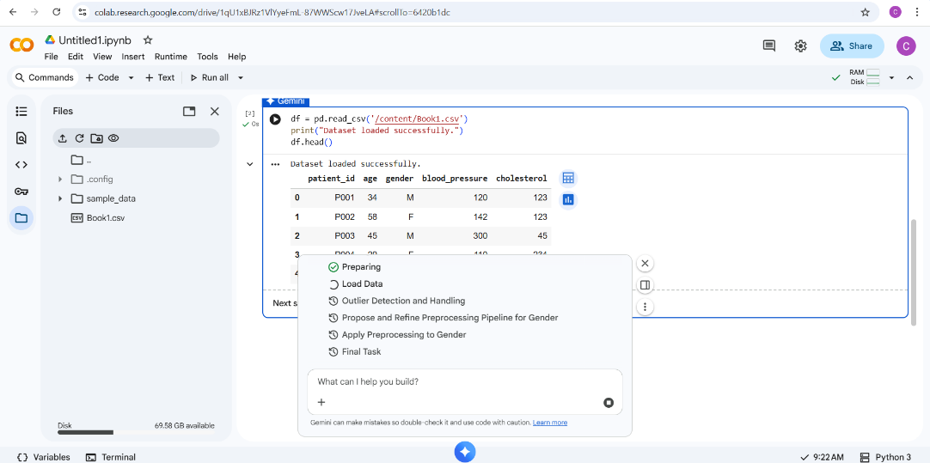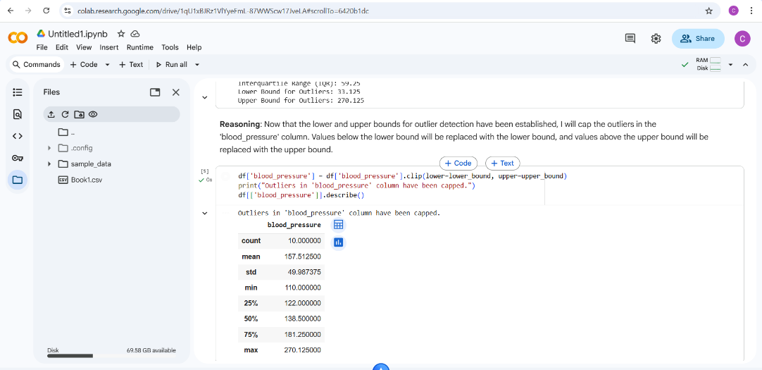  - Task 2: Standardize categorical values in the gender column and encode them into numeric form. Let the AI-assisted coding tool propose the preprocessing pipeline, then refine the pipeline manually based on your understanding.  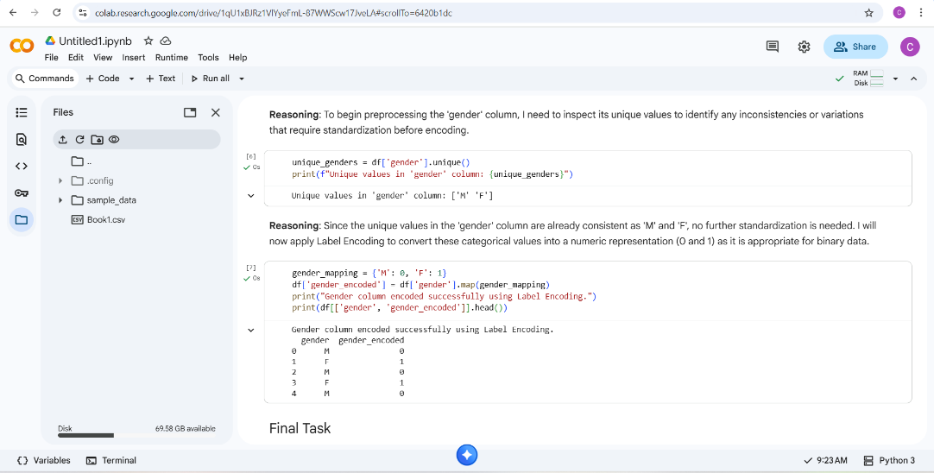  Lab Question 3: Financial Transactions Dataset  A bank gives you transaction data with columns: transaction_id, amount, currency, timestamp, and merchant. The dataset contains multiple issues: different currency units (USD, INR, EUR), timestamps in various time zones, and duplicated rows.  - Task 1: Use AI-assisted coding to write a script that removes duplicate transactions and converts all amount values into a single currency (e.g., USD) using a provided conversion dictionary.  - Task 2: Normalize the timestamp column into UTC format and create a new column transaction_hour for downstream time-series analysis. Compare the AI’s preprocessing code against your own optimized version.  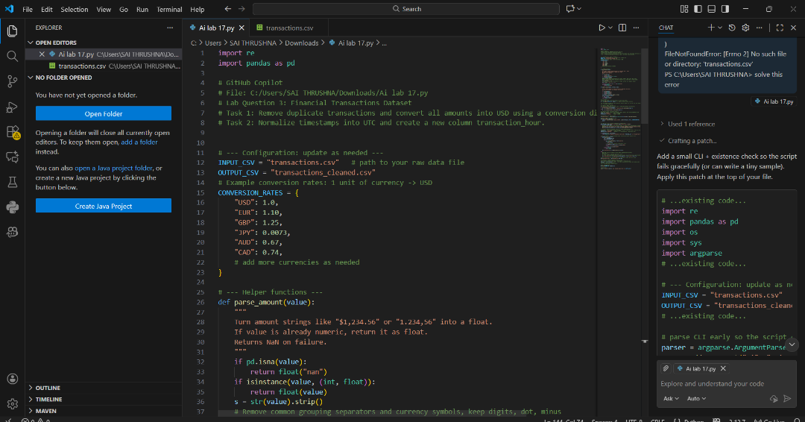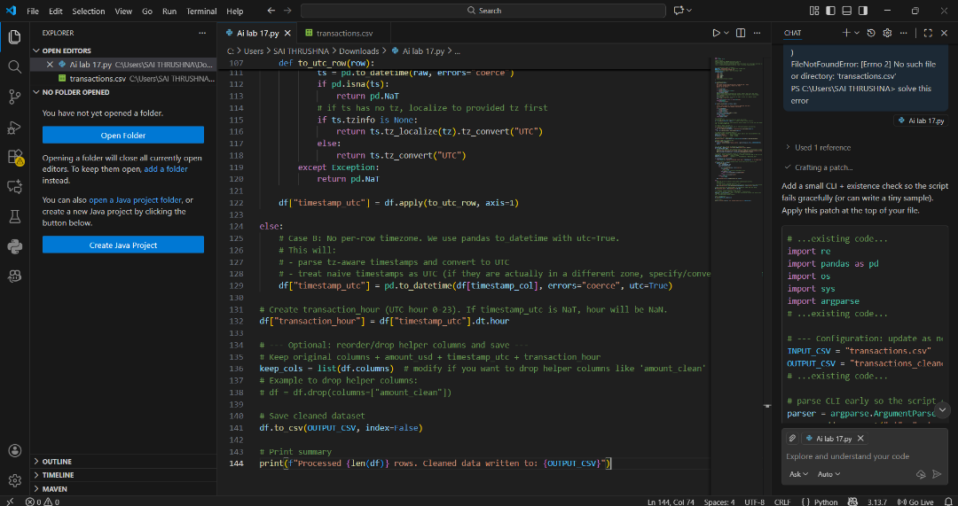 |  |  |  |  |  | Week 9- Monday

