AI ASSISTED CODING
ASSIGNMENT – 11.4
BATCH- 18
2403A51355
Task 1:-
Prompt:-
I need a simple contact manager app to store names and phone numbers of the users it should also include adding searching and deleting contacts use arrays to store contacts .
USING ARRAYS:-
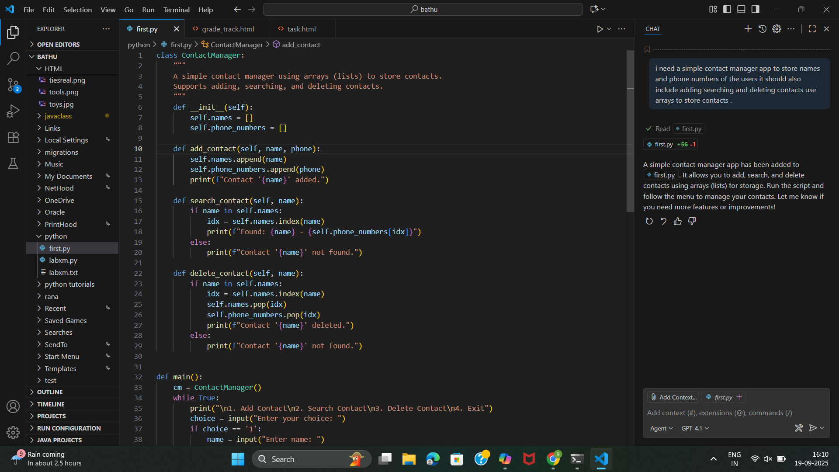
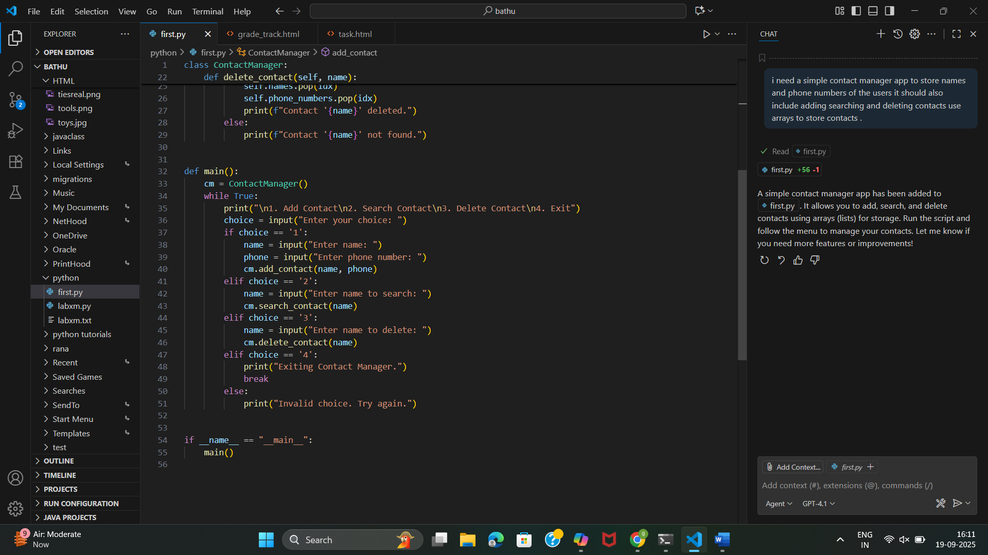
OUTPUT:-
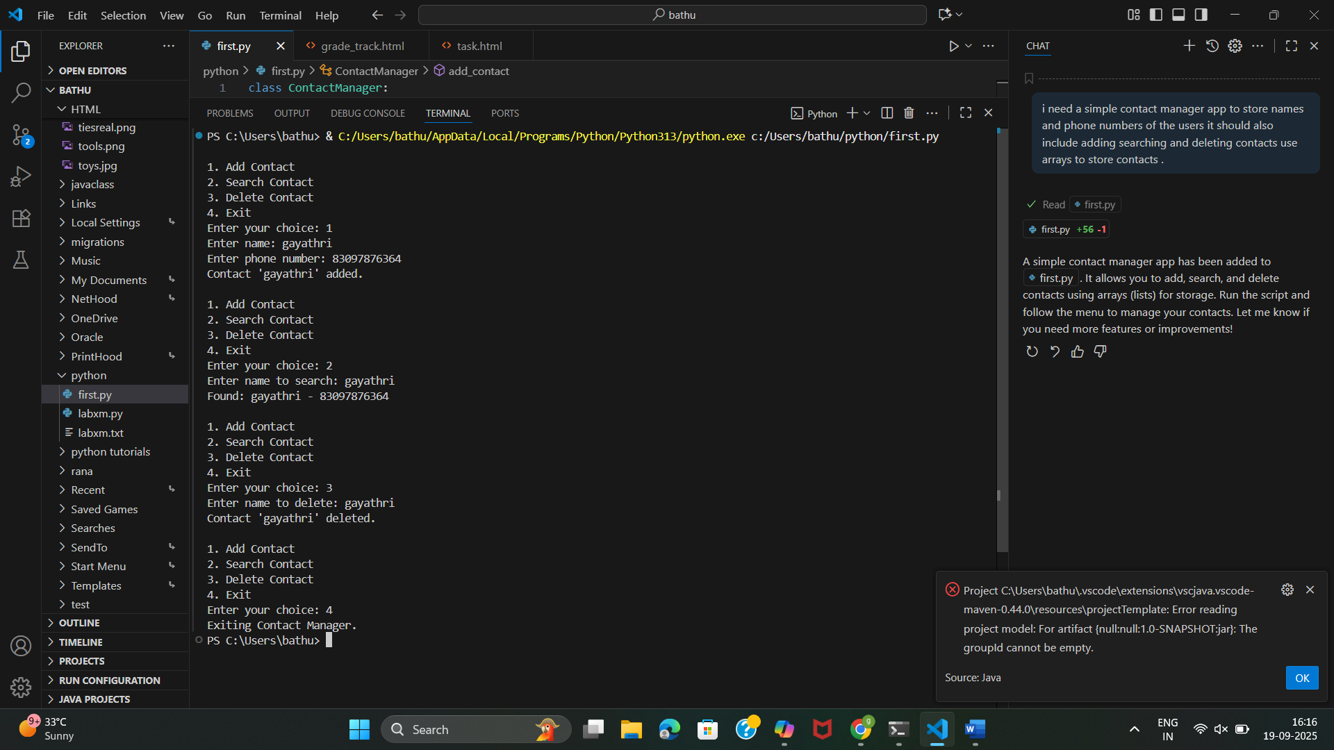
Using linked lists:-
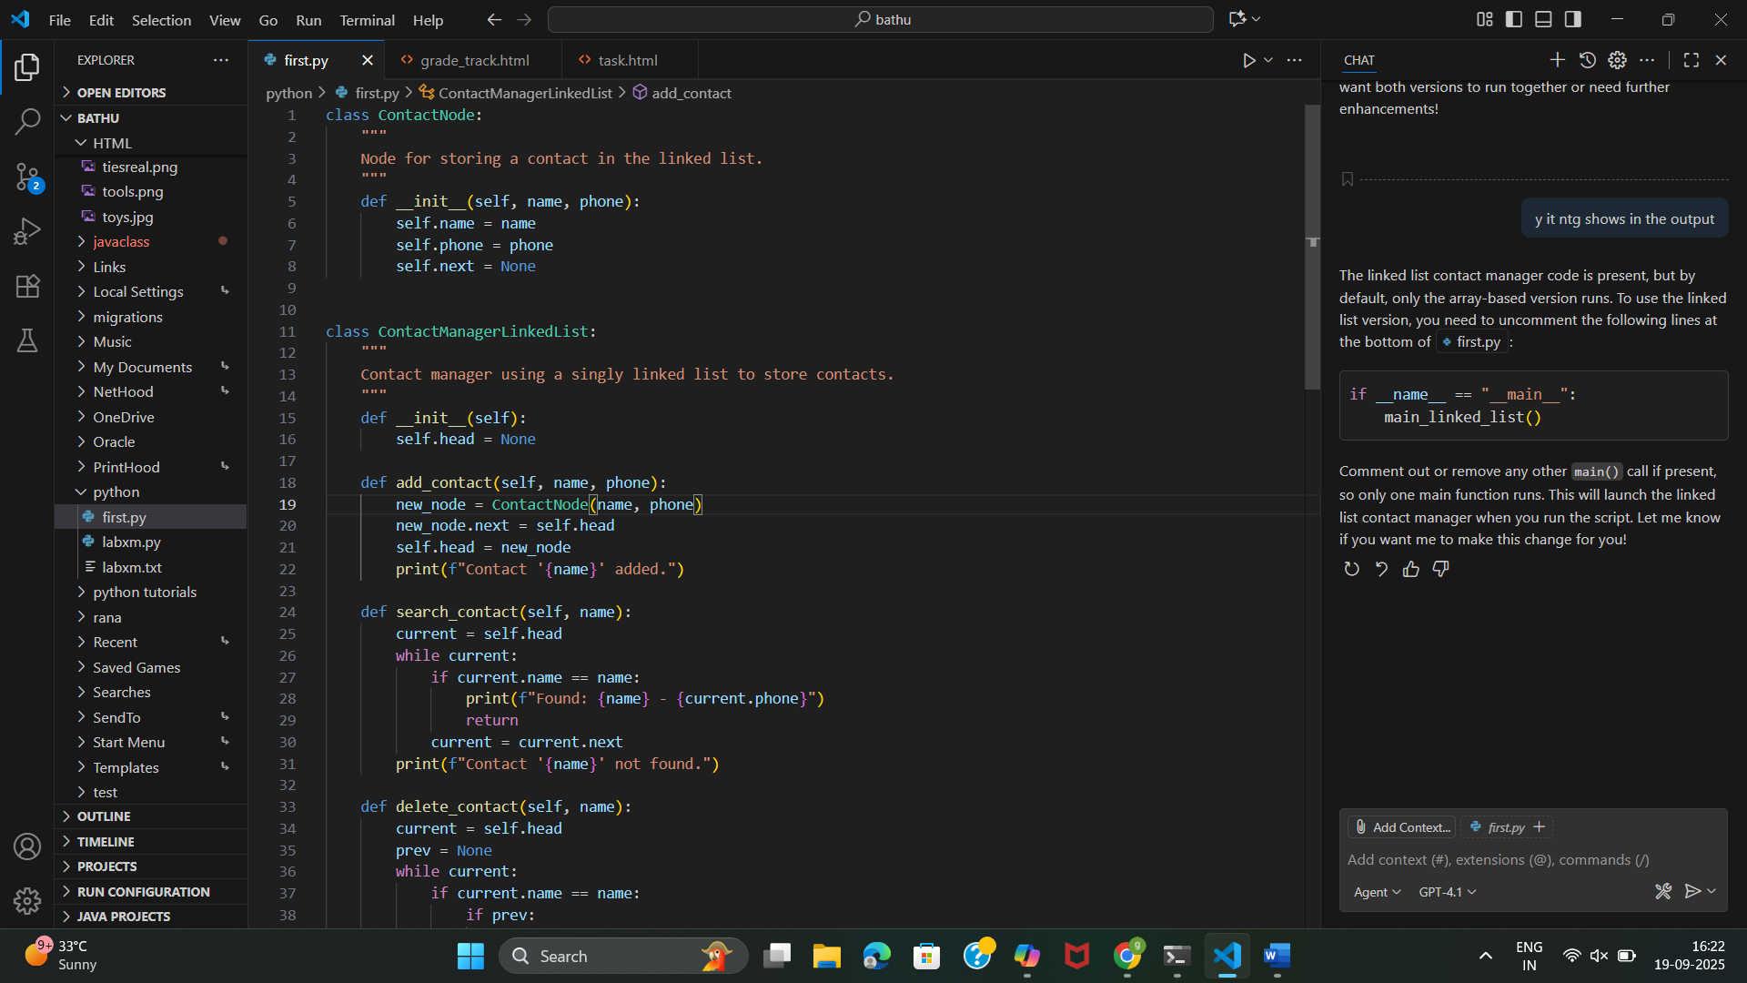
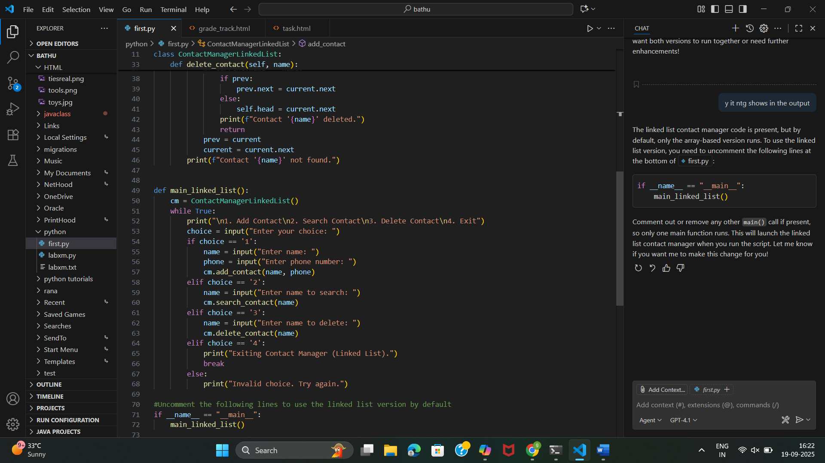
Output:-
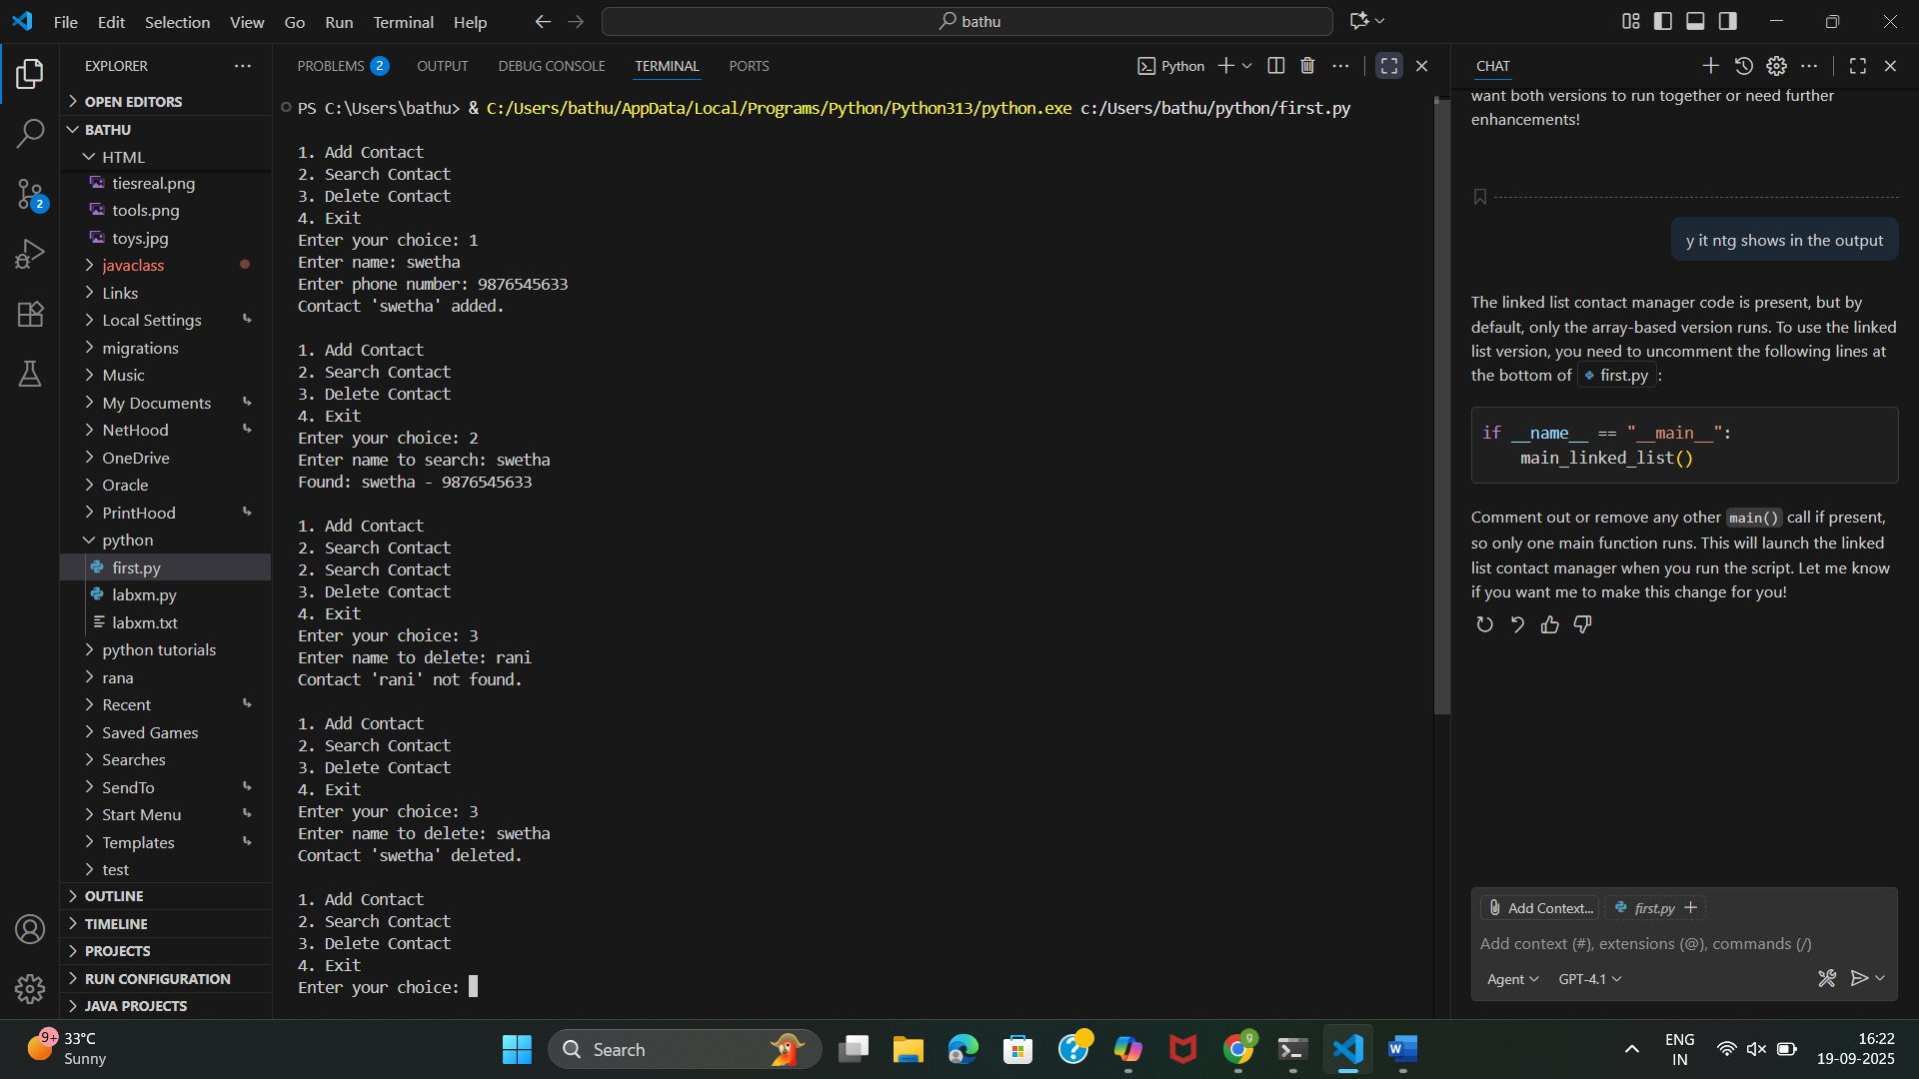

Array:
- Insertion: Adding a contact at the end is fast but inserting at the beginning or middle is slower (O(n)), as elements may need to be shifted.
- Deletion: Deleting a contact requires searching for the name (O(n)), then removing it (O(n)) because all subsequent elements must be shifted left.
Linked List:
- Insertion: Adding a contact at the head is always O(1) (very fast), regardless of list size. Inserting elsewhere requires traversal (O(n)).
- Deletion: Deleting a contact requires searching for the node (O(n)), but removal itself is O(1) once found (just change pointers), with no shifting of elements.

TASK 2:-
PROMPT:- In our university the help disk receives the support tickets from the students and staff but the issue is it requires last in first out a stack based ideal implement a stack to handle the support tickets use operations pop(ticket), push, peek stimulate atleast 5 tickets which being received and being resolved.
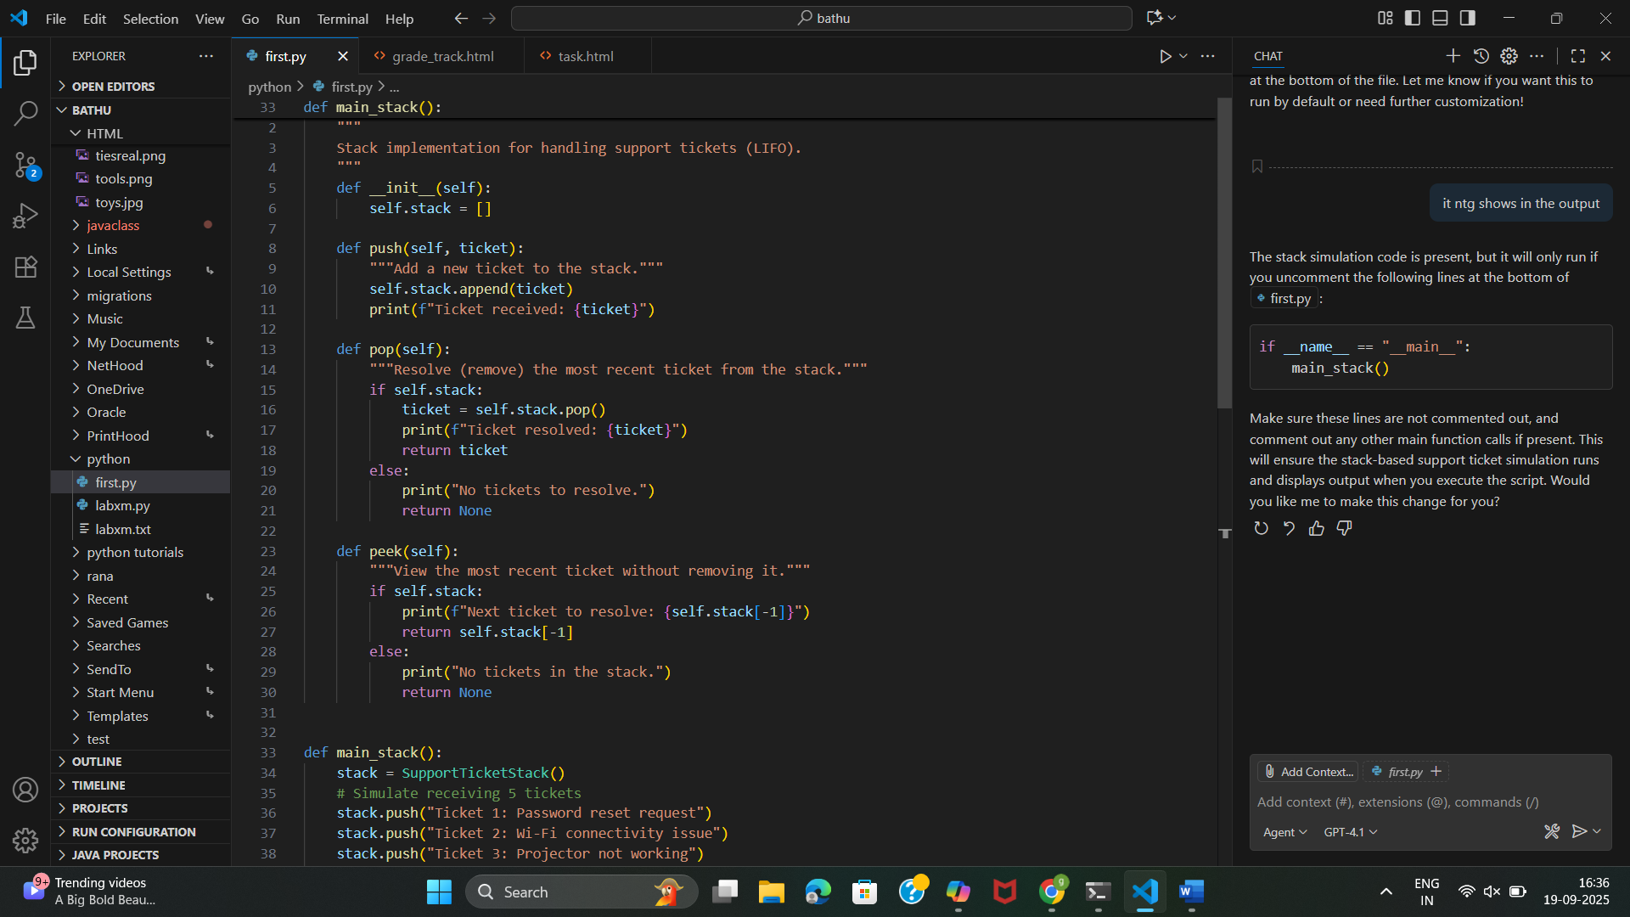
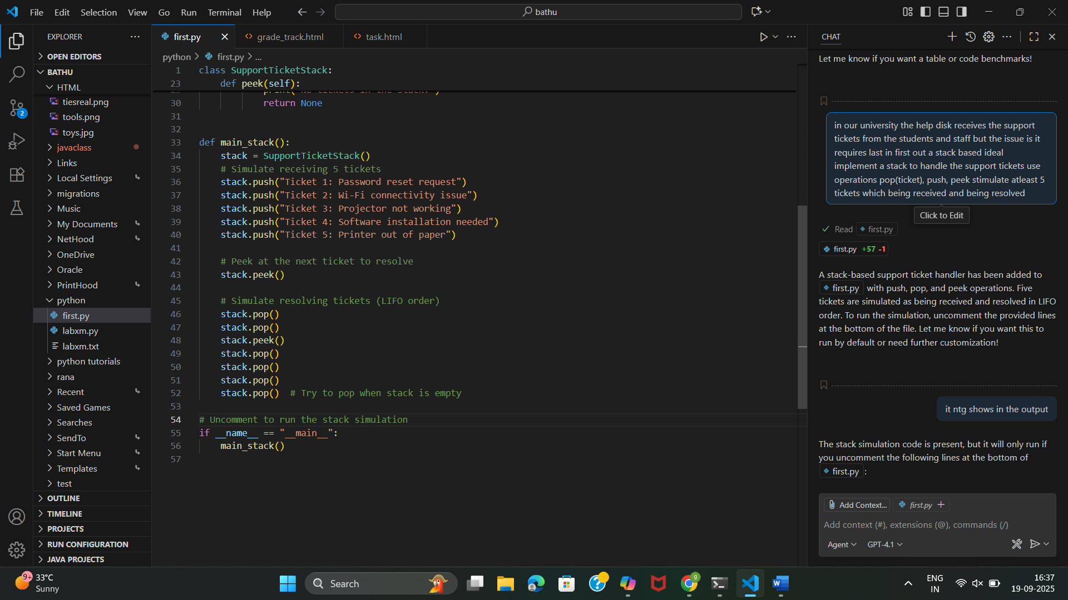
Output:-
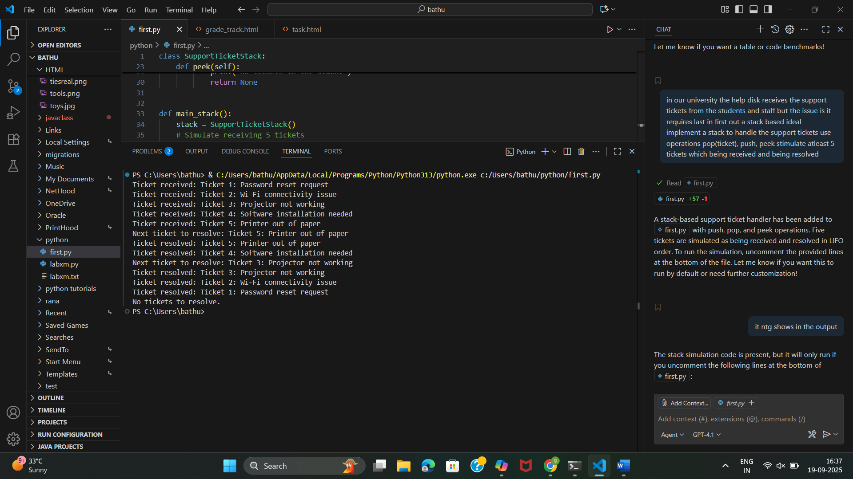

TASK 3:-
PROMPT:- Students join a queue Implement a queue for book requests (FIFO).Extend it to a priority queue where faculty members’ requests are served before students.
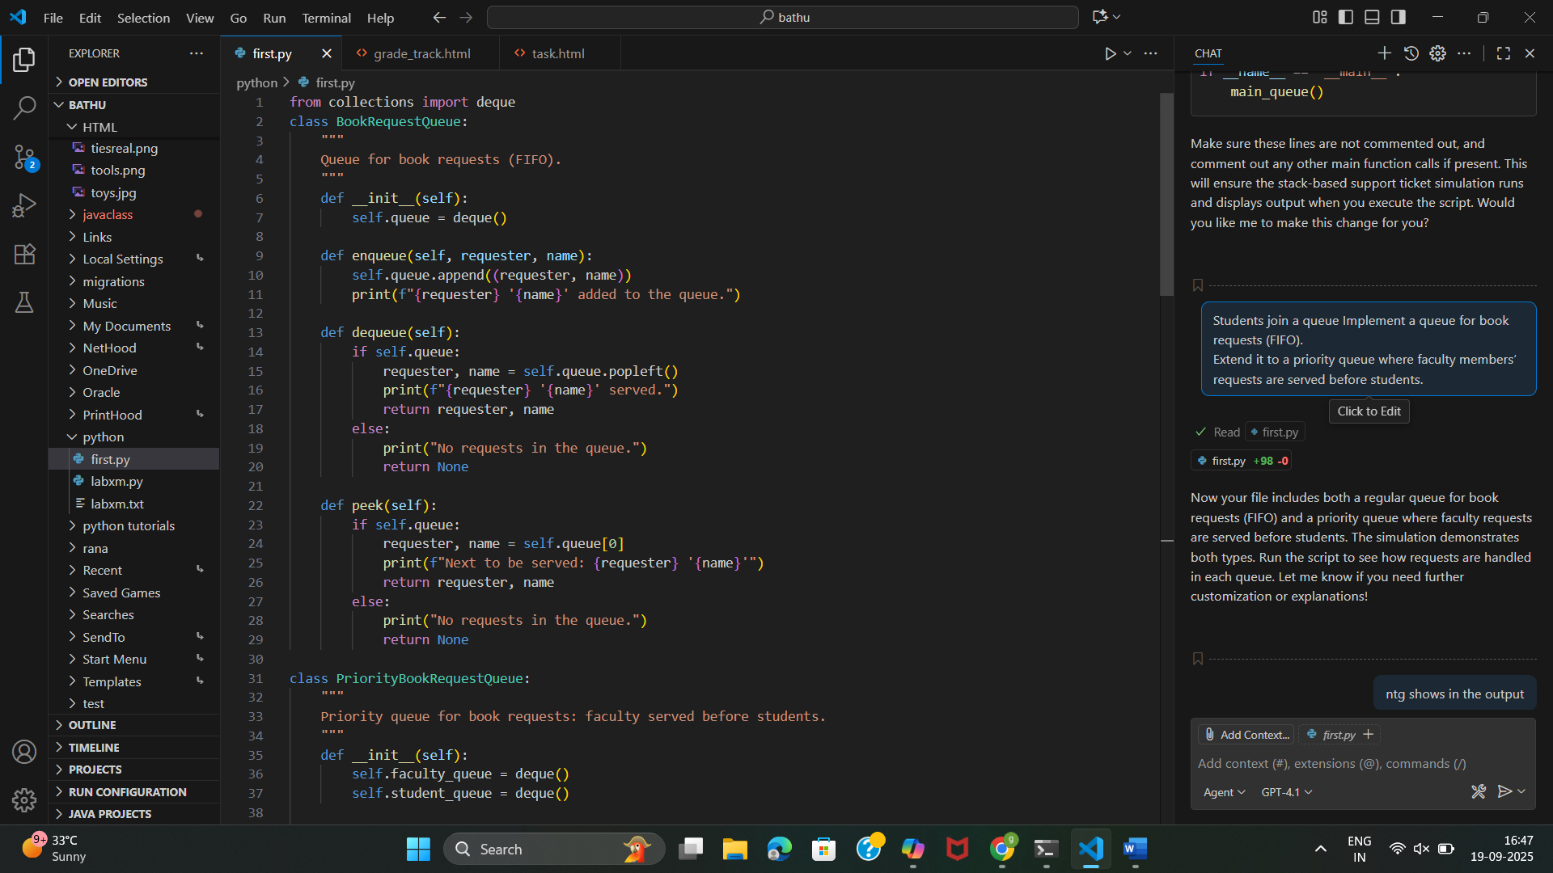
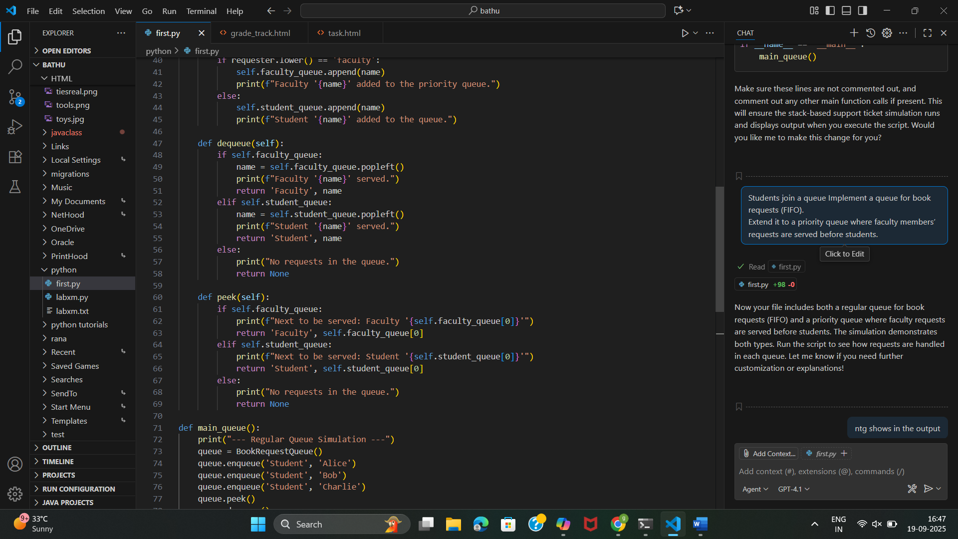
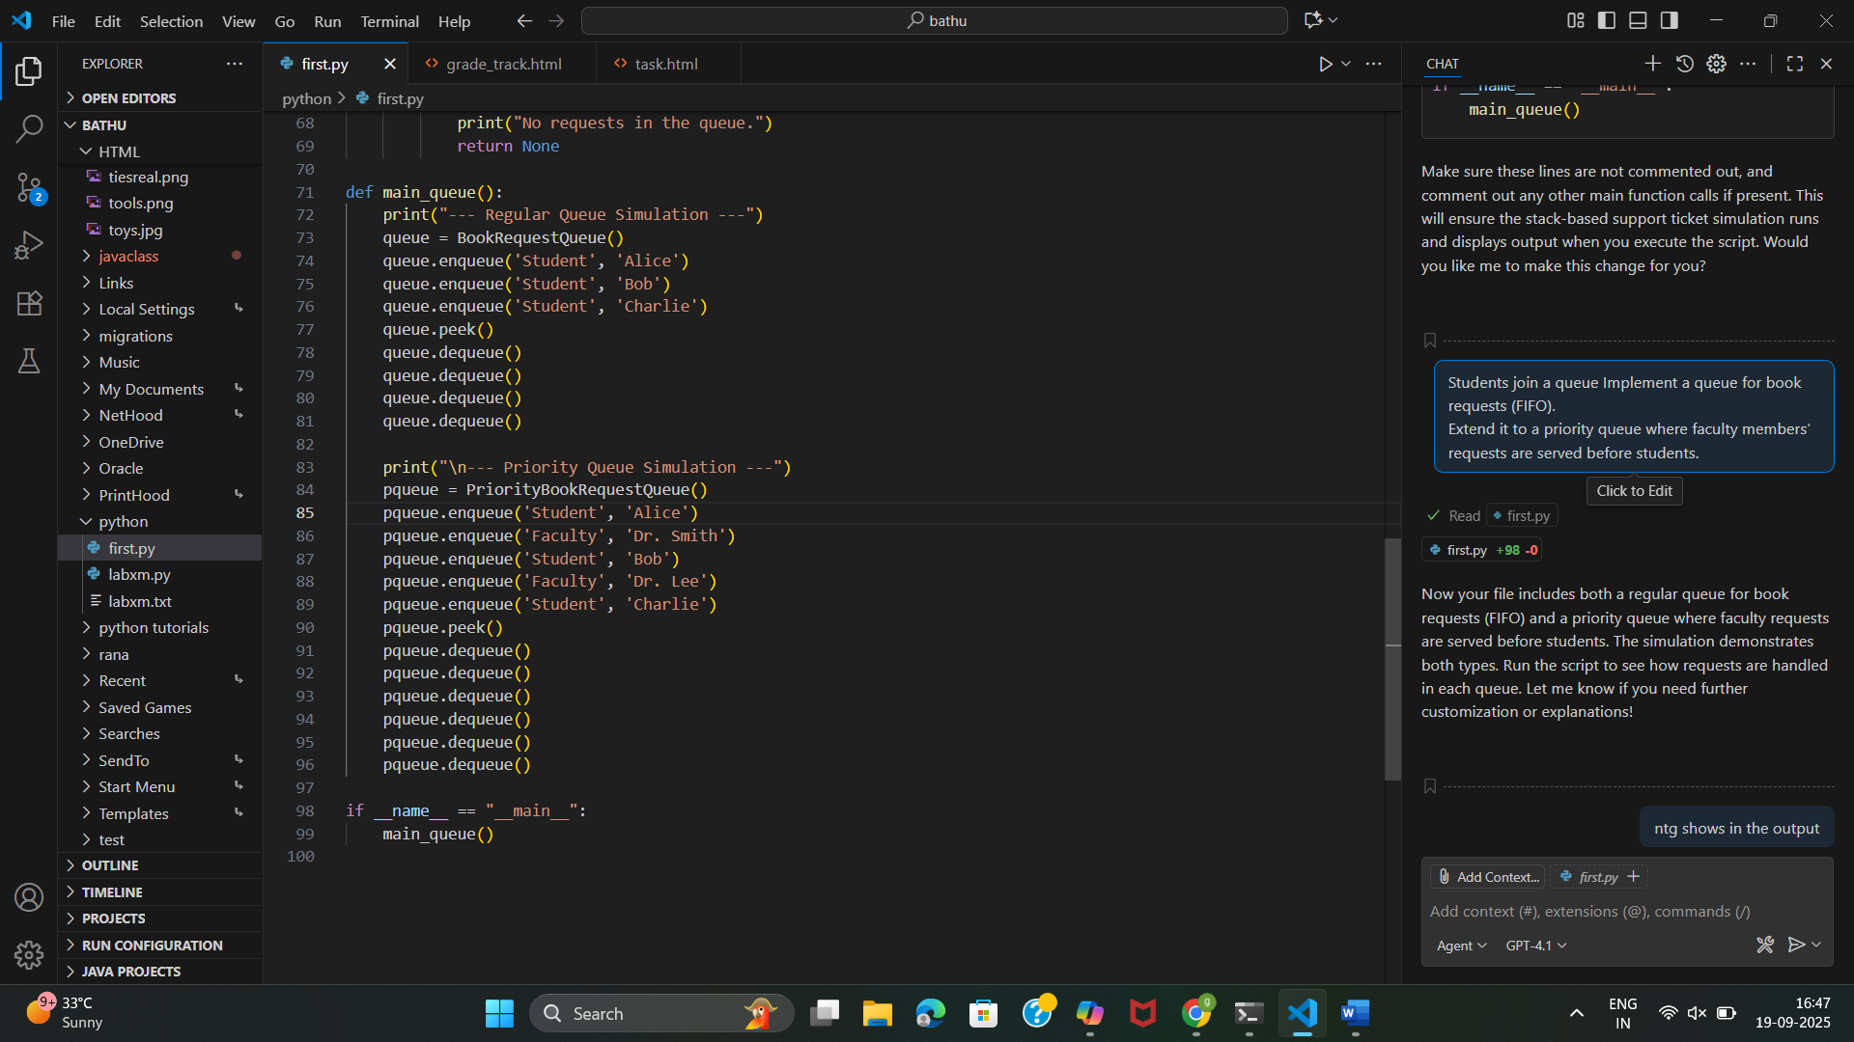
Output:-
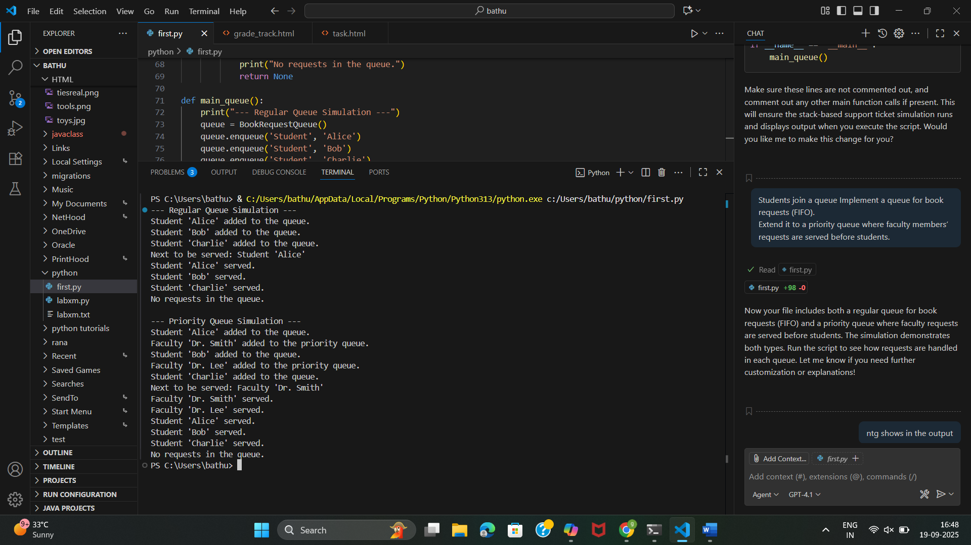
TASk 4:-
Prompt:-
Create a binary search tree (BST) to store building names in alphabetical order. Buildings and rooms are represented as nodes connected by paths.Implement insert, search, and traversal (inorder, preorder, postorder) Extend the system into a graph representation of rooms and paths.
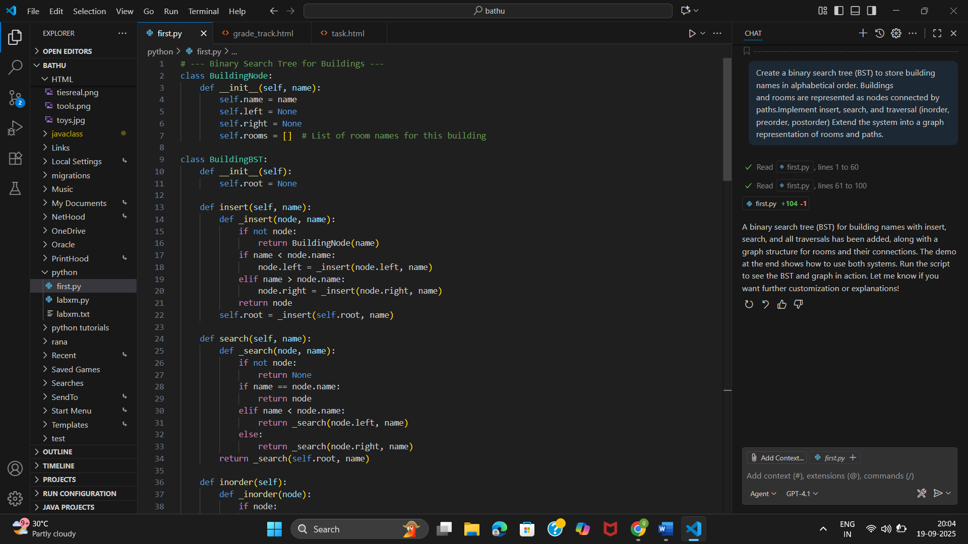
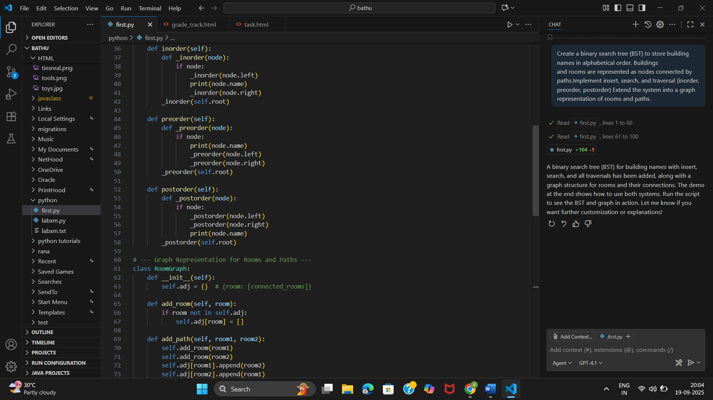

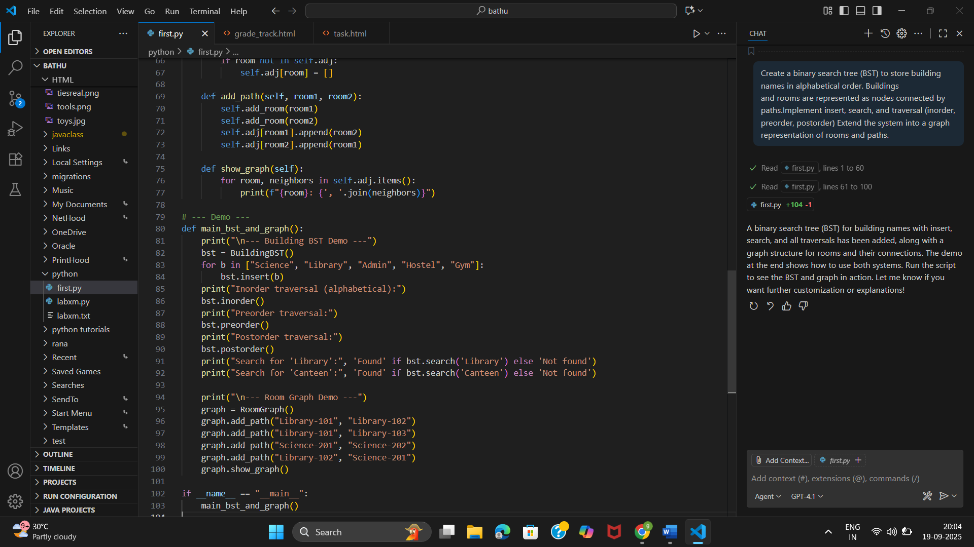
Output:-
