Question Paper Set A13
AI-Assisted Coding Exam — Python (1 hour)
- You may either (a) write the exact prompt to have your AI assistant generate code, or (b) write the code yourself. If you use AI, submit the prompt and the final code you executed.
- Use VS Code Copilot / Gemini / CursorAI. Credit your prompts.
- Prefer Python standard library; write clear, tested, well-documented code.
- Each subgroup (A–O) has two tasks. Attempt all. Medium complexity, use-case based.
- Syllabus pillars:
A–C: AI completion (classes, loops, conditionals)
D–E: Debugging with AI
F–G: TDD with AI
H–I: Documentation & Code Review
J–K: Code Quality & Performance
L–M: Files/CSV & Regex
N–O: Algorithms & Data Structures
Deliverables for each question
1) If using AI: the exact prompt you issued. If manual: note 'manual' and a brief design reason.
2) solution.py
3) tests.py (unittest/pytest; write tests first for TDD items)
4) Docstrings & inline comments (AI-assisted allowed)
5) Short README.md (approach, assumptions, complexity, run tests)
6) For debugging/refactor: brief before/after note

Subgroup B

B.1 — [S13B1] Apply surge/penalty rules (conditionals)
Scenario (agritech):
Context:
Pricing in the agritech app uses a base per-km rate and time-based surge after business peaks. Product wants a deterministic calculator for receipts and audits.

Your Task:
Implement a fare function: fare = km * base_per_km * surgeMultiplier, where surge applies strictly after 18:00 local time.

Data & Edge Cases:
Input is a list of rides with `time` as HH:MM (24h) and `km` as float. Edge case: exactly at 18:00 should be treated as non-surge for 18:00:00; after 18:00 (e.g., 18:01) surges.

AI Assistance Expectation:
Prompt AI to outline parsing HH:MM, applying conditionals, and rounding to 2 decimals; then implement and write a quick test.

Constraints & Notes:
No external libraries; round each fare to 2 decimals; do not mutate input.
Sample Input
[{'time': '08:00', 'km': 3.0}, {'time': '18:30', 'km': 5.0}]
Sample Output
[66.0, 132.0]
Acceptance Criteria: Correct surge threshold and rounding

B.2 — [S13B2] Debug rolling mean (off-by-one)
Scenario (agritech):
Context:
A team in agritech noticed off-by-one bugs in a rolling KPI computation (moving averages) that undercount windows.

Your Task:
Use AI to identify the bug and fix the window iteration so all valid windows are included.

Data & Edge Cases:
For xs=[13, 14, 15, 16] and w=2, number of windows should be len(xs)-w+1.

AI Assistance Expectation:
Ask AI to add a failing test first, propose the minimal fix, and verify with the sample.

Constraints & Notes:
Guard invalid w (<=0 or >len(xs)); preserve O(n*w) simple solution.
Sample Input
xs=[13, 14, 15, 16], w=2
Buggy code:
def rolling_mean(xs, w):
sums = []
for i in range(len(xs)-w):
window = xs[i:i+w]
sums.append(sum(window)/w)
return sums
Sample Output
[13.5, 14.5, 15.5]
Acceptance Criteria: All valid windows included; passes tests; no index errors

OUTPUT:
B.1)
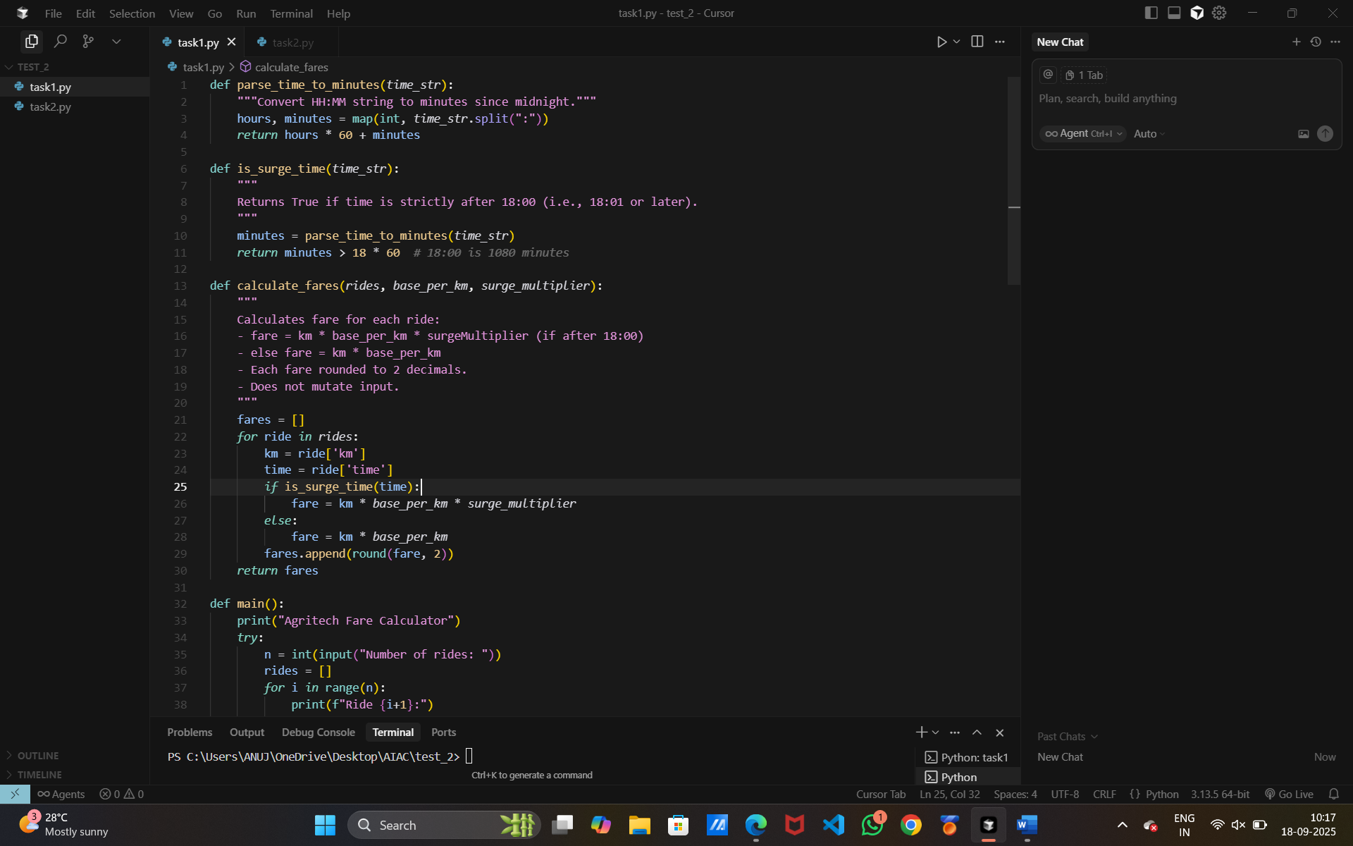
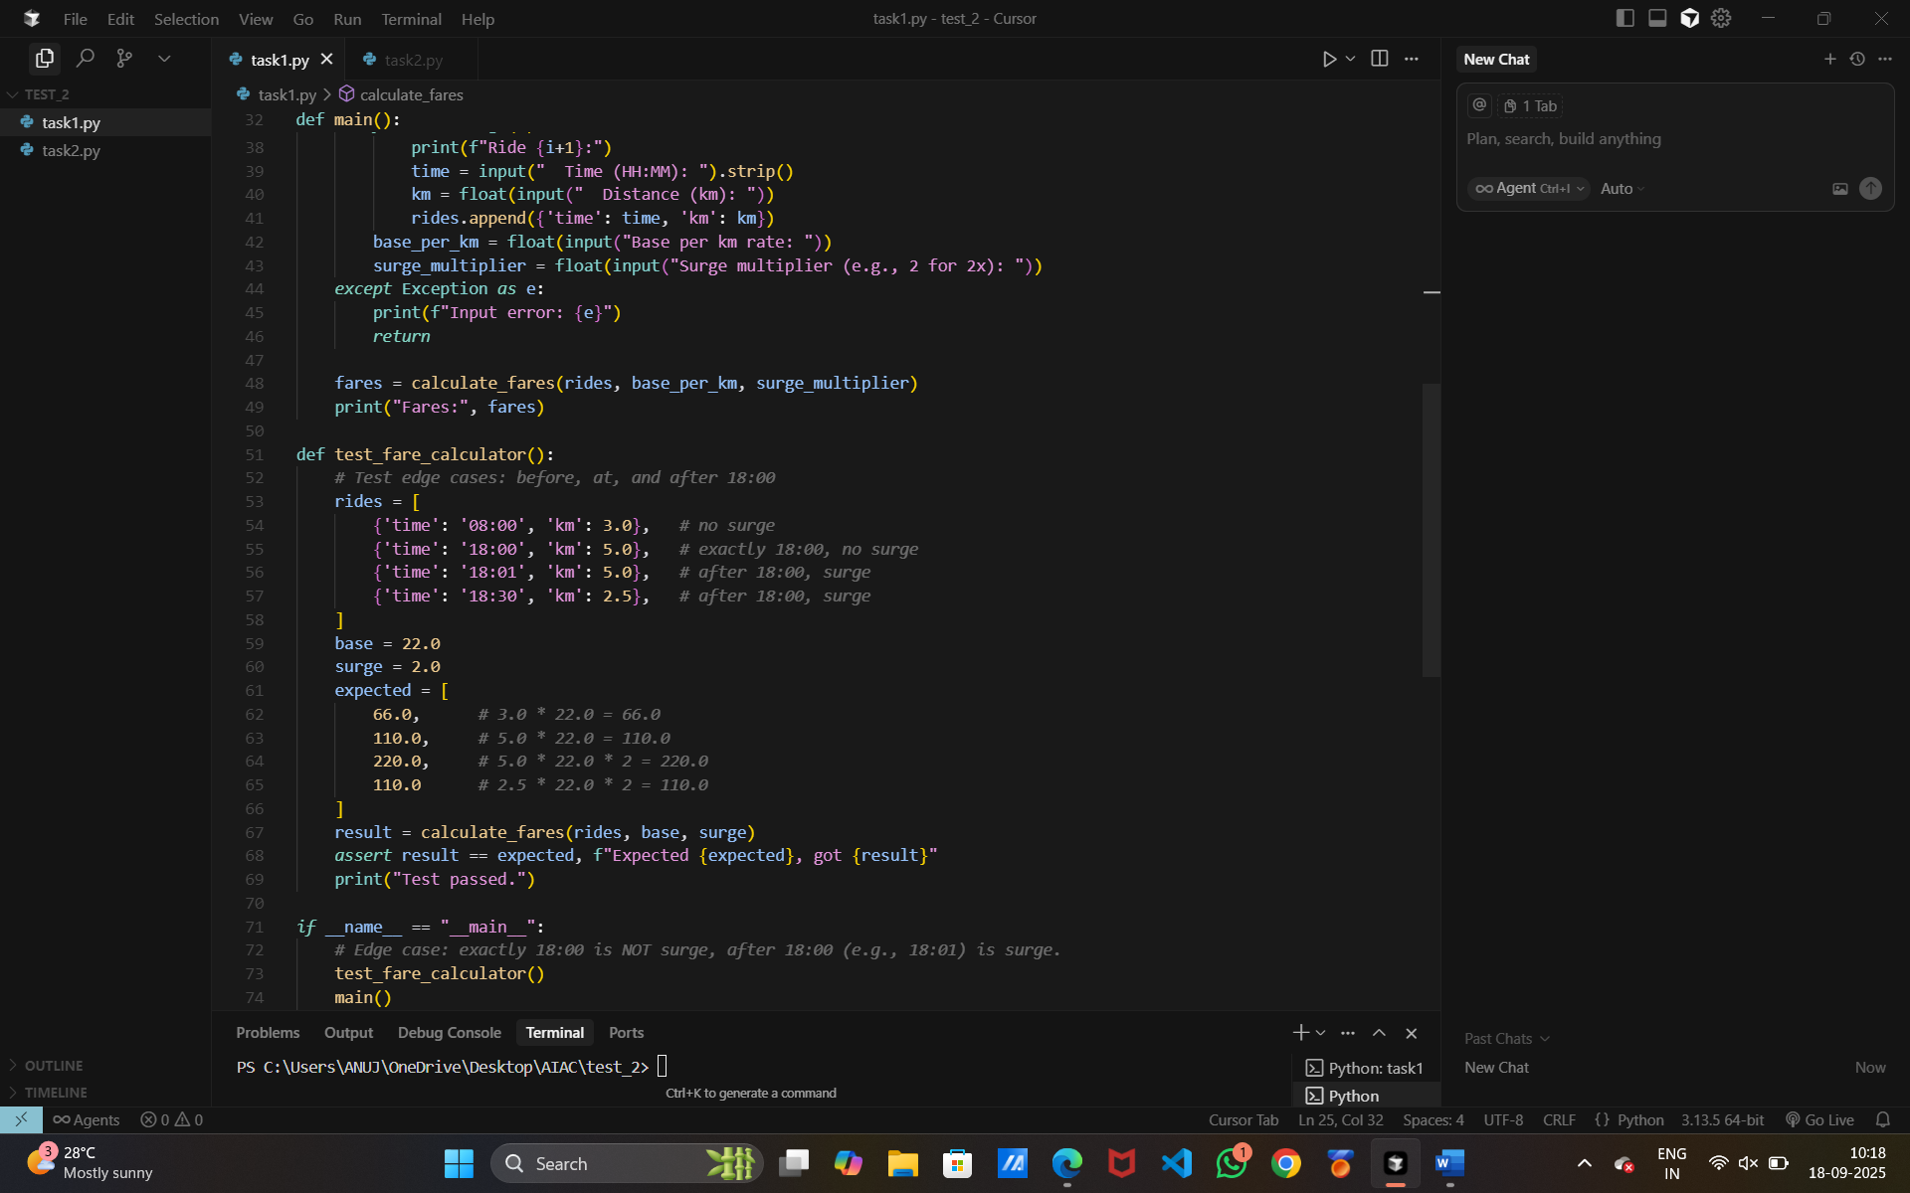

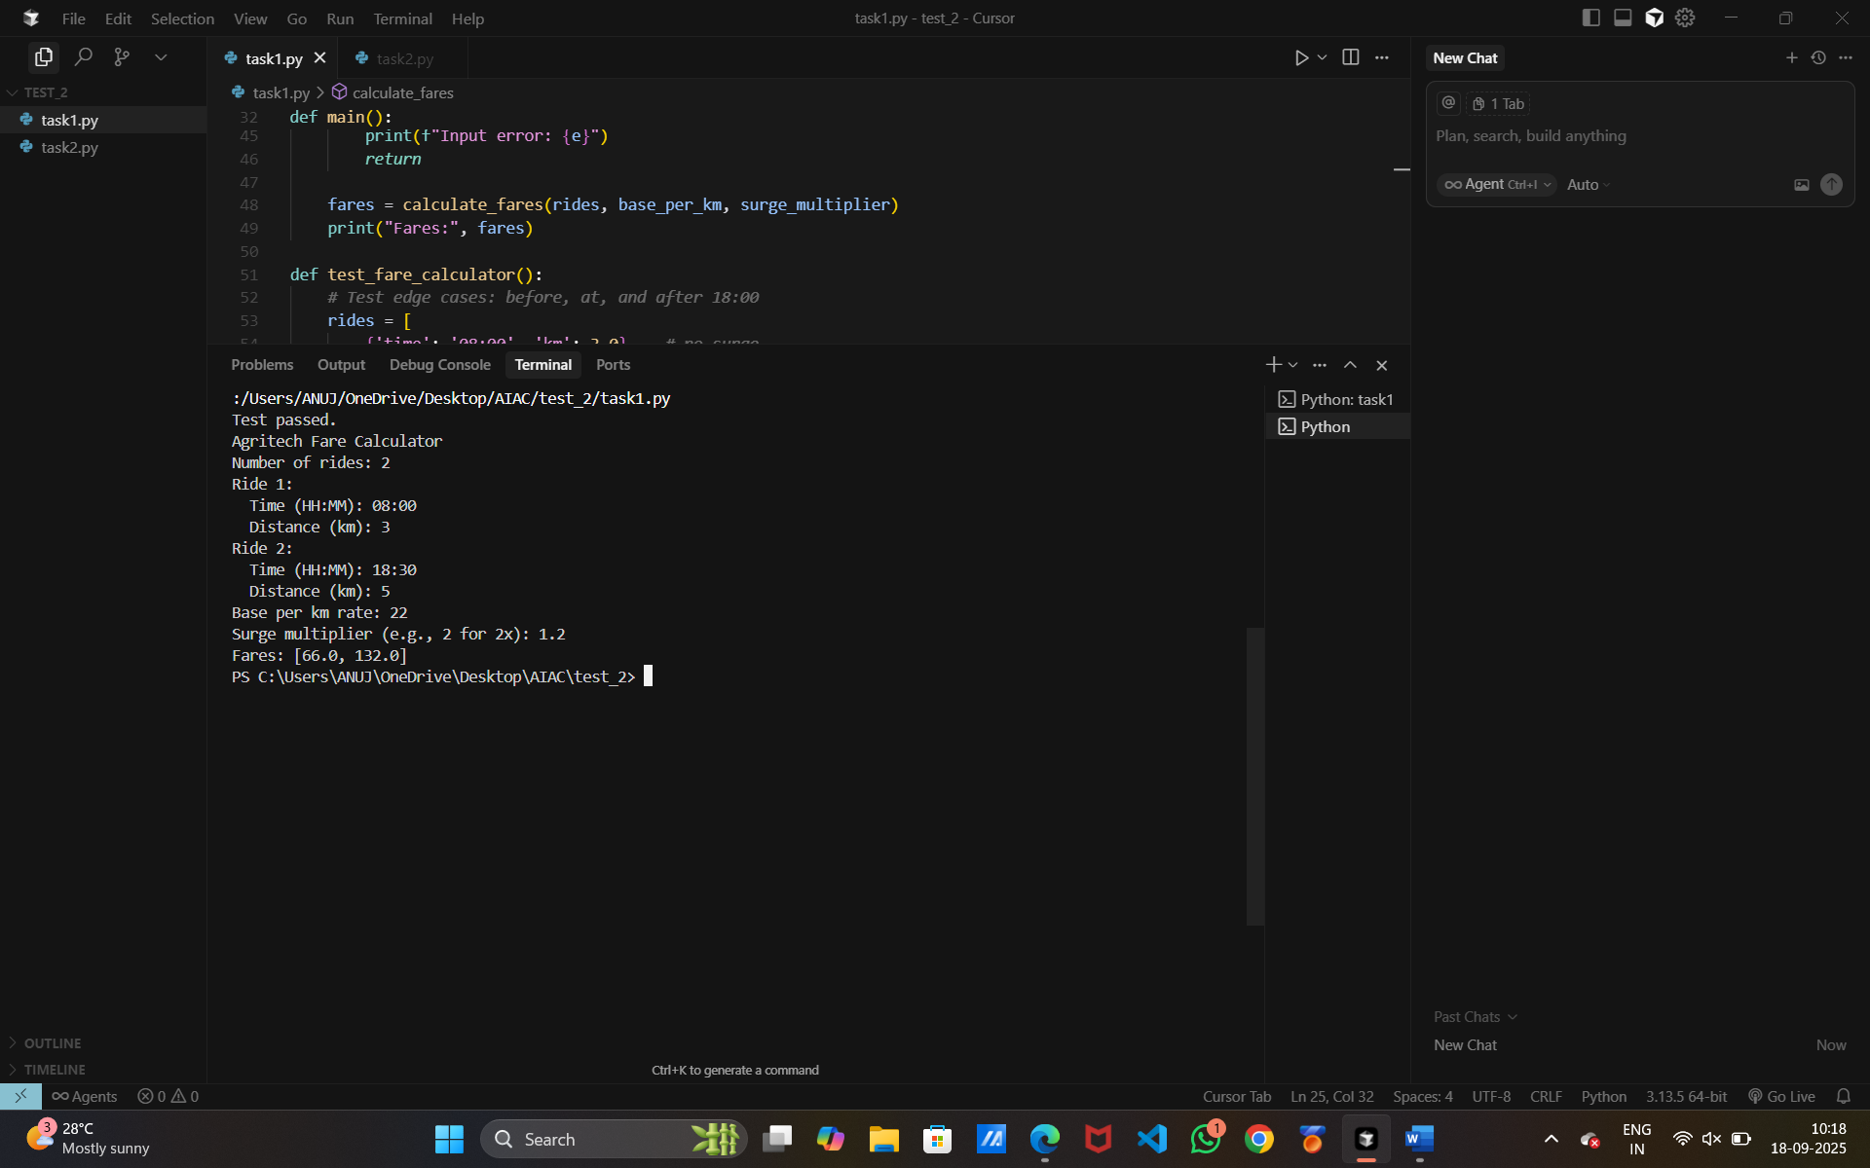

B.2)
