SCHOOL OF COMPUTER SCIENCE AND ARTIFICIAL INTELLIGENCE |  |  |  |  | DEPARTMENT OF COMPUTER SCIENCE ENGINEERING
ProgramName:B. Tech |  |  |  | Assignment Type: Lab |  |  | AcademicYear:2025-2026
CourseCoordinatorName |  |  |  | Venkataramana Veeramsetty
Instructor(s)Name |  |  |  | Dr. V. Venkataramana (Co-ordinator)  Dr. T. Sampath Kumar  Dr. Pramoda Patro  Dr. Brij Kishor Tiwari  Dr.J.Ravichander  Dr. Mohammand Ali Shaik  Dr. Anirodh Kumar  Mr. S.Naresh Kumar  Dr. RAJESH VELPULA  Mr. Kundhan Kumar  Ms. Ch.Rajitha  Mr. M Prakash  Mr. B.Raju  Intern 1 (Dharma teja)  Intern 2 (Sai Prasad)  Intern 3 (Sowmya)  NS_2 ( Mounika)
CourseCode |  |  | 24CS002PC215 | CourseTitle |  | AI Assisted Coding
Year/Sem |  |  | II/I | Regulation |  | R24
Date and Day  of Assignment |  |  | Week4 - Wednesday | Time(s)
Duration |  |  | 2 Hours | Applicableto  Batches
AssignmentNumber:8.3(Present assignment number)/24(Total number of assignments)
 | Q.No. | Question |  |  |  |  |  | ExpectedTime  to complete
 | 1 | Lab 8: Test-Driven Development with AI – Generating and Working with Test Cases  Lab Objectives:  - To introduce students to test-driven development (TDD) using AI code generation tools.  - To enable the generation of test cases before writing code implementations.  - To reinforce the importance of testing, validation, and error handling.  - To encourage writing clean and reliable code based on AI-generated test expectations.  Lab Outcomes (LOs):  After completing this lab, students will be able to:  - Use AI tools to write test cases for Python functions and classes.  - Implement functions based on test cases in a test-first development style.  - Use unittest or pytest to validate code correctness.  - Analyze the completeness and coverage of AI-generated tests.  - Compare AI-generated and manually written test cases for quality and logic  Task Description#1  Use AI to generate test cases for is_valid_email(email) and then implement the validator function.  Requirements:  - Must contain @ and . characters.  - Must not start or end with special characters.  - Should not allow multiple @.  Expected Output#1  - Email validation logic passing all test cases  Task Description#2 (Loops)  - Ask AI to generate test cases for assign_grade(score) function. Handle boundary and invalid inputs.  Requirements  - AI should generate test cases for assign_grade(score) where: 90-100: A, 80-89: B, 70-79: C, 60-69: D, <60: F  - Include boundary values and invalid inputs (e.g., -5, 105, "eighty").  Expected Output#2  Grade assignment function passing test suite  Task Description#3  - Generate test cases using AI for is_sentence_palindrome(sentence). Ignore case, punctuation, and spaces  Requirement  - Ask AI to create test cases for is_sentence_palindrome(sentence)  (ignores case, spaces, and punctuation).  - Example:  "A man a plan a canal Panama" → True  Expected Output#3  - Function returns True/False for cleaned sentences  - Implement the function to pass AI-generated tests.  Task Description#4  - Let AI fix it Prompt AI to generate test cases for a ShoppingCart class (add_item, remove_item, total_cost).  Methods:  Add_item(name,orice)  Remove_item(name)  Total_cost()  Expected Output#4  - Full class with tested functionalities  Task Description#5  - Use AI to write test cases for convert_date_format(date_str) to switch from "YYYY-MM-DD" to "DD-MM-YYYY".  Example: "2023-10-15" → "15-10-2023"  Expected Output#5  - Function converts input format correctly for all test cases  Note: Report should be submitted a word document for all tasks in a single document with prompts, comments & code explanation, and output and if required, screenshots  Evaluation Criteria:  Criteria Max Marks  Task #1 0.5  Task #2 0.5  Task #3 0.5  Task #4 0.5  Task #5 0.5  Total 2.5 Marks |  |  |  |  |  | Week4 - Wednesday

Task Description#1
Use AI to generate test cases for is_valid_email(email) and then implement the validator function.

Prompt: Write a python function that ask the user to enter the mail and that function checks the given mail is valid or not.And display the result on to screen.The mail must contains only one @ and characters.
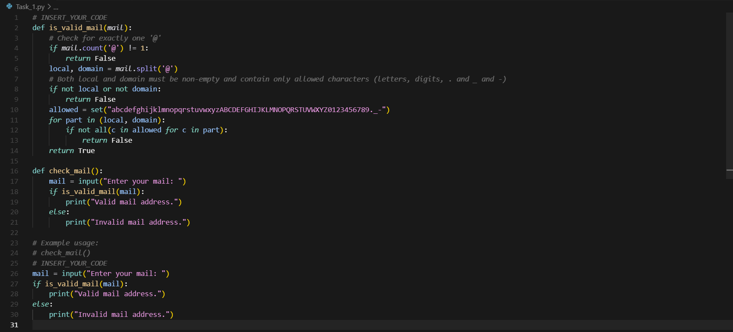

Test case:
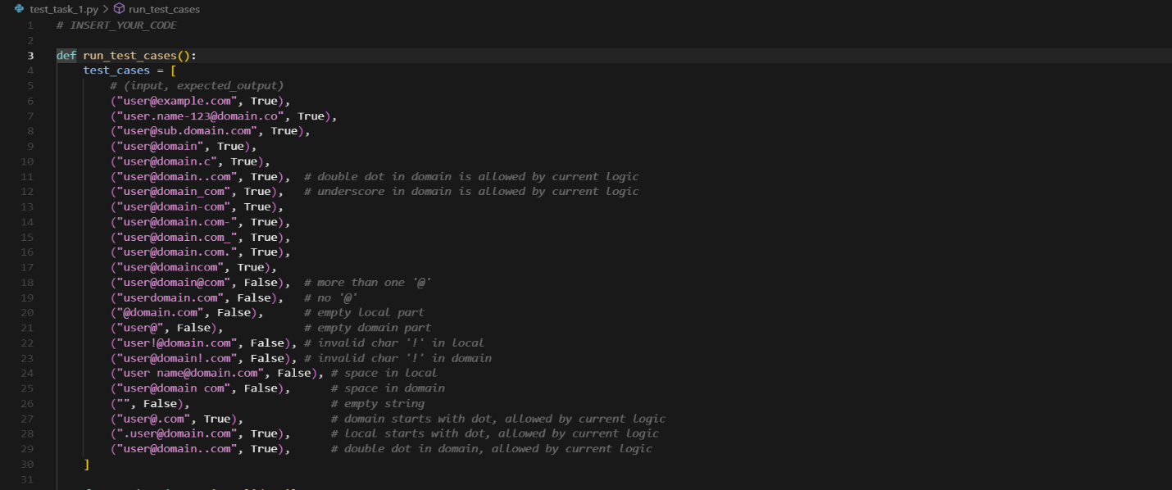
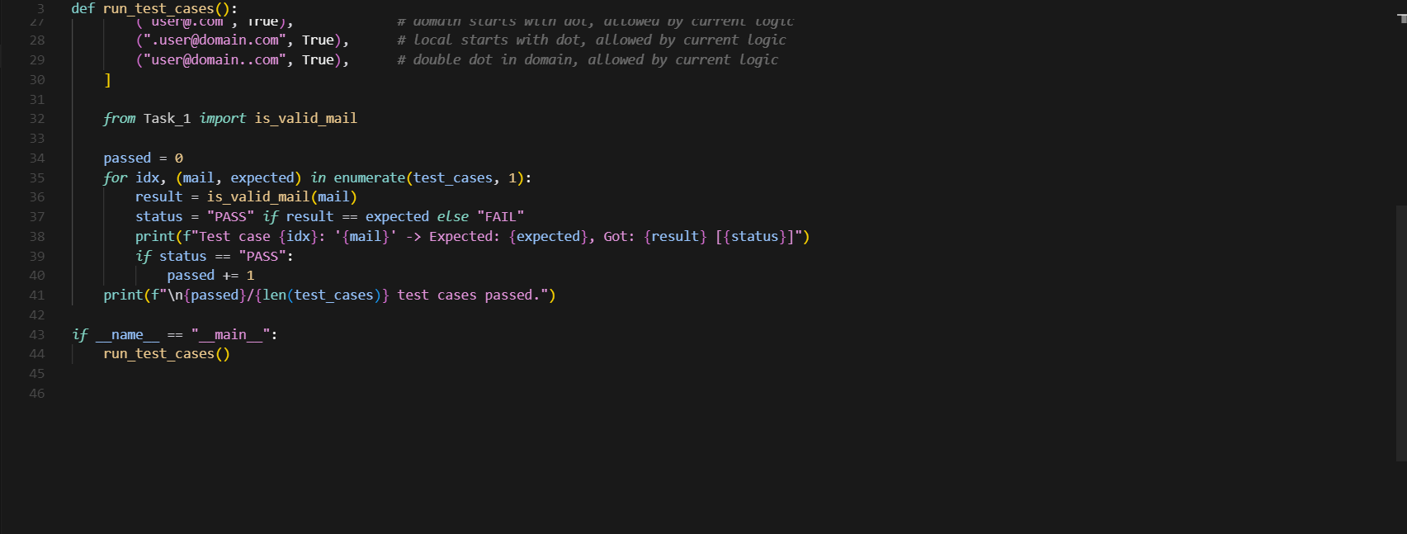

Output:
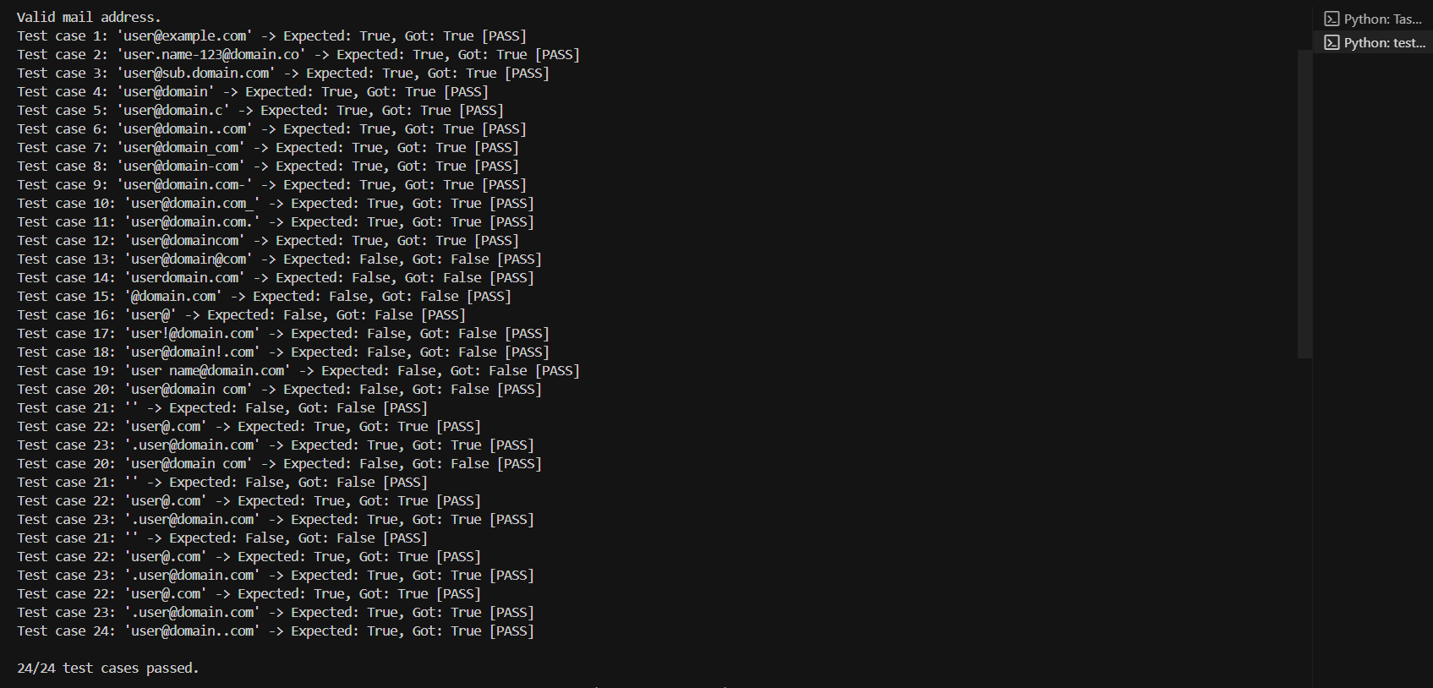
Task Description#2 (Loops)
- Ask AI to generate test cases for assign_grade(score) function. Handle boundary and invalid inputs.
Requirements
- AI should generate test cases for assign_grade(score) where: 90-100: A, 80-89: B, 70-79: C, 60-69: D, <60: F
- Include boundary values and invalid inputs (e.g., -5, 105, "eighty").
- Prompt:
Ask AI to generate code for assign_grade(score) function. Handle boundary and invalid inputs.
AI should generate code for assign_grade(score) where: 90-100: A, 80-89: B, 70-79: C, 60-69: D, <60: F
Include boundary values and invalid inputs (e.g., -5, 105, "eighty").
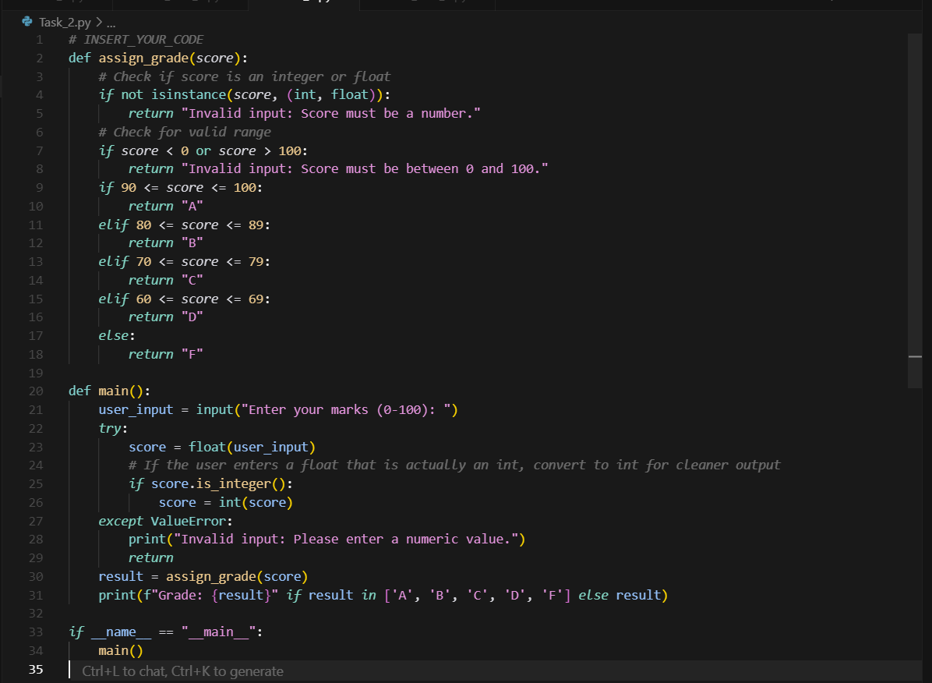
TEST CASE:
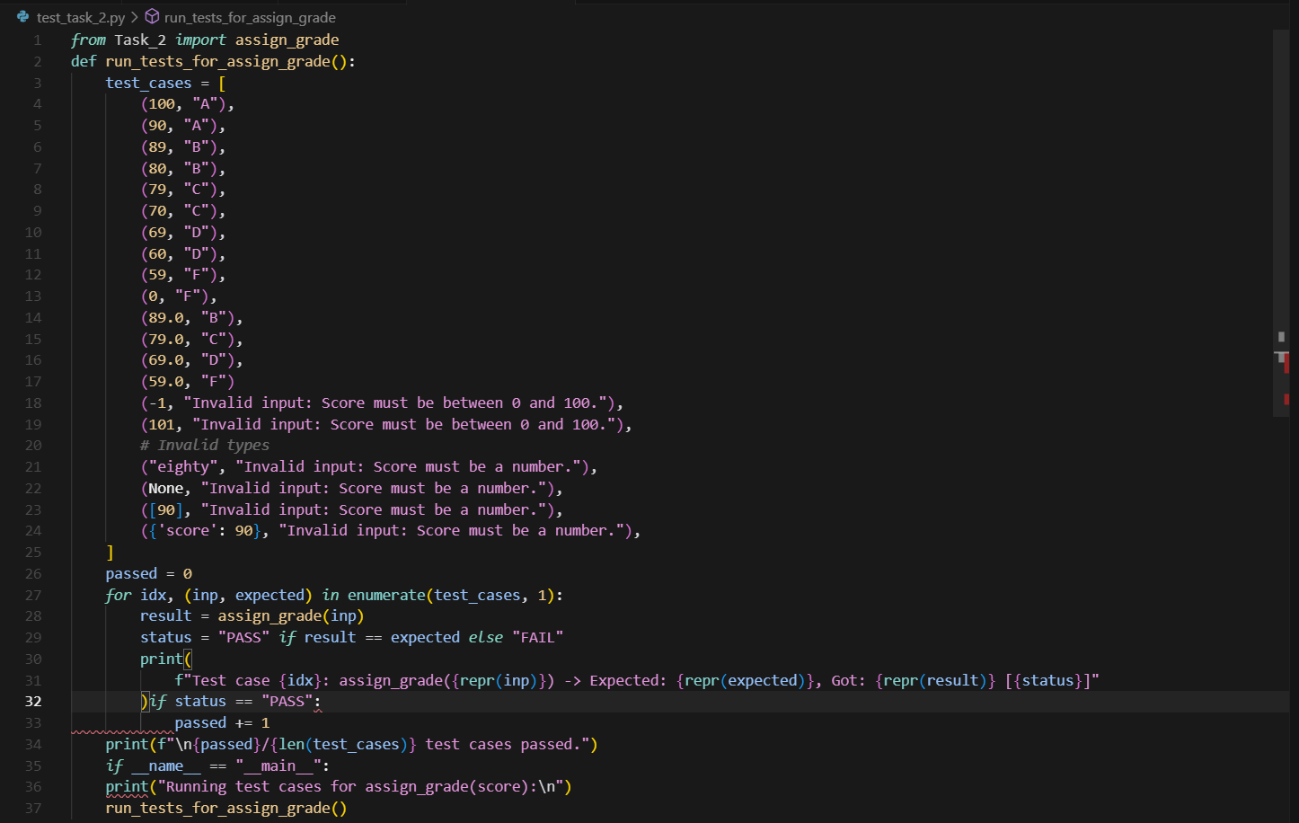

OUTPUT:
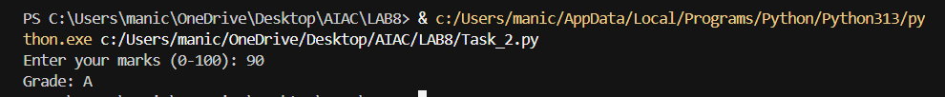
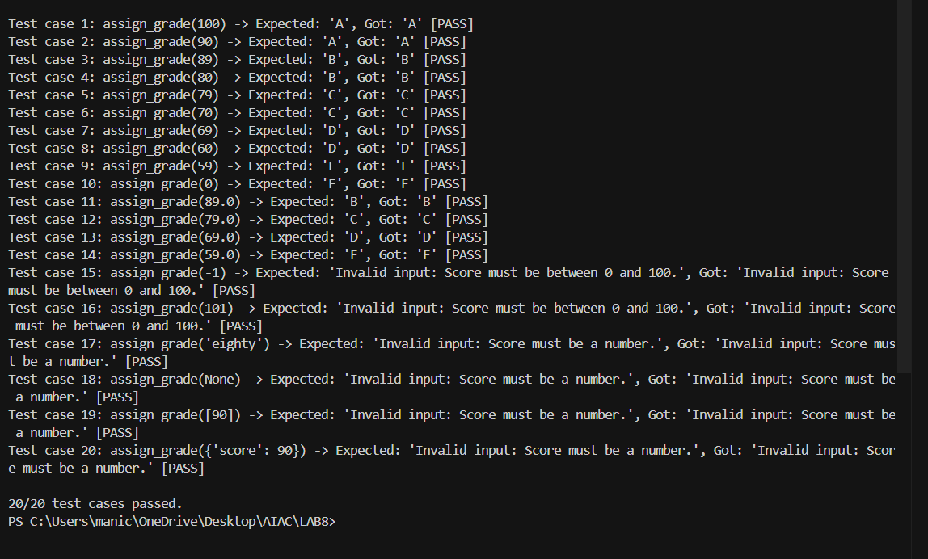

Task Description#3
- Generate test cases using AI for is_sentence_palindrome(sentence). Ignore case, punctuation, and spaces

Requirement
- Ask AI to create test cases for is_sentence_palindrome(sentence)
(ignores case, spaces, and punctuation).

- Example:
"A man a plan a canal Panama" → True

Prompt: Generate the code using AI for is_sentence_palindrome(sentence). Ignore case, punctuation, and spaces.Ask the user to give the input.
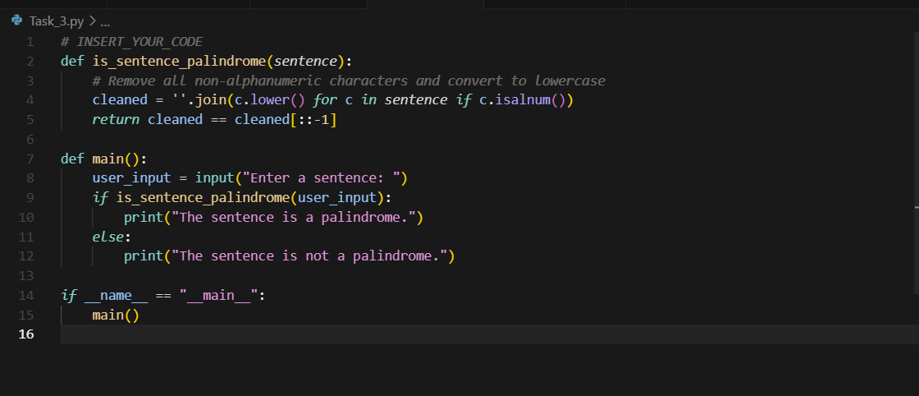
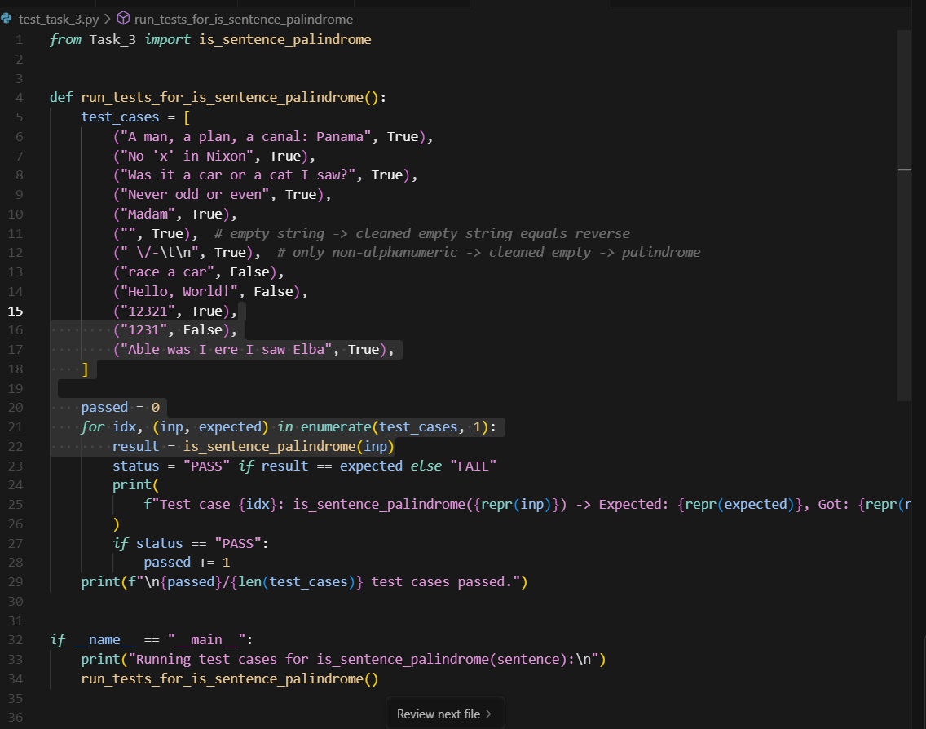

OUTPUT:
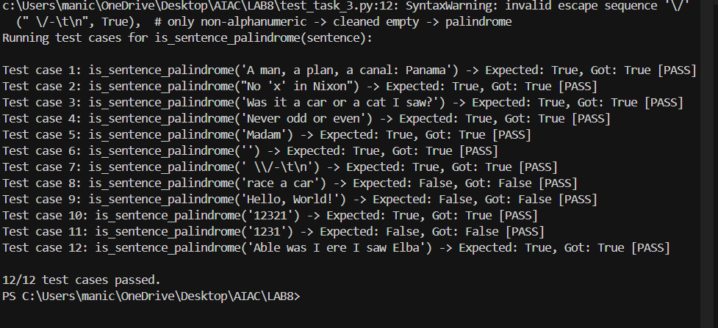

Task Description#4
- Let AI fix it Prompt AI to generate test cases for a ShoppingCart class (add_item, remove_item, total_cost).

Methods:
Add_item(name,orice)
Remove_item(name)
Total_cost()
- Full class with tested functionalities

Prompt:Generate the code for a ShoppingCart class (add_item, remove_item, total_cost).
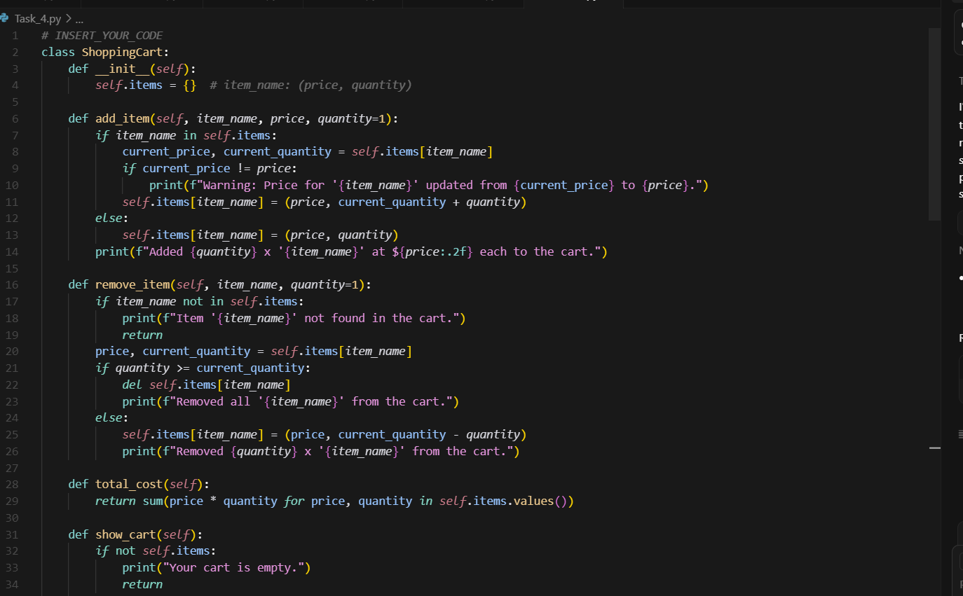

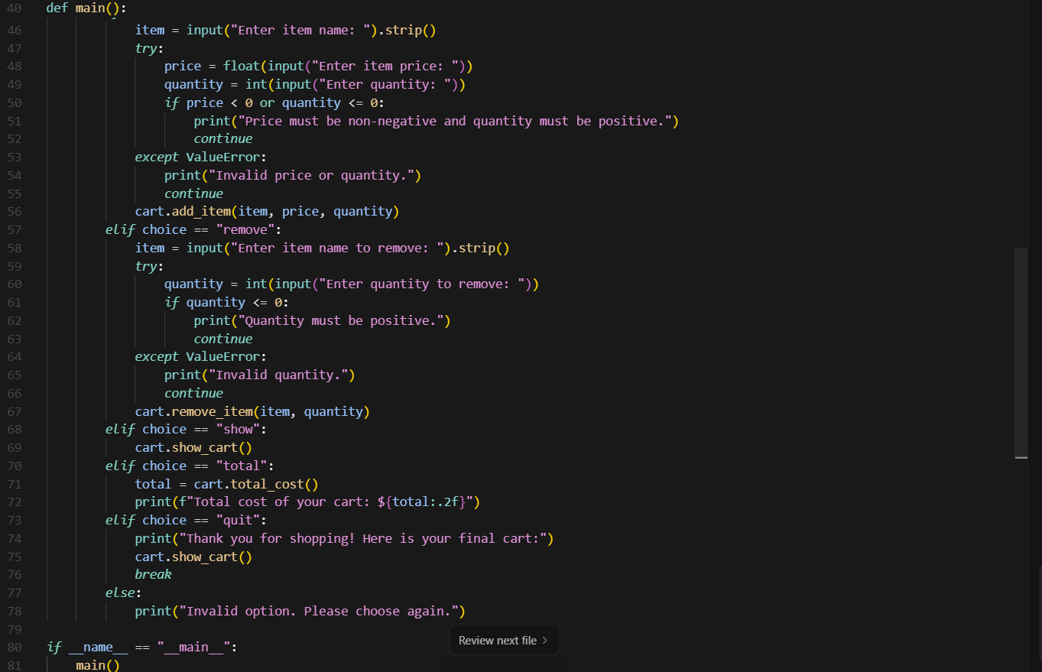
TEST CASE:
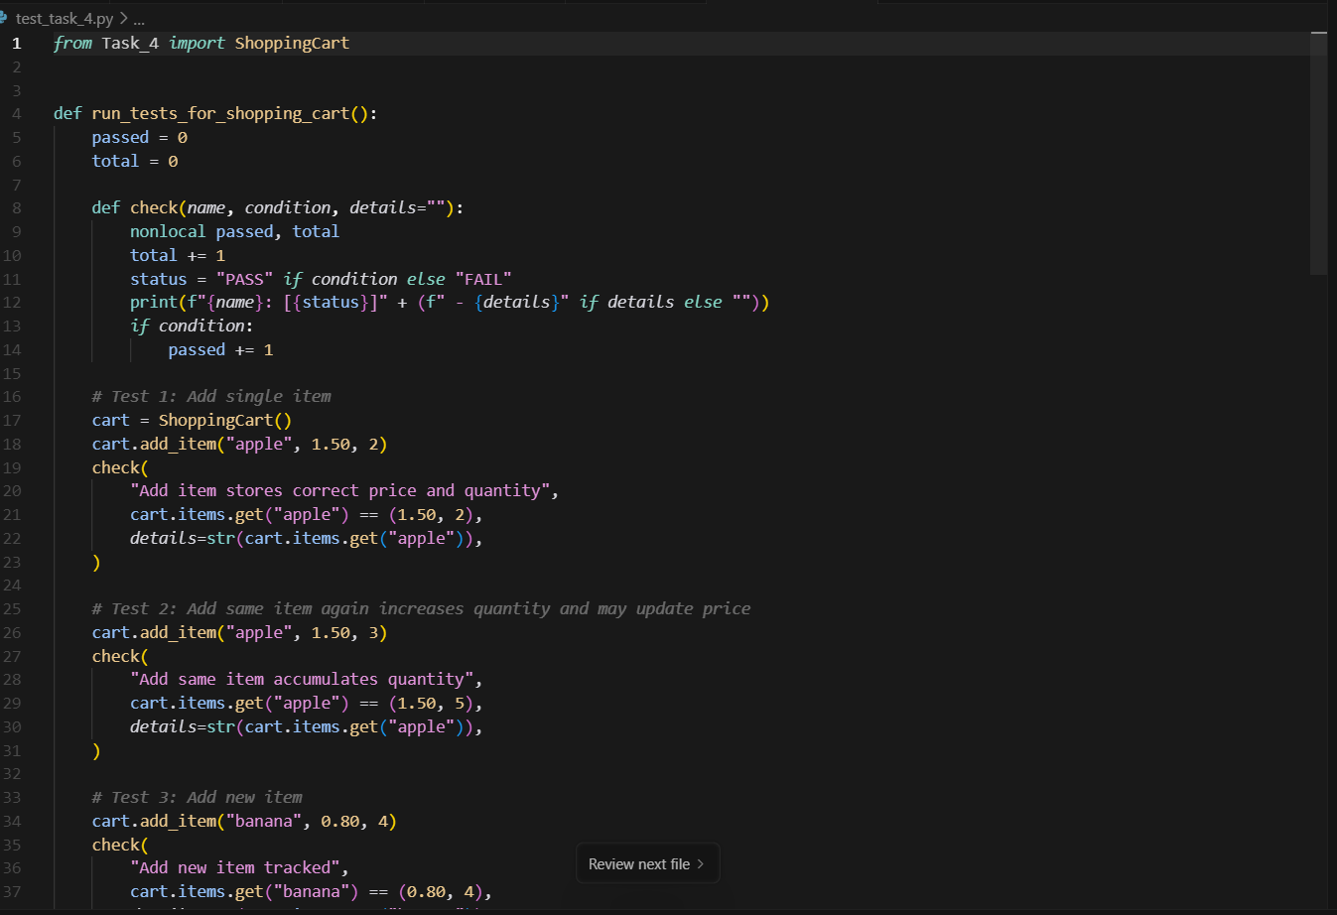
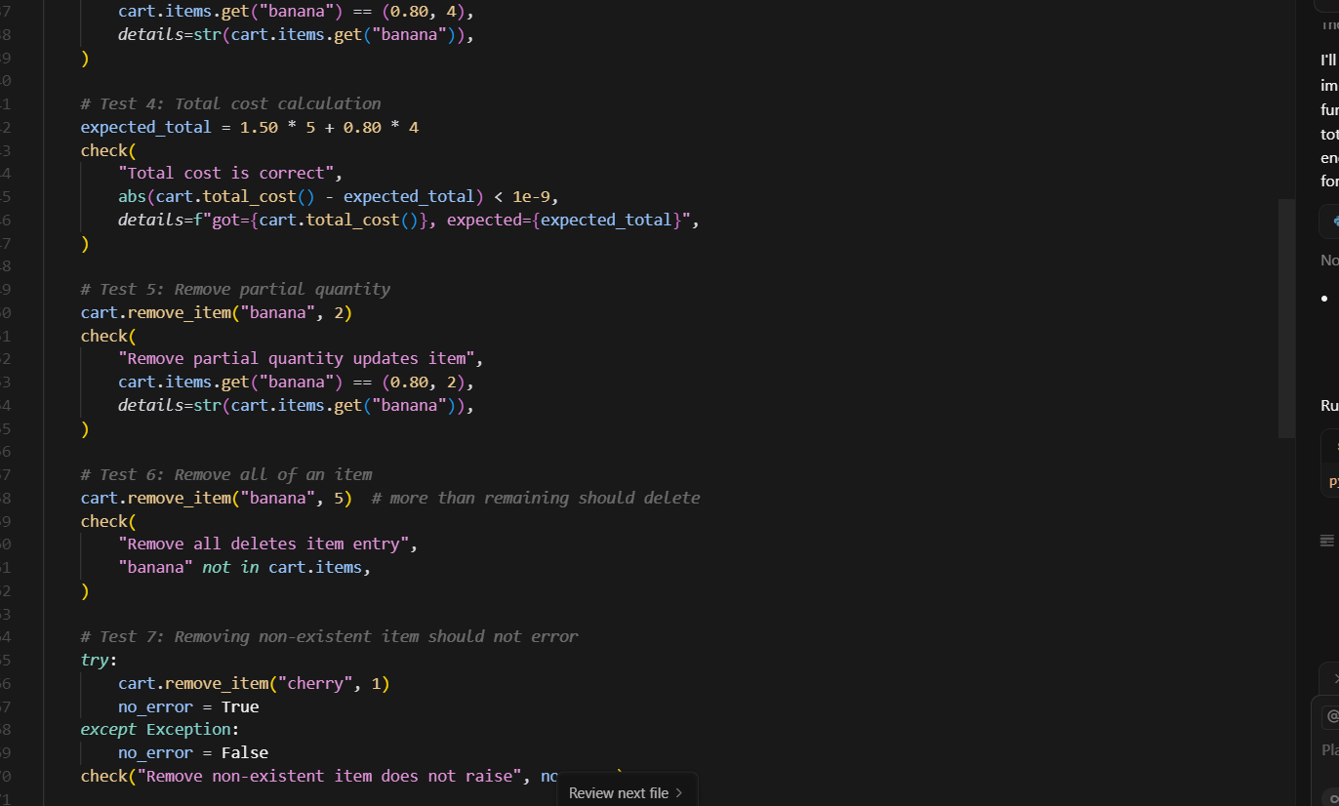
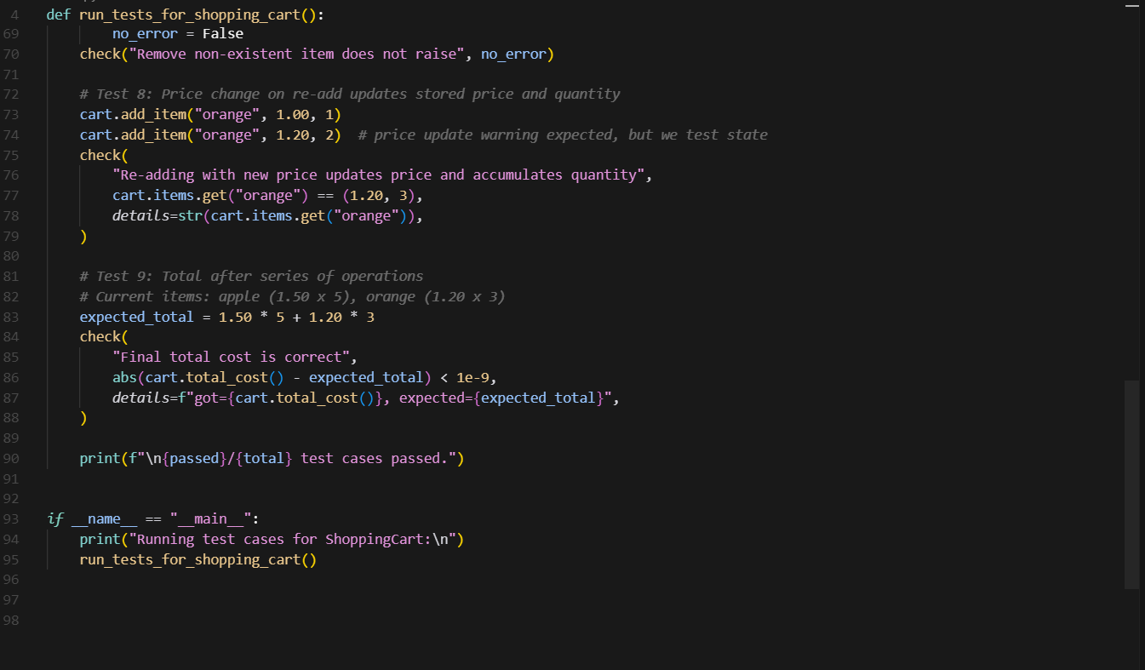

OUTPUT:
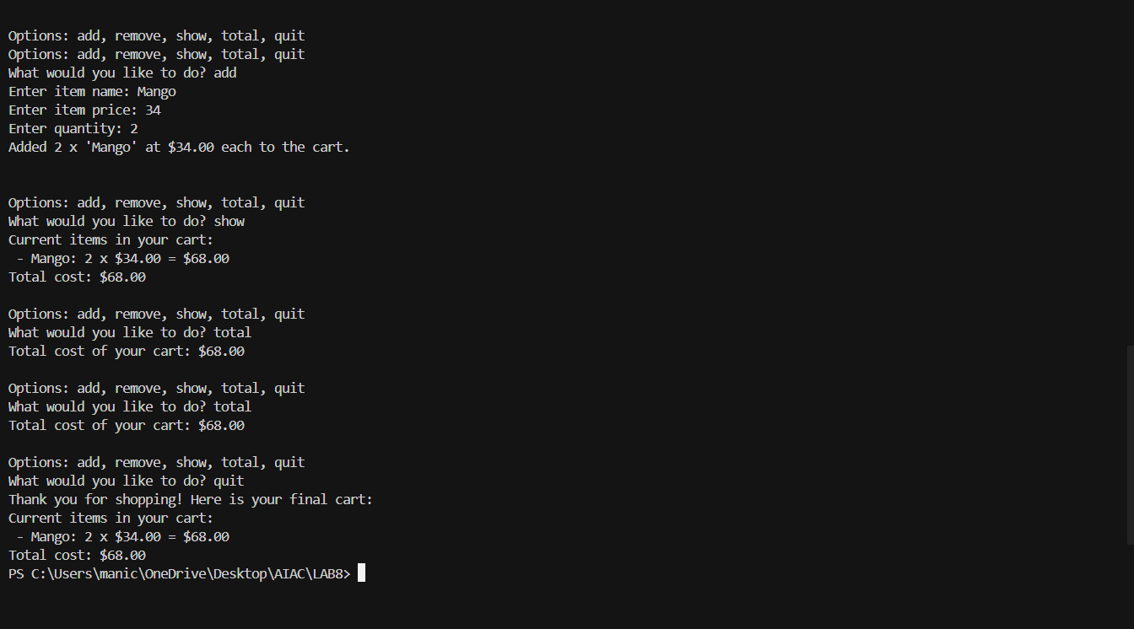
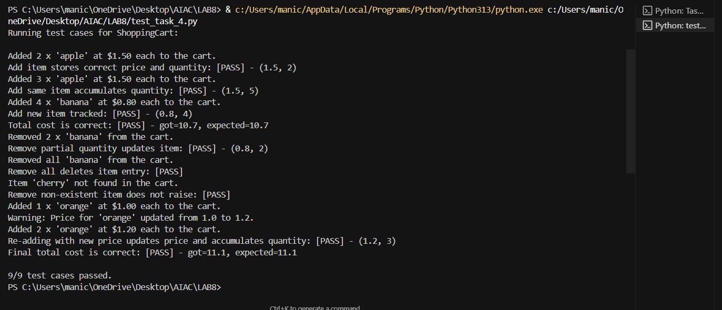

Task Description#5
- Use AI to write test cases for convert_date_format(date_str) to switch from "YYYY-MM-DD" to "DD-MM-YYYY".
Example: "2023-10-15" → "15-10-2023"

Prompt: Write a python function to convert_date_format(date_str) to switch from "YYYY-MM-DD" to "DD-MM-YYYY".
For example: "2023-10-15" → "15-10-2023"
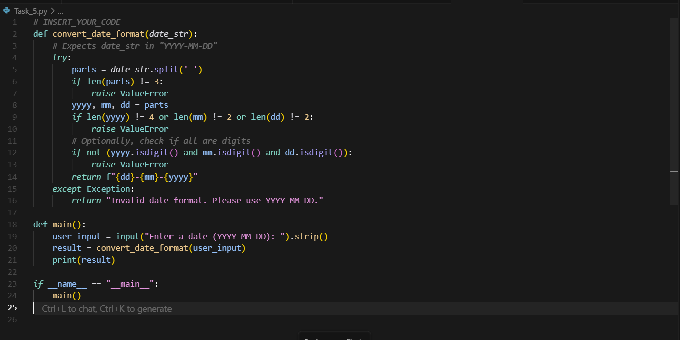
TESTCASE:
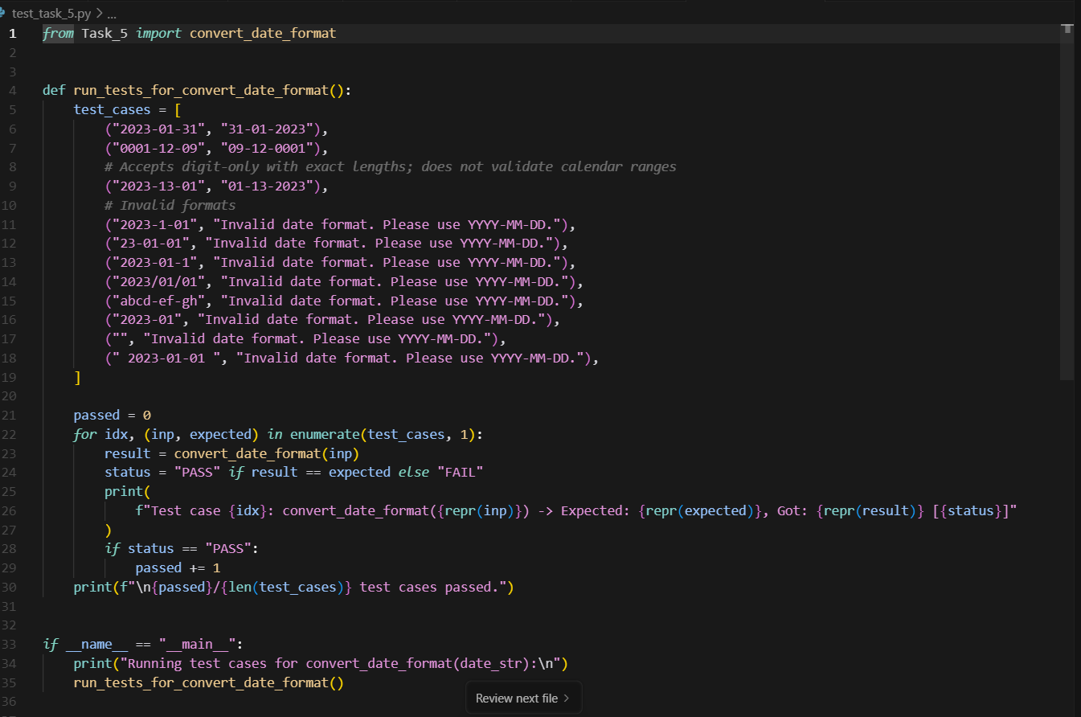

OUTPUT:
