]SCHOOL OF COMPUTER SCIENCE AND ARTIFICIAL INTELLIGENCE |  |  |  |  | DEPARTMENT OF COMPUTER SCIENCE ENGINEERING
ProgramName:B. Tech |  |  |  | Assignment Type: Lab |  |  | AcademicYear:2025-2026
CourseCoordinatorName |  |  |  | Venkataramana Veeramsetty
Instructor(s)Name |  |  |  | Dr. V. Venkataramana (Co-ordinator)  Dr. T. Sampath Kumar  Dr. Pramoda Patro  Dr. Brij Kishor Tiwari  Dr.J.Ravichander  Dr. Mohammand Ali Shaik  Dr. Anirodh Kumar  Mr. S.Naresh Kumar  Dr. RAJESH VELPULA  Mr. Kundhan Kumar  Ms. Ch.Rajitha  Mr. M Prakash  Mr. B.Raju  Intern 1 (Dharma teja)  Intern 2 (Sai Prasad)  Intern 3 (Sowmya)  NS_2 ( Mounika)
rCourseCode |  |  | 24CS002PC215 | CourseTitle |  | AI Assisted Coding
Year/Sem |  |  | II/I | Regulation |  | R24
Date and Day  of Assignment |  |  | Week5- Wednesday | Time(s)
Duration |  |  | 2 Hours | Applicableto  Batches
AssignmentNumber:9.3(Present assignment number)/24(Total number of assignments)
 | Q.No. | Question |  |  |  |  |  | ExpectedTime  to complete
 | 1 | Lab 8: Documentation Generation: Automatic documentation and code comments  Lab Objectives:  - To understand the importance of documentation and code comments in software development.  - To explore how AI-assisted coding tools can generate meaningful documentation and inline comments.  - To practice generating function-level and module-level docstrings automatically.  - To evaluate the quality, accuracy, and limitations of AI-generated documentation.  - To develop a small automated tool for documentation generation in Python..  Lab Outcomes (LOs):  After completing this lab, students will be able to:  - Apply AI-assisted coding tools to generate docstrings and inline comments for Python code.  - Critically analyze AI-generated documentation for correctness, completeness, and readability.  - Create structured documentation (function-level, module-level) following standard formats.  - Design and implement a mini documentation generator tool to automate code commenting and docstring creation.  Task Description#1 Basic Docstring Generation  - Write python function to return sum of even and odd numbers in the given list.  - Incorporate manual docstring in code with Google Style  - Use an AI-assisted tool (e.g., Copilot, Cursor AI) to generate a docstring describing the function.  - Compare the AI-generated docstring with your manually written one.  Expected Outcome#1: Students understand how AI can produce function-level documentation.  Task Description#2 Automatic Inline Comments  - Write python program for sru_student class with attributes like name, roll no., hostel_status and fee_update method and display_details method.  - Write comments manually for each line/code block  - Ask an AI tool to add inline comments explaining each line/step.  - Compare the AI-generated comments with your manually written one.  Expected Output#2: Students critically analyze AI-generated code comments.  Task Description#3  - Write a Python script with 3–4 functions (e.g., calculator: add, subtract, multiply, divide).  - Incorporate manual docstring in code with NumPy Style  - Use AI assistance to generate a module-level docstring + individual function docstrings.  - Compare the AI-generated docstring with your manually written one.  Expected Output#3: Students learn structured documentation for multi-function scripts  Push documentation whole workspace as .md file in GitHub Repository  Note: Report should be submitted a word document for all tasks in a single document with prompts, comments & code explanation, and output and if required, screenshots |  |  |  |  |  | Week4 - Wednesday

Task Description#1 Basic Docstring Generation
- Write python function to return sum of even and odd numbers in the given list.
- Incorporate manual docstring in code with Google Style
- Use an AI-assisted tool (e.g., Copilot, Cursor AI) to generate a docstring describing the function.
- Compare the AI-generated docstring with your manually written one.

Prompt: Write python function to return sum of even and odd numbers in the given list.

CODE: 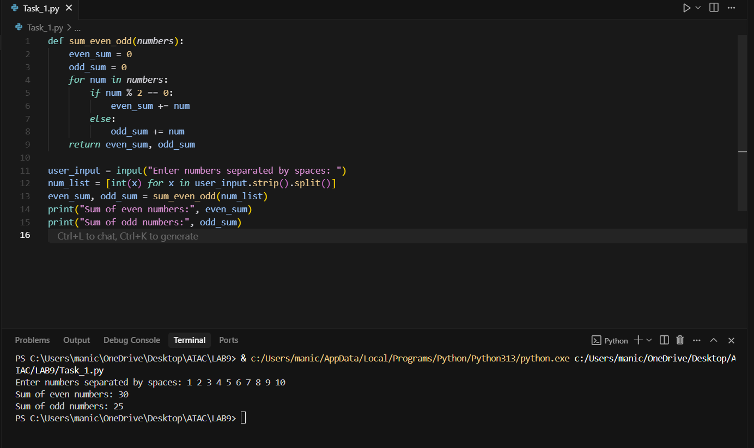

Manual doc string: Takes the input from the user and checking the even numbers and odd numbers.Doing add operations separately for even and odd numbers.
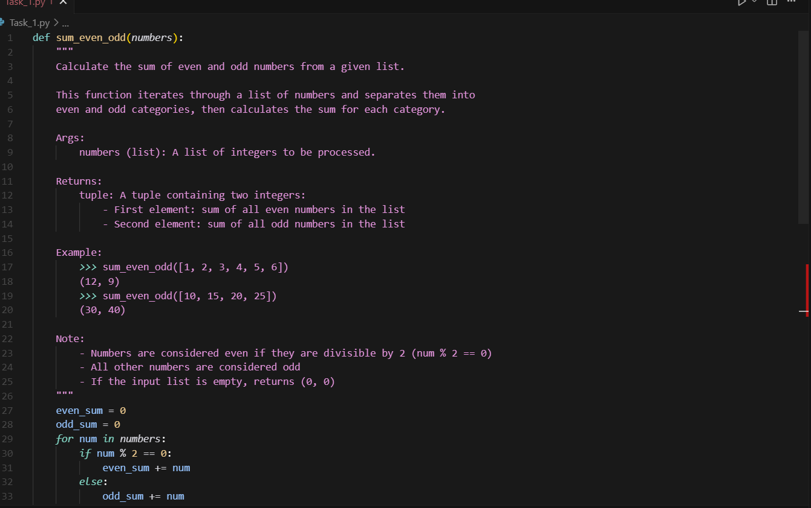

AI GENERATED DOCUMENTATION:
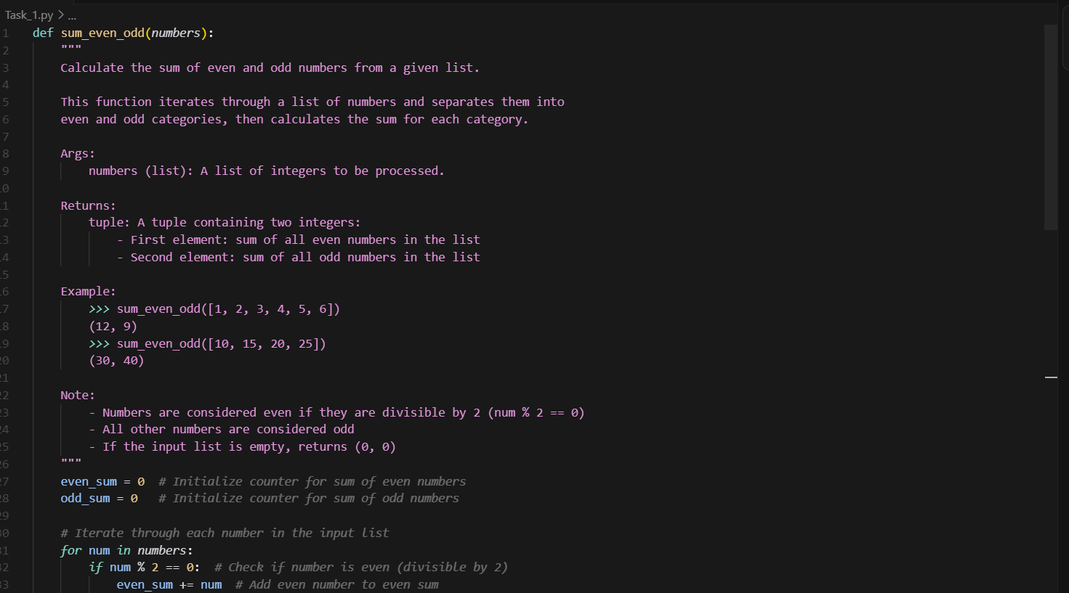
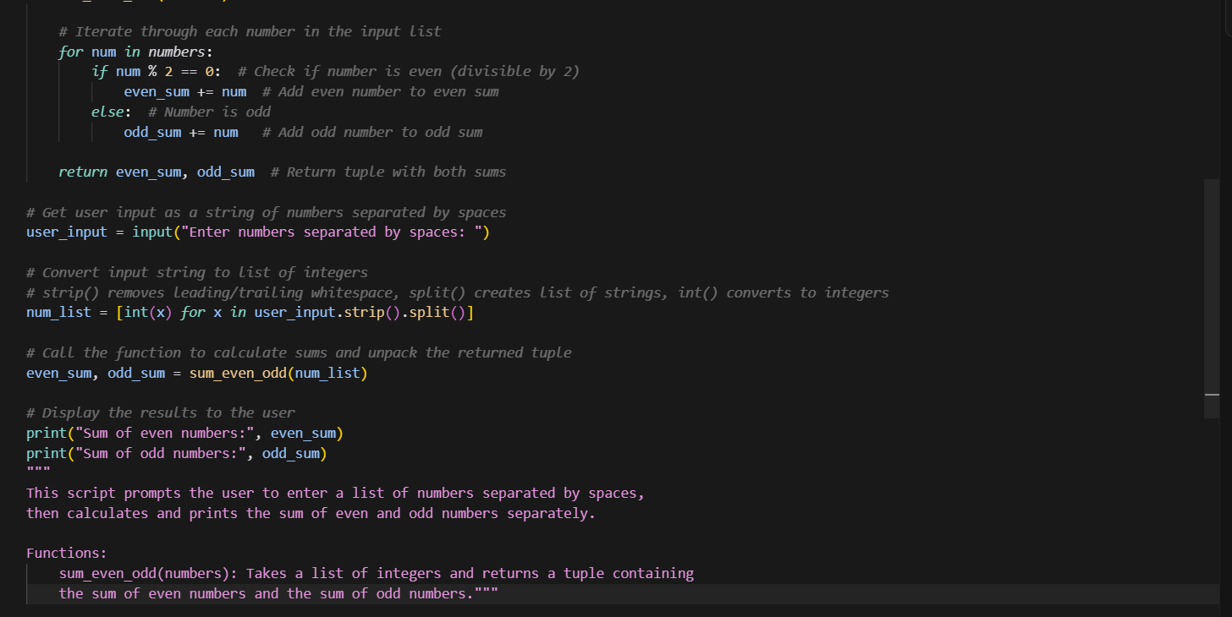

Task Description#2 Automatic Inline Comments
- Write python program for sru_student class with attributes like name, roll no., hostel_status and fee_update method and display_details method.
- Write comments manually for each line/code block
- Ask an AI tool to add inline comments explaining each line/step.
- Compare the AI-generated comments with your manually written one.

Prompt: Write python program for sru_student class with attributes like name, roll no., hostel_status and fee_update method and display_details method.Ask the user to give input.
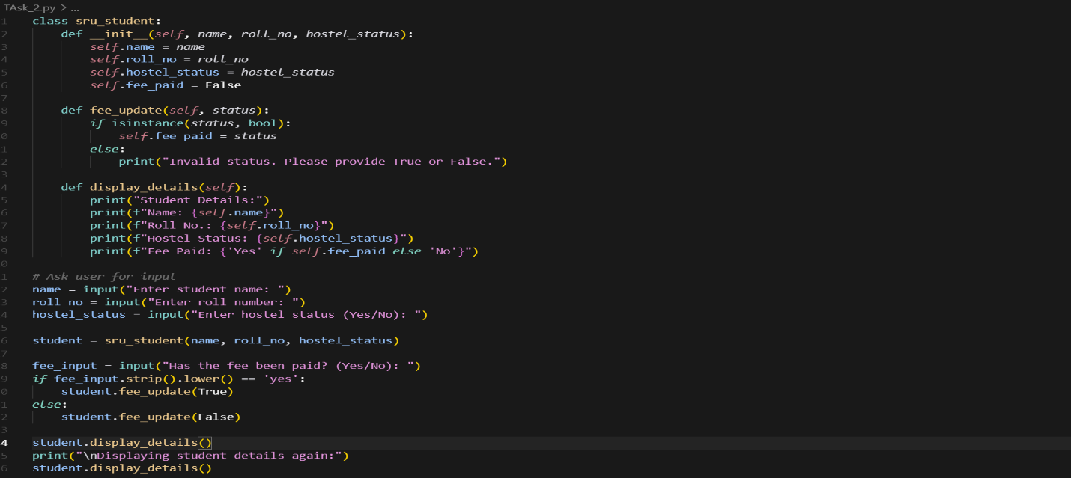
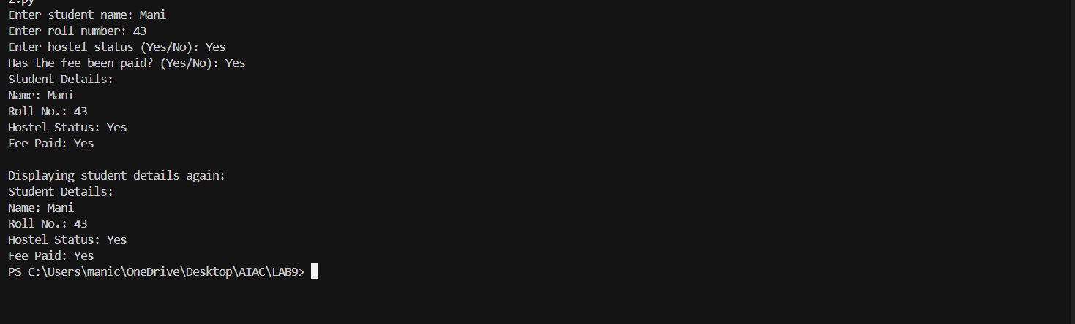

Manual documentation : This program creates a student profile with name, roll number, and hostel status.
It lets you update whether the student has paid the fee or not.
Finally, it shows all the student details clearly on the screen.
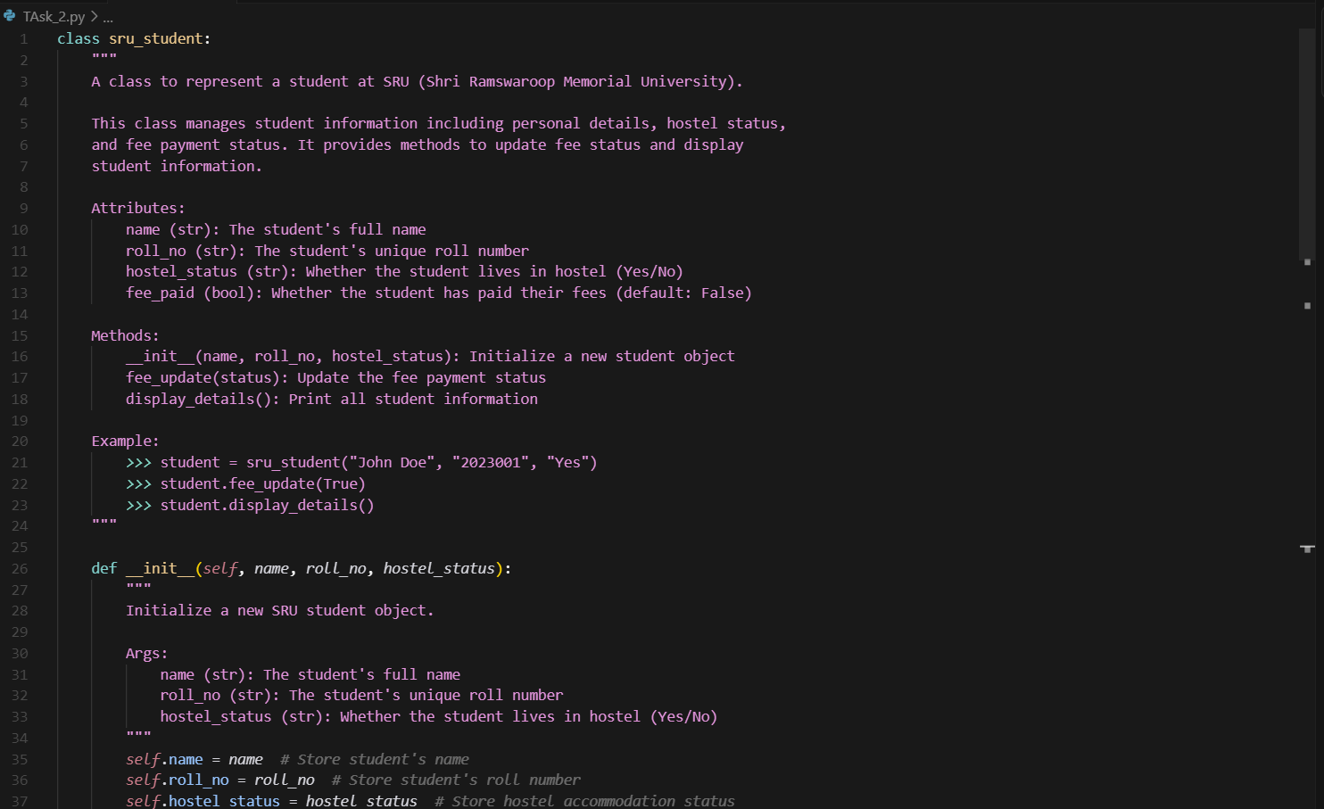
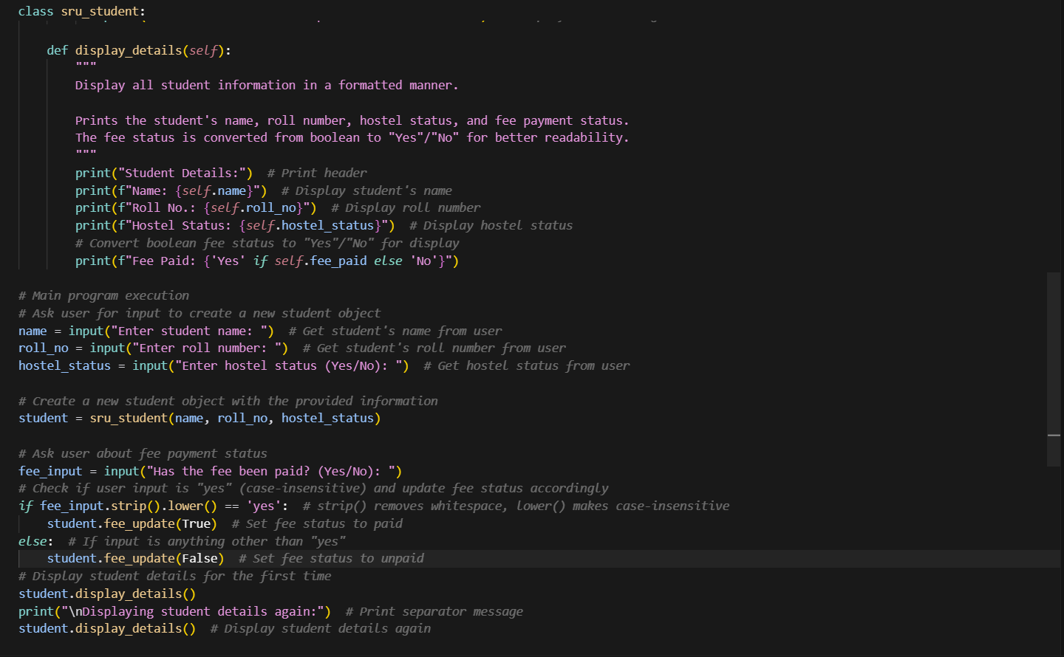

Task Description#3
- Write a Python script with 3–4 functions (e.g., calculator: add, subtract, multiply, divide).
- Incorporate manual docstring in code with NumPy Style
- Use AI assistance to generate a module-level docstring + individual function docstrings.
- Compare the AI-generated docstring with your manually written one.
Prompt: Write a Python script with 3–4 functions (e.g., calculator: add, subtract, multiply, divide).
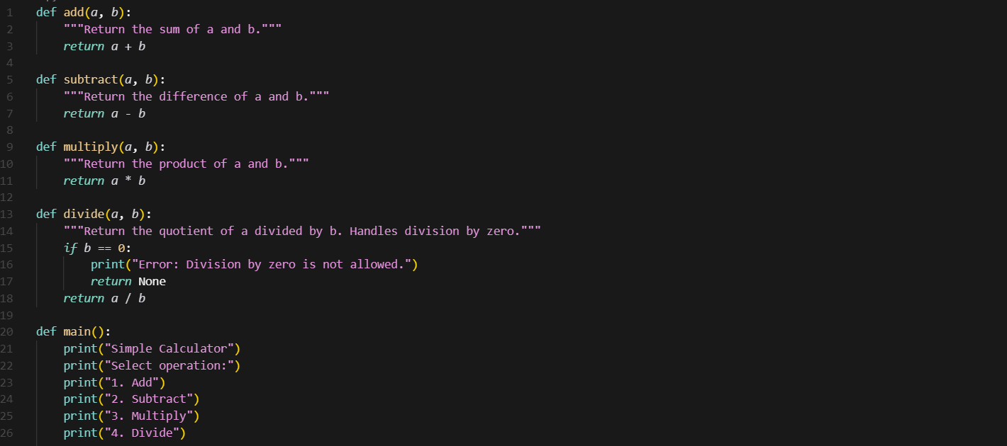

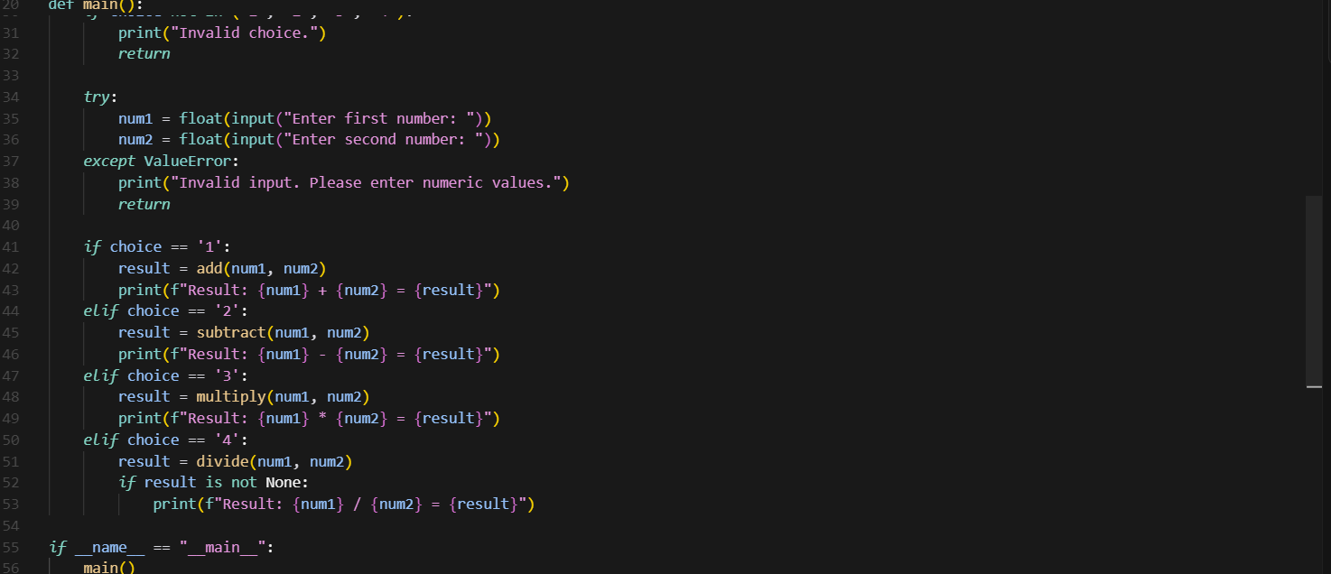
Manual documentation:
This program is a simple calculator that performs addition, subtraction, multiplication, and division.
It asks the user to choose an operation and enter two numbers, then shows the result.
It also checks for invalid inputs and prevents division by zero.
