SCHOOL OF COMPUTER SCIENCE AND ARTIFICIAL INTELLIGENCE |  |  |  |  | DEPARTMENT OF COMPUTER SCIENCE ENGINEERING
Program Name: B. Tech |  |  |  | Assignment Type: Lab |  |  | Academic Year:2025-2026
Course Coordinator Name |  |  |  | Venkataramana Veeramsetty
Instructor(s) Name |  |  |  | Dr. V. Venkataramana (Co-ordinator)  Dr. T. Sampath Kumar  Dr. Pramoda Patro  Dr. Brij Kishor Tiwari  Dr.J.Ravichander  Dr. Mohammand Ali Shaik  Dr. Anirodh Kumar  Mr. S.Naresh Kumar  Dr. RAJESH VELPULA  Mr. Kundhan Kumar  Ms. Ch.Rajitha  Mr. M Prakash  Mr. B.Raju  Intern 1 (Dharma teja)  Intern 2 (Sai Prasad)  Intern 3 (Sowmya)  NS_2 ( Mounika)
Course Code |  |  | 24CS002PC215 | Course Title |  | AI Assisted Coding
Year/Sem |  |  | II/I | Regulation |  | R24
Date and Day  of Assignment |  |  | Week7 - Monday | Time(s)
Duration |  |  | 2 Hours | Applicable to  Batches
AssignmentNumber:14.1(Present assignment number)/24(Total number of assignments)
 | Q.No. | Question |  |  |  |  |  | Expected Time  to complete
 | 1 | Lab 14: Web Design Application – AI-Assisted HTML/CSS/JS Generation  Lab Objectives  - Design functional, visually appealing web applications using HTML, CSS, and JavaScript with AI assistance.  - Apply responsive, accessible, and interactive design principles.  - Create practical UI components for real-world web applications.  - Use AI to optimize layout, UX, and performance.  Task 1 – Portfolio Website Design  You are building a personal portfolio website to showcase your work.  Requirements:  - Create sections for About Me, Projects, and Contact.  - Use AI to:  - Suggest color palettes and typography.  - Create a responsive layout with Grid/Flexbox.  - Add smooth scrolling navigation.  Prompt: Build a portfolio of mine .My name is MANI CHANDANA SEELAM. student att SR Universitty LOCATION IS hasanparthy warangal and my project is classroom issue tracker and add other projects as your wish.Take other info as your wish baed on my name.  Task 2 – Online Store Product Page  Design a product display page for an online store.  Requirements:  - Display product image, title, price, and "Add to Cart" button.  - Use AI to:  - Style with BEM methodology.  - Make layout responsive.  - Add hover effects and "Add to Cart" alert.  Task 3 – Event Registration Form  Build an event registration form for a conference.  Requirements:  - Collect name, email, phone number, and session selection.  - Use AI to:  - Add form validation with JavaScript.  - Make the form accessible with labels and ARIA.  - Style with a professional look.  Task Description #4 (Data – Fetch API & Render List with Loading/Error States)  - Task: Fetch JSON from an API and render items to the DOM with loading and error UI.  - Instructions:  - Ask AI to write fetch() logic, create DOM nodes safely, and add skeleton/loading text.  ✅ Deliverables (For All Tasks)  - AI-generated prompts for code and test case generation.  - At least 3 assert test cases for each task.  - AI-generated initial code and execution screenshots.  - Analysis of whether code passes all tests.  - Improved final version with inline comments and explanation.  - Compiled report (Word/PDF) with prompts, test cases, assertions, code, and output. |  |  |  |  |  | Week7 - Monday
Task 1 – Portfolio Website Design
You are building a personal portfolio website to showcase your work.
Requirements:
- Create sections for About Me, Projects, and Contact.
- Use AI to:
  - Suggest color palettes and typography.
  - Create a responsive layout with Grid/Flexbox.
  - Add smooth scrolling navigation.
Prompt: Build a portfolio of mine .My name is MANI CHANDANA SEELAM. student att SR Universitty LOCATION IS hasanparthy warangal and my project is classroom issue tracker and add other projects as your wish.Take other info as your wish baed on my name.
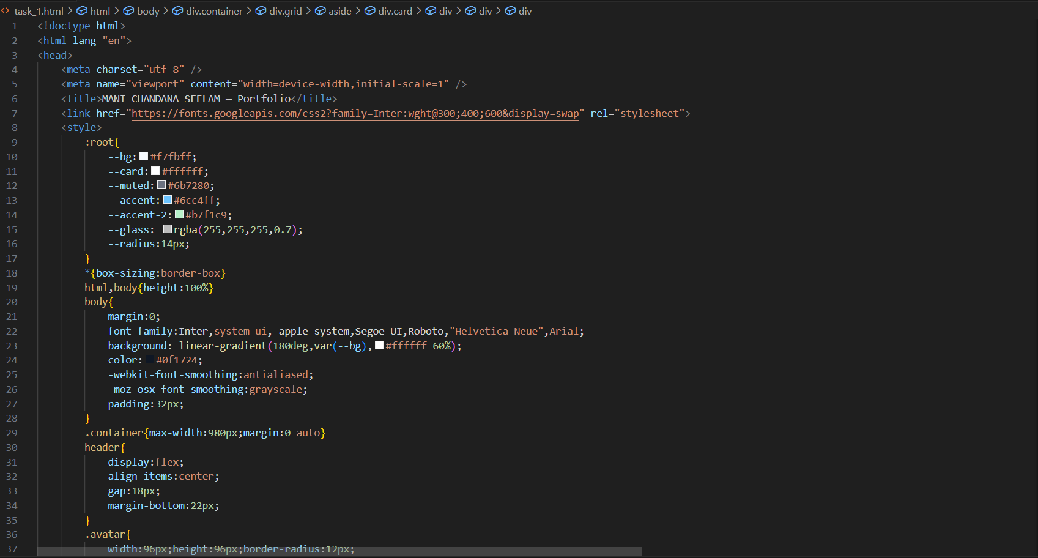
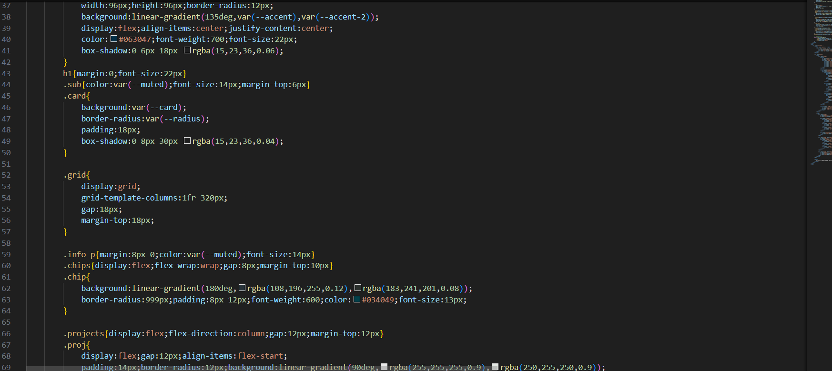
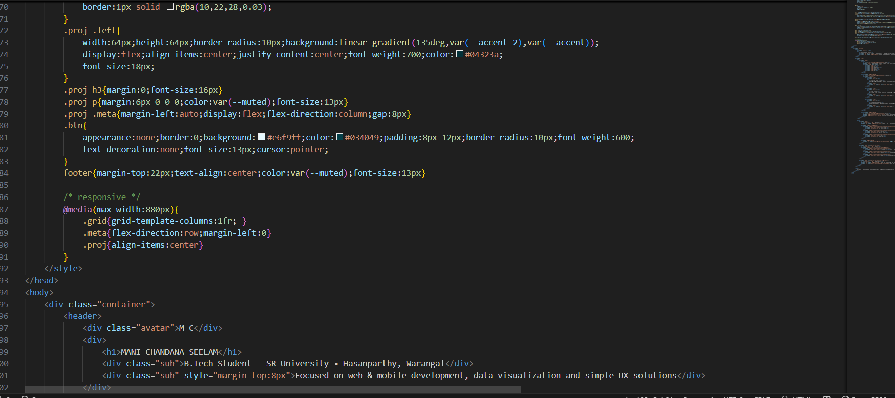
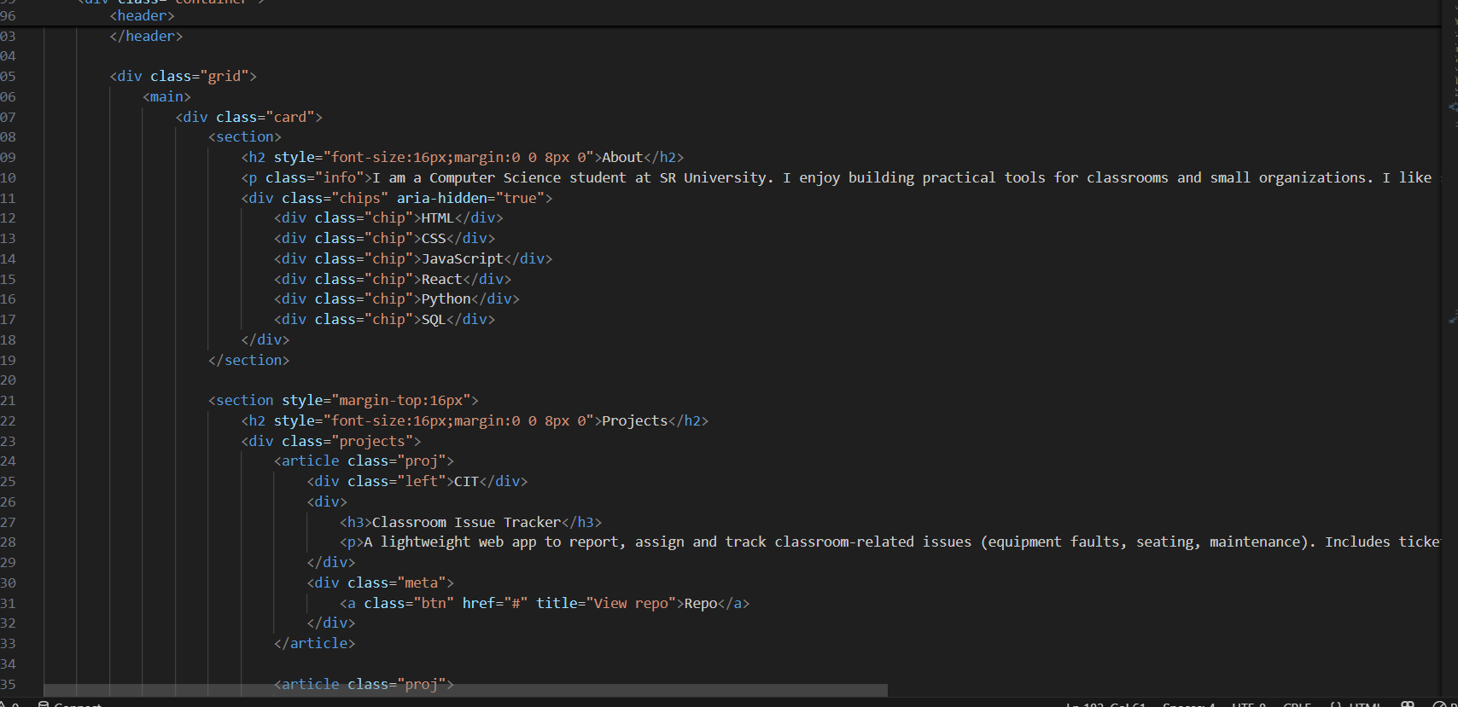
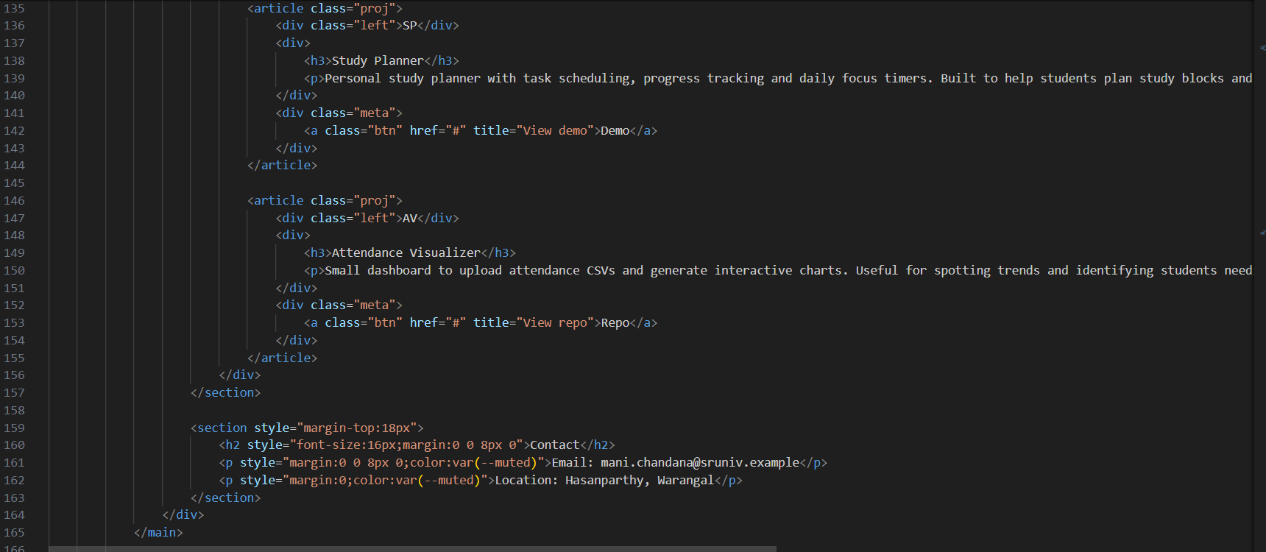
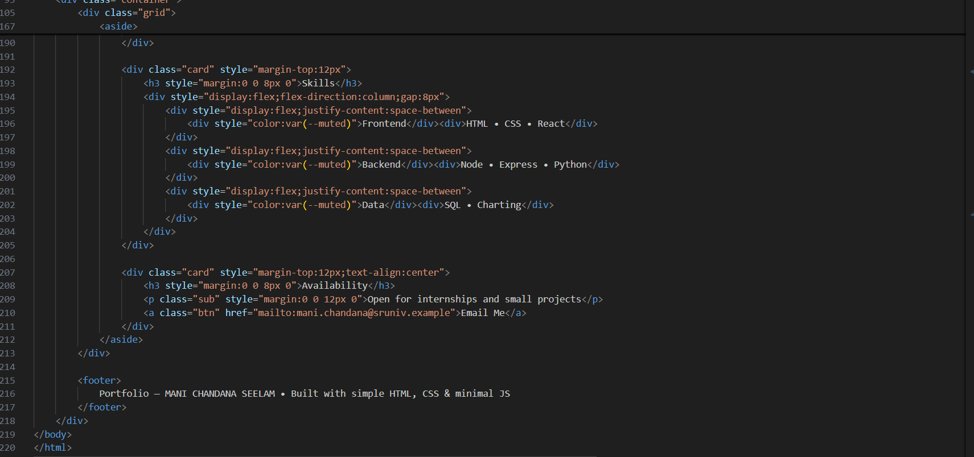

OUTPUT:
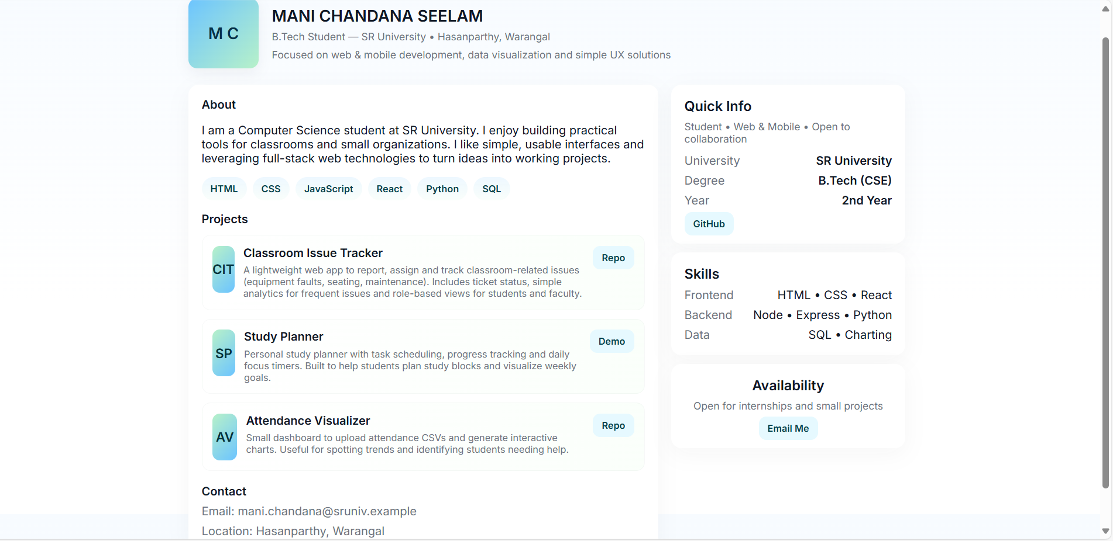
Task:2:
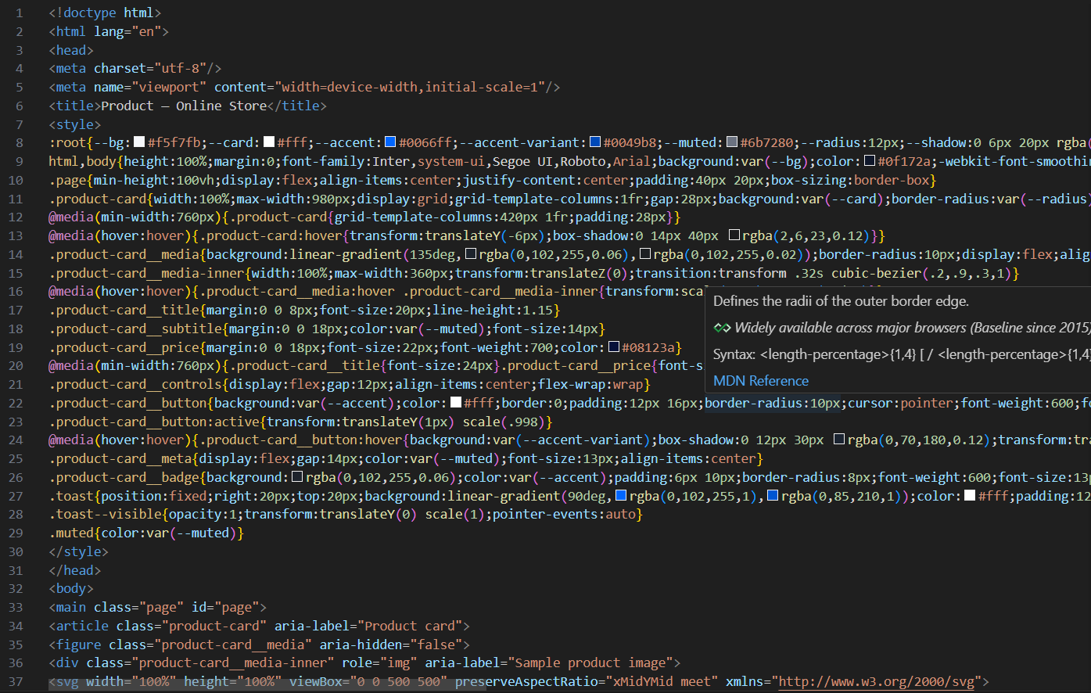
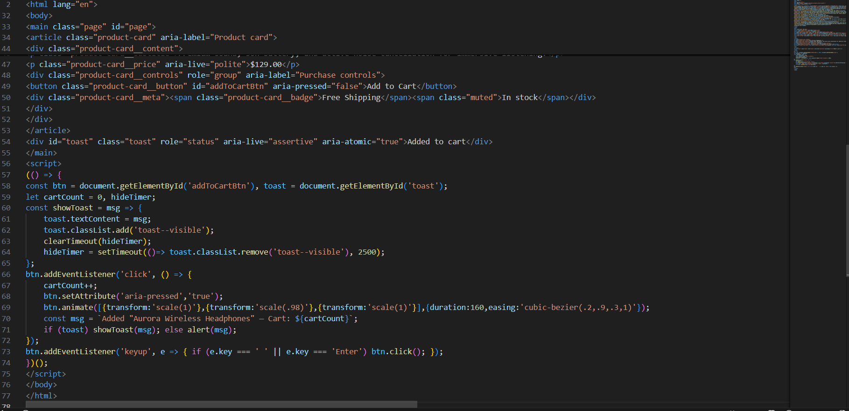
OUTPUT:
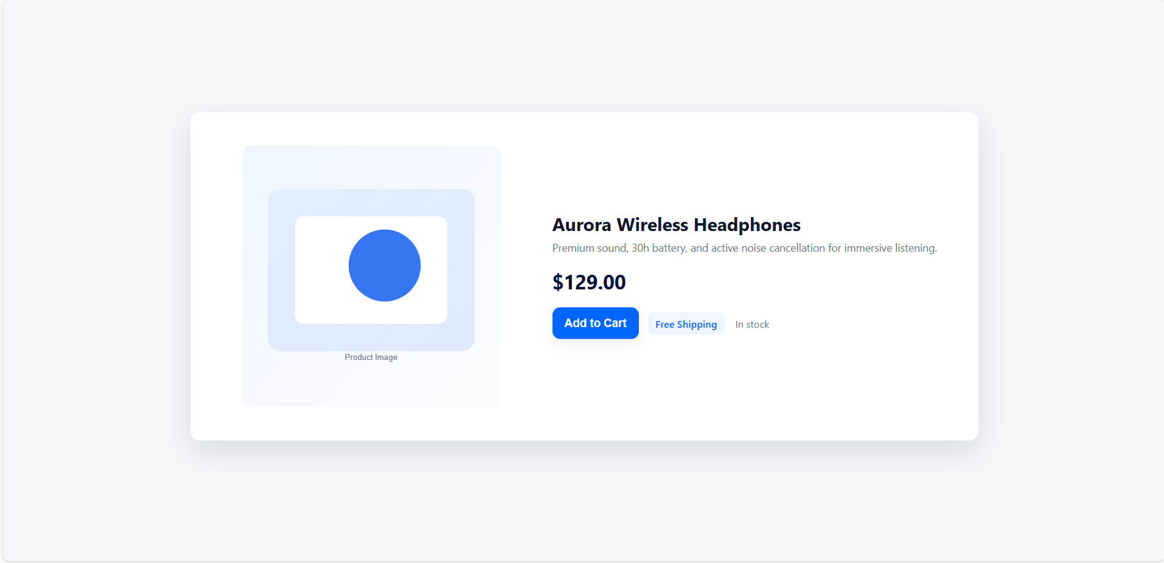
Task 3 – Event Registration Form
Build an event registration form for a conference.
Requirements:
- Collect name, email, phone number, and session selection.
- Use AI to:
  - Add form validation with JavaScript.
  - Make the form accessible with labels and ARIA.
Style with a professional look
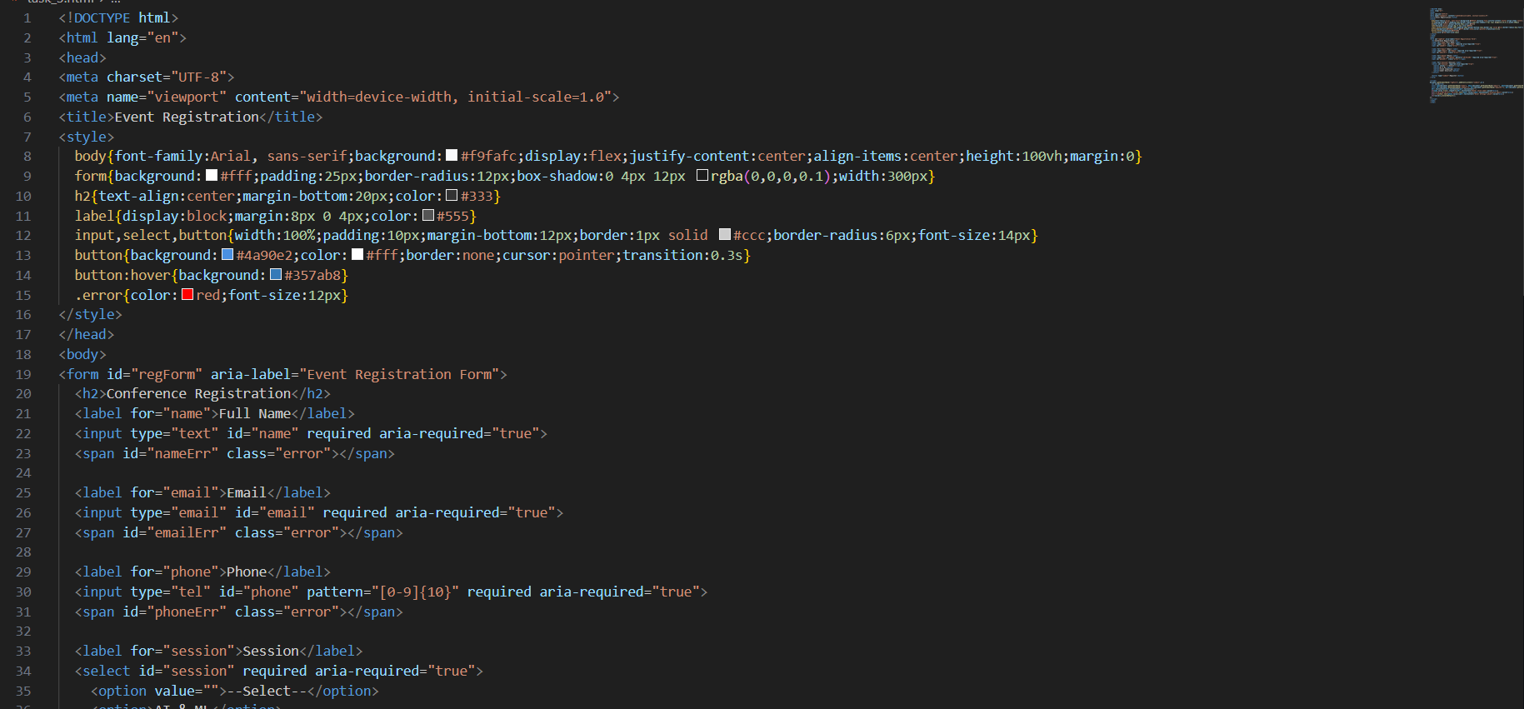
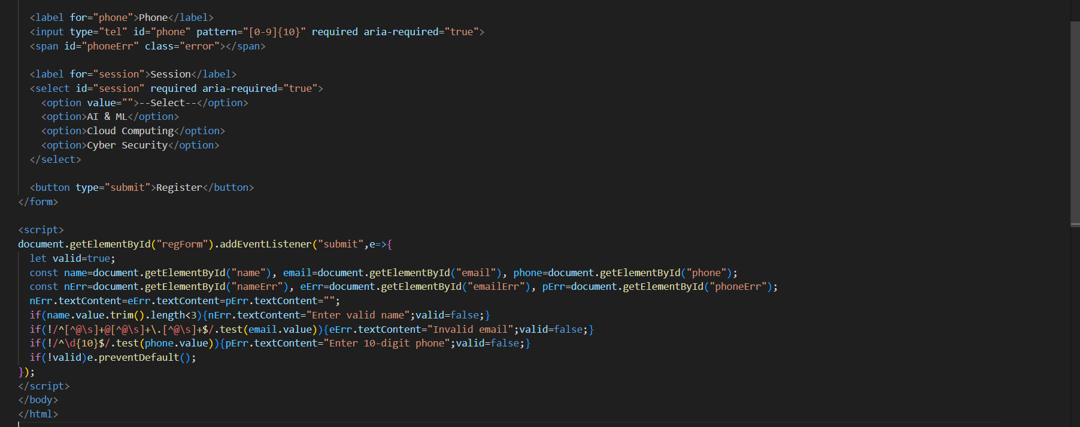
Output:
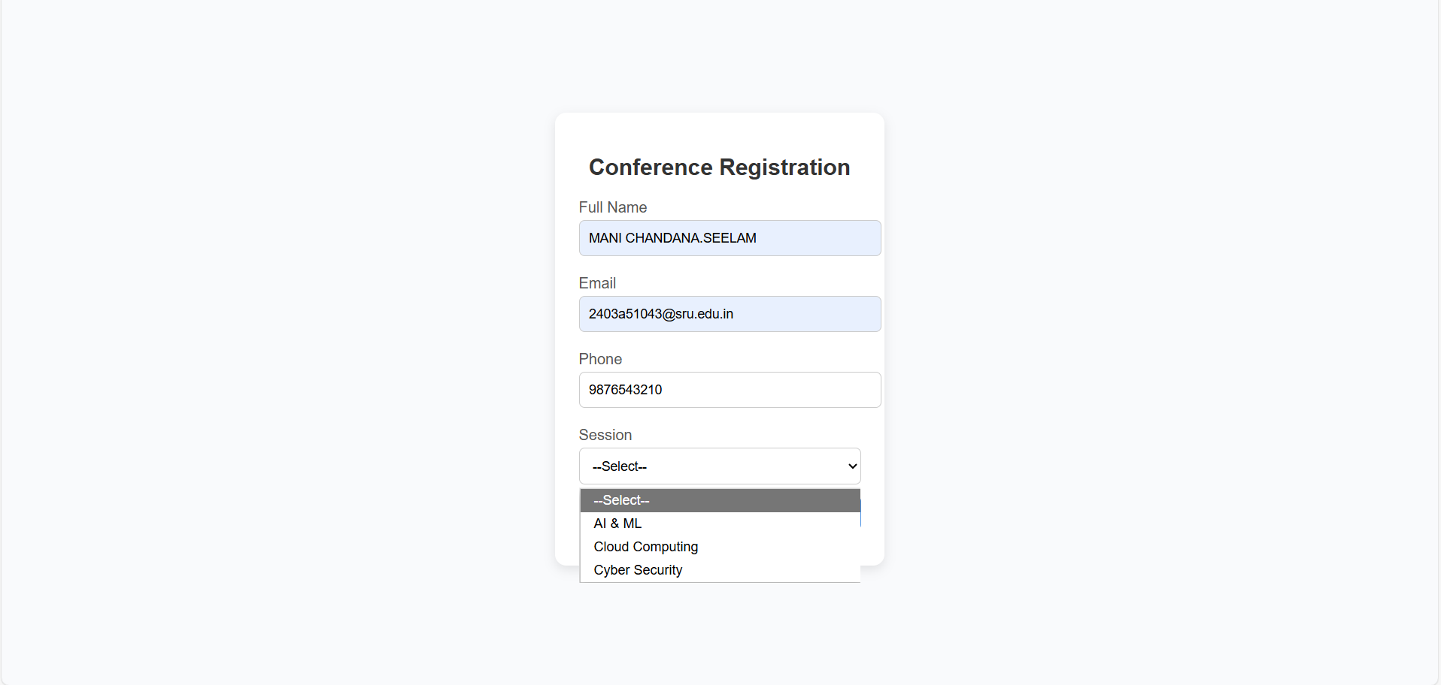
Task Description #4 (Data – Fetch API & Render List with Loading/Error States)
- Task: Fetch JSON from an API and render items to the DOM with loading and error UI.
- Instructions:
  - Ask AI to write fetch() logic, create DOM nodes safely, and add skeleton/loading text.

