**Task Description #2  
•** A function in Python that returns the maximum of three numbers using GitHub Copilot. Use an appropriate comment as a prompt.

**Prompt:create a python code that returns the maximum of three numbers.input the three numbers.**

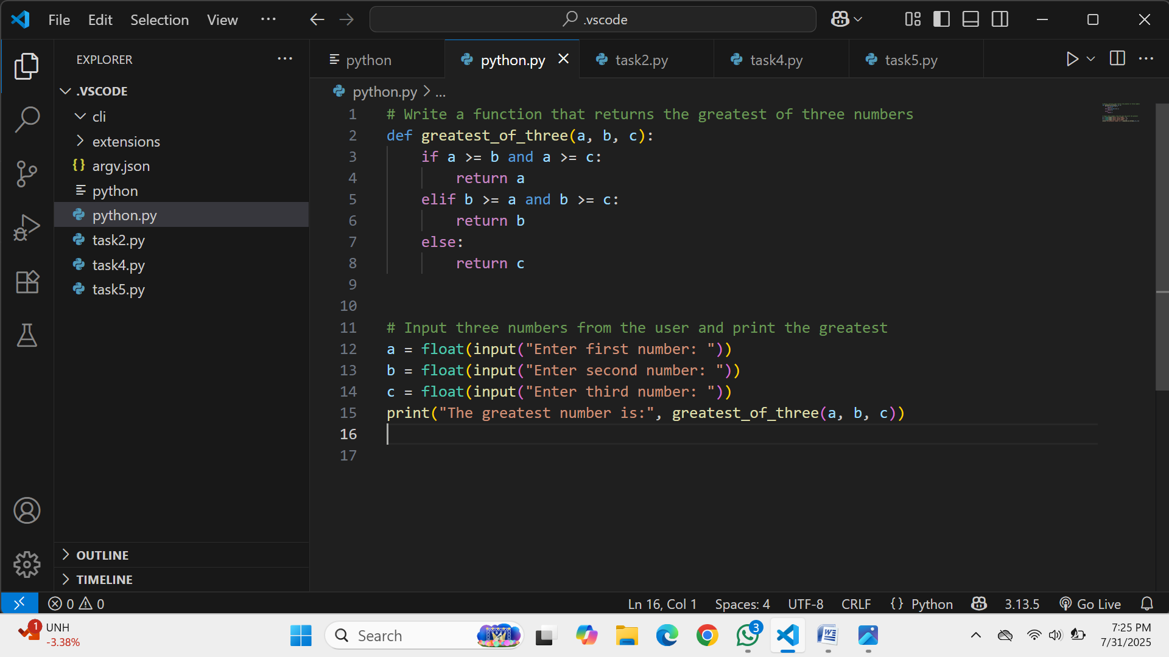

**Expected Output #2  
•** Python function that takes three inputs and returns the largest value. Include the code and output

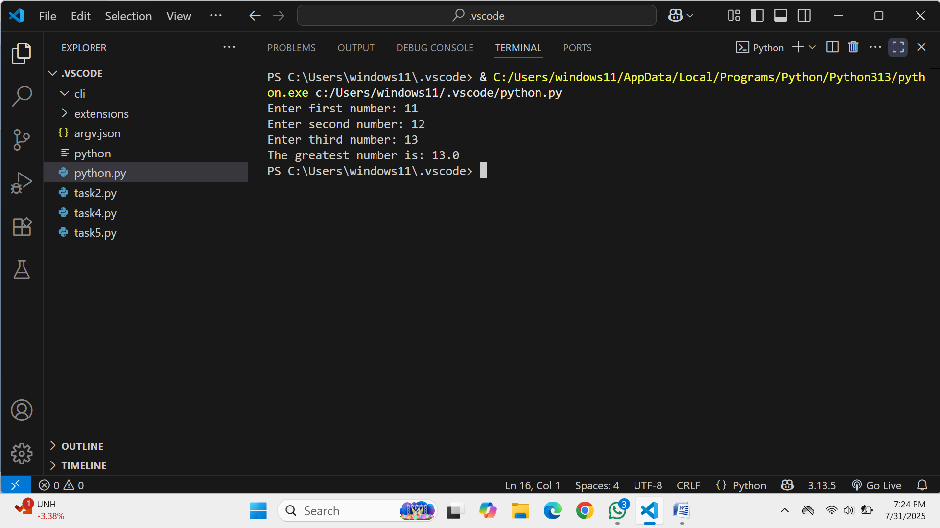

**Task Description #3**

**•** Use GitHub Copilot to create a recursive Python function that calculates the factorial of a number.

Prompt:#create a python function that calculates factorial of a number using recursive function.input tne number n.

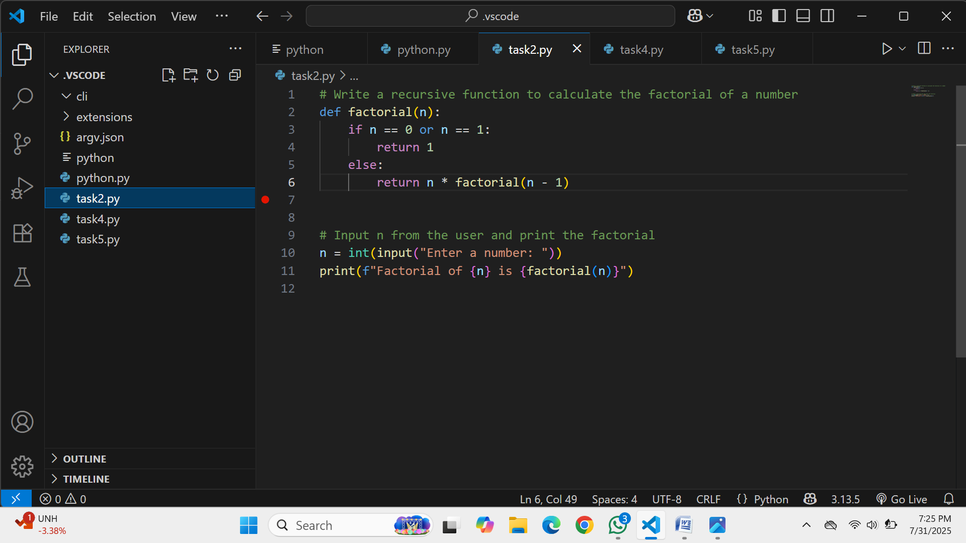

**Expected Output #3  
•** Python function for factorial using recursion with input and output examples.

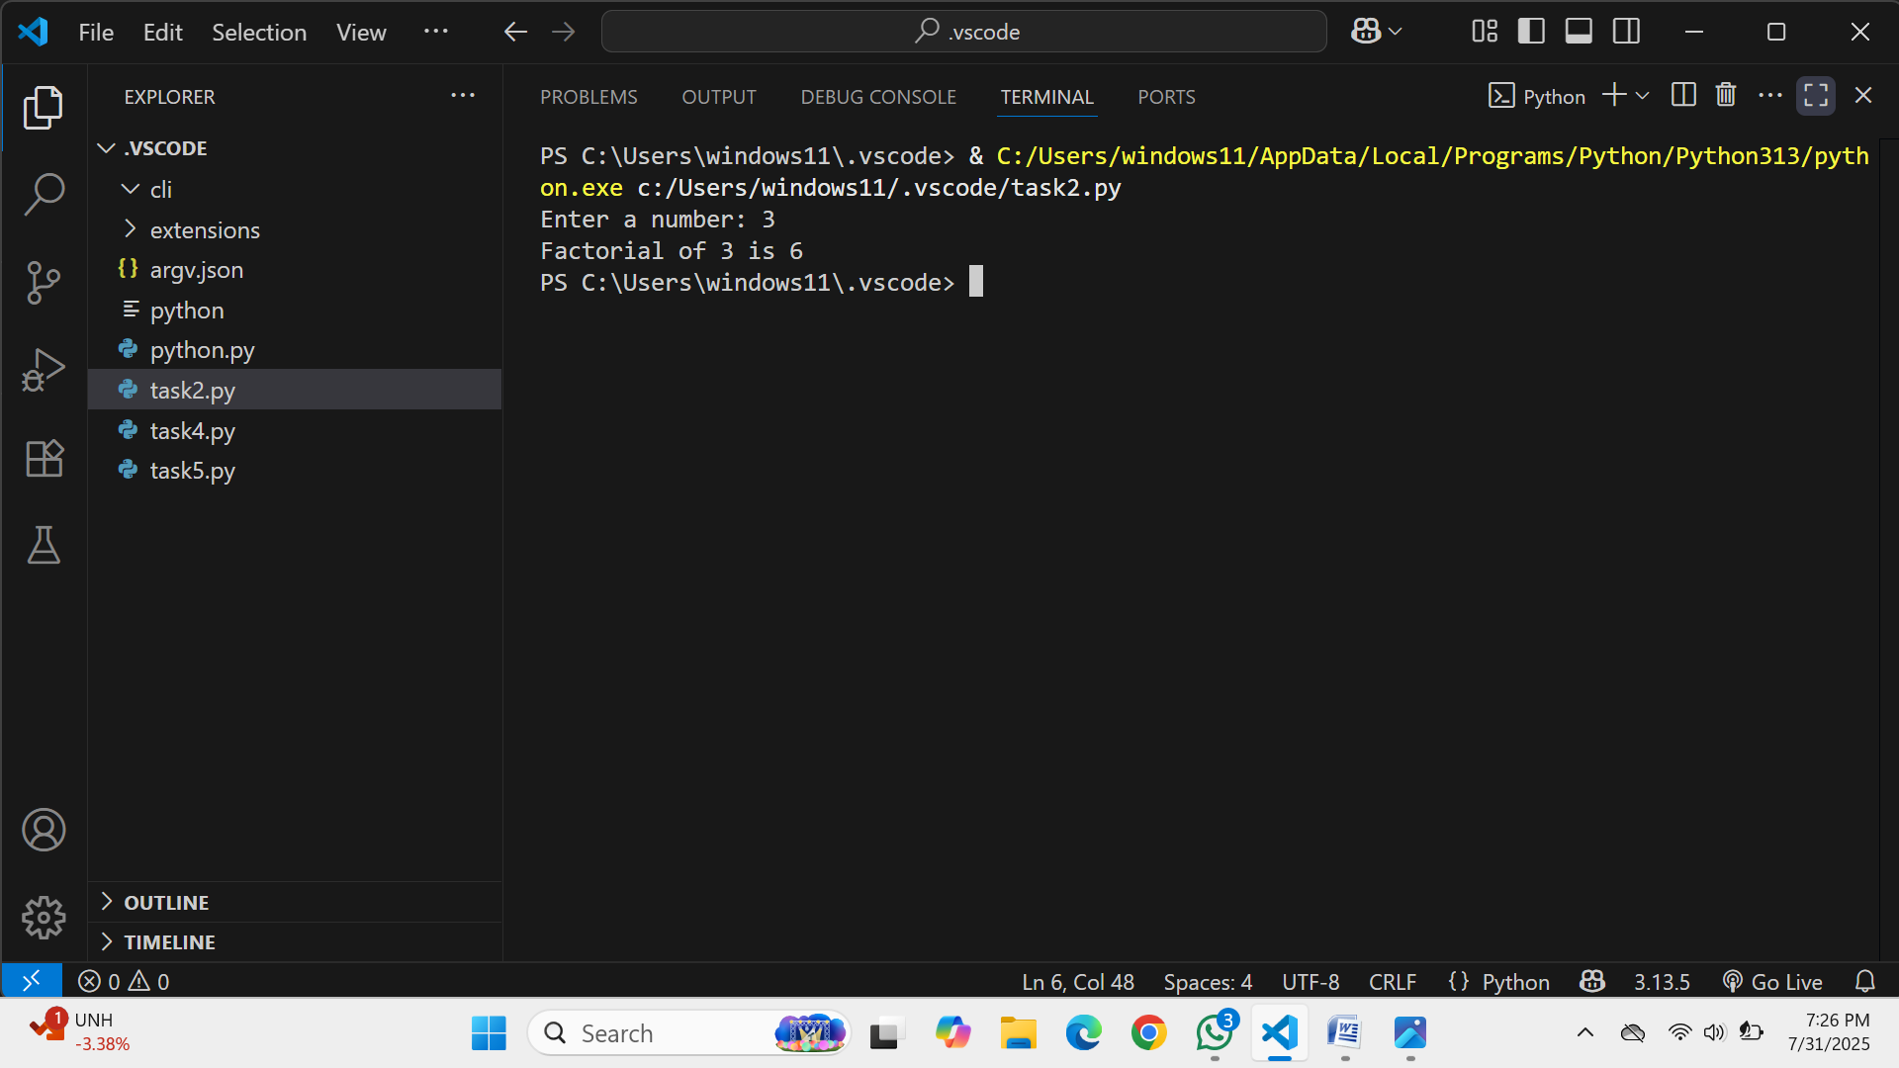

**Task Description #4  
•** Prompt GitHub Copilot to create a class named Student with attributes name, roll_no, and marks. Add a method to display student details.

**Prompt:#create a python code that takes input of student name,roll no,and marks and display those student display.**

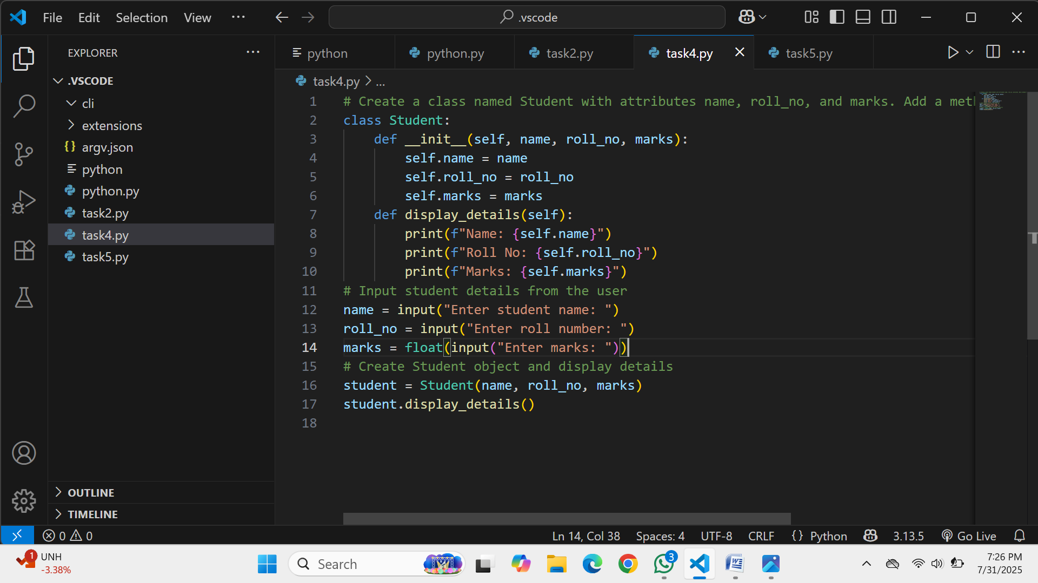

**Expected Output #4  
•** Python class definition with an initializer and a display method. Include object creation and output.

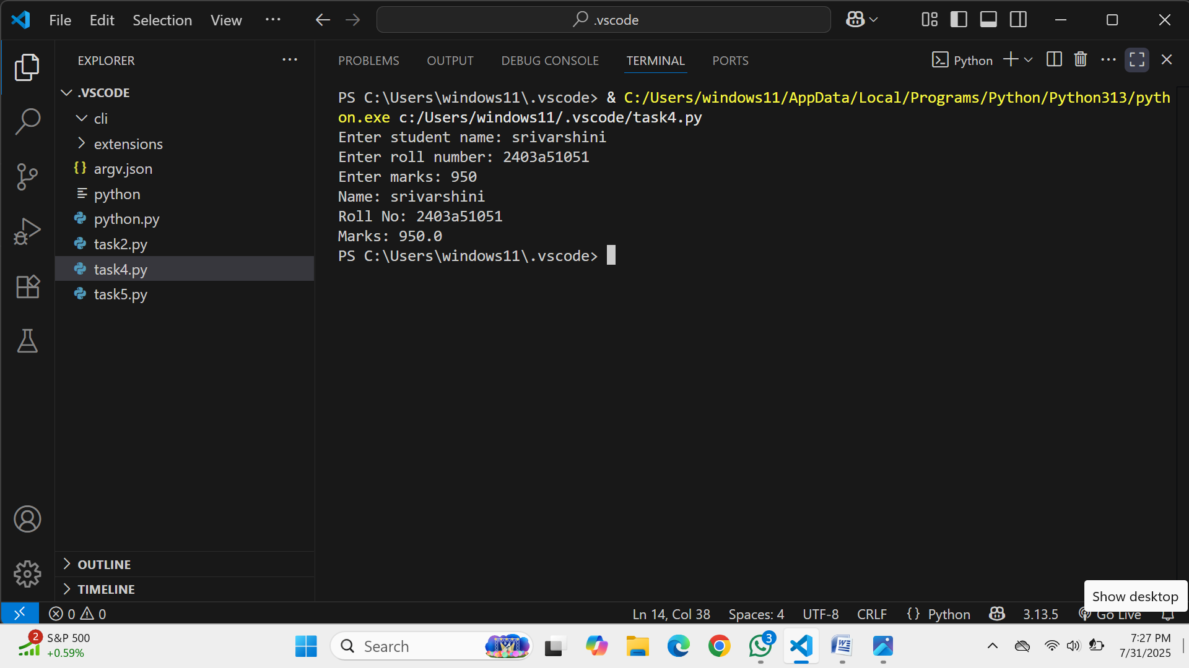

**Task Description #5  
•** Ask GitHub Copilot to generate a Python function that takes a string as input and returns the frequency of each word.

**Prompt:#generate a python code that takes input as a string and returns the frequency of each letter .**

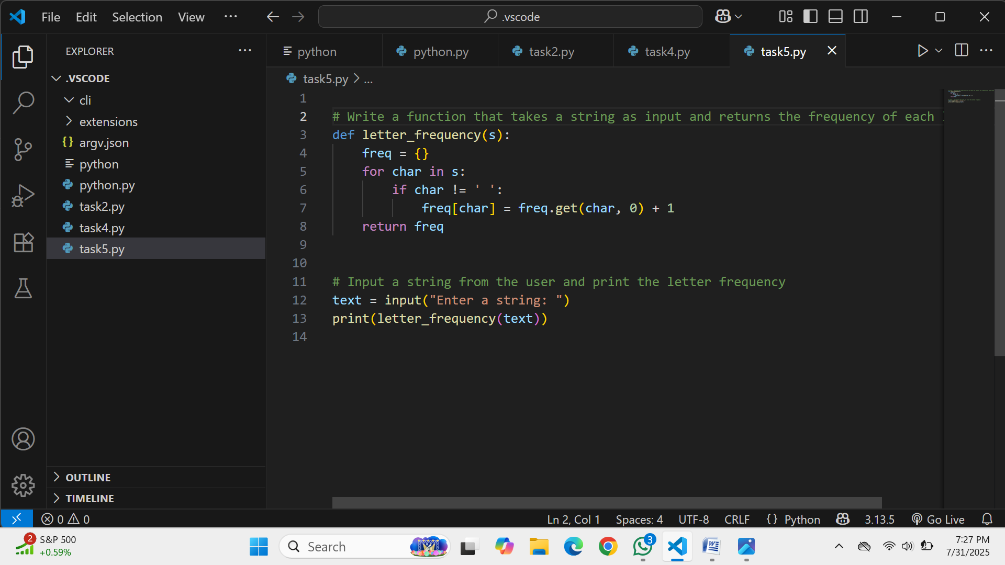

**Expected Output #5**

**•** Python function that returns word frequency using a dictionary. Provide sample input and output.

