LAB-13.4

- Task1: Refactor repeated loops into a cleaner, more Pythonic approach.
Instructions:
- Analyze the legacy code.
- Identify the part that uses loops to compute values.
- Refactor using list comprehensions or helper functions while keeping the output the same.
Legacy Code:
numbers = [1, 2, 3, 4, 5]
squares = []
for n in numbers:
squares.append(n ** 2)
print(squares)
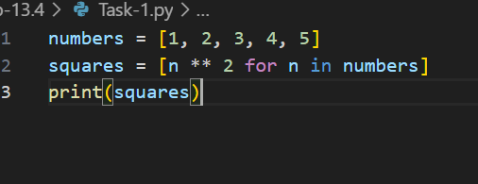
OUTPUT:
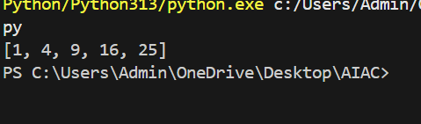

Task 2
Task: Simplify string concatenation.
Instructions:
- Review the loop that builds a sentence using +=.
- Refactor using " ".join() to improve efficiency and readability.
Legacy Code:
words = ["AI", "helps", "in", "refactoring", "code"]
sentence = ""
for word in words:
sentence += word + " "
print(sentence.strip())

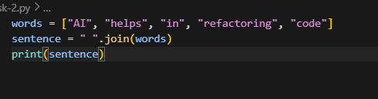
OUTPUT:
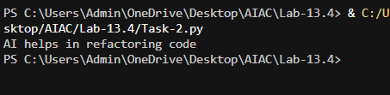

Task 3
Task: Replace manual dictionary lookup with a safer method.
Instructions:
- Check how the code accesses dictionary keys.
- Use .get() or another Pythonic approach to handle missing keys gracefully.
Legacy Code:
student_scores = {"Alice": 85, "Bob": 90}
if "Charlie" in student_scores:
print(student_scores["Charlie"])
else:
print("Not Found")
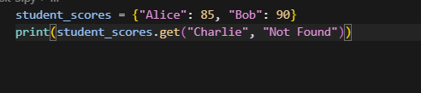

OUTPUT:
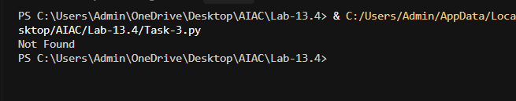

Task 4
Task: Refactor repetitive if-else blocks.
Instructions:
- Examine multiple if-elif statements for operations.
- Refactor using dictionary mapping to make the code scalable and clean.
Legacy Code:
operation = "multiply"
a, b = 5, 3

if operation == "add":
result = a + b
elif operation == "subtract":
result = a - b
elif operation == "multiply":
result = a * b
else:
result = None

print(result)
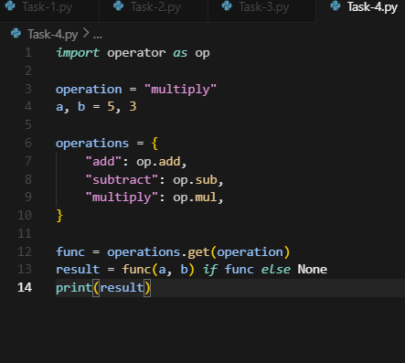

OUTPUT:
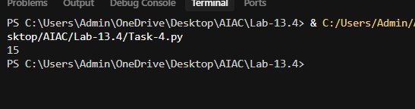

Task 5
Task: Optimize nested loops for searching.
Instructions:
- Identify the nested loop used to find an element.
- Refactor using Python’s in keyword or other efficient search techniques.
Legacy Code:
items = [10, 20, 30, 40, 50]
found = False
for i in items:
if i == 30:
found = True
break
print("Found" if found else "Not Found")
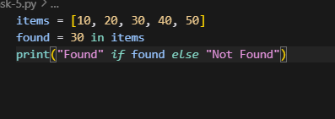
OUTPUT:
