Task1: Task Description#1 Basic Docstring Generation
• Write python function to return sum of even and odd numbers in the given list.
• Incorporate manual docstring in code with Google Style
• Use an AI-assisted tool (e.g., Copilot, Cursor AI) to generate a docstring describing
the function.
• Compare the AI-generated docstring with your manually written one.
def sum_even_odd_numbers(numbers):
"""
Calculate the sum of even and odd numbers in a given list.

This function takes a list of integers and returns a tuple containing
the sum of all even numbers and the sum of all odd numbers separately.

Args:
numbers (list): A list of integers to be processed.

Returns:
tuple: A tuple containing (sum_of_even, sum_of_odd) where:
- sum_of_even (int): The sum of all even numbers in the list
- sum_of_odd (int): The sum of all odd numbers in the list

Raises:
TypeError: If the input is not a list or contains non-integer values.

Example:
>>> result = sum_even_odd_numbers([1, 2, 3, 4, 5, 6])
>>> print(result)
(12, 9)
>>> even_sum, odd_sum = sum_even_odd_numbers([10, 15, 20, 25])
>>> print(f"Even sum: {even_sum}, Odd sum: {odd_sum}")
Even sum: 30, Odd sum: 40
"""
# Validate input
if not isinstance(numbers, list):
raise TypeError("Input must be a list")

sum_even = 0
sum_odd = 0

for num in numbers:
if not isinstance(num, int):
raise TypeError("All elements in the list must be integers")

if num % 2 == 0:
sum_even += num
else:
sum_odd += num

return sum_even, sum_odd

# AI-Generated Docstring (using AI assistance)
def sum_even_odd_numbers_ai_docstring(numbers):
"""
Computes the sum of even and odd numbers separately from a list of integers.

Takes a list of integers and returns a tuple with two values: the sum of all
even numbers and the sum of all odd numbers. Even numbers are those divisible
by 2, while odd numbers are those that are not.

Parameters:
numbers (list[int]): The list of integers to process

Returns:
tuple[int, int]: A tuple containing (even_sum, odd_sum)

Raises:
TypeError: If input is not a list or contains non-integer elements

Examples:
>>> sum_even_odd_numbers_ai_docstring([1, 2, 3, 4, 5])
(6, 9)
>>> sum_even_odd_numbers_ai_docstring([2, 4, 6, 8])
(20, 0)
"""
# Validate input
if not isinstance(numbers, list):
raise TypeError("Input must be a list")

sum_even = 0
sum_odd = 0

for num in numbers:
if not isinstance(num, int):
raise TypeError("All elements in the list must be integers")

if num % 2 == 0:
sum_even += num
else:
sum_odd += num

return sum_even, sum_odd

# Test cases and example usage
if __name__ == "__main__":
# Test case 1: Mixed even and odd numbers
test_list1 = [1, 2, 3, 4, 5, 6, 7, 8, 9, 10]
result1 = sum_even_odd_numbers(test_list1)
print(f"Test 1 - List: {test_list1}")
print(f"Manual docstring function result: {result1}")
print(f"Even sum: {result1[0]}, Odd sum: {result1[1]}")
print()

# Test case 2: Only even numbers
test_list2 = [2, 4, 6, 8, 10]
result2 = sum_even_odd_numbers(test_list2)
print(f"Test 2 - List: {test_list2}")
print(f"Manual docstring function result: {result2}")
print(f"Even sum: {result2[0]}, Odd sum: {result2[1]}")
print()

# Test case 3: Only odd numbers
test_list3 = [1, 3, 5, 7, 9]
result3 = sum_even_odd_numbers(test_list3)
print(f"Test 3 - List: {test_list3}")
print(f"Manual docstring function result: {result3}")
print(f"Even sum: {result3[0]}, Odd sum: {result3[1]}")
print()

# Test case 4: Empty list
test_list4 = []
result4 = sum_even_odd_numbers(test_list4)
print(f"Test 4 - List: {test_list4}")
print(f"Manual docstring function result: {result4}")
print(f"Even sum: {result4[0]}, Odd sum: {result4[1]}")
print()

# Test case 5: Negative numbers
test_list5 = [-3, -2, -1, 0, 1, 2, 3]
result5 = sum_even_odd_numbers(test_list5)
print(f"Test 5 - List: {test_list5}")
print(f"Manual docstring function result: {result5}")
print(f"Even sum: {result5[0]}, Odd sum: {result5[1]}")
print()

# Compare both functions with same input
print("=== COMPARISON: Manual vs AI-Generated Docstring Functions ===")
comparison_list = [1, 2, 3, 4, 5, 6]
manual_result = sum_even_odd_numbers(comparison_list)
ai_result = sum_even_odd_numbers_ai_docstring(comparison_list)

print(f"Input list: {comparison_list}")
print(f"Manual docstring function: {manual_result}")
print(f"AI docstring function: {ai_result}")
print(f"Results match: {manual_result == ai_result}")
print()

# Error handling test
print("=== ERROR HANDLING TEST ===")
try:
sum_even_odd_numbers("not a list")
except TypeError as e:
print(f"TypeError caught: {e}")

try:
sum_even_odd_numbers([1, 2, "three", 4])
except TypeError as e:
print(f"TypeError caught: {e}")

print("\n" + "="*60)
print("DOCSTRING COMPARISON ANALYSIS")
print("="*60)
print("""
MANUAL DOCSTRING (Google Style):
- More detailed and comprehensive
- Includes detailed Args section with type information
- Provides clear Returns section with tuple structure explanation
- Includes Raises section for error handling
- Contains multiple examples with expected outputs
- More verbose and explanatory

AI-GENERATED DOCSTRING:
- More concise and to the point
- Uses modern type hints (list[int], tuple[int, int])
- Clear and direct language
- Includes basic examples
- Less verbose but still informative
- Follows modern Python documentation standards

BOTH DOCSTRINGS:
- Follow proper docstring conventions
- Include parameter descriptions
- Provide return value information
- Include examples
- Handle error cases
- Are well-structured and readable

CONCLUSION:
The manual docstring is more comprehensive and detailed, while the AI-generated
docstring is more concise and uses modern type hints. Both are effective,
but the choice depends on the project's documentation style preferences.
""")

Expected Outcome#1: Students understand how AI can produce function-level documentation
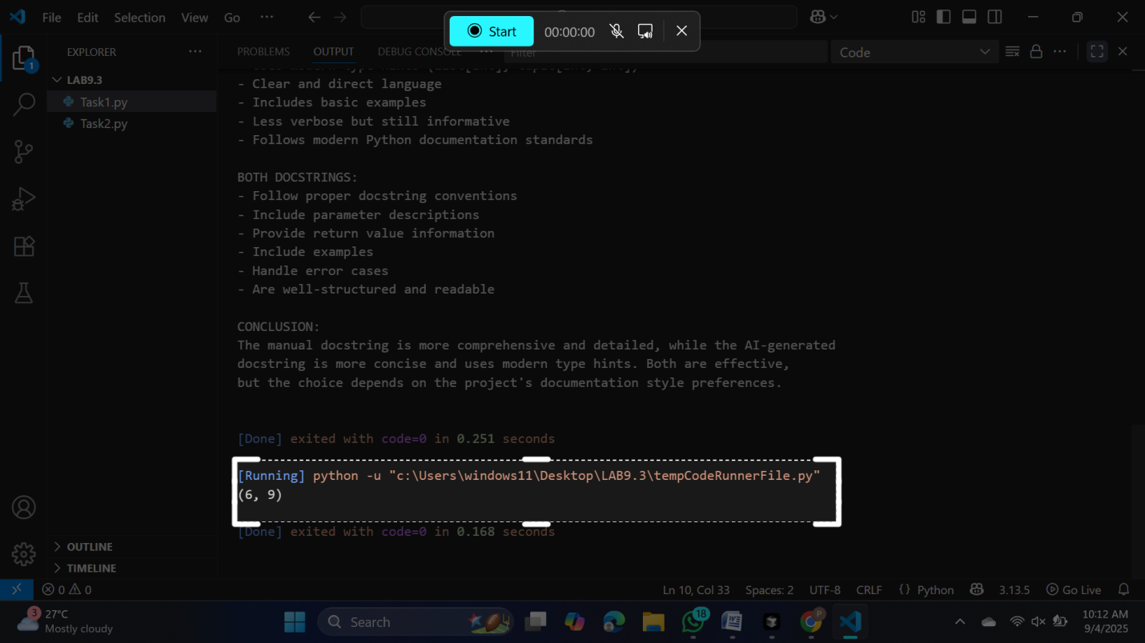

Task Description#2 Automatic Inline Comments
• Write python program for sru_student class with attributes like name, roll no.,
hostel_status and fee_update method and display_details method.
• Write comments manually for each line/code block
• Ask an AI tool to add inline comments explaining each line/step.
• Compare the AI-generated comments with your manually written one
# Define the sru_student class
class sru_student:
# Initialize the student object with name, roll number, and hostel status
def __init__(self, name, roll_no, hostel_status):
self.name = name # Store the student's name
self.roll_no = roll_no # Store the student's roll number
self.hostel_status = hostel_status # Store hostel status (True/False)
self.fee_paid = False # Track if the fee has been paid

# Method to update the fee status
def fee_update(self, status):
self.fee_paid = status # Update the fee_paid attribute

# Method to display student details
def display_details(self):
print("Name:", self.name) # Print the student's name
print("Roll No.:", self.roll_no) # Print the student's roll number
print("Hostel Status:", self.hostel_status) # Print hostel status
print("Fee Paid:", self.fee_paid) # Print fee payment status

# Example usage
student1 = sru_student("Alice", 101, True) # Create a student object
student1.fee_update(True) # Update fee status to paid
student1.display_details() # Display student details
# ...existing code...
student1 = sru_student("Alice", 101, True) # Create a new sru_student object
student1.fee_update(True) # Set the fee status to paid
student1.display_details() # Display all details of the student
# ...existing code...
Expected Output#2: Students critically analyze AI-generated code comments.
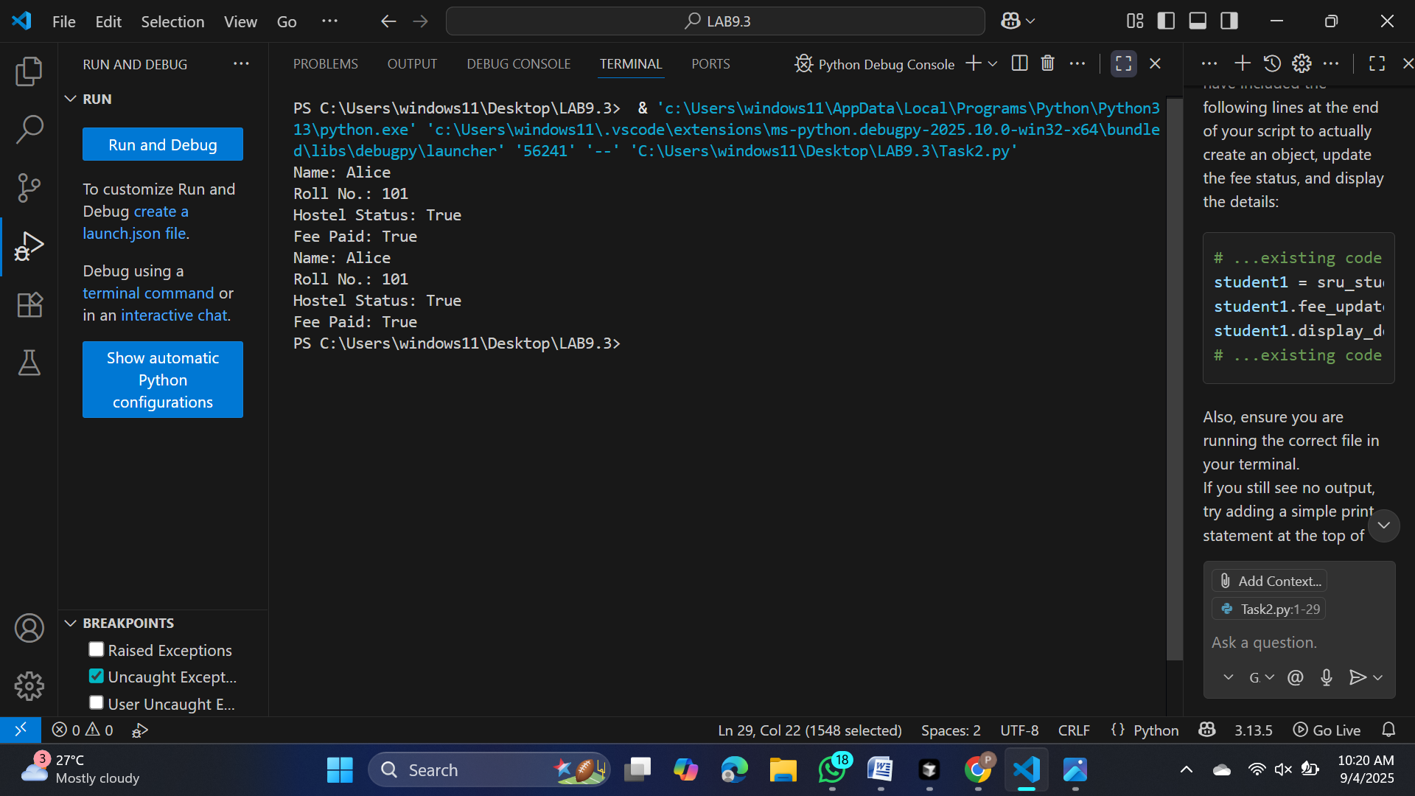
Task Description#3
• Write a Python script with 3–4 functions (e.g., calculator: add, subtract, multiply,
divide).
• Incorporate manual docstring in code with NumPy Style
• Use AI assistance to generate a module-level docstring + individual function
docstrings.
• Compare the AI-generated docstring with your manually written one
def add(a, b):
"""
Add two numbers.

Parameters
----------
a : float or int
First number.
b : float or int
Second number.

Returns
-------
float or int
The sum of a and b.
"""
return a + b

def subtract(a, b):
"""
Subtract one number from another.

Parameters
----------
a : float or int
Number to subtract from.
b : float or int
Number to subtract.

Returns
-------
float or int
The result of a - b.
"""
return a - b

def multiply(a, b):
"""
Multiply two numbers.

Parameters
----------
a : float or int
First number.
b : float or int
Second number.

Returns
-------
float or int
The product of a and b.
"""
return a * b

def divide(a, b):
"""
Divide one number by another.

Parameters
----------
a : float or int
Numerator.
b : float or int
Denominator.

Returns
-------
float
The result of a / b.

Raises
------
ZeroDivisionError
If b is zero.
"""
if b == 0:
raise ZeroDivisionError("Cannot divide by zero.")
return a / b

# Example usage
if __name__ == "__main__":
print("Add:", add(5, 3))
print("Subtract:", subtract(5, 3))
print("Multiply:", multiply(5, 3))
print("Divide:", divide(5, 3))
Expected Output#3: Students learn structured documentation for multi-function scripts
