SCHOOL OF COMPUTER SCIENCE AND ARTIFICIAL INTELLIGENCE |  |  |  |  |  | DEPARTMENT OF COMPUTER SCIENCE ENGINEERING
Program Name: B. Tech |  |  |  |  | Assignment Type: Lab |  |  | Academic Year:2025-2026
Course Coordinator Name |  |  |  |  | Venkataramana Veeramsetty
Instructor(s) Name |  |  |  |  | Dr. V. Venkataramana (Co-ordinator)  Dr. T. Sampath Kumar  Dr. Pramoda Patro  Dr. Brij Kishor Tiwari  Dr.J.Ravichander  Dr. Mohammand Ali Shaik  Dr. Anirodh Kumar  Mr. S.Naresh Kumar  Dr. RAJESH VELPULA  Mr. Kundhan Kumar  Ms. Ch.Rajitha  Mr. M Prakash  Mr. B.Raju  Intern 1 (Dharma teja)  Intern 2 (Sai Prasad)  Intern 3 (Sowmya)  NS_2 ( Mounika)
Course Code |  |  |  | 24CS002PC215 | Course Title |  | AI Assisted Coding
Year/Sem |  |  |  | II/I | Regulation |  | R24
Date and Day  of Assignment |  |  |  | Week10 - Monday | Time(s)
Duration |  |  |  | 2 Hours | Applicable to  Batches
AssignmentNumber:20.1(Present assignment number)/24(Total number of assignments)
 |  | Q.No. | Question |  |  |  |  |  | Expected Time  to complete
 | 1 |  | Lab 20 – Security Testing: Identifying Vulnerabilities in AI-Generated Code  Lab Objectives:  - Understand how to test AI-generated code for common security vulnerabilities.  - Learn to apply secure coding principles while analyzing AI outputs.  - Practice detecting risks such as SQL injection, XSS, hardcoded credentials, and weak encryption.  - Enhance code reliability and safety by using AI for secure refactoring.  Task 1 – Input Validation Check  Task:  Analyze an AI-generated Python login script for input validation vulnerabilities.  Instructions:  - Prompt AI to generate a simple username-password login program.  - Review whether input sanitization and validation are implemented.  - Suggest secure improvements (e.g., using re for input validation).  Expected Output:  - A secure version of the login script with proper input validation.  PROMPT: Generate a simple Python username-password login program. Then analyze it for any input validation or sanitization issues. After the analysis, provide a secure and improved version of the script that includes proper input validation using the re module (for example, to ensure usernames and passwords contain only valid characters and have appropriate length). The final output should be a secure Python login script with comments explaining each security.  CODE:  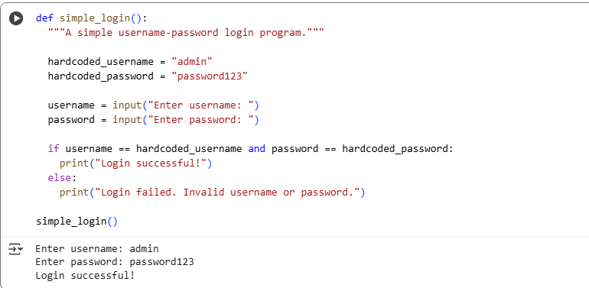  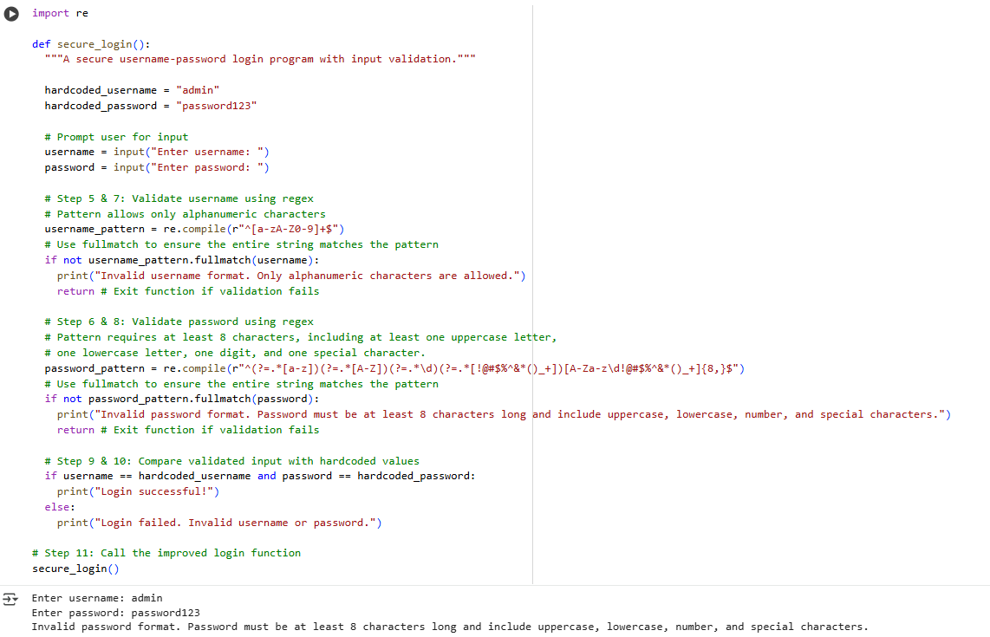  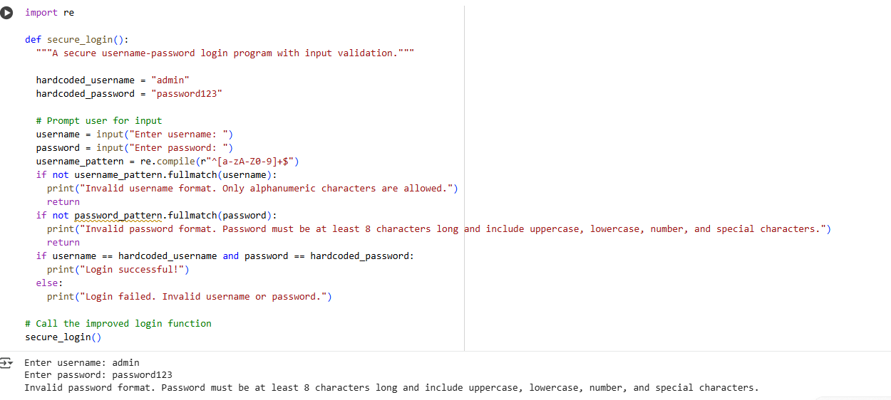  OBSERVATION: The initial AI-generated login script lacked proper input validation, allowing potentially unsafe or malformed inputs. The improved version uses regular expressions (re module) to validate usernames and passwords, ensuring only permitted characters and secure input formats are accepted.  Task 2 – SQL Injection Prevention  Task:  Test an AI-generated script that performs SQL queries on a database.  Instructions:  - Ask AI to generate a Python script using SQLite/MySQL to fetch user details.  - Identify if the code is vulnerable to SQL injection (e.g., using string concatenation in queries).  - Refactor using parameterized queries (prepared statements).  Expected Output:  - A secure database query script resistant to SQL injection.  PROMPT: Generate a python code on sql queries using SQLite/MySQL to fetch user details. and Identify if the code is vulnerable to SQL injection (e.g., using string concatenation in queries) and Refactor the code using parameterized queries (prepared statements).  CODE:  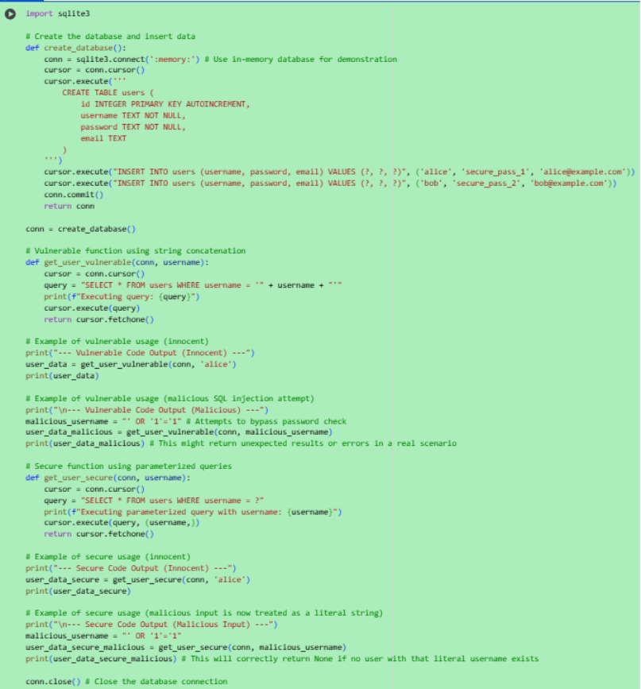  OUTPUT:  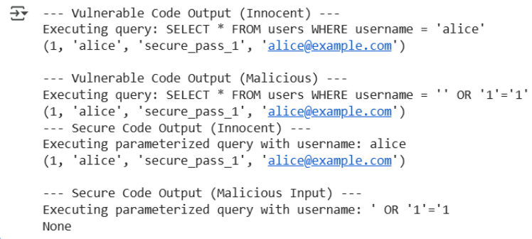  OBSERVATION: The code clearly demonstrates the vulnerability of using string concatenation for SQL queries, as a malicious input can bypass the intended logic. In contrast, the parameterized query correctly treats the malicious input as a literal string, preventing the SQL injection.  Task 3 – Cross-Site Scripting (XSS) Check  Task:  Evaluate an AI-generated HTML form with JavaScript for XSS vulnerabilities.  Instructions:  - Ask AI to generate a feedback form with JavaScript-based output.  - Test whether untrusted inputs are directly rendered without escaping.  - Implement secure measures (e.g., escaping HTML entities, using CSP).  Expected Output:  - A secure form that prevents XSS attacks.  PROMPT: Generate an HTML feedback form with JavaScript that displays user input on the page. Check if it is vulnerable to Cross-Site Scripting (XSS) by entering malicious input, then modify the code to securely handle input by escaping HTML entities and applying Content Security Policy (CSP) measures  CODE:  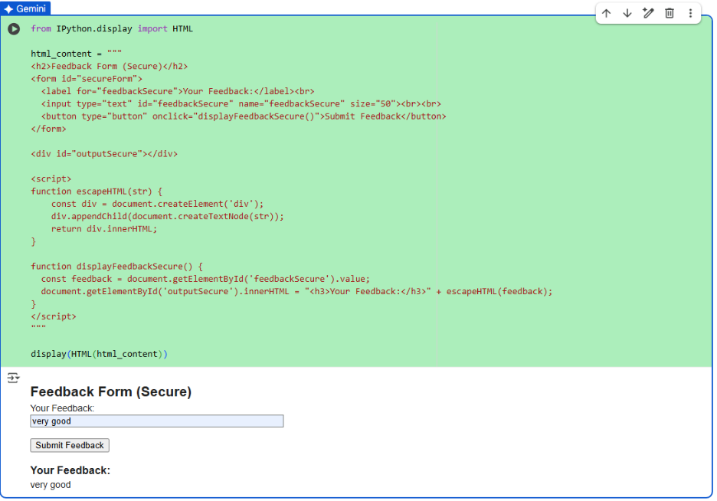  OBSERVATION: This code successfully displays the secure HTML feedback form within the Colab output using IPython.display.HTML. The included JavaScript uses escape HTML to safely display user input, preventing XSS vulnerabilities.  Task 4 – Real-Time Application: Security Audit of AI-Generated Code  Scenario:  Students pick an AI-generated project snippet (e.g., login form, API integration, or file upload).  Instructions:  - Perform a security audit to detect possible vulnerabilities.  - Prompt AI to suggest secure coding practices to fix issues.  - Compare insecure vs secure versions side by side.  Expected Output:  - A security-audited code snippet with documented vulnerabilities and fixes.  PROMPT: Students pick an AI-generated project snippet (e.g., login form, API integration, or file upload) and Perform a security audit to detect possible vulnerabilities. and Compare insecure vs secure versions side by side. give code for it  CODE:  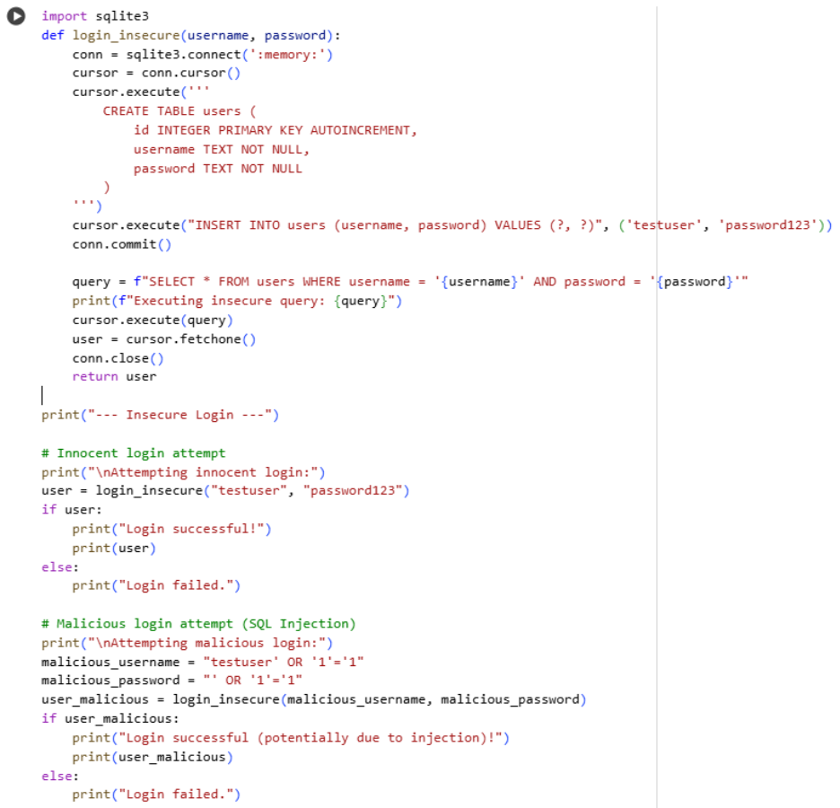  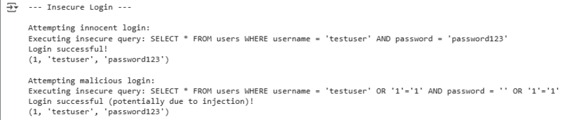  OBSERVATION: These code examples clearly show the danger of building SQL queries with string formatting, as demonstrated by the successful malicious login attempt in the insecure version. By contrast, the secure version uses parameterized queries (? placeholders), which correctly treat the input as data rather than executable code. This simple change effectively prevents SQL injection attacks and is a fundamental practice for secure database interactions.  ✅ Deliverables (For All Tasks)  - AI-generated prompts for code and test case generation.  - At least 3 assert test cases for each task.  - AI-generated initial code and execution screenshots.  - Analysis of whether code passes all tests.  - Improved final version with inline comments and explanation.  - Compiled report (Word/PDF) with prompts, test cases, assertions, code, and output. |  |  |  |  |  | Week10 - Monday

