SCHOOL OF COMPUTER SCIENCE AND ARTIFICIAL INTELLIGENCE |  |  |  |  |  | DEPARTMENT OF COMPUTER SCIENCE ENGINEERING
Program Name: B. Tech |  |  |  |  | Assignment Type: Lab |  |  | Academic Year:2025-2026
Course Coordinator Name |  |  |  |  | Venkataramana Veeramsetty
Instructor(s) Name |  |  |  |  | Dr. V. Venkataramana (Co-ordinator)  Dr. T. Sampath Kumar  Dr. Pramoda Patro  Dr. Brij Kishor Tiwari  Dr.J.Ravichander  Dr. Mohammand Ali Shaik  Dr. Anirodh Kumar  Mr. S.Naresh Kumar  Dr. RAJESH VELPULA  Mr. Kundhan Kumar  Ms. Ch.Rajitha  Mr. M Prakash  Mr. B.Raju  Intern 1 (Dharma teja)  Intern 2 (Sai Prasad)  Intern 3 (Sowmya)  NS_2 ( Mounika)
Course Code |  |  |  | 24CS002PC215 | Course Title |  | AI Assisted Coding
Year/Sem |  |  |  | II/I | Regulation |  | R24
Date and Day  of Assignment |  |  |  | Week5 - Monday | Time(s)
Duration |  |  |  | 2 Hours | Applicable to  Batches
AssignmentNumber: 9.1(Present assignment number)/24(Total number of assignments)
 | Q.No. |  | Question |  |  |  |  |  | Expected Time  to complete
 |  | 1 | Lab 9 – Code Review and Quality: Using AI to improve code quality and readability  Lab Objectives  - Inline comments  - Docstrings  - Auto-documentation tools  - AI-assisted summarization  Task Description #1 (AI-Assisted Bug Detection)  Scenario: A junior developer wrote the following Python function to calculate factorials:  def factorial(n):  result = 1  for i in range(1, n):  result = result * i  return result  - Run the code and test it with factorial(5)  (expected output = 120).  - Use AI (prompting) to review this code and identify the bug.  - Ask AI to suggest corrections and rewrite the code.  - Compare AI’s corrected code with your own fix.  PROMPT: I have a working Python function, but it's poorly written. Here's the code:  def factorial(n):  result = 1  for i in range(1, n):  result = result * i  return result  Can you find the bug and provide the corrected version of this function?  ORIGINAL CODE:  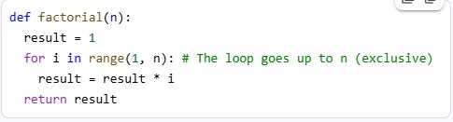  CORRECT CODE:  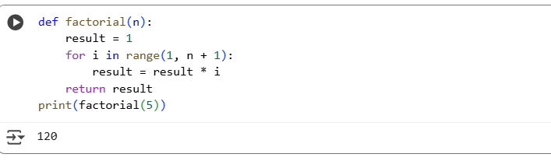  OBSERVATION: This code defines a function called factorial that calculates the factorial of a given non-negative integer n. It then calls this function with the input 5 and prints the result, which is 120.  Task Description #2 (Improving Readability & Documentation)  Scenario: The following code works but is poorly written:  def calc(a,b,c):  if c=="add":  return a+b  elif c=="sub":  return a-b  elif c=="mul":  return a*b  elif c=="div":  return a/b  - Use AI to review this code for readability, naming, and documentation issues.  - Prompt AI to rewrite the code with:  - Clear function & variable names.  - Proper docstrings.  - Exception handling for division by zero.  - Compare the before-and-after versions to evaluate AI’s contribution.  PROMPT:  def calc(a,b,c):  if c=="add":  return a+b  elif c=="sub":  return a-b  elif c=="mul":  return a*b  elif c=="div":  return a/b  Can you find the bug and provide the corrected version of this function?  ORIGINAL CODE:  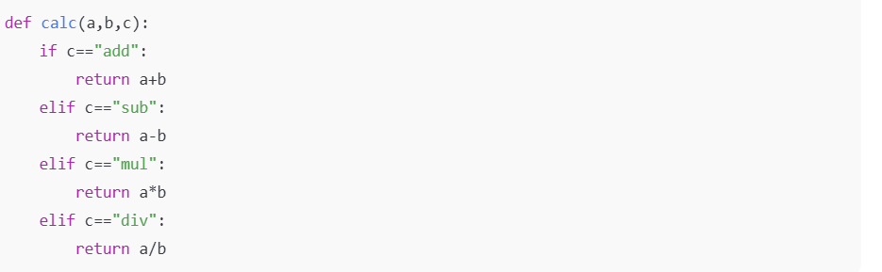  CORRECT CODE:  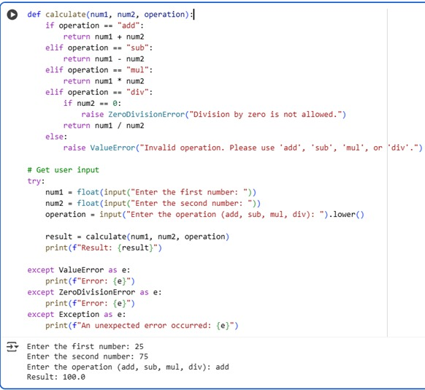  OBSERVATION: Your original calc function lacked error handling for division by zero and invalid operations, which could cause the program to crash. My calculate function fixes these issues by explicitly checking for these conditions and raising appropriate exceptions (ZeroDivisionError and ValueError). Additionally, my code uses clearer variable names and includes a docstring for better readability and documentation, along with an example of how to handle these exceptions.  Task Description #3 (Enforcing Coding Standards)  Scenario: A team project requires following PEP8 style guide. One developer submits:  def Checkprime(n):  for i in range(2,n):  if n%i==0:  return False  return True  - Run this code and verify correctness.  - Use AI to perform a code quality review for PEP8 compliance.  - Prompt AI to return a refactored version with proper indentation, spacing, and naming conventions.  - Discuss how automated AI review can save time in large-scale projects.  PROMPT:  def Checkprime(n):  for i in range(2,n):  if n%i==0:  return False  return True  rewrite the code using return a refactored version with proper indentation, spacing, and naming conventions.  ORIGINAL CODE:  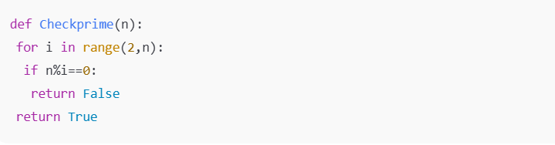  CORRECT CODE:  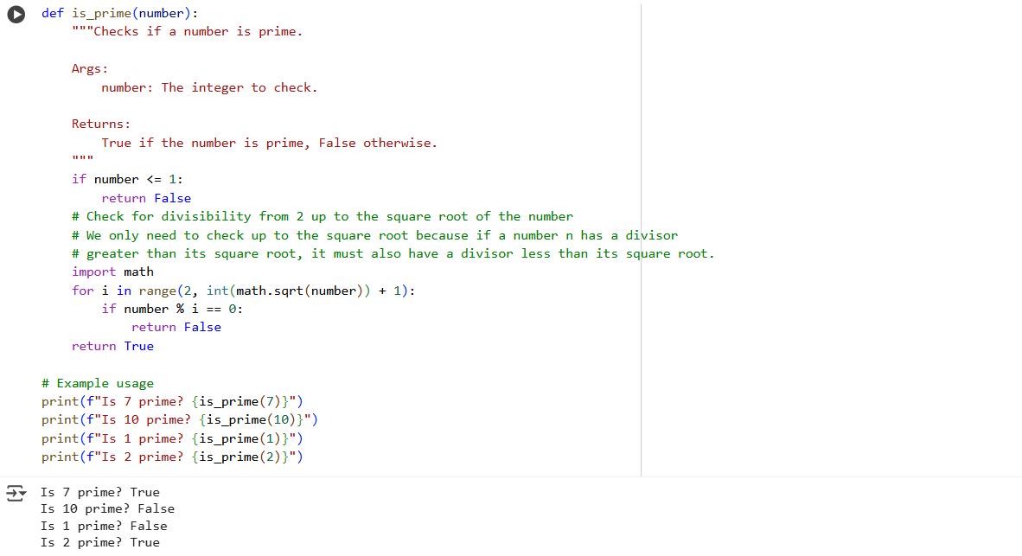  OBSERVATION: This function is a much better way to check if a number is prime compared to the original. It's easier to read because of clearer names and explanations (the docstring). It correctly handles numbers that aren't prime right away (like 1 or negative numbers). Plus, it's faster for big numbers because it doesn't check every single possible divisor, only the necessary ones up to the square root.  Task Description #4 (AI as a Code Reviewer in Real Projects)  Scenario: You are part of a GitHub project. A teammate submits this pull request:  def processData(d):  return [x*2 for x in d if x%2==0]  - Review this function manually for readability, reusability, and edge cases.  - Use AI to generate a code review comment, focusing on:  - Naming conventions.  - Input validation (e.g., what if d is not a list?).  - Adding type hints.  - Modify the function based on AI’s suggestions.  PROMPT 1: Manually review this function for readability, naming, and edge cases (e.g., invalid input). List at least two possible improvements." • def processData(d): • return [x*2 for x in d if x%2==0]  PROMPT 2: Rewrite the function using your suggestions and add a descriptive docstring.  ORIGINAL CODE:  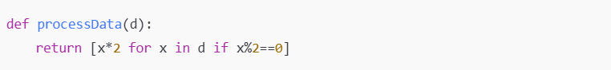  CORRECT CODE:  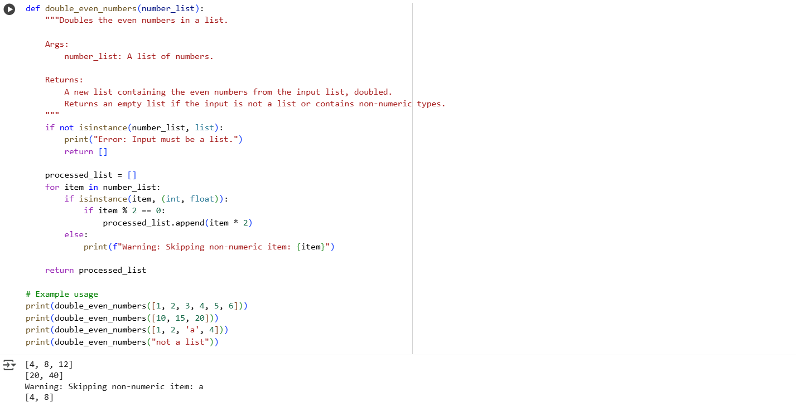  OBSERVATION: The improved double_even_numbers function is more robust and informative than the original implicit behavior of the list comprehension, handling various input scenarios gracefully.  - Write a short reflection: Would you trust AI as a standalone reviewer, or only as a support tool? Why?  ANSWER: I would trust AI as a support tool, not a standalone reviewer. It’s excellent for automating routine checks and improving code quality quickly, but final review decisions should be made by a human who understands the project's context, goals, and edge cases. |  |  |  |  |  | Week5 - Monday

