SCHOOL OF COMPUTER SCIENCE AND ARTIFICIAL INTELLIGENCE |  |  |  |  | DEPARTMENT OF COMPUTER SCIENCE ENGINEERING
ProgramName:B. Tech |  |  |  | Assignment Type: Lab |  |  | AcademicYear:2025-2026
CourseCoordinatorName |  |  |  | Venkataramana Veeramsetty
Instructor(s)Name |  |  |  | Dr. V. Venkataramana (Co-ordinator)  Dr. T. Sampath Kumar  Dr. Pramoda Patro  Dr. Brij Kishor Tiwari  Dr.J.Ravichander  Dr. Mohammand Ali Shaik  Dr. Anirodh Kumar  Mr. S.Naresh Kumar  Dr. RAJESH VELPULA  Mr. Kundhan Kumar  Ms. Ch.Rajitha  Mr. M Prakash  Mr. B.Raju  Intern 1 (Dharma teja)  Intern 2 (Sai Prasad)  Intern 3 (Sowmya)  NS_2 ( Mounika)
CourseCode |  |  | 24CS002PC215 | CourseTitle |  | AI Assisted Coding
Year/Sem |  |  | II/I | Regulation |  | R24
Date and Day  of Assignment |  |  | Week1 - Thursday | Time(s)
Duration |  |  | 2 Hours | Applicableto  Batches |  | 24CSBTB01 To 24CSBTB39
AssignmentNumber:2.4(Present assignment number)/24(Total number of assignments)
 | Q.No. | Question |  |  |  |  |  | ExpectedTime  to complete
 | 1 | Lab 2: Exploring Additional AI Coding Tools – Gemini (Colab) and Cursor AI  Lab Objectives:  - To explore and evaluate the functionality of Google Gemini for AI-assisted coding within Google Colab.  - To understand and use Cursor AI for code generation, explanation, and refactoring.  - To compare outputs and usability between Gemini, GitHub Copilot, and Cursor AI.  - To perform code optimization and documentation using AI tools.  Lab Outcomes (LOs):  After completing this lab, students will be able to:  - Generate Python code using Google Gemini in Google Colab.  - Analyze the effectiveness of code explanations and suggestions by Gemini.  - Set up and use Cursor AI for AI-powered coding assistance.  - Evaluate and refactor code using Cursor AI features.  - Compare AI tool behavior and code quality across different platforms.  Task Description #1  • Open Google Colab and use Google Gemini to generate Python code that performs sorting of a list using both the bubble sort algorithm and Python’s built-in sort() function. Compare the two implementations.  PROMPT-write the python code that performs sorting of a list using both the bubble sort algorithm and python’s built-in-sort() function.  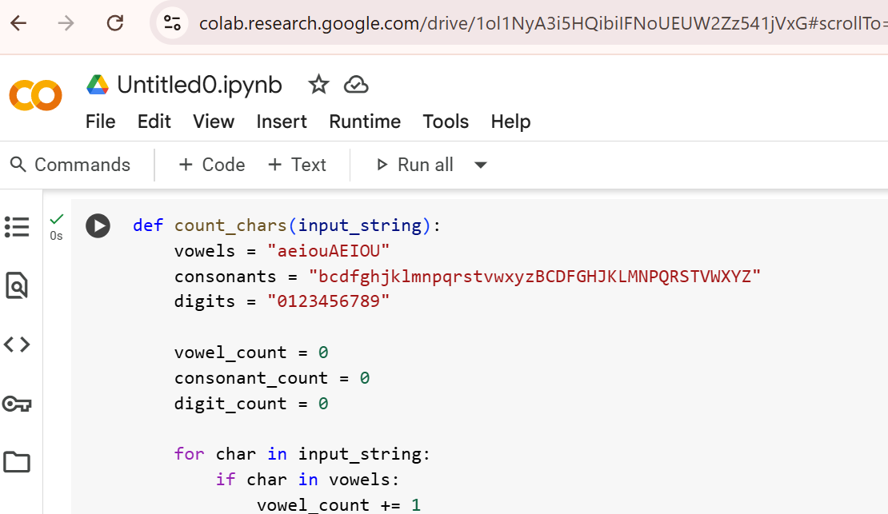  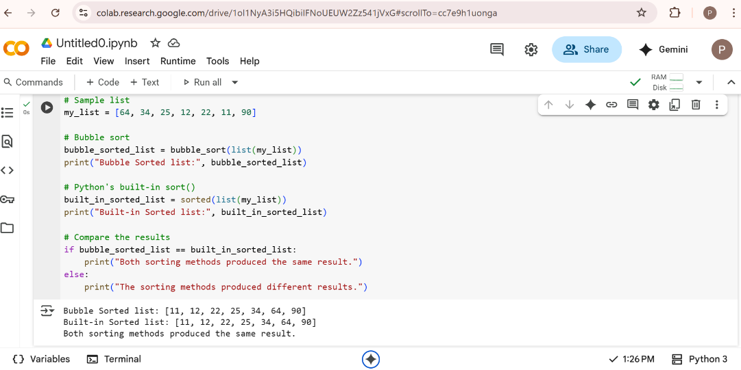  Expected Output #1  • Two sorting implementations: Bubble sort (manual logic) and Built-in sort()  Task Description #2  • In Colab, use Google Gemini to generate a Python function that takes a string and returns:  The number of vowels, The number of consonants, The number of digits in the string  PROMPT-Write a python code by using function that takes a string and returns number of vowels,consonants,digits in the string    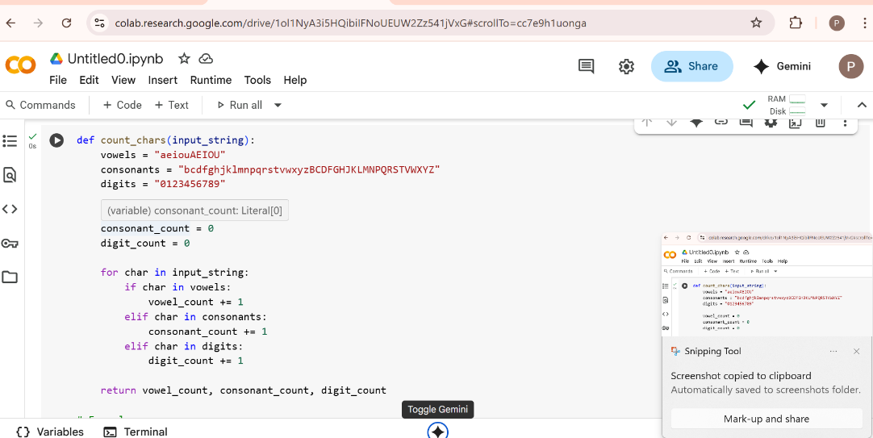  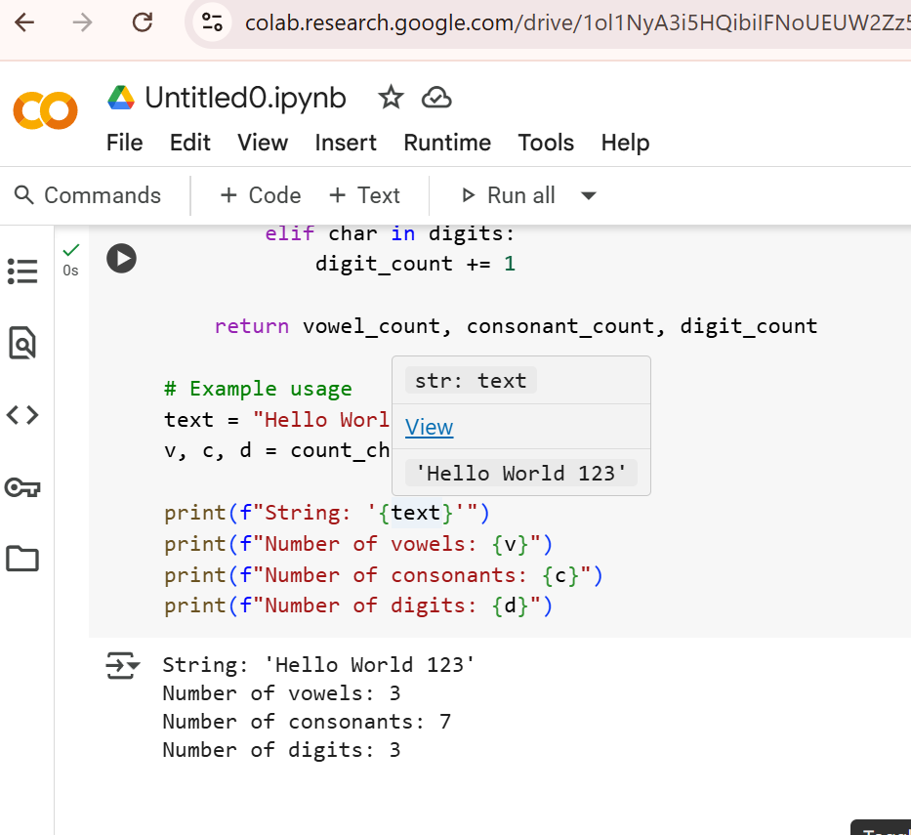  Expected Output #2-  • Complete function that Iterates through characters of a string and Counts vowels, consonants, and digits  Task Description #3  • Install and set up Cursor AI. Use it to generate a Python program that performs file handling:  Create a text file  Write sample text  Read and display the content  PROMPT-write the python code that performs file handling like we have to create a text file,write the sample text and display the content  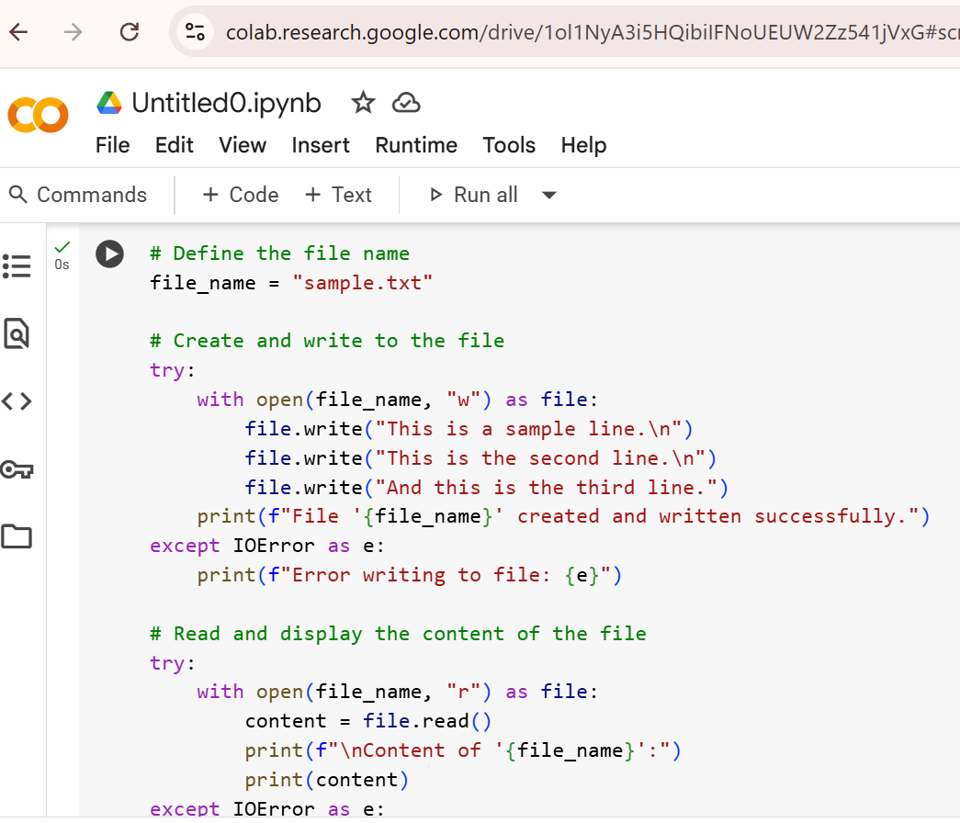  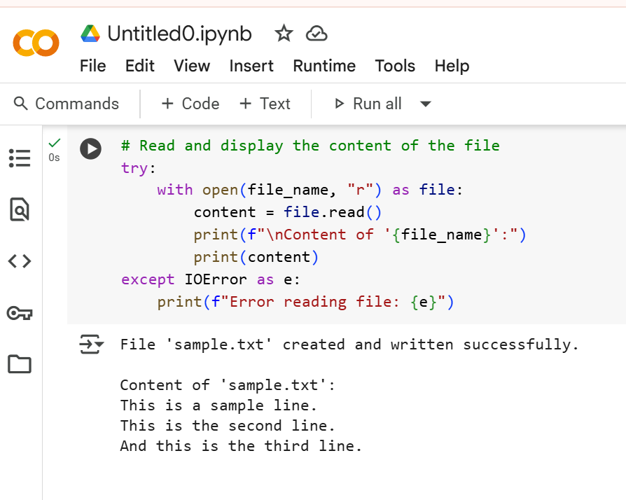  Expected Output #3  • Functional code that creates a .txt file, writes content to it, and reads it back.  • Screenshot of Cursor AI interface showing: Prompt used,  Generated code, Output of file operations  Task Description #4  • Ask Google Gemini to generate a Python program that implements a simple calculator using functions (add, subtract, multiply, divide). Then, ask Gemini to explain how the code works.  PROMPT-write the python code by using functions that implements a simple calculator that includes add,sub,multiply,divide.  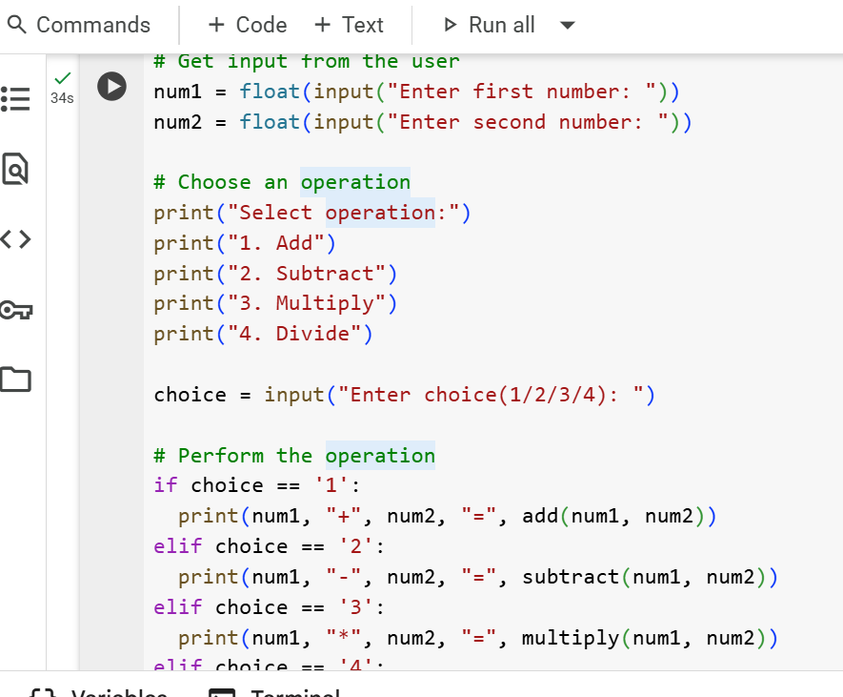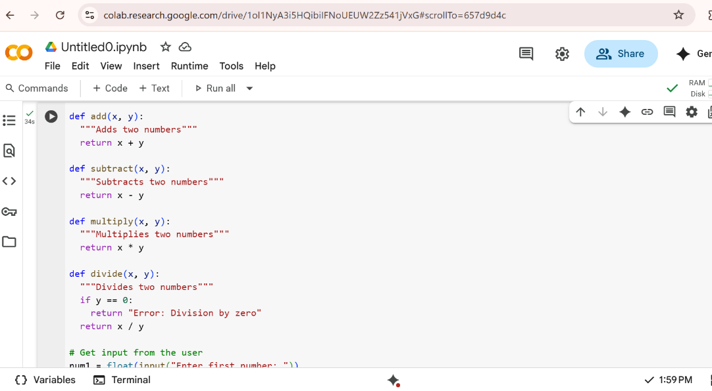  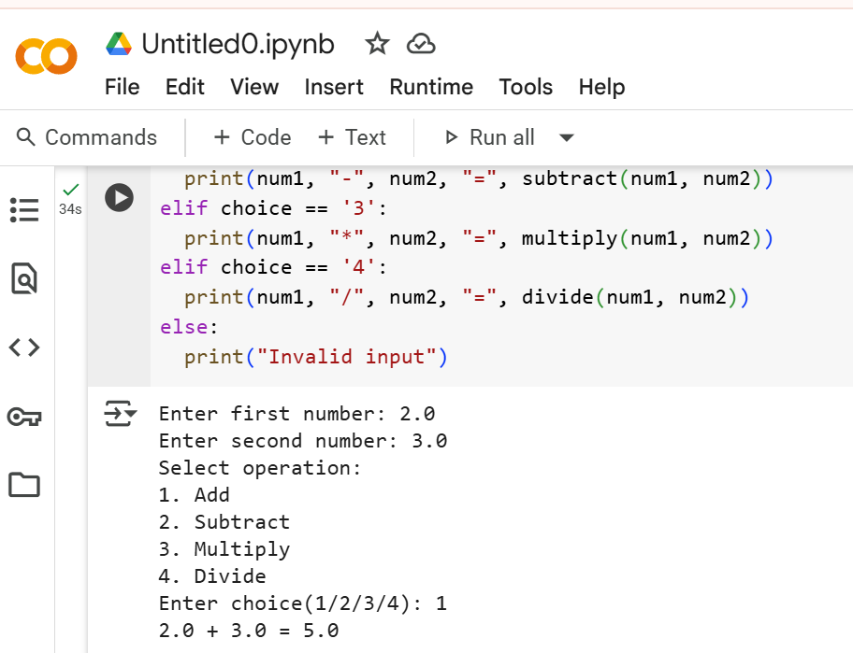  Expected Output #4  • Complete calculator code with user input and operation selection.  • Line-by-line explanation or markdown-style explanation provided by Gemini.  • Screenshot of both the code and explanation in Colab.  Task Description #5  • Use Cursor AI to create a Python program that checks if a given year is a leap year or not. Try different prompt styles and see how Cursor modifies its code suggestions.  PROMPT-write the python code whether the given year is leap year or not  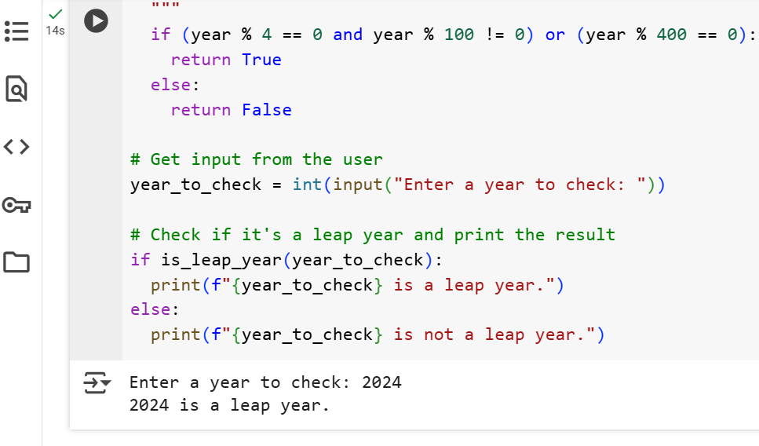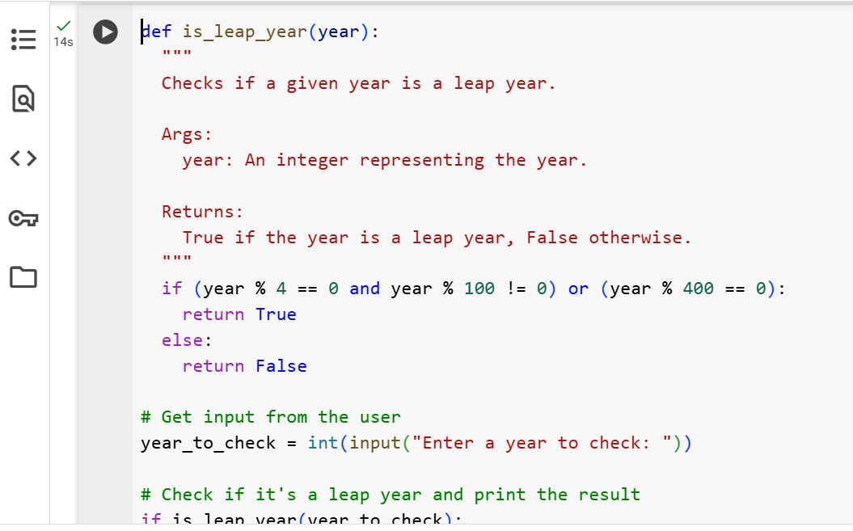  Expected Output #5  • A functional program to check leap year with sample input/output  • At least two versions of the code (from different prompts)  • A short comparison of which version is better and why  Note: Report should be submitted a word document for all tasks in a single document with prompts, comments & code explanation, and output and if required, screenshots  Evaluation Criteria:  Criteria Max Marks  Two sorting implementations: Bubble sort (manual logic) and Built-in sort() (Task#1) 0.5  Counts vowels, consonants, and digits(Task#2) 0.5  Functional code that creates a .txt file, writes content to it, and reads it back- Use cursor (Task#3) 0.5  Complete calculator code with user input and operation selection. (Task#4) 0.5  A functional program to check leap year with sample input/output-use Cursor (Task#5) 0.5  Total 2.5 Marks |  |  |  |  |  | Week1 - Thursday

