Lab 8: Documentation Generation: Automatic documentation and code comments
Lab Objectives:
• To understand the importance of documentation and code comments in software
development.
• To explore how AI-assisted coding tools can generate meaningful documentation and
Week4 -
Wednesday
inline comments.
• To practice generating function-level and module-level docstrings automatically.
• To evaluate the quality, accuracy, and limitations of AI-generated documentation.
• To develop a small automated tool for documentation generation in Python..
Lab Outcomes (LOs):
After completing this lab, students will be able to:
• Apply AI-assisted coding tools to generate docstrings and inline comments for Python
code.
• Critically analyze AI-generated documentation for correctness, completeness, and
readability.
• Create structured documentation (function-level, module-level) following standard
formats.
• Design and implement a mini documentation generator tool to automate code
commenting and docstring creation.
Task Description#1 Basic Docstring Generation
• Write python function to return sum of even and odd numbers in the given list.
• Incorporate manual docstring in code with Google Style
• Use an AI-assisted tool (e.g., Copilot, Cursor AI) to generate a docstring describing
the function.
• Compare the AI-generated docstring with your manually written one.
Expected Outcome#1: Students understand how AI can produce function-level documentation

prompt:generate a python function that takes list of numbers from user and returns the sum of all odd and even numbers.

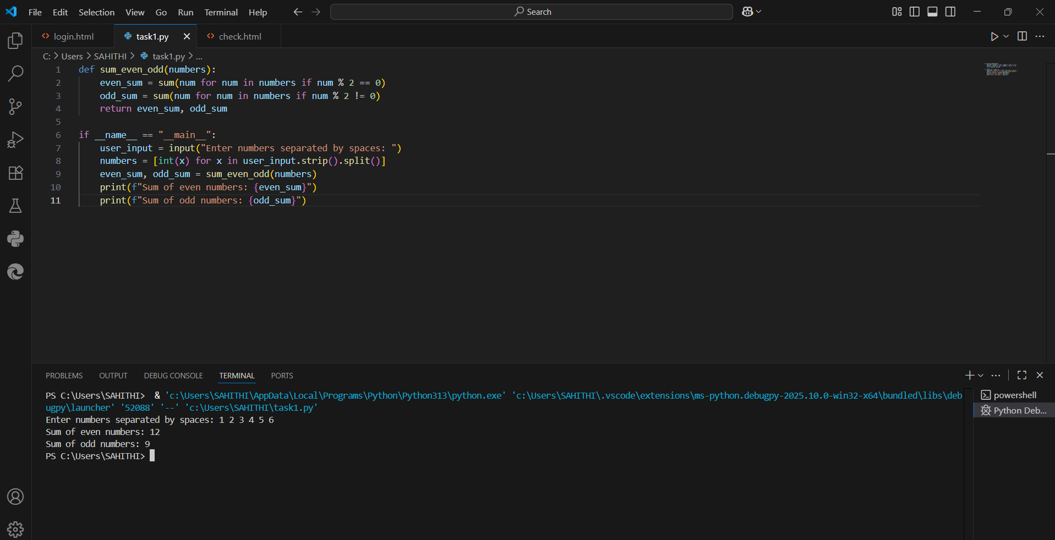

AI generated docstring:
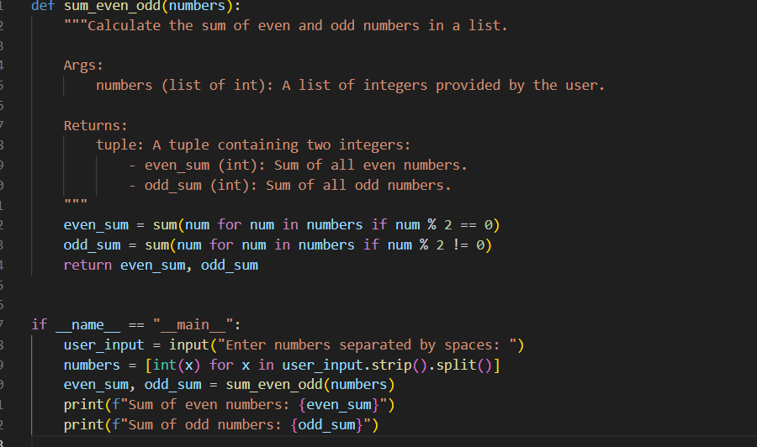
Manually added docstring:
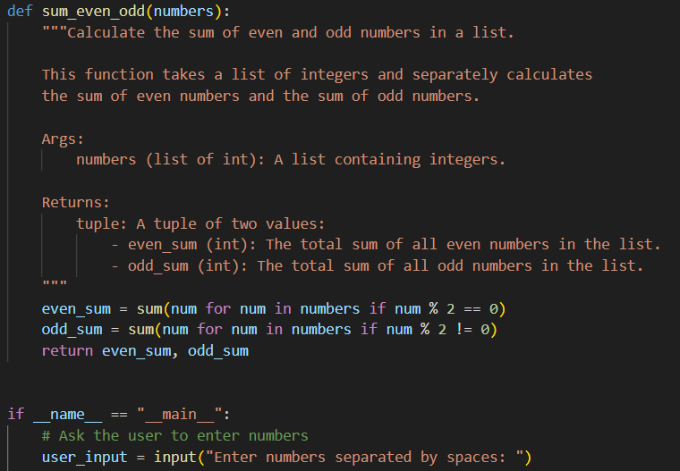

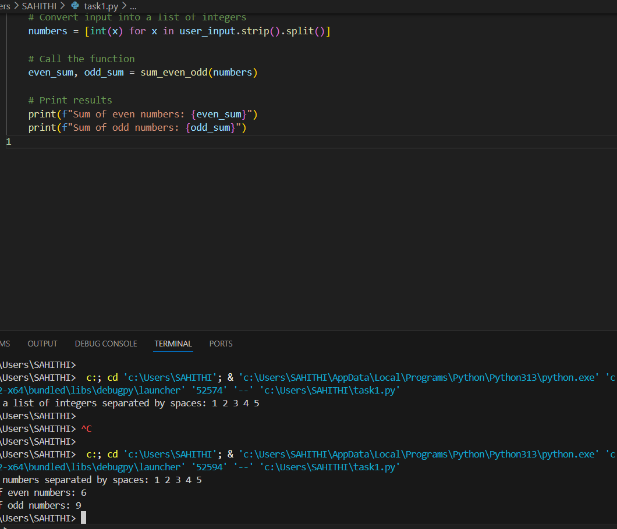

DIFFERENCE: When I wrote the docstring, I explained it in a way that anyone could easily understand.
I mentioned clearly that the user will enter numbers (with spaces), and the program will calculate two things — the sum of even numbers and the sum of odd numbers.
It feels more like I am telling a friend how the code works step by step.
When the AI wrote the docstring, it was correct but very short and general.
It didn’t explain the input part properly, and it only gave a small description of what the function does.
It looks professional, but it doesn’t give as much detail as mine.
ask Description#2 Automatic Inline Comments
• Write python program for sru_student class with attributes like name, roll no.,
hostel_status and fee_update method and display_details method.
• Write comments manually for each line/code block
• Ask an AI tool to add inline comments explaining each line/step.
• Compare the AI-generated comments with your manually written one.
Expected Output#2: Students critically analyze AI-generated code comments

MANUALLY WRITTEN CODE:
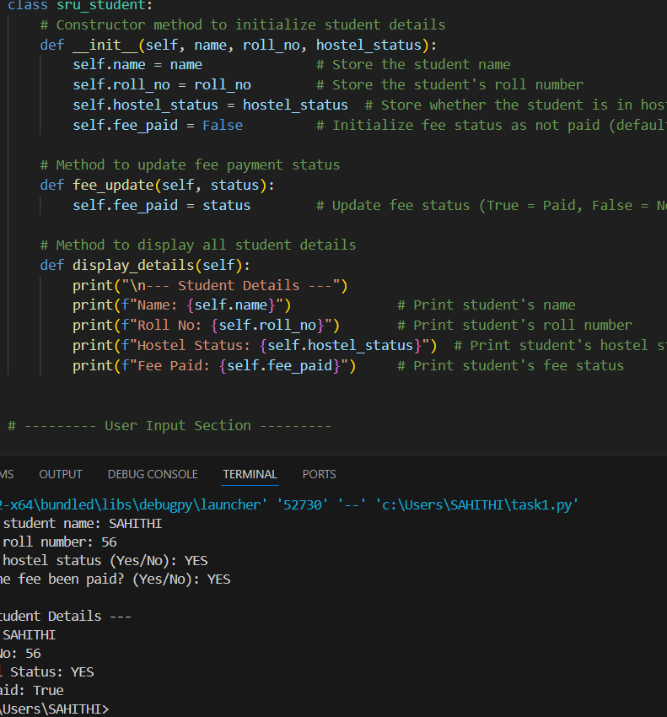

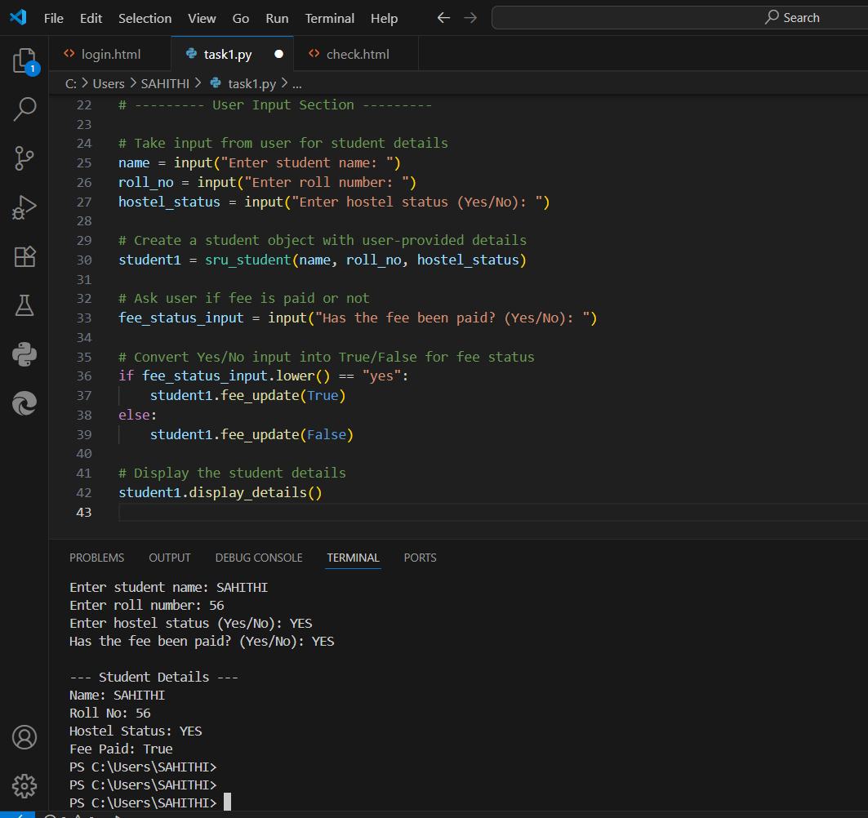

AI GENERATED:
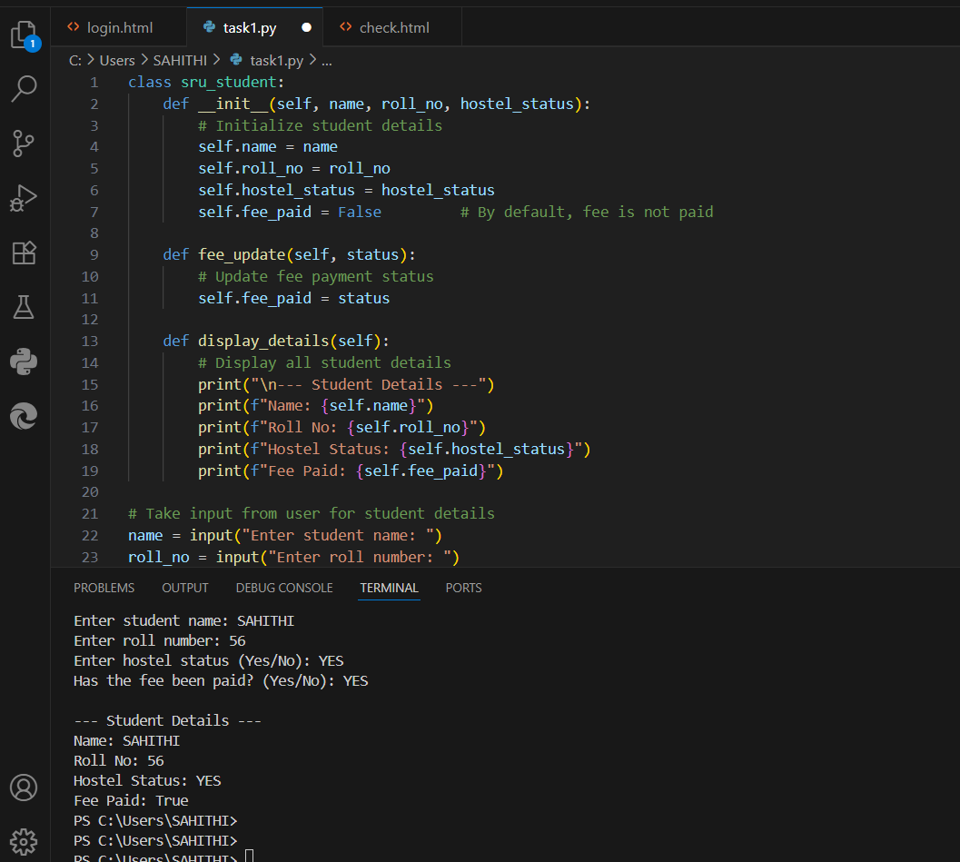

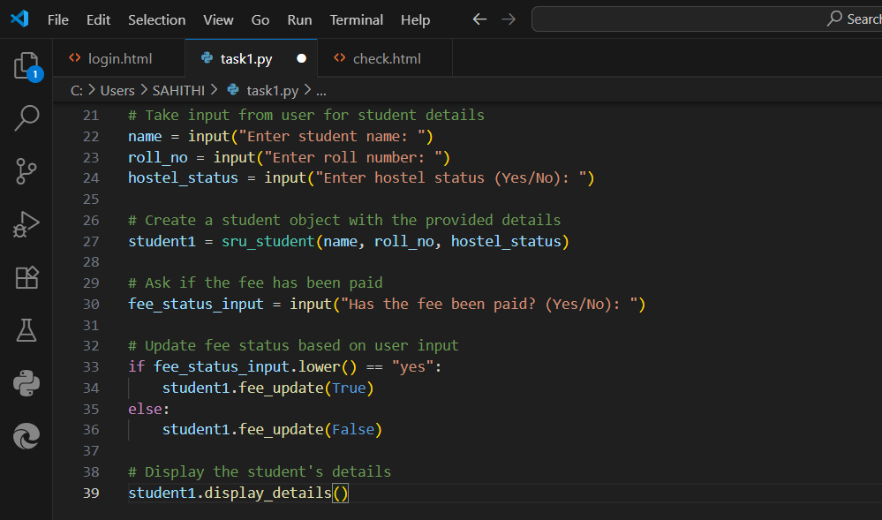

DIFFERENCES:

I have written comments in possible clear ay and the ai also given the comments
Accurately.infact ai gave more detailed version but even for small snippet of code it has given comments which is a good idea but have risk during code scan.except that my comments and ai comments are concise.

Task Description#3
• Write a Python script with 3–4 functions (e.g., calculator: add, subtract, multiply,
divide).
• Incorporate manual docstring in code with NumPy Style
• Use AI assistance to generate a module-level docstring + individual function
docstrings.
• Compare the AI-generated docstring with your manually written one

MANUAL CODE:
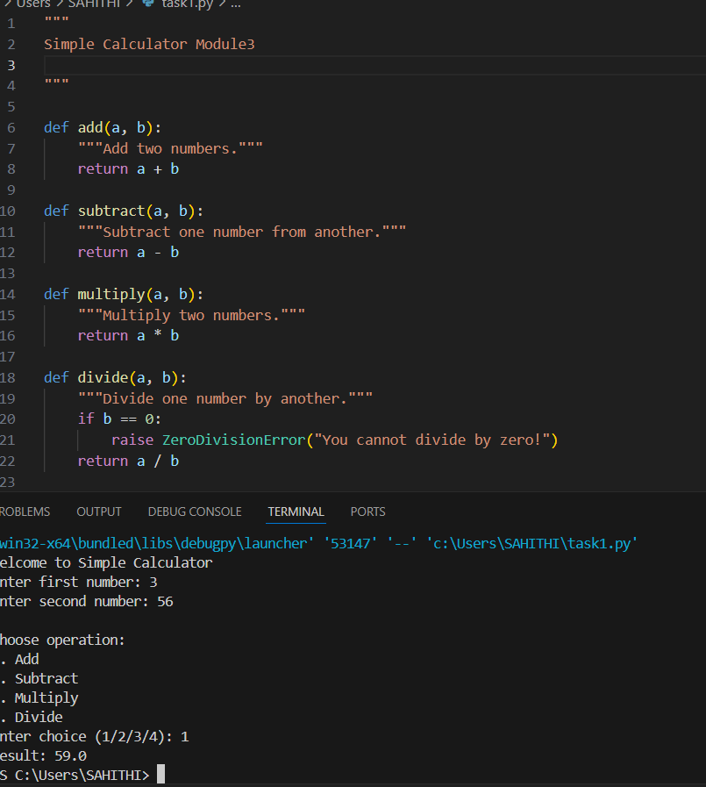

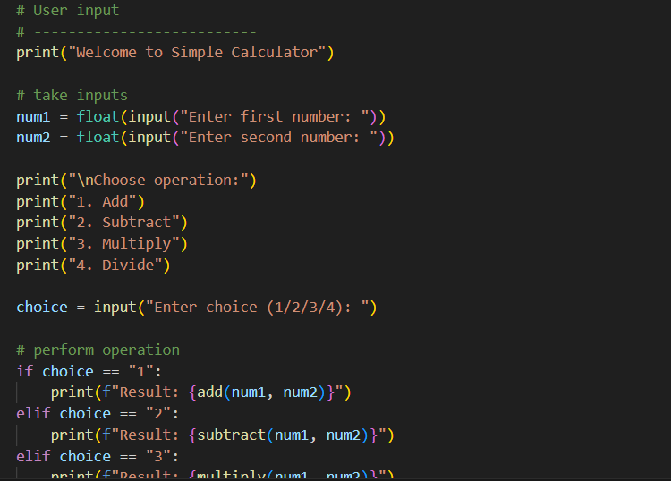

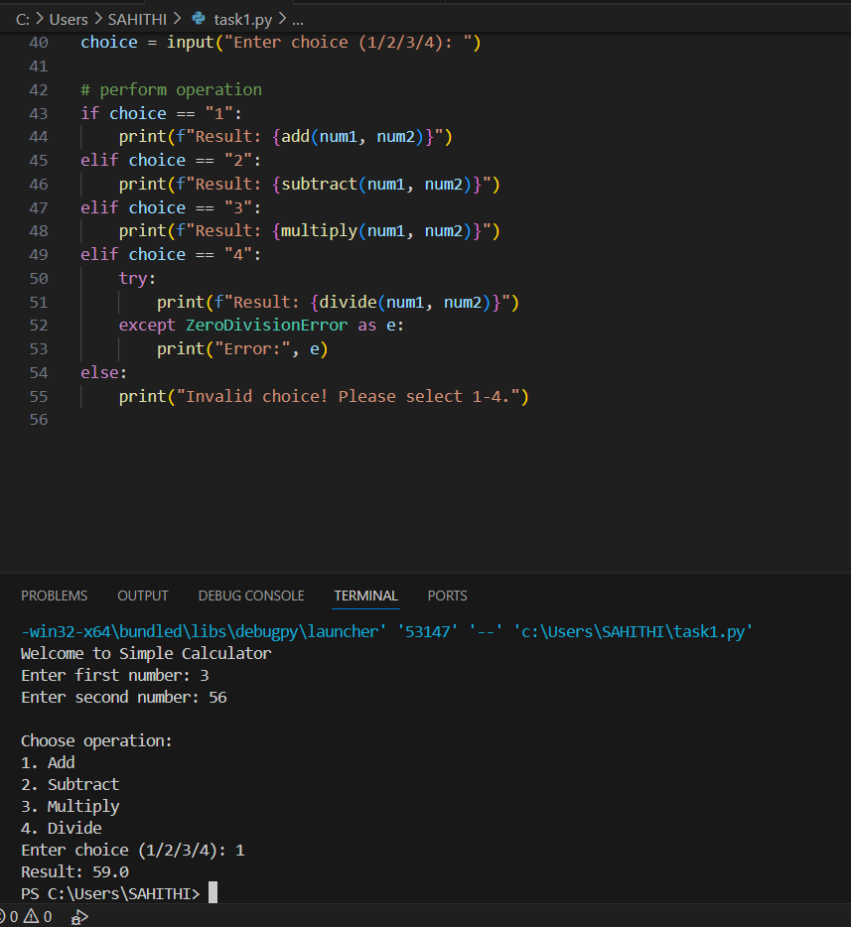

AI GENERATED:
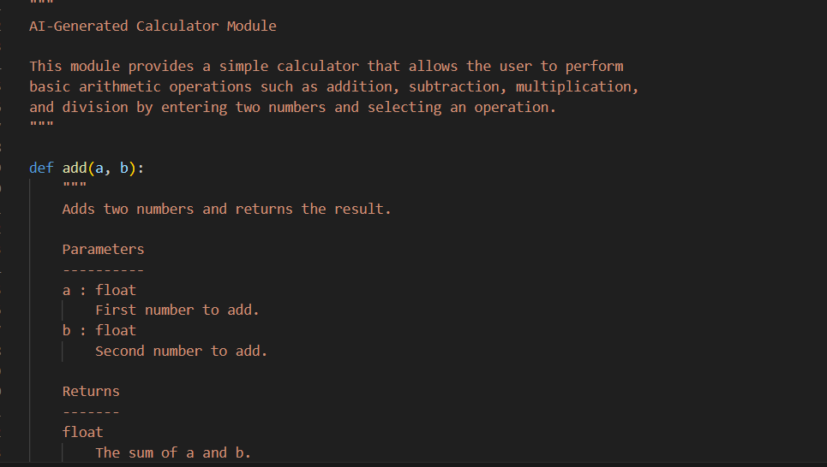

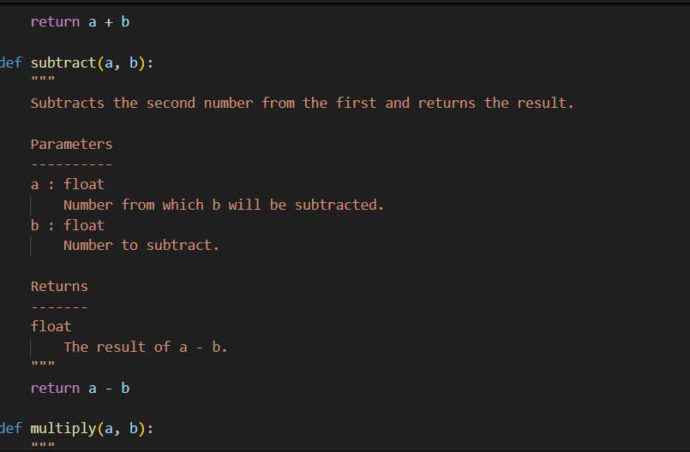

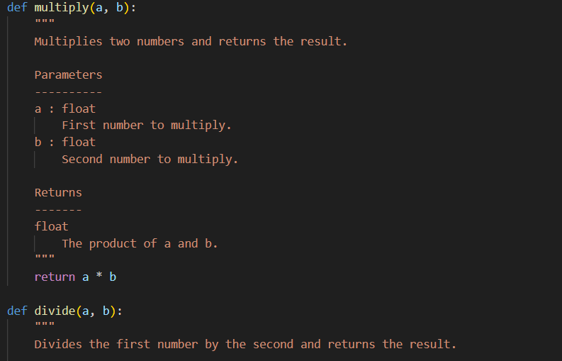

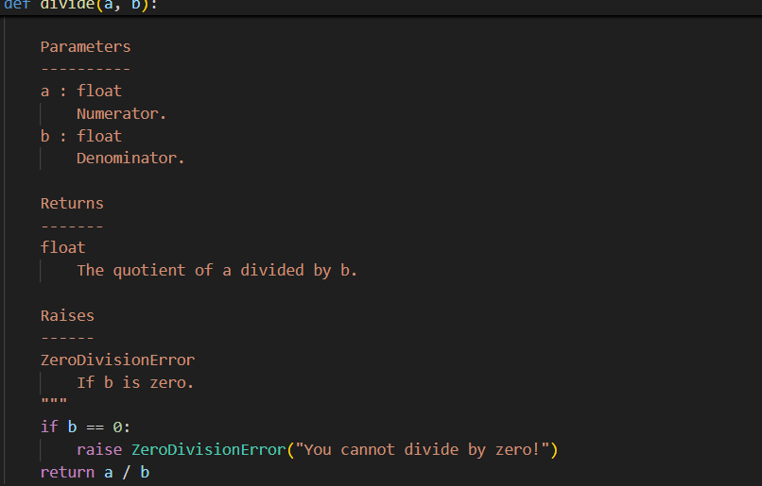

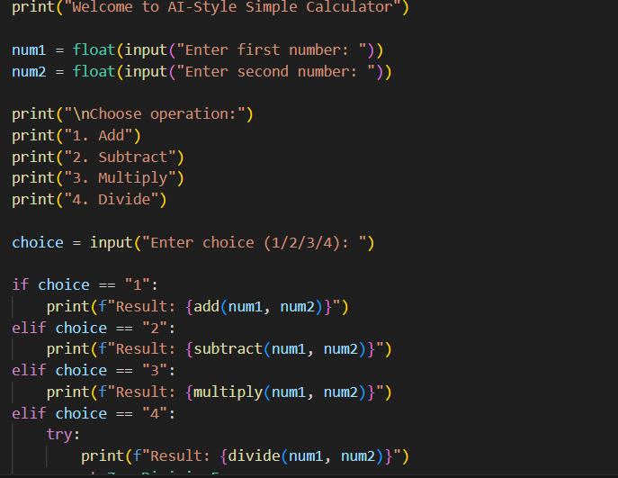

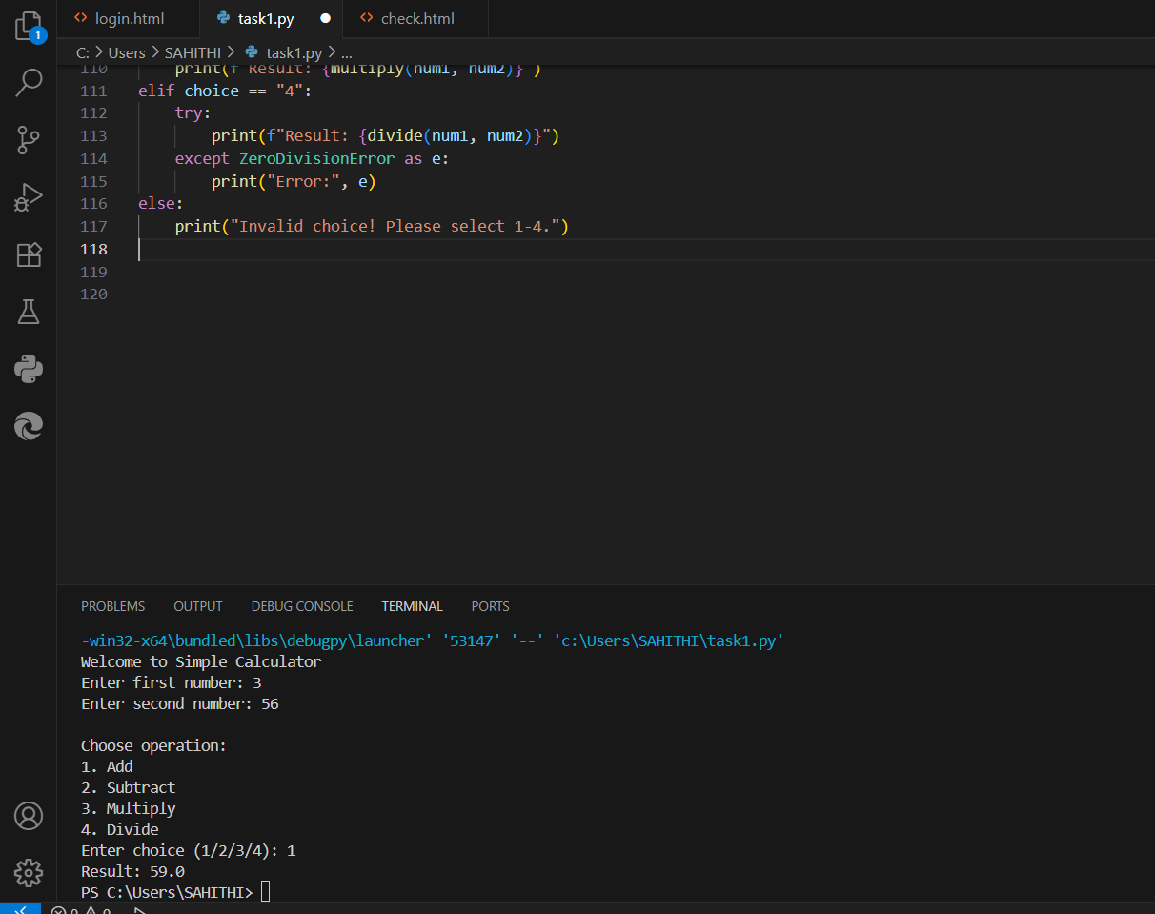

DIFFERENCES:
When I wrote the manual docstrings, I kept them simple and to the point. I just described what each function does in a short sentence, like “Add two numbers,” without adding extra details. The module description was also brief, saying it is a simple calculator with basic operations. For division, I only mentioned that the second number must not be zero. This made the manual docstrings easy to read and beginner-friendly. On the other hand, the AI-generated docstrings were more formal and detailed. They explained not only what the function does but also what it returns, often in full sentences. The module description included more context, mentioning that the user can enter numbers and select operations. The error handling for division was also clearly stated as raising a ZeroDivisionError if the second number is zero. Overall, the manual docstrings feel like something I wrote myself, short and simple, while the AI-generated docstrings are more professional and thorough, making them better suited for official documentation or reports.But the code generated is very complex compared to mine.

