Lab 11 – Data Structures with AI: Implementing Fundamental Structures
Lab Objectives
- Use AI to assist in designing and implementing fundamental data structures in Python.
- Learn how to prompt AI for structure creation, optimization, and documentation.
- Improve understanding of Lists, Stacks, Queues, Linked Lists, Trees, Graphs, and Hash Tables.
Enhance code quality with AI-generated comments and performance suggestions.
Task Description #1 – Stack Implementation
Task: Use AI to generate a Stack class with push, pop, peek, and is_empty methods.
Sample Input Code:
class Stack:
pass
Expected Output:
- A functional stack implementation with all required methods and docstrings.
Prompt: Write a Python class Stack with methods push, pop, peek, and is_empty
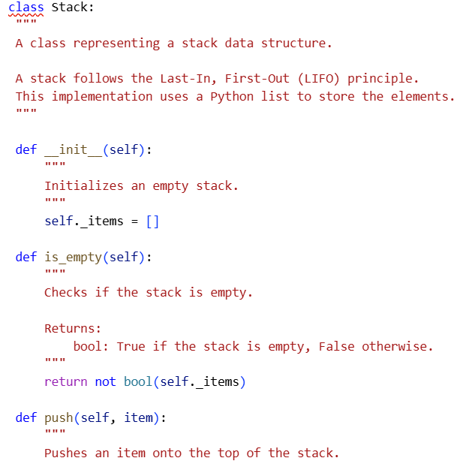
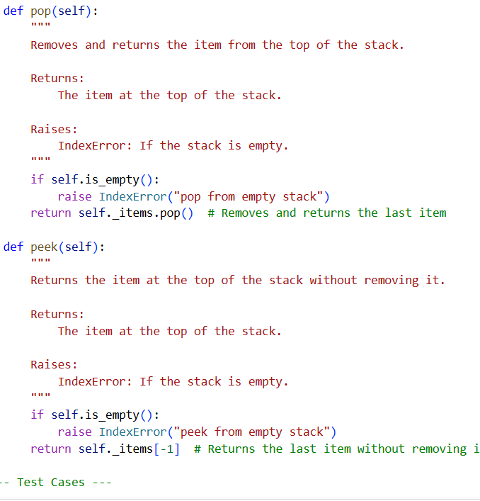

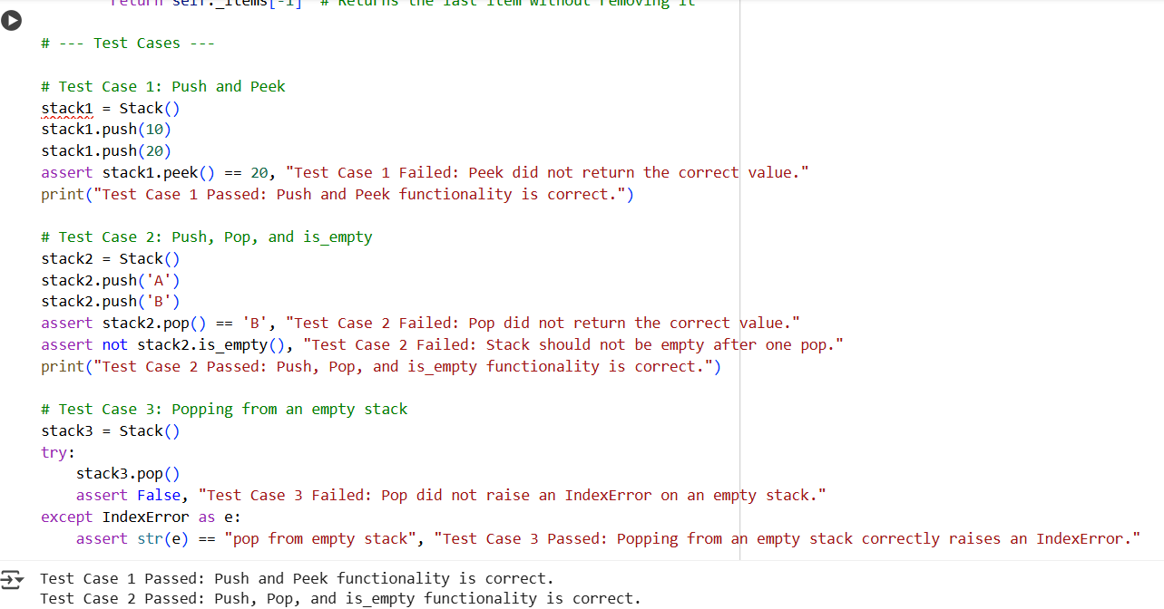

Task Description #2 – Queue Implementation
Task: Use AI to implement a Queue using Python lists.
Sample Input Code:
class Queue:
pass
Expected Output:
- FIFO-based queue class with enqueue, dequeue, peek, and size methods.
Prompt: Write a Python Queue class using lists with enqueue, dequeue, peek, and size methods.

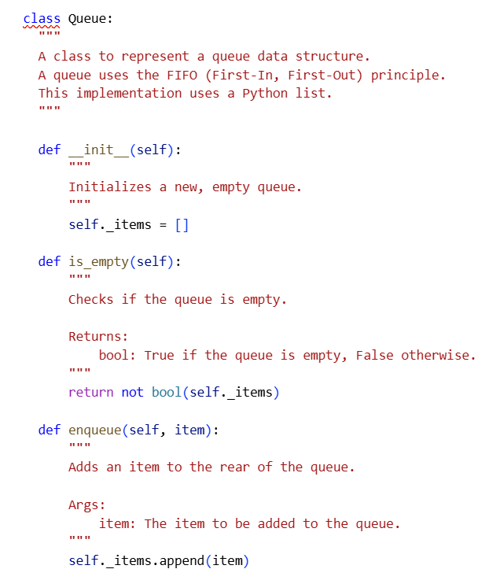

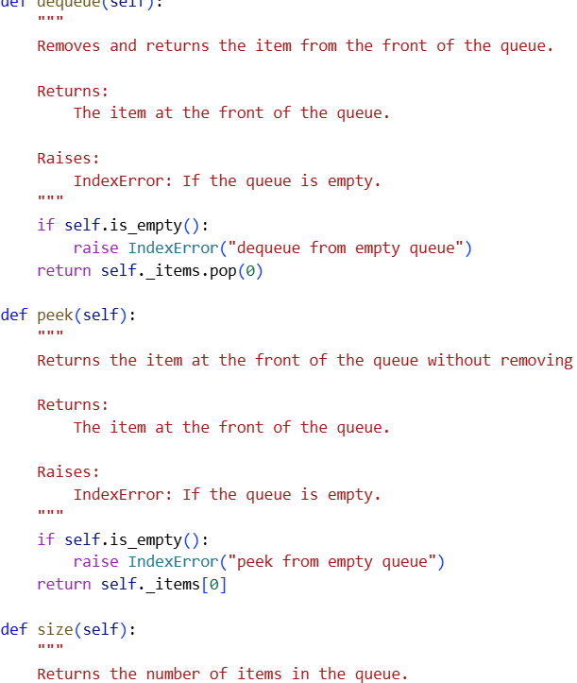

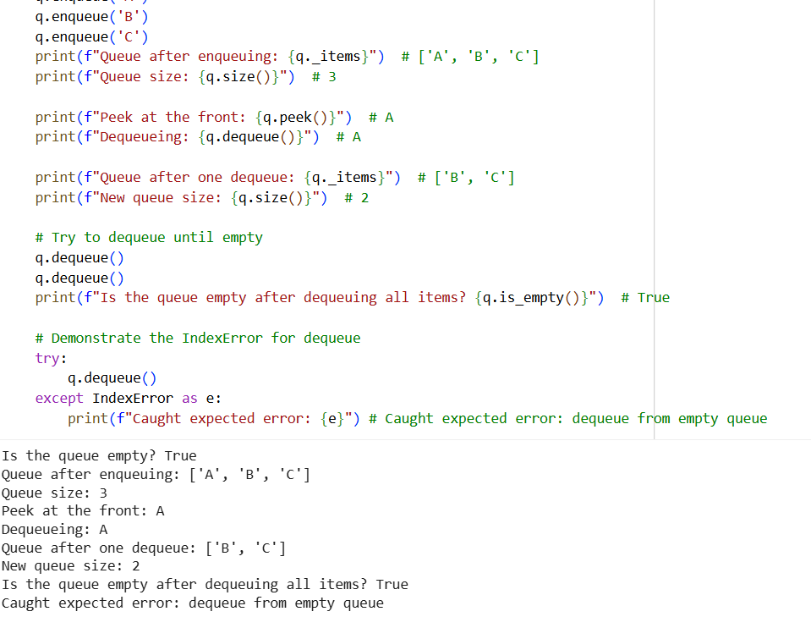

Task Description #3 – Linked List
Task: Use AI to generate a Singly Linked List with insert and display methods.
Sample Input Code:
class Node:
pass

class LinkedList:
pass
Expected Output:
A working linked list implementation with clear method documentation.

Prompt: Write a Python Singly Linked List with Node and LinkedList classes. Implement insert and display methods with docstrings. Add 3 assert test cases

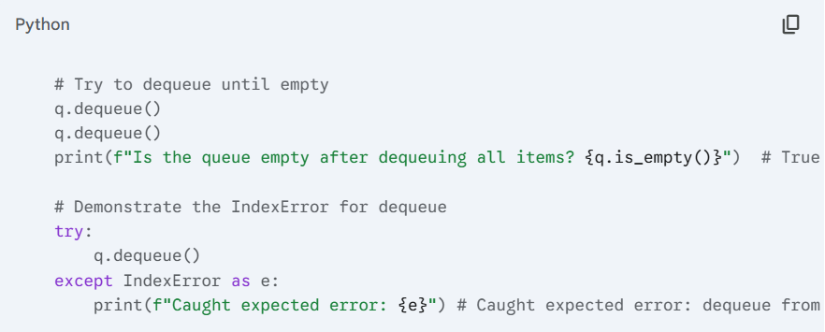
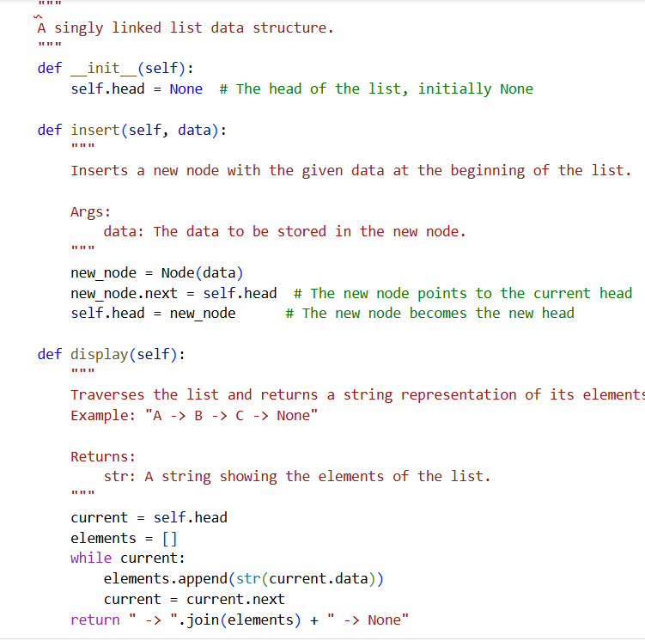
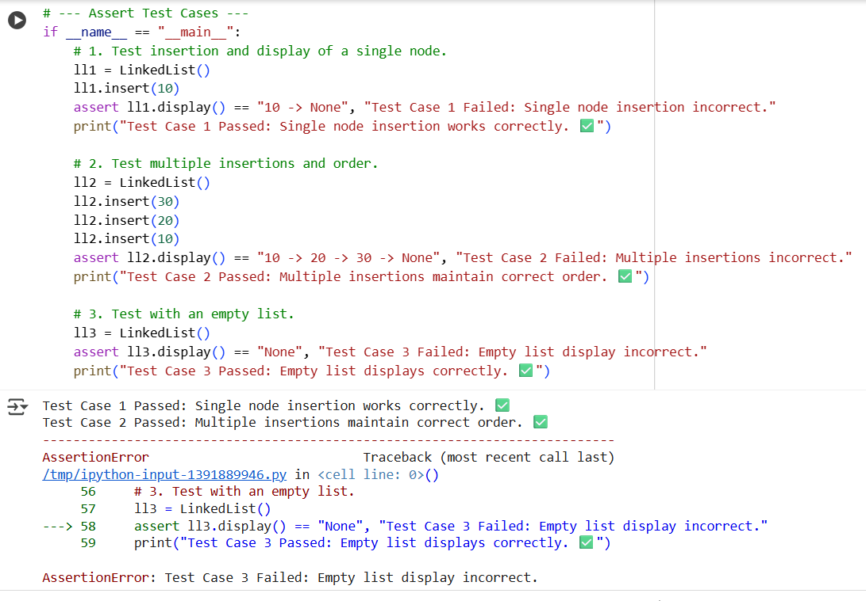

Task Description #4 – Binary Search Tree (BST)
Task: Use AI to create a BST with insert and in-order traversal methods.
Sample Input Code:
class BST:
pass
Expected Output:
- BST implementation with recursive insert and traversal methods.
Prompt: Write a Python Binary Search Tree (BST) with insert and inorder traversal methods. Use recursion. Add docstrings and 3 assert test cases.

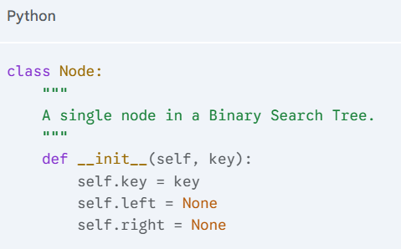

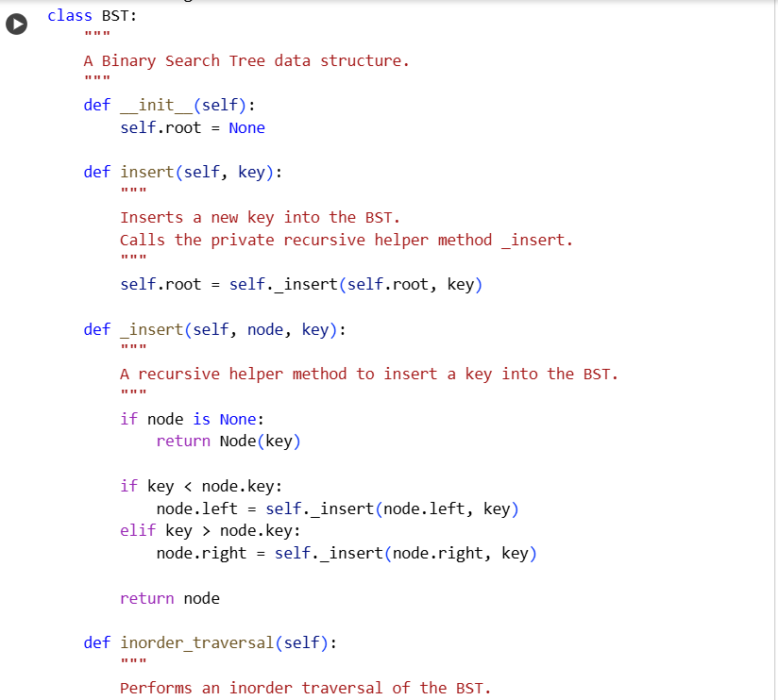

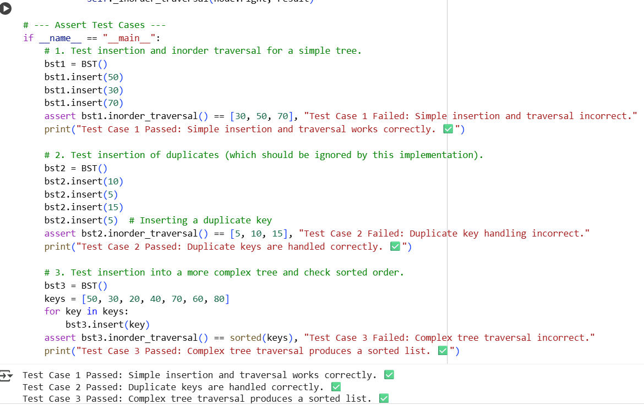

Task Description #5 – Hash Table
Task: Use AI to implement a hash table with basic insert, search, and delete methods.
Sample Input Code:
class HashTable:
pass
Expected Output:
Collision handling using chaining, with well-commented methods.
Prompt: Write a Python Hash Table class using chaining (list of lists). Implement insert, search, and delete methods. Add docstrings and 3 assert test cases
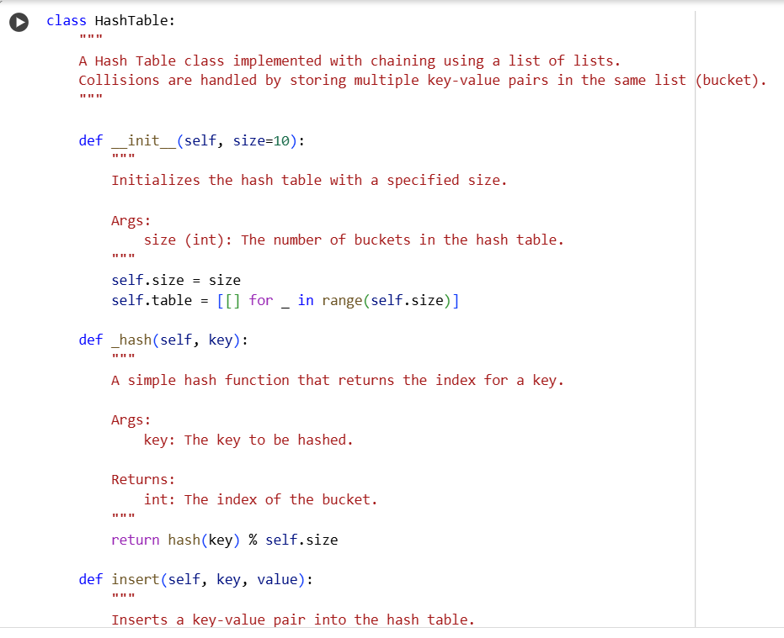

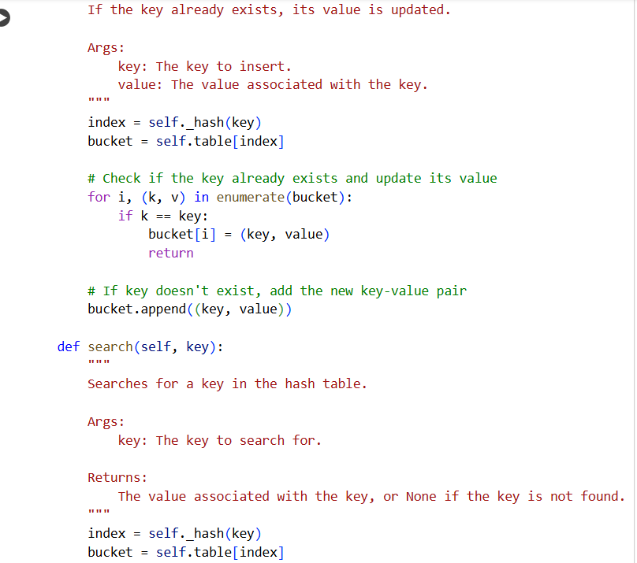

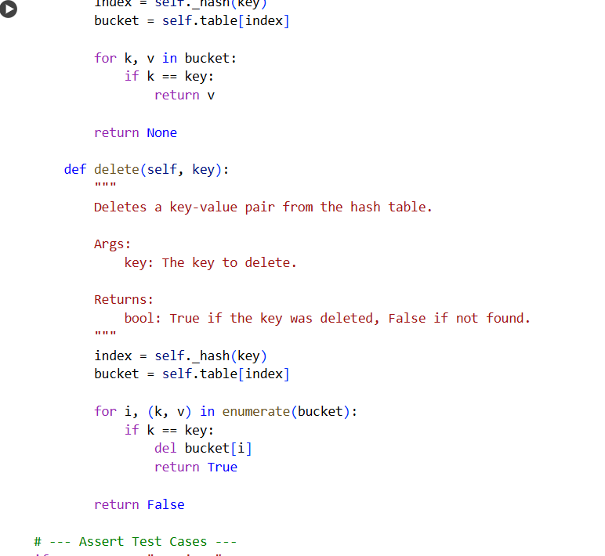

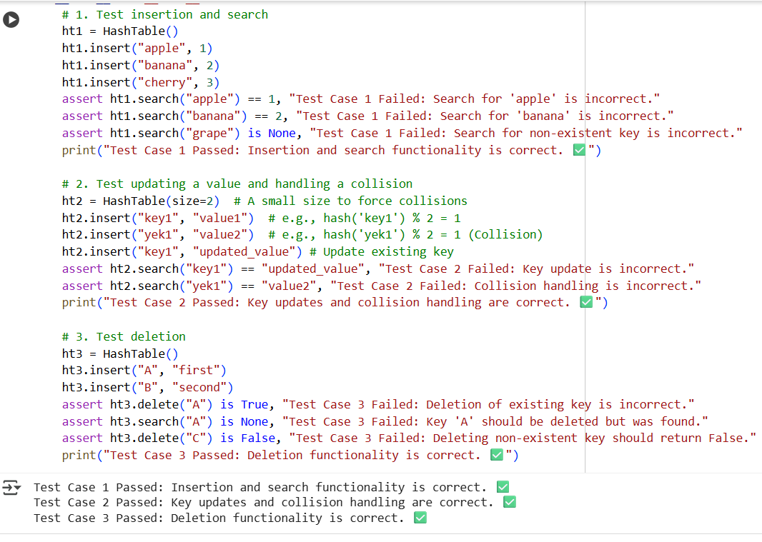

Task Description #6 – Graph Representation
Task: Use AI to implement a graph using an adjacency list.
Sample Input Code:
class Graph:
pass
Expected Output:
- Graph with methods to add vertices, add edges, and display connections.
Prompt: Write a Python Graph class using adjacency list. Add methods to add vertices, add edges, and display connections. Add docstrings and 3 assert test cases.
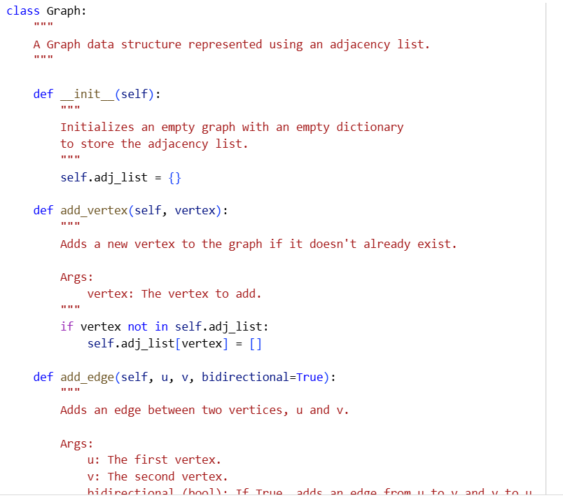

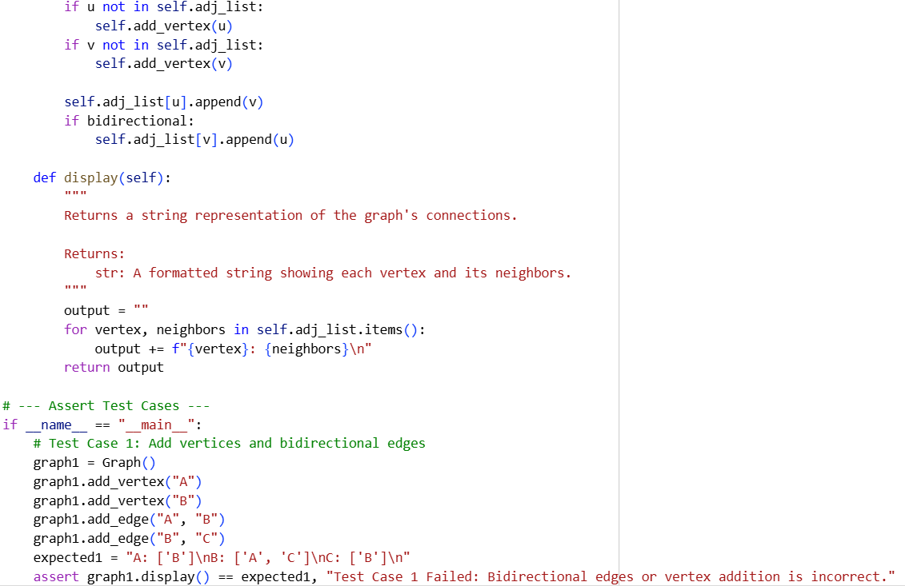

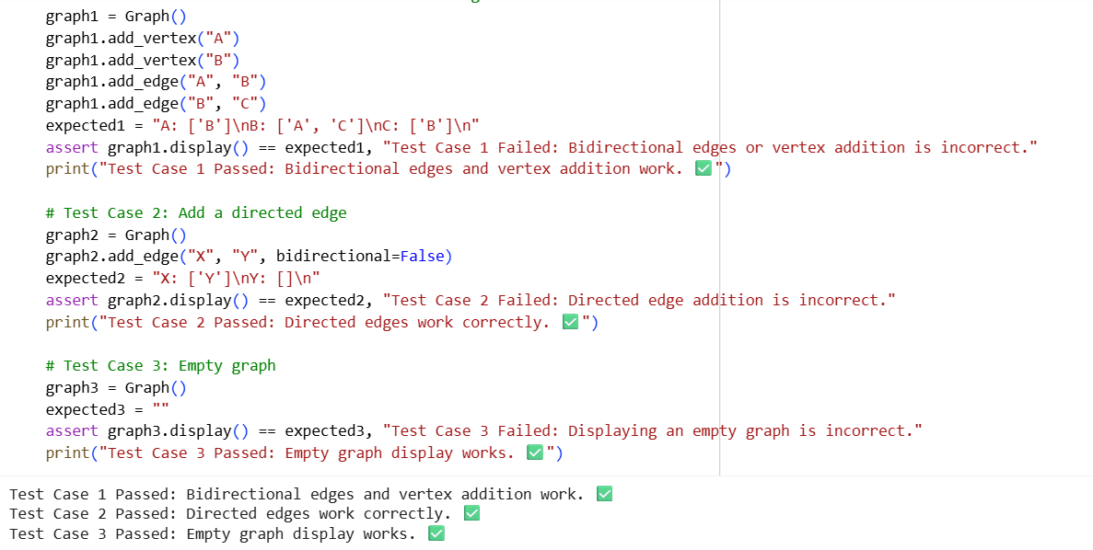

Task Description #7 – Priority Queue
Task: Use AI to implement a priority queue using Python’s heapq module.
Sample Input Code:
class PriorityQueue:
pass
Expected Output:
Implementation with enqueue (priority), dequeue (highest priority), and display methods

Prompt: Write a Python PriorityQueue class using heapq. Implement enqueue (with priority), dequeue (highest priority), and display methods. Add docstrings and 3 assert test cases.
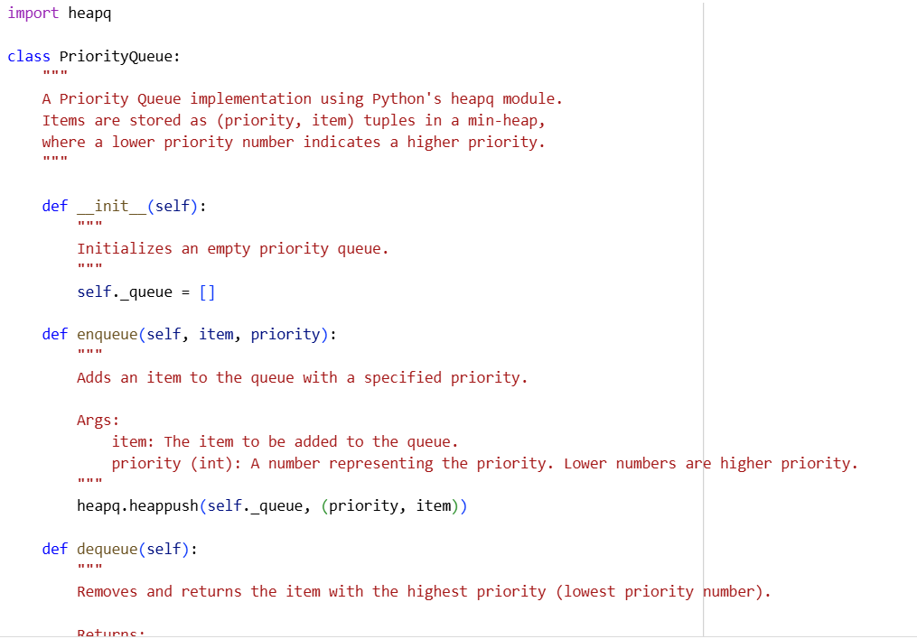

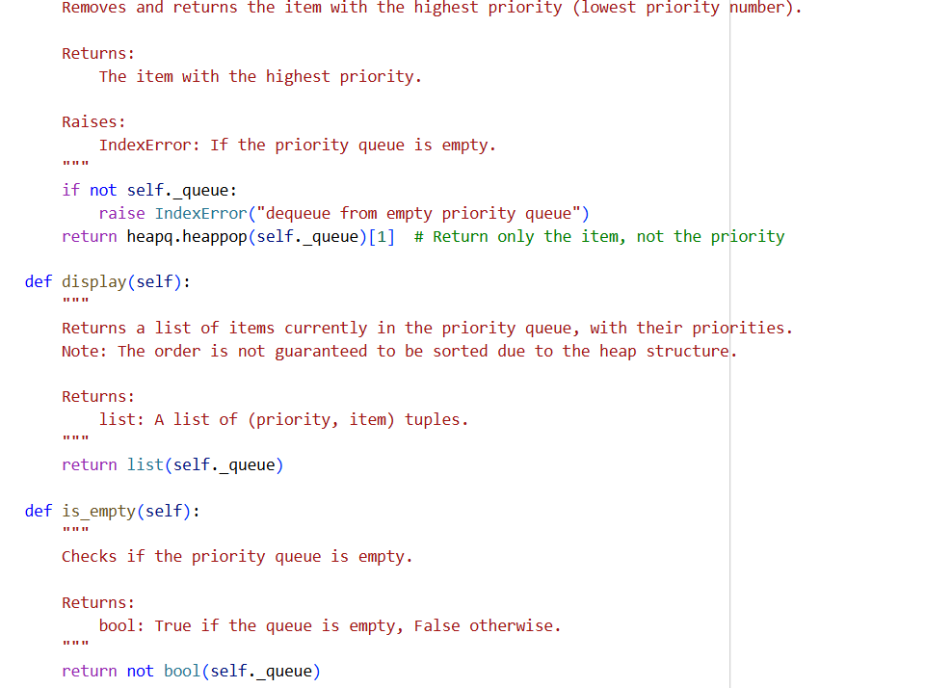

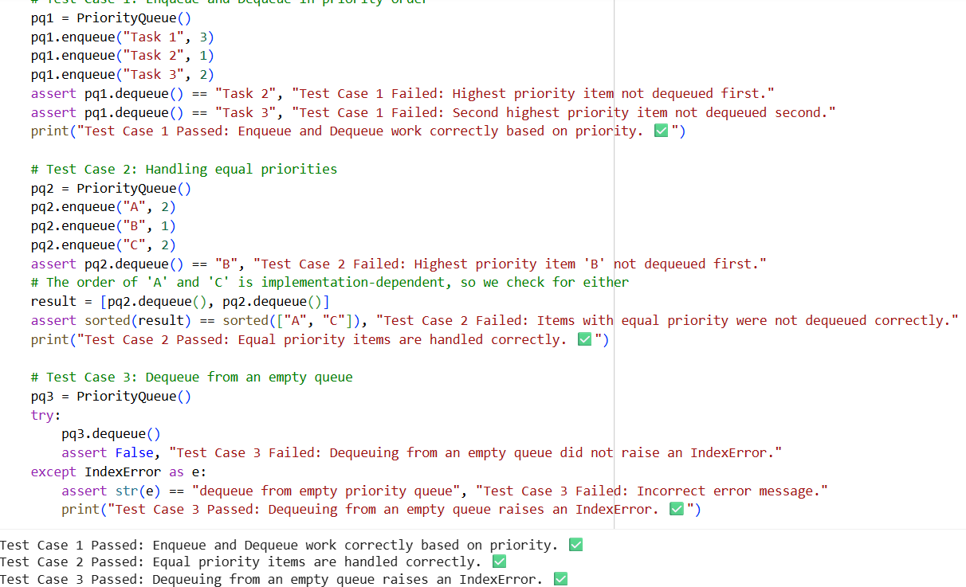

Task Description #8 – Deque
Task: Use AI to implement a double-ended queue using collections.deque.
Sample Input Code:
class DequeDS:
pass
Expected Output:
Insert and remove from both ends with docstrings.

Prompt: Write a Python DequeDS class using collections.deque. Implement insert/remove from both ends. Add docstrings and 3 assert test cases
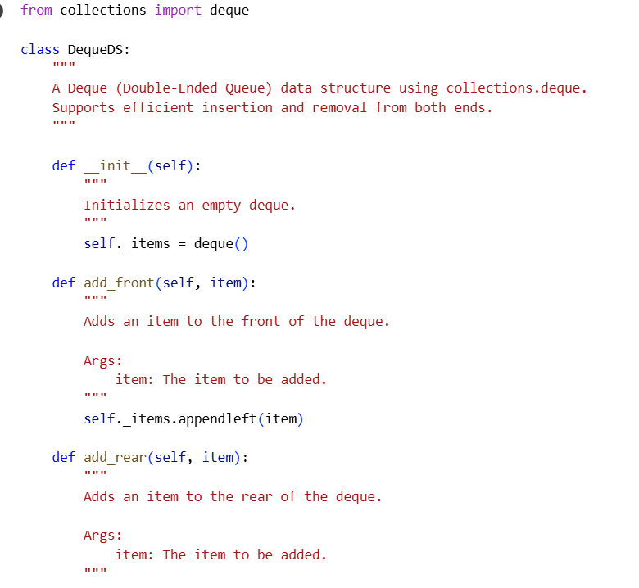

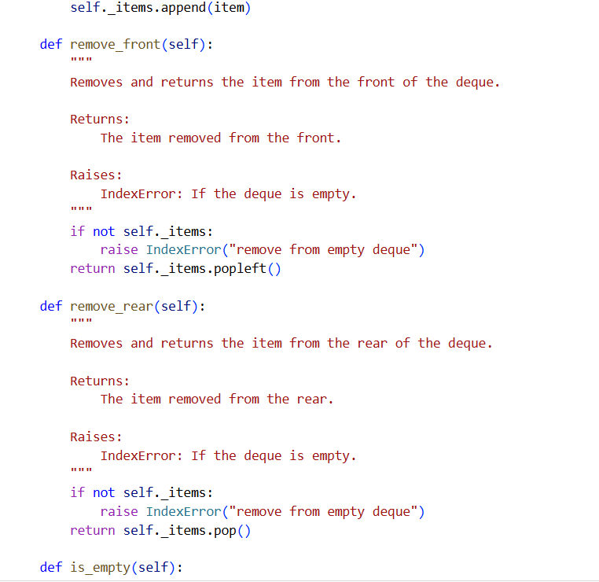





Task Description #9 – AI-Generated Data Structure Comparisons
Task: Use AI to generate a comparison table of different data structures (stack, queue, linked list, etc.) including time complexities.
Sample Input Code:
# No code, prompt AI for a data structure comparison table
Expected Output:
A markdown table with structure names, operations, and complexities

Prompt: Generate a markdown table comparing Stack, Queue, Linked List, BST, Graph, Hash Table, Priority Queue, and Deque with time complexities.

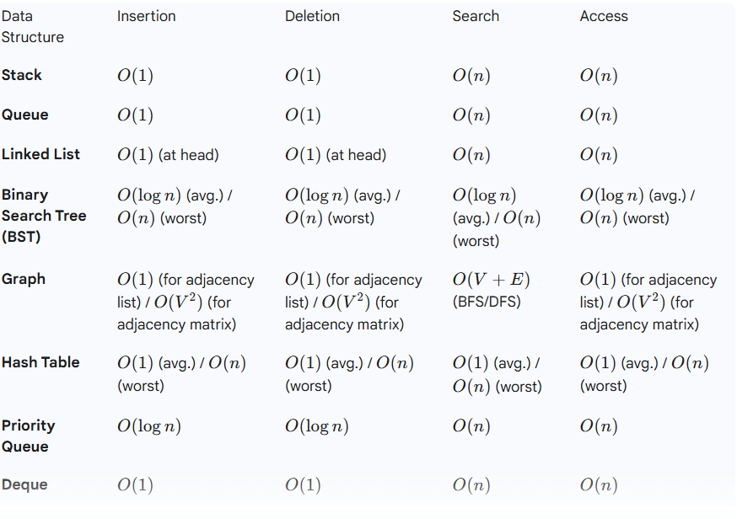
Task Description #10 Real-Time Application Challenge – Choose the Right Data Structure
Scenario:
Your college wants to develop a Campus Resource Management System that handles:
- Student Attendance Tracking – Daily log of students entering/exiting the campus.
- Event Registration System – Manage participants in events with quick search and removal.
- Library Book Borrowing – Keep track of available books and their due dates.
- Bus Scheduling System – Maintain bus routes and stop connections.
- Cafeteria Order Queue – Serve students in the order they arrive.
Student Task:
- For each feature, select the most appropriate data structure from the list below:
  - Stack
  - Queue
  - Priority Queue
  - Linked List
  - Binary Search Tree (BST)
  - Graph
  - Hash Table
  - Deque
- Justify your choice in 2–3 sentences per feature.
- Implement one selected feature as a working Python program with AI-assisted code generation.
Expected Output:
- A table mapping feature → chosen data structure → justification.
- A functional Python program implementing the chosen feature with comments and docstrings.
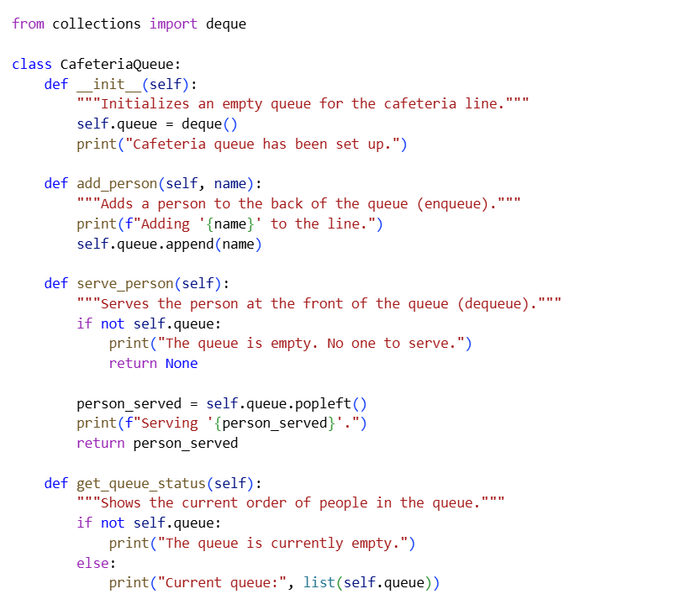

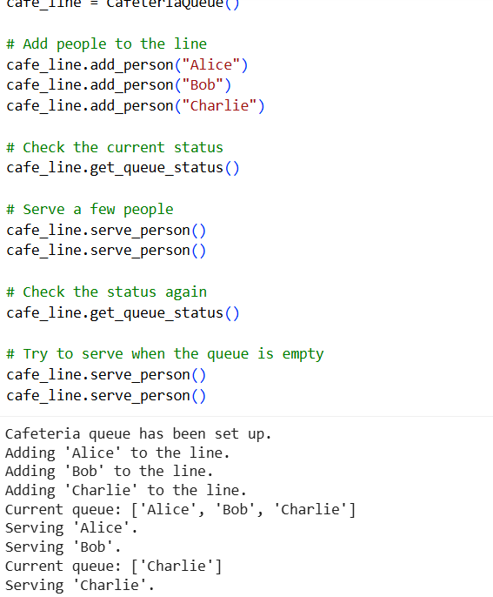

Observation and Justification:

For student attendance tracking, a linked list is most suitable since it allows us to keep adding daily entry and exit records in a simple, ordered way. For the event registration system, a hash table is ideal because it helps quickly find or remove participants without searching through the entire list. In the library, a binary search tree (BST) works best as it keeps books sorted and makes searching by title, ID, or due date efficient. For the bus scheduling system, a graph is the natural choice because bus stops and routes can be represented as connected points, making it easy to manage and find routes. Finally, in the cafeteria, a queue fits perfectly since it ensures students are served in the exact order they arrive, maintaining fairness.

