SCHOOL OF COMPUTER SCIENCE AND ARTIFICIAL INTELLIGENCE |  |  |  |  | DEPARTMENT OF COMPUTER SCIENCE ENGINEERING
ProgramName:B. Tech |  |  |  | Assignment Type: Lab |  |  | AcademicYear:2025-2026
CourseCoordinatorName |  |  |  | Venkataramana Veeramsetty
Instructor(s)Name |  |  |  | Dr. V. Venkataramana (Co-ordinator)  Dr. T. Sampath Kumar  Dr. Pramoda Patro  Dr. Brij Kishor Tiwari  Dr.J.Ravichander  Dr. Mohammand Ali Shaik  Dr. Anirodh Kumar  Mr. S.Naresh Kumar  Dr. RAJESH VELPULA  Mr. Kundhan Kumar  Ms. Ch.Rajitha  Mr. M Prakash  Mr. B.Raju  Intern 1 (Dharma teja)  Intern 2 (Sai Prasad)  Intern 3 (Sowmya)  NS_2 ( Mounika)
CourseCode |  |  | 24CS002PC215 | CourseTitle |  | AI Assisted Coding
Year/Sem |  |  | II/I | Regulation |  | R24
Date and Day  of Assignment |  |  | Week4 - Wednesday | Time(s)
Duration |  |  | 2 Hours | Applicableto  Batches
AssignmentNumber:9.3(Present assignment number)/24(Total number of assignments)
 | Q.No. | Question |  |  |  |  |  | ExpectedTime  to complete

 | 1 | Lab 8: Documentation Generation: Automatic documentation and code comments  Lab Objectives:  - To understand the importance of documentation and code comments in software development.  - To explore how AI-assisted coding tools can generate meaningful documentation and inline comments.  - To practice generating function-level and module-level docstrings automatically.  - To evaluate the quality, accuracy, and limitations of AI-generated documentation.  - To develop a small automated tool for documentation generation in Python..  Lab Outcomes (LOs):  After completing this lab, students will be able to:  - Apply AI-assisted coding tools to generate docstrings and inline comments for Python code.  - Critically analyze AI-generated documentation for correctness, completeness, and readability.  - Create structured documentation (function-level, module-level) following standard formats.  - Design and implement a mini documentation generator tool to automate code commenting and docstring creation.  Task Description#1 Basic Docstring Generation  - Write python function to return sum of even and odd numbers in the given list.  - Incorporate manual docstring in code with Google Style  - Use an AI-assisted tool (e.g., Copilot, Cursor AI) to generate a docstring describing the function.  - Compare the AI-generated docstring with your manually written one  Prompt : write a python function , to calculate the sum of even and odd numbers with user input  #MANUAL DOCSTRING : This function sums the even and odd numbers from the user input …  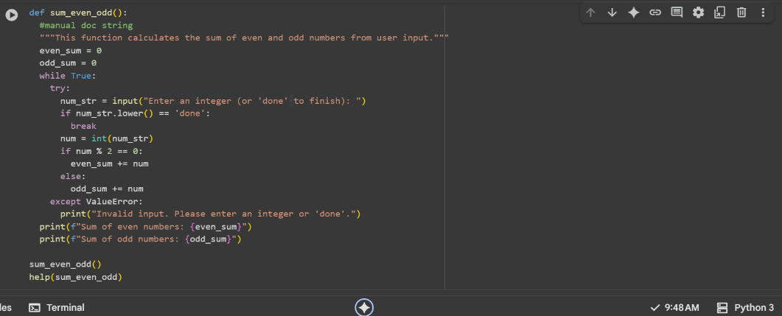  # AI-GENERATED DOCSTRING : This Function Calculates the Sum Of Even and Odd numbers from the user input …  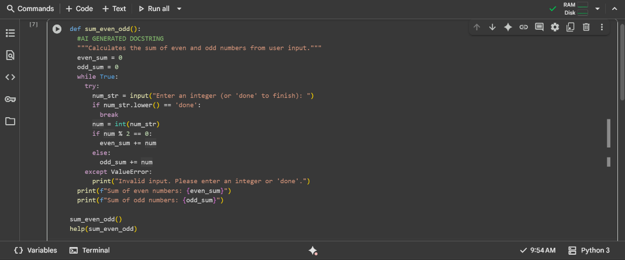  Expected Outcome#1: Students understand how AI can produce function-level  documentation.  #COMPARISON/OBSERVATION :  Docstring manual : A simple but grammatically flawed description that uses the most basic verb to state the purpose.  Docstring AI : A marginally more descriptive version due to its phrasing, but it shares the exact same grammatical and structural flaws.  Task Description#2 Automatic Inline Comments  - Write python program for sru_student class with attributes like name, roll no., hostel_status and fee_update method and display_details method.  - Write comments manually for each line/code block  - Ask an AI tool to add inline comments explaining each line/step.  - Compare the AI-generated comments with your manually written one.  prompt :  write python program for SRU_student class with attributes like name,rolln,hostel_status and fee update method and display details method , with user input . without any comments  #MANUALLY ENTERED COMMENTS FOR THE CODE  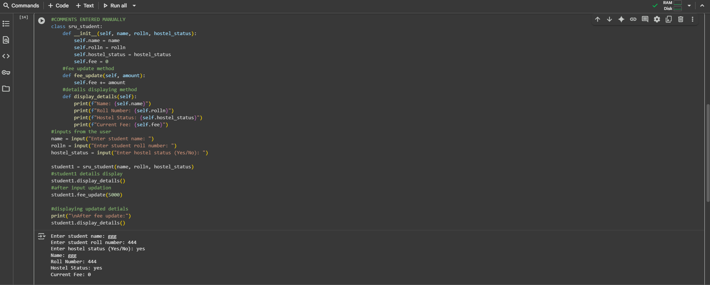  #AI-GENERATED COMMENTS FOR THE CODE  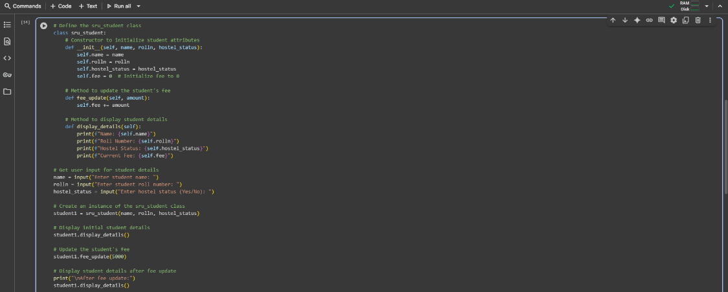  Expected Output#2: Students critically analyze AI-generated code comments.  #COMPARISON/OBSERVATION :  Manual comments : They state what the code is doing in the simplest terms but offer no context or purpose.  AI Generated comments : They clearly explain the purpose of the code block that follows. For example, Method to update the student's fee is much clearer than just , fee update method.  Task Description#3  - Write a Python script with 3–4 functions (e.g., calculator: add, subtract, multiply, divide).  - Incorporate manual docstring in code with NumPy Style  - Use AI assistance to generate a module-level docstring + individual function docstrings.  - Compare the AI-generated docstring with your manually written one.  Prompt :  write a python program with functions (calculator , add , subtract , multiply, divide) with user input and without comments  #MANUAL DOCSTRING : """ This function performs an arithmetic operation with the desired user input and  parameters are passed to the function with :  num1 and num2  then the function returns the value after completing the operation ...  """  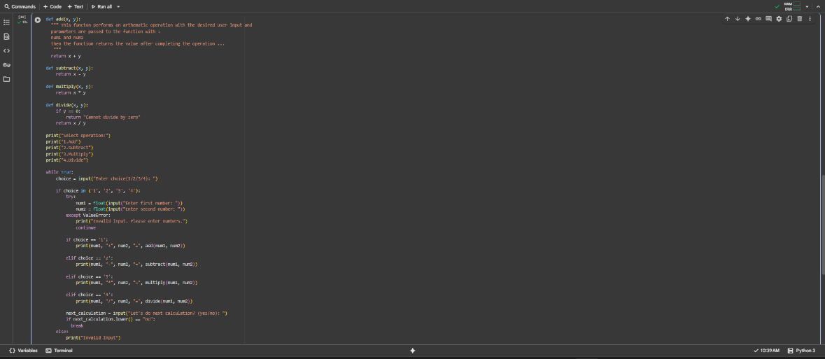  #AI-GENERATED DOCSTRING : """  Adds two numbers.  Parameters  ----------  x : float  The first number.  y : float  The second number.  Returns  -------  float  The sum of x and y.  """  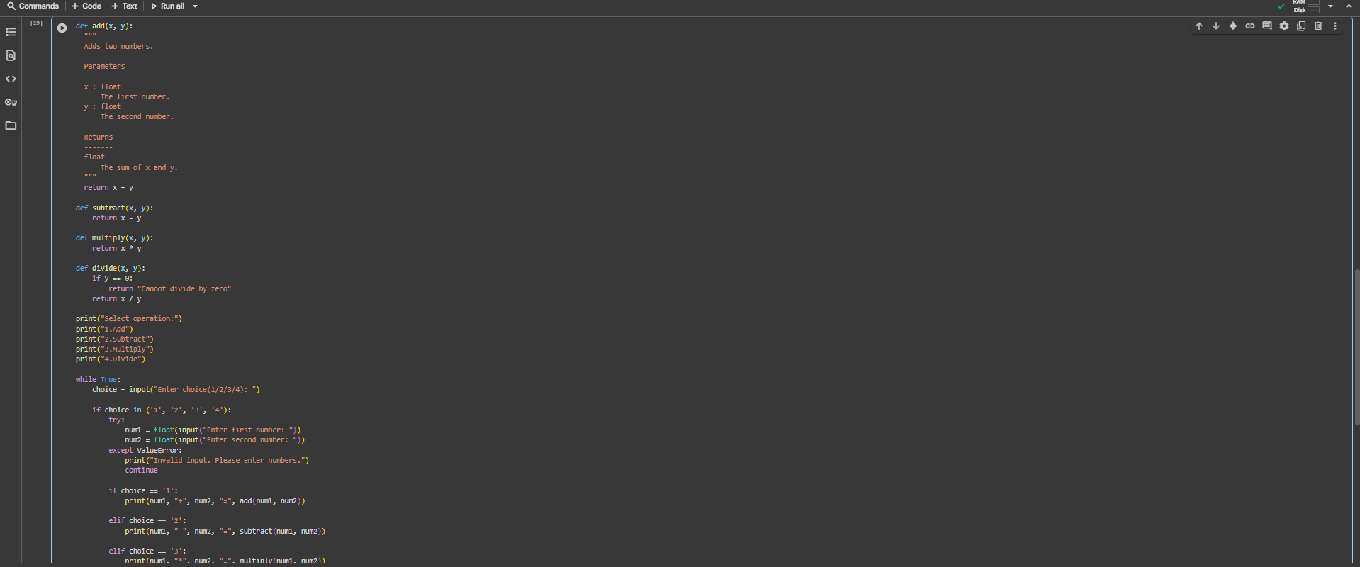  Expected Output#3: Students learn structured documentation for multi-function scripts  #COMPARISON / OBSERVATION :  The AI's docstring is a helpful guide that clearly explains just one part of the code. It shows you what information to put in and what answer you will get out. The handmade docstring, however, is messy because it wrongly tries to talk about the entire program at once. So, the first one is a good set of instructions, while the second is just a confusing note that doesn't really help.  Push documentation whole workspace as .md file in GitHub Repository  Note: Report should be submitted a word document for all tasks in a single document with prompts, comments & code explanation, and output and if required, screenshots | Week4 - Wednesday

