SCHOOL OF COMPUTER SCIENCE AND ARTIFICIAL INTELLIGENCE |  |  |  |  | DEPARTMENT OF COMPUTER SCIENCE ENGINEERING
Program Name: B. Tech |  |  |  | Assignment Type: Lab |  |  | Academic Year:2025-2026
Course Coordinator Name |  |  |  | Venkataramana Veeramsetty
Instructor(s) Name |  |  |  | Dr. V. Venkataramana (Co-ordinator)  Dr. T. Sampath Kumar  Dr. Pramoda Patro  Dr. Brij Kishor Tiwari  Dr.J.Ravichander  Dr. Mohammand Ali Shaik  Dr. Anirodh Kumar  Mr. S.Naresh Kumar  Dr. RAJESH VELPULA  Mr. Kundhan Kumar  Ms. Ch.Rajitha  Mr. M Prakash  Mr. B.Raju  Intern 1 (Dharma teja)  Intern 2 (Sai Prasad)  Intern 3 (Sowmya)  NS_2 ( Mounika)
Course Code |  |  | 24CS002PC215 | Course Title |  | AI Assisted Coding
Year/Sem |  |  | II/I | Regulation |  | R24
Date and Day  of Assignment |  |  | Week10 - Monday | Time(s)
Duration |  |  | 2 Hours | Applicable to  Batches
AssignmentNumber:20.1(Present assignment number)/24(Total number of assignments)
 | Q.No. | Question |  |  |  |  |  | Expected Time  to complete
 | 1 | Lab 20 – Security Testing: Identifying Vulnerabilities in AI-Generated Code  Lab Objectives:  - Understand how to test AI-generated code for common security vulnerabilities.  - Learn to apply secure coding principles while analyzing AI outputs.  - Practice detecting risks such as SQL injection, XSS, hardcoded credentials, and weak encryption.  - Enhance code reliability and safety by using AI for secure refactoring.  Task 1 – Input Validation Check  Task:  Analyze an AI-generated Python login script for input validation vulnerabilities.  Instructions:  - Prompt AI to generate a simple username-password login program.  - Review whether input sanitization and validation are implemented.  - Suggest secure improvements (e.g., using re for input validation)  Prompt : generate python script of a simple username-password login program.  And Suggest secure improvements for this code…  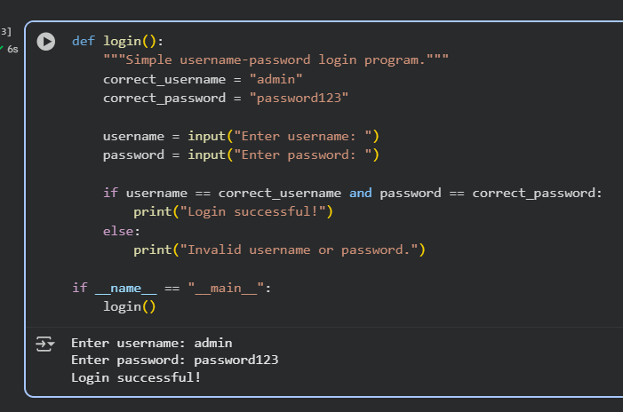  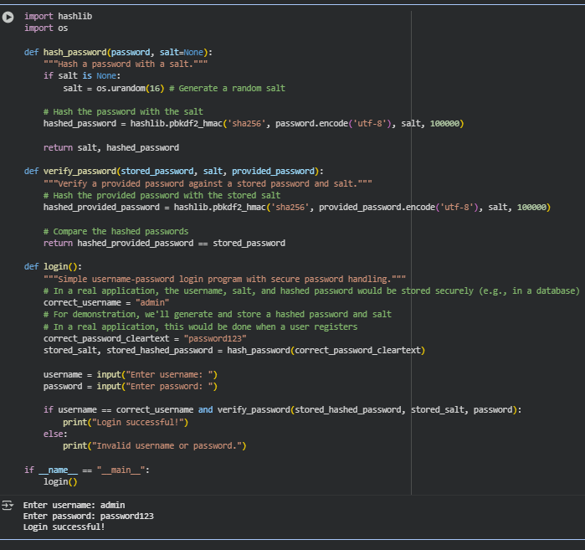  Expected Output:  - A secure version of the login script with proper input validation.  Task 2 – SQL Injection Prevention  Task:  Test an AI-generated script that performs SQL queries on a database.  Instructions:  - Ask AI to generate a Python script using SQLite/MySQL to fetch user details.  - Identify if the code is vulnerable to SQL injection (e.g., using string concatenation in queries).  - Refactor using parameterized queries (prepared statements).  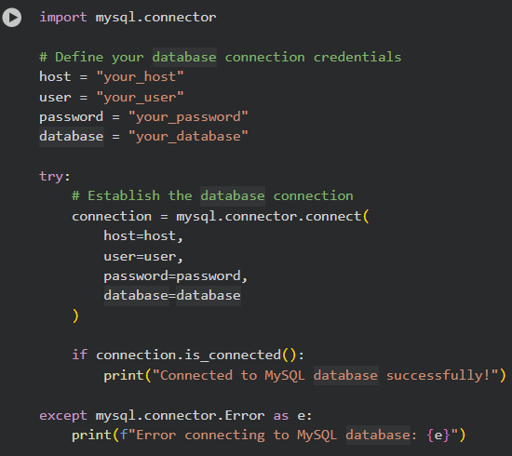  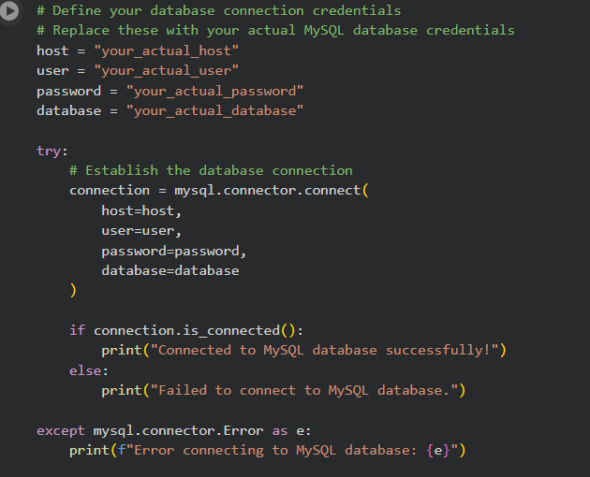  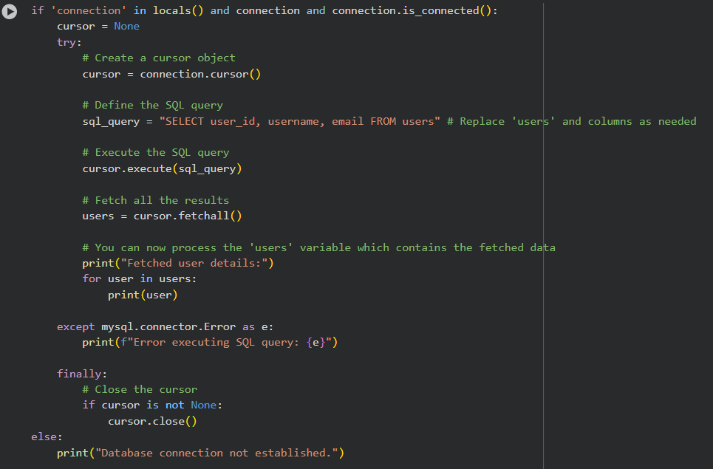  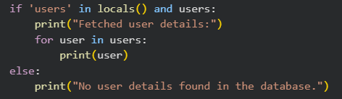  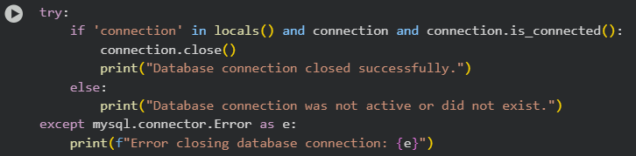  Expected Output:  - A secure database query script resistant to SQL injection.  Task 3 – Cross-Site Scripting (XSS) Check  Task:  Evaluate an AI-generated HTML form with JavaScript for XSS vulnerabilities.  Instructions:  - Ask AI to generate a feedback form with JavaScript-based output.  - Test whether untrusted inputs are directly rendered without escaping.  - Implement secure measures (e.g., escaping HTML entities, using CSP).  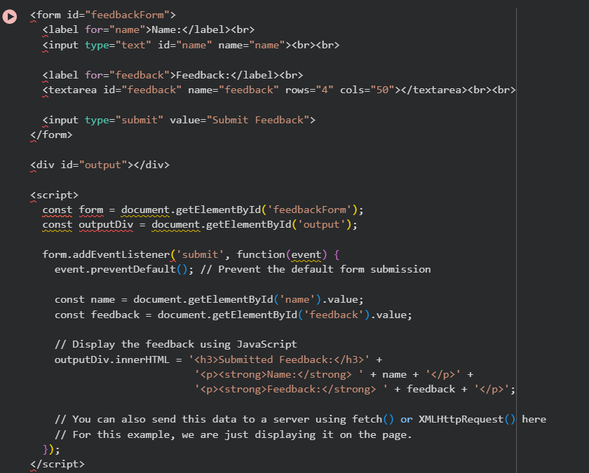  Rescripted with good security measures .  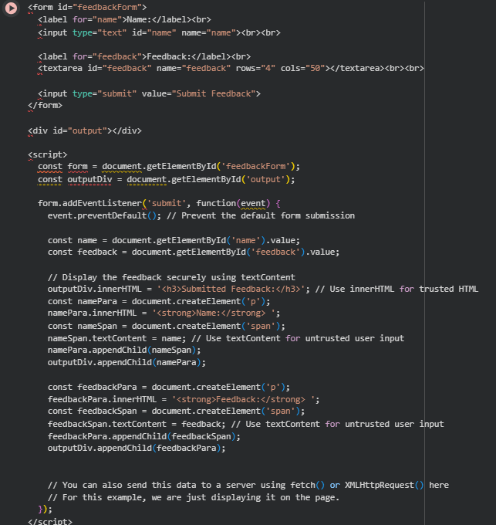  Expected Output:  - A secure form that prevents XSS attacks.  Task 4 – Real-Time Application: Security Audit of AI-Generated Code  Scenario:  Students pick an AI-generated project snippet (e.g., login form, API integration, or file upload).  Instructions:  - Perform a security audit to detect possible vulnerabilities.  - Prompt AI to suggest secure coding practices to fix issues.  - Compare insecure vs secure versions side by side.  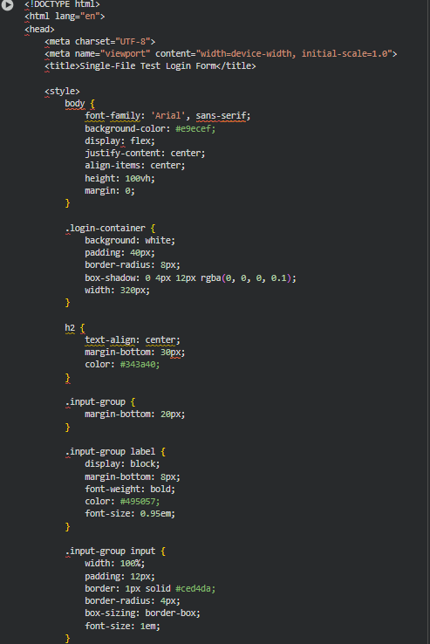  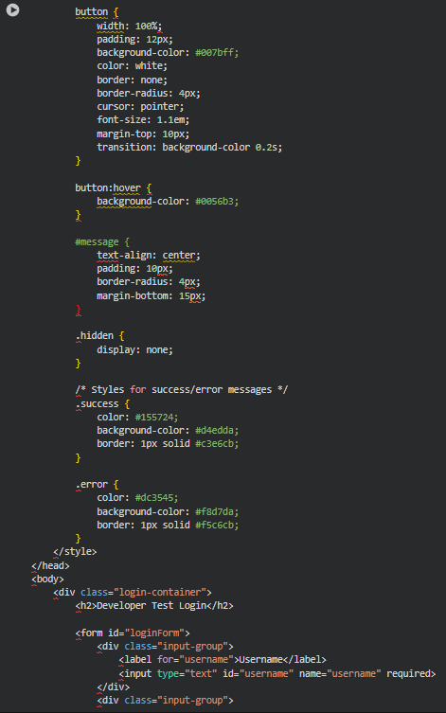  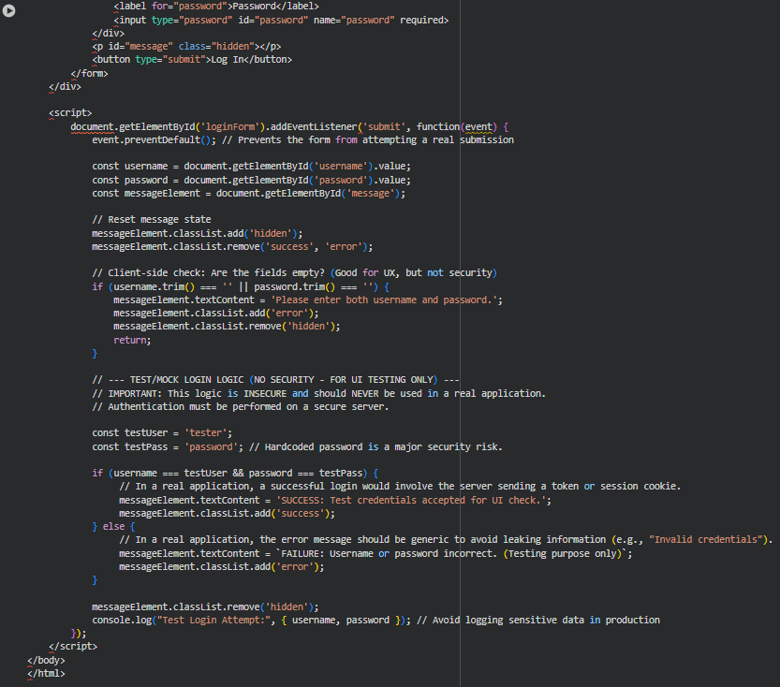  Expected Output:  - A security-audited code snippet with documented vulnerabilities and fixes.  Insecure Client-Side Approach  - Where logic runs: In the user's browser (client-side JavaScript).  - Credential storage: Often hardcoded or easily accessible in the client-side code.  - Authentication process: Browser compares entered credentials directly against hardcoded or visible values.  - Security: Extremely insecure. Credentials and logic are exposed. Easily bypassed. Vulnerable to tampering and credential theft. Should NEVER be used for real authentication.  - Purpose (in this case): To demonstrate the front-end UI and user experience of a login form without needing a backend server setup.  Secure Server-Side Approach  - Where logic runs: On a secure server application.  - Credential storage: Stored securely on the server, typically in a database using strong hashing and salting techniques.  - Authentication process: Browser sends entered credentials (securely via HTTPS) to the server. The server retrieves the stored hash and salt for the username, hashes the provided password using the stored salt, and compares the resulting hash to the stored hash.  - Security: Much more secure. Authentication logic and credentials are not exposed to the user. Protected against simple bypassing and credential theft attempts (assuming proper server-side implementation).  - Purpose: To verify user identity securely and authorize access to protected resources.  ✅ Deliverables (For All Tasks)  - AI-generated prompts for code and test case generation.  - At least 3 assert test cases for each task.  - AI-generated initial code and execution screenshots.  - Analysis of whether code passes all tests.  - Improved final version with inline comments and explanation.  - Compiled report (Word/PDF) with prompts, test cases, assertions, code, and output. |  |  |  |  |  | Week10 - Monday

