SCHOOL OF COMPUTER SCIENCE AND ARTIFICIAL INTELLIGENCE |  |  |  |  | DEPARTMENT OF COMPUTER SCIENCE ENGINEERING
Program Name: B. Tech |  |  |  | Assignment Type: Lab |  |  | Academic Year:2025-2026
Course Coordinator Name |  |  |  | Venkataramana Veeramsetty
Instructor(s) Name |  |  |  | Dr. V. Venkataramana (Co-ordinator)  Dr. T. Sampath Kumar  Dr. Pramoda Patro  Dr. Brij Kishor Tiwari  Dr.J.Ravichander  Dr. Mohammand Ali Shaik  Dr. Anirodh Kumar  Mr. S.Naresh Kumar  Dr. RAJESH VELPULA  Mr. Kundhan Kumar  Ms. Ch.Rajitha  Mr. M Prakash  Mr. B.Raju  Intern 1 (Dharma teja)  Intern 2 (Sai Prasad)  Intern 3 (Sowmya)  NS_2 ( Mounika)
Course Code |  |  | 24CS002PC215 | Course Title |  | AI Assisted Coding
Year/Sem |  |  | II/I | Regulation |  | R24
Date and Day  of Assignment |  |  | Week5 - Monday | Time(s)
Duration |  |  | 2 Hours | Applicable to  Batches
AssignmentNumber: 9.1(Present assignment number)/24(Total number of assignments)
 | Q.No. | Question |  |  |  |  |  | Expected Time  to complete
 | 1 | Lab 17– AI for Data Processing: Data cleaning and preprocessing scripts  The objective of this lab is to enable students to understand and apply AI-assisted coding tools for automating and enhancing data preprocessing tasks. Students will:  - Gain practical experience in cleaning, transforming, and standardizing real-world datasets with issues such as missing values, duplicates, outliers, inconsistent formats, and noisy text.  - Learn to leverage AI coding assistants to generate preprocessing scripts, while critically evaluating and refining the AI-generated code for accuracy, efficiency, and best practices.  - Develop the ability to design end-to-end preprocessing pipelines that prepare raw data for downstream machine learning and analytics applications.  - Build confidence in combining human expertise with AI assistance, ensuring data quality and integrity in diverse domains such as customer feedback, healthcare, and finance.  Lab Question 1: Customer Feedback Dataset  You are given a CSV file containing customer feedback collected from an e-commerce website. The dataset includes columns: customer_id, feedback_text, rating, and date. However, the file has many missing values, typos, and inconsistent date formats.  - Task 1: Use an AI-assisted coding tool to generate a script that detects and fills missing rating values with the column’s median and standardizes the date column into YYYY-MM-DD format.  prompt : generate python script that detects and fills missing rating values with the column’s median and standardizes the date column into YYYY-MM-DD format . check for errors  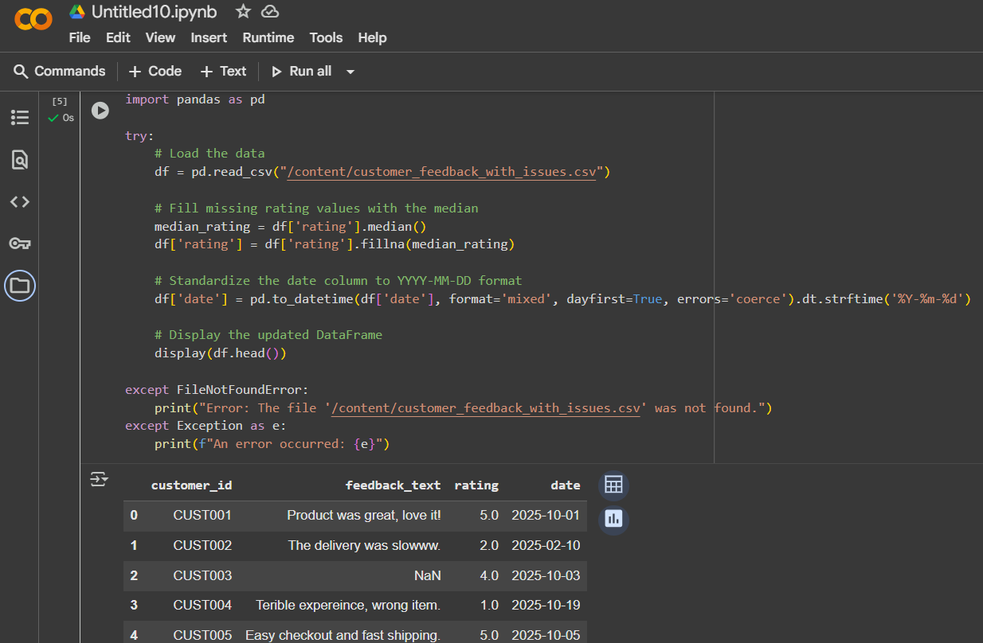  - Task 2: Clean the feedback_text column by removing stopwords, correcting common spelling mistakes, and converting text to lowercase using AI suggestions. Compare the AI-generated preprocessing code with your manually written version.  Prompt :  Clean the feedback_text column by removing stopwords, correcting common spelling mistakes, and converting text to lowercase .  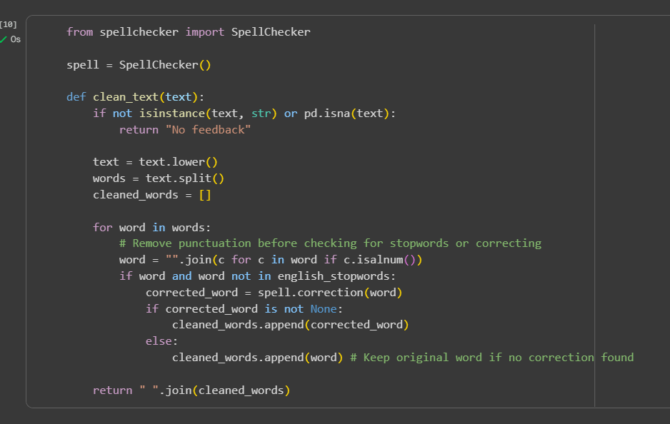  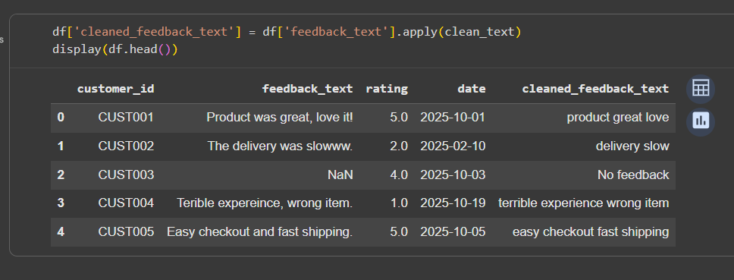  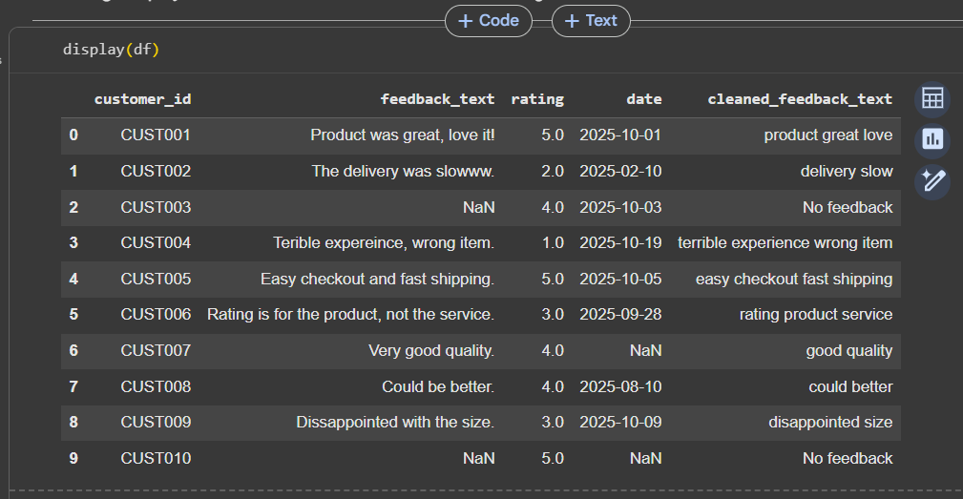  Comparison / summary :  Automated cleaning using libraries like NLTK and PySpellchecker is significantly faster and more consistent than manual cleaning. It allows for efficient processing of large datasets by applying predefined rules and corrections systematically. Manual cleaning is time consuming, prone to human error, and not scalable for large volumes of text. The automated approach ensures standardization and reproducibility of the cleaning process. While initial setup is required, the long-term benefits in terms of speed and accuracy are substantial.  Lab Question 2: Medical Records Dataset  A hospital provides you with a dataset of anonymized medical records containing attributes like patient_id, age, gender, blood_pressure, and cholesterol. Some columns include outliers and inconsistent categorical labels (e.g., Male, M, male).  - Task 1: Write a script (with AI assistance) to detect and handle outliers in the blood_pressure column using statistical methods (e.g., IQR or z-score).  Prompt :  write a python code to detect and handle outliers in the blood_pressure column using statistical methods (e.g., IQR or z-score)  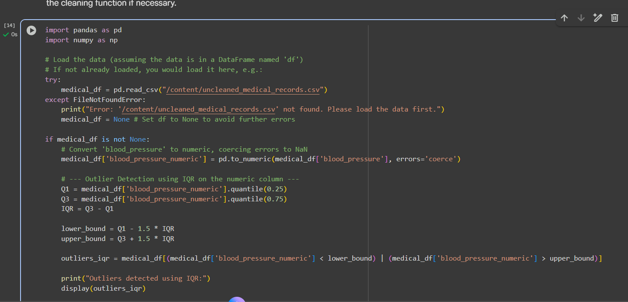  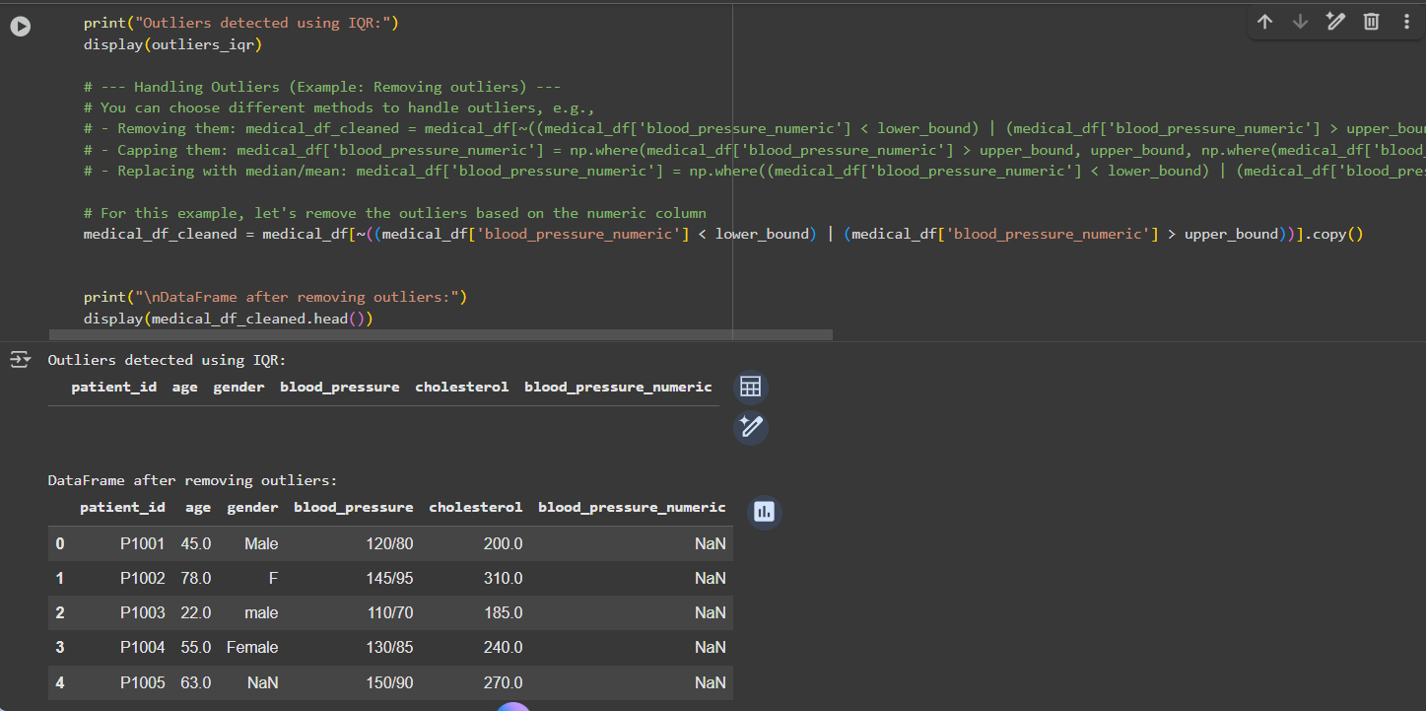  - Task 2: Standardize categorical values in the gender column and encode them into numeric form. Let the AI-assisted coding tool propose the preprocessing pipeline, then refine the pipeline manually based on your understanding.  - Prompt : Standardize categorical values in the gender column and encode them into numeric form …  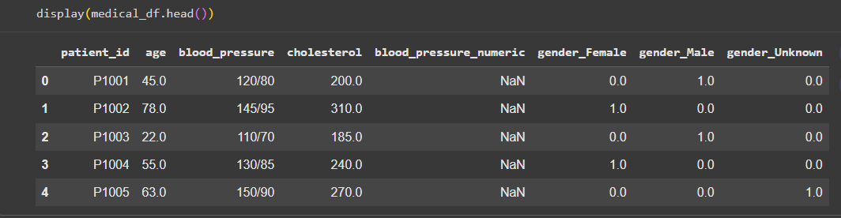  Lab Question 3: Financial Transactions Dataset  A bank gives you transaction data with columns: transaction_id, amount, currency, timestamp, and merchant. The dataset contains multiple issues: different currency units (USD, INR, EUR), timestamps in various time zones, and duplicated rows.  - Task 1: Use AI-assisted coding to write a script that removes duplicate transactions and converts all amount values into a single currency (e.g., USD) using a provided conversion dictionary.  Prompt : write a script that removes duplicate transactions and converts all amount values into a single currency (e.g., USD) using a provided conversion dictionary give in single cell only total  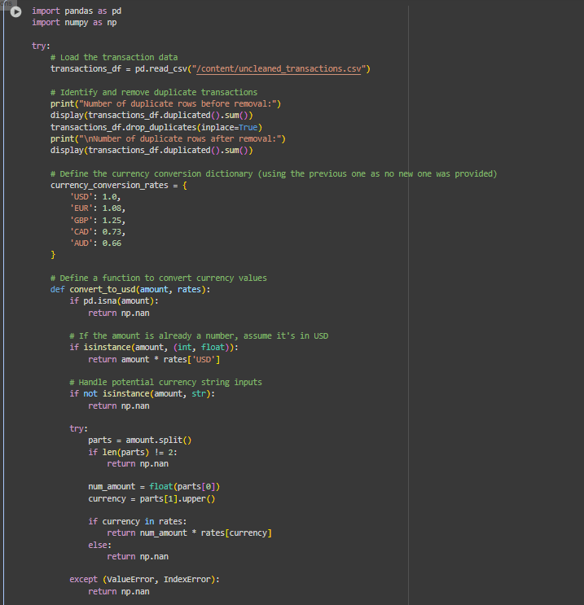  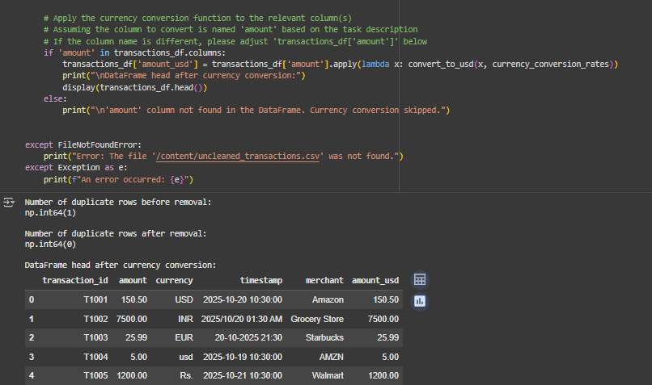  - Task 2: Normalize the timestamp column into UTC format and create a new column transaction_hour for downstream time-series analysis. Compare the AI’s preprocessing code against your own optimized version.  Prompt : Normalize the timestamp column into UTC format and create a new column transaction_hour for downstream time-series analysis ... give in single cell only code and output  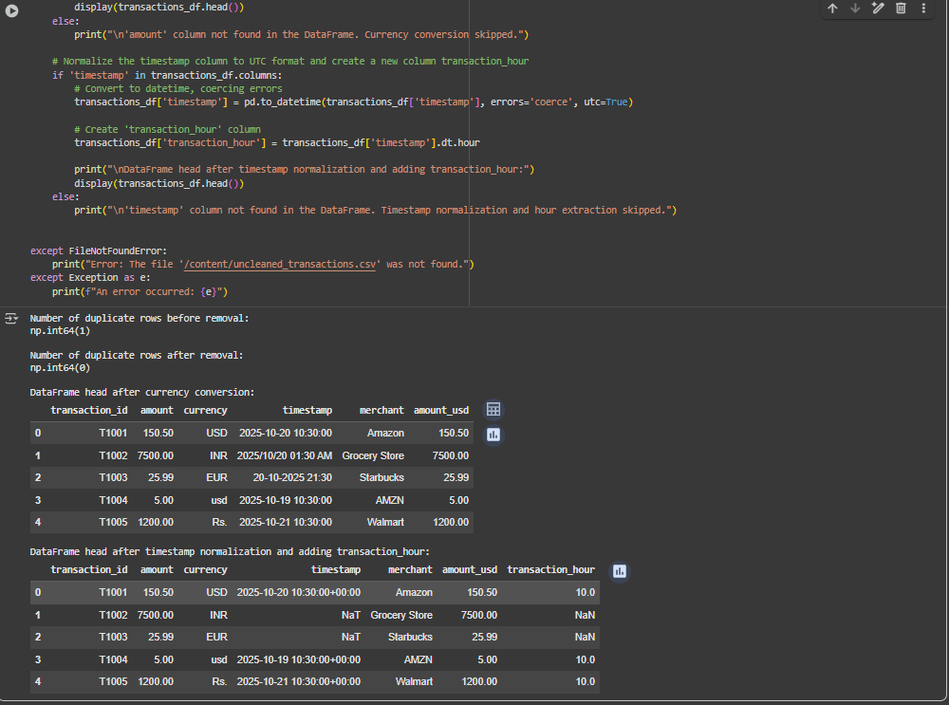 |  |  |  |  |  | Week 9- Monday

