SCHOOL OF COMPUTER SCIENCE AND ARTIFICIAL INTELLIGENCE |  |  |  |  | DEPARTMENT OF COMPUTER SCIENCE ENGINEERING
ProgramName:B. Tech |  |  |  | Assignment Type: Lab |  |  | AcademicYear:2025-2026
CourseCoordinatorName |  |  |  | Venkataramana Veeramsetty
Instructor(s)Name |  |  |  | 1. Dr. Mohammed Ali Shaik  2. Dr. T Sampath Kumar  3. Mr. S Naresh Kumar  4. Dr. V. Rajesh  5. Dr. Brij Kishore  6. Dr Pramoda Patro  7. Dr. Venkataramana  8. Dr. Ravi Chander  9. Dr. Jagjeeth Singh
CourseCode |  |  | 24CS002PC215 | CourseTitle |  | AI Assisted Coding
Year/Sem |  |  | II/I | Regulation |  | R24
Date and Day  of Assignment |  |  | Week2-Tuesday | Time(s)
Duration |  |  | 2 Hours | Applicableto  Batches |  | 24CSBTB01 To 24CSBTB39
AssignmentNumber:3.2(Present assignment number)/24(Total number of assignments)
 | Q.No. | Question |  |  |  |  |  | ExpectedTime  to complete
 | 1 | Lab 3: Prompt Engineering – Improving Prompts and Context Management  Lab Objectives:  - To understand how prompt structure and wording influence AI-generated code.  - To explore how context (like comments and function names) helps AI generate relevant output.  - To evaluate the quality and accuracy of code based on prompt clarity.  - To develop effective prompting strategies for AI-assisted programming.  Lab Outcomes (LOs):  After completing this lab, students will be able to:  - Generate Python code using Google Gemini in Google Colab.  - Analyze the effectiveness of code explanations and suggestions by Gemini.  - Set up and use Cursor AI for AI-powered coding assistance.  - Evaluate and refactor code using Cursor AI features.  - Compare AI tool behavior and code quality across different platforms.  Task Description#1  - Ask AI to write a function to calculate compound interest, starting with only the function name. Then add a docstring, then input-output example  Expected Output#1  - Comparison of AI-generated code styles  Answer:  prompt:  - By taking possible inputs give me a python code that can calculate compound interest using function name,then add a dockstring.  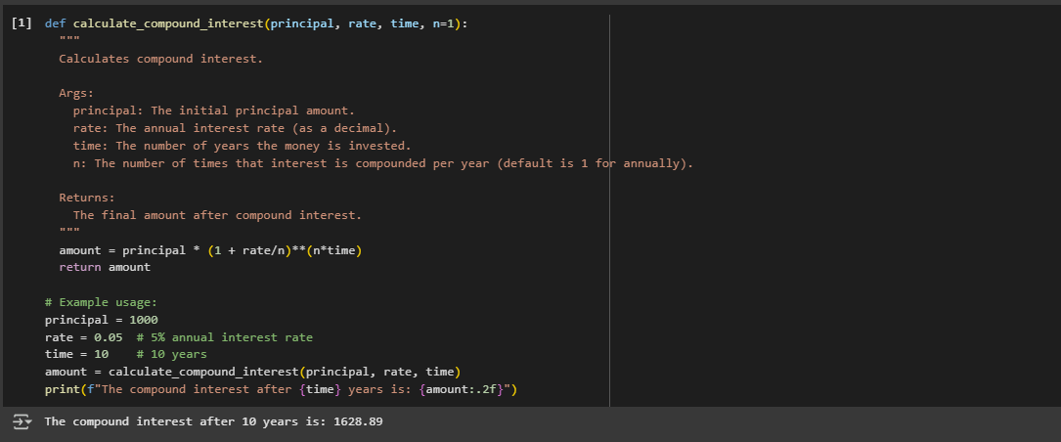  - Generate a program using function by adding a dockstring and then input output to calculate compound interest.  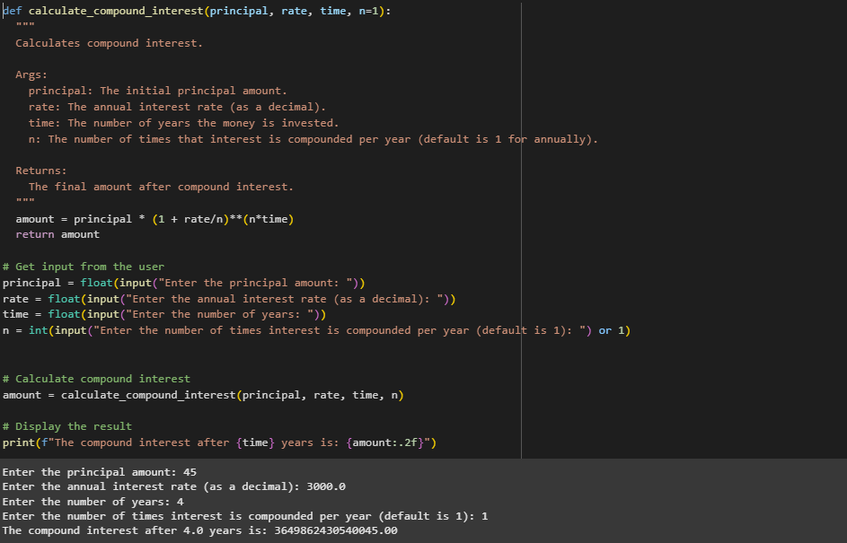  Task Description#2  - Do math stuff, then refine it to: # Write a function to calculate average, median, and mode of a list of numbers.  Expected Output#2  - AI-generated function evolves from unclear to accurate multi-statistical operation.  Answer:  Prompt:  - Using function write a program that calculate average,median, and mode by taking list of number.  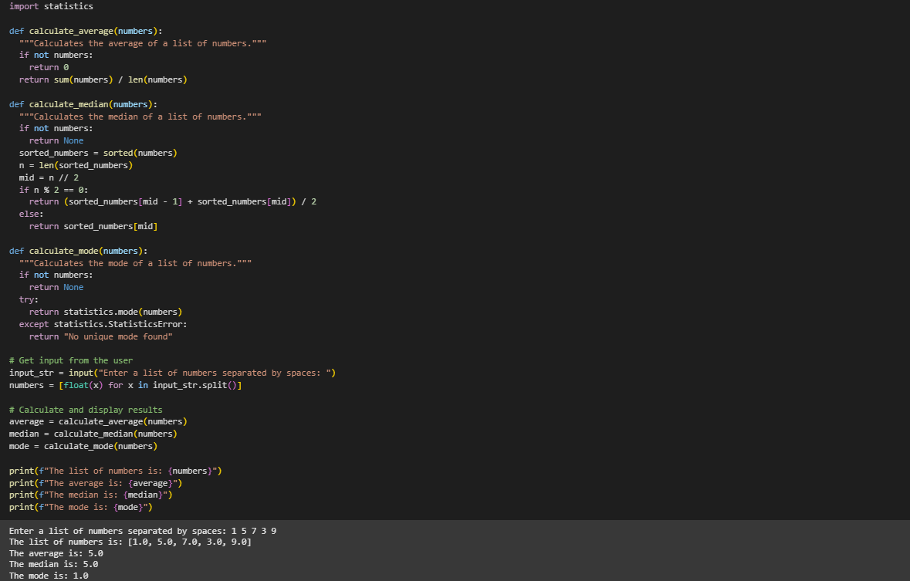  - Write a python code which can provide the values of average, median, mode after taking list values from the user separated by comas.  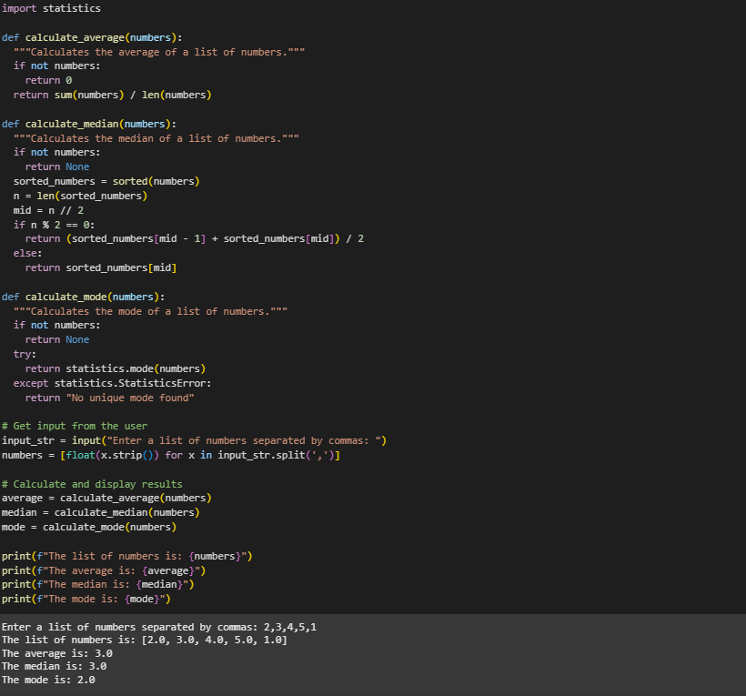  Task Description#3  - Provide multiple examples of input-output to the AI for convert_to_binary(num) function. Observe how AI uses few-shot prompting to generalize.  Expected Output#3  - Enhanced AI output with clearer prompts  Answer:  Prompt:  - Write a python code that can convert given integer value in binary number that can easily understandable by humans.  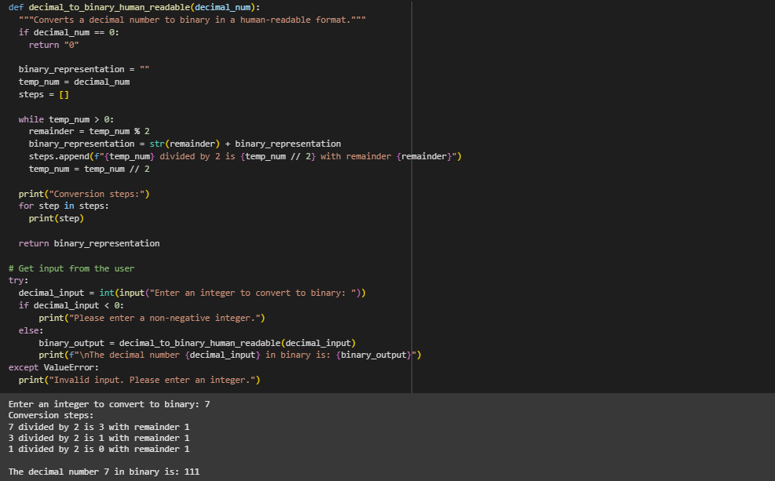  - Generate a python program that takes an integer value from user and converts it into binary number with detail explaination.  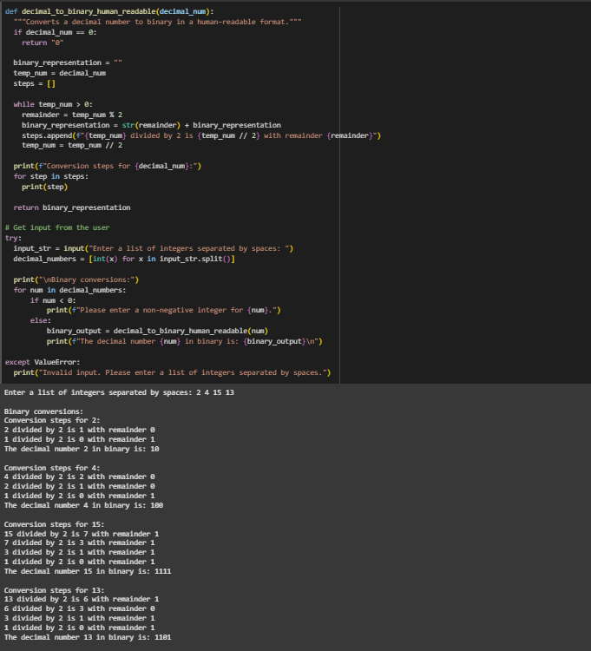  Task Description#4  - Create an user interface for an hotel to generate bill based on customer requirements  Expected Output#4  - Consistent functions with shared logic  Answer:  Prompt:  - Write a python code to generate a bill based on customer requirements by creating an user interface for hotel.  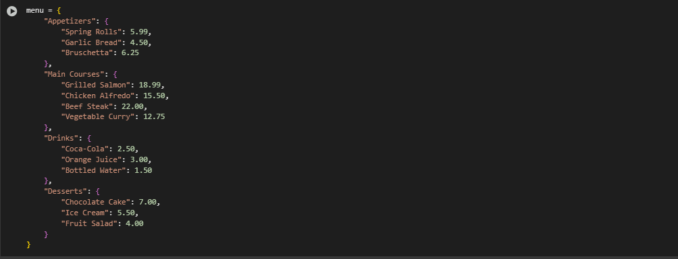  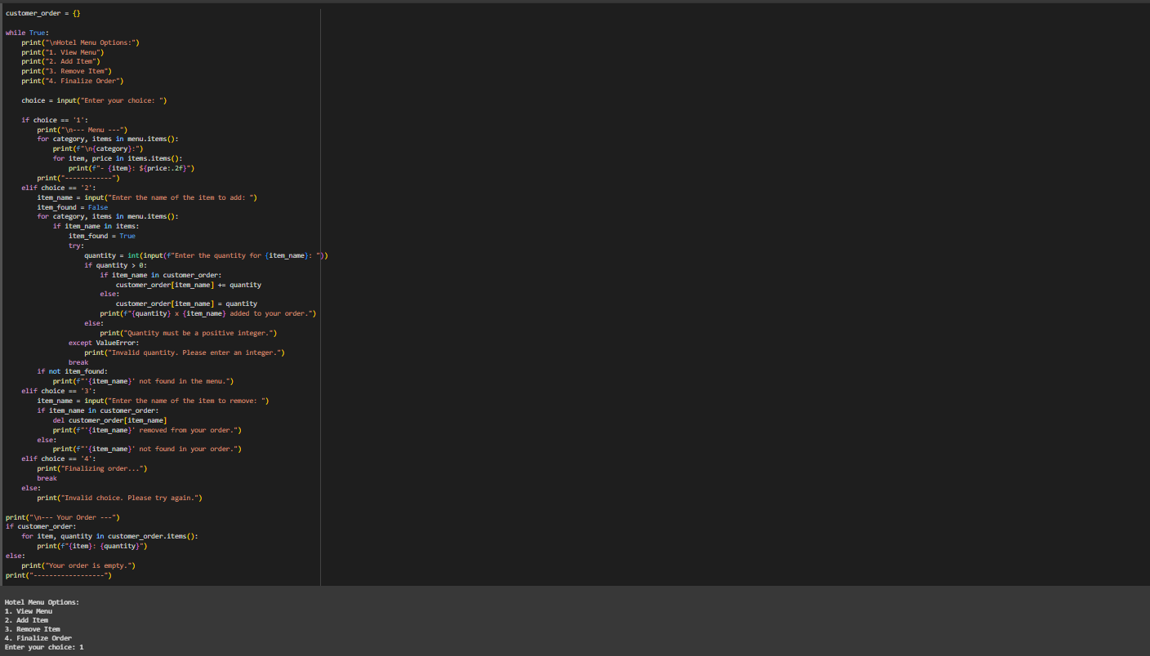  Task Description#5  - Analyzing Prompt Specificity: Improving Temperature Conversion Function with Clear Instructions  Expected Output#5  - Code quality difference analysis for various prompts  Answer:  Prompt:  - Write a python code using conversion function that takes an input from user in celsius and converts it to kelvin.  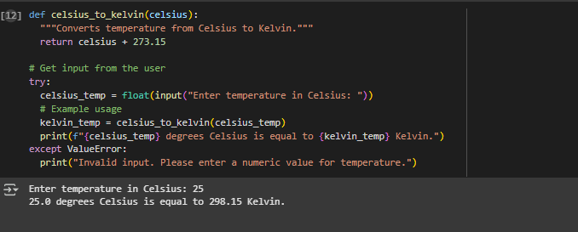  - Write a python code using conversion function that takess an input from user in fahrenheit and converts it into kelvin.  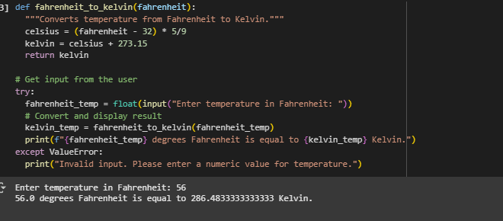  Note: Report should be submitted a word document for all tasks in a single document with prompts, comments & code explanation, and output and if required, screenshots  Evaluation Criteria: |  |  |  |  |  | 03.08.2025 EOD
  Criteria | Max Marks
  Task#1 | 0.5
  Task#2 | 0.5
  Task #3 | 0.5
  Task #4 | 0.5
  Task #5 | 0.5
  Total | 2.5 Marks

