SCHOOL OF COMPUTER SCIENCE AND ARTIFICIAL INTELLIGENCE |  |  |  |  | DEPARTMENT OF COMPUTER SCIENCE ENGINEERING
Program Name: B. Tech |  |  |  | Assignment Type: Lab |  |  | Academic Year:2025-2026
Course Coordinator Name |  |  |  | Venkataramana Veeramsetty
Instructor(s) Name
  Dr. V. Venkataramana (Co-ordinator)
  Dr. T. Sampath Kumar
  Dr. Pramoda Patro
  Dr. Brij Kishor Tiwari
  Dr.J.Ravichander
  Dr. Mohammand Ali Shaik
  Dr. Anirodh Kumar
  Mr. S.Naresh Kumar
  Dr. RAJESH VELPULA
  Mr. Kundhan Kumar
  Ms. Ch.Rajitha
  Mr. M Prakash
  Mr. B.Raju
  Intern 1 (Dharma teja)
  Intern 2 (Sai Prasad)
  Intern 3 (Sowmya)
  NS_2 ( Mounika)
Course Code |  |  | 24CS002PC215 | Course Title |  | AI Assisted Coding
Year/Sem |  |  | II/I | Regulation |  | R24
Date and Day  of Assignment |  |  | Week6 - Monday | Time(s)
Duration |  |  | 2 Hours | Applicable to  Batches
AssignmentNumber:12.1(Present assignment number)/24(Total number of assignments)
 | Q.No. | Question |  |  |  |  |  | Expected Time  to complete
 | 1 | Lab 12: Algorithms with AI Assistance – Sorting, Searching, and Optimizing Algorithms  Lab Objectives:  - Apply AI-assisted programming to implement and optimize sorting and searching algorithms.  - Compare different algorithms in terms of efficiency and use cases.  - Understand how AI tools can suggest optimized code and complexity improvements.  Task Description #1 (Sorting – Merge Sort Implementation)  - Task: Use AI to generate a Python program that implements the Merge Sort algorithm.  - Instructions:  - Prompt AI to create a function merge_sort(arr) that sorts a list in ascending order.  - Ask AI to include time complexity and space complexity in the function docstring.  - Verify the generated code with test cases.  - Expected Output:  - A functional Python script implementing Merge Sort with proper documentation.  Answer:  Prompt.  Write a python program which creates a function merge_sort(arr) which sorts a list in ascending order also include time complexity and space complexity and space complexity in the function dockstring which should be taking list from user and if I put invaid value in list then it shows invalid value and ask user again to enter the values.  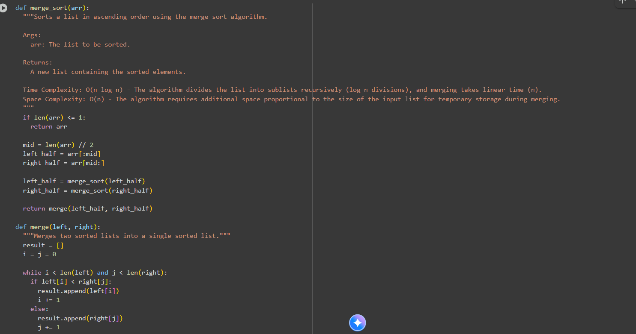  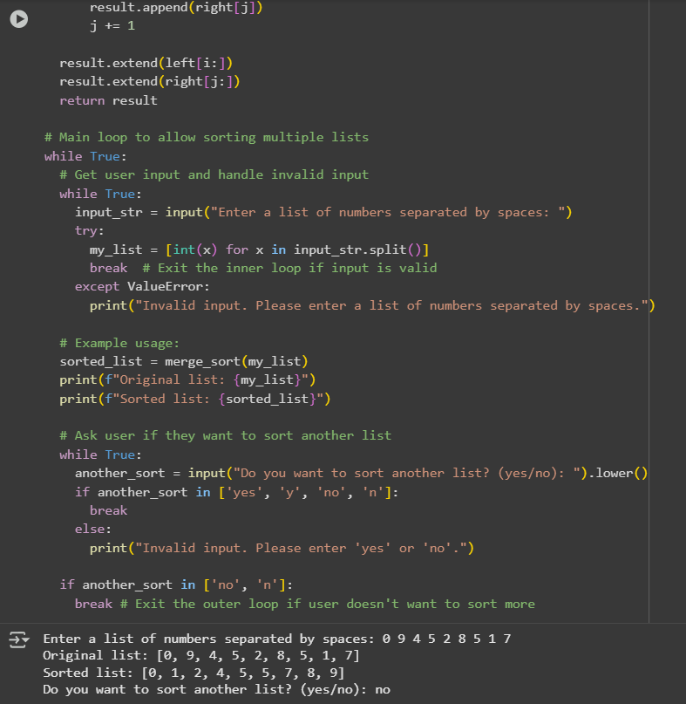  Task Description #2 (Searching – Binary Search with AI Optimization)  - Task: Use AI to create a binary search function that finds a target element in a sorted list.  - Instructions:  - Prompt AI to create a function binary_search(arr, target) returning the index of the target or -1 if not found.  - Include docstrings explaining best, average, and worst-case complexities.  - Test with various inputs.  - Expected Output:  - Python code implementing binary search with AI-generated comments and docstrings.  Answer:  Prompt.  Wrtie a python program that generates a binary search function that finds a target element in a sorted list by creating function binary search(arr, target) and returning the index of the target without doing sorting of list or -1 if not found also include docstrings in simple words which will be explaining best, average, and worst case complexities and the code should be user input ask user again and again if the target element is not right or not found.  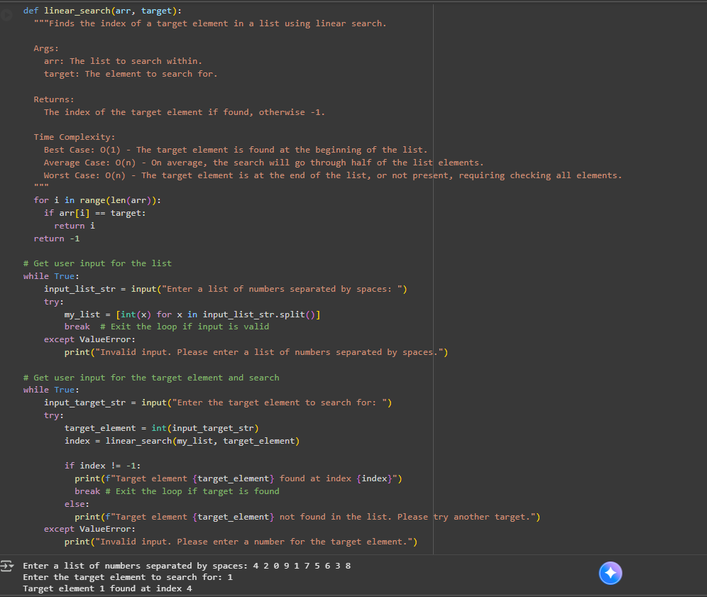  Task Description #3 (Real-Time Application – Inventory Management System)  - Scenario: A retail store’s inventory system contains thousands of products, each with attributes like product ID, name, price, and stock quantity. Store staff need to:  - Quickly search for a product by ID or name.  - Sort products by price or quantity for stock analysis.  - Task:  - Use AI to suggest the most efficient search and sort algorithms for this use case.  - Implement the recommended algorithms in Python.  - Justify the choice based on dataset size, update frequency, and performance requirements.  - Expected Output:  - A table mapping operation → recommended algorithm → justification.  - Working Python functions for searching and sorting the inventory.  Answer:  Prompt.  Write a python program for an inventory management system. Each product has an id,name,price and quantity.use binary search to find a product by ID, use a dictionary to search by name, and use merge sort to sort products by price or quantity. Include a table that maps operations to recommended algorithms with justifications. Add test cases to show searching and sorting results.  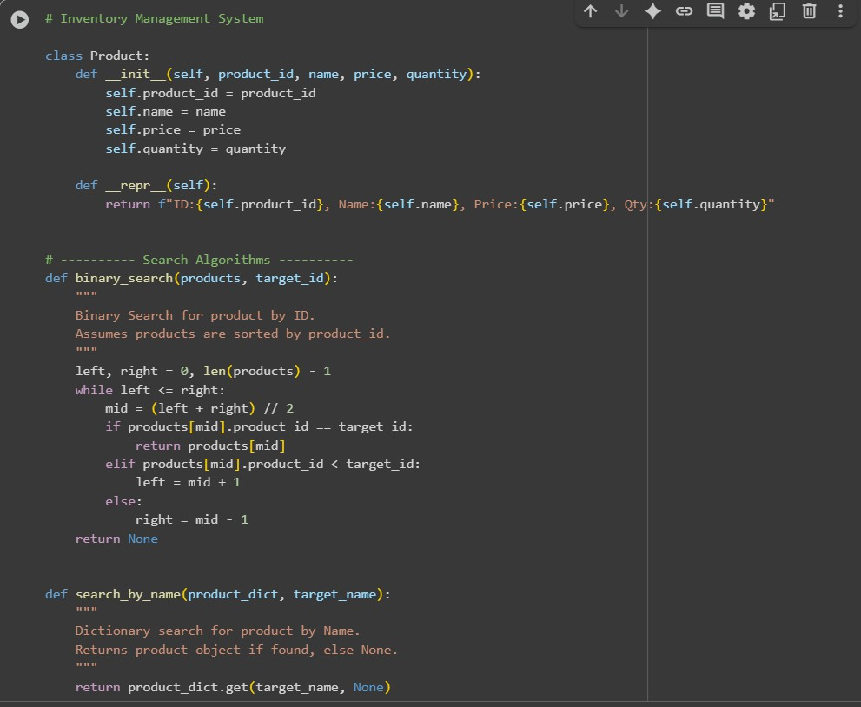  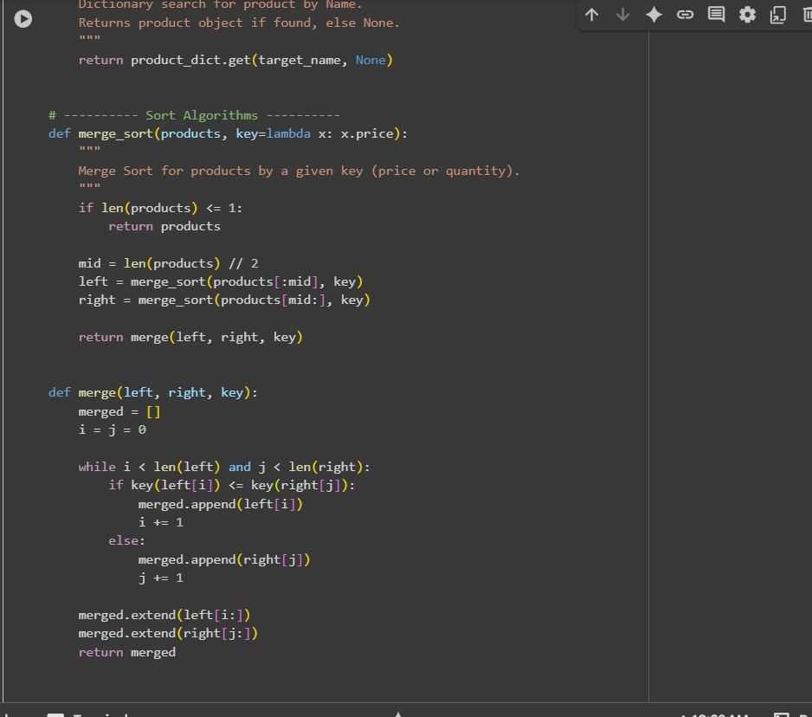  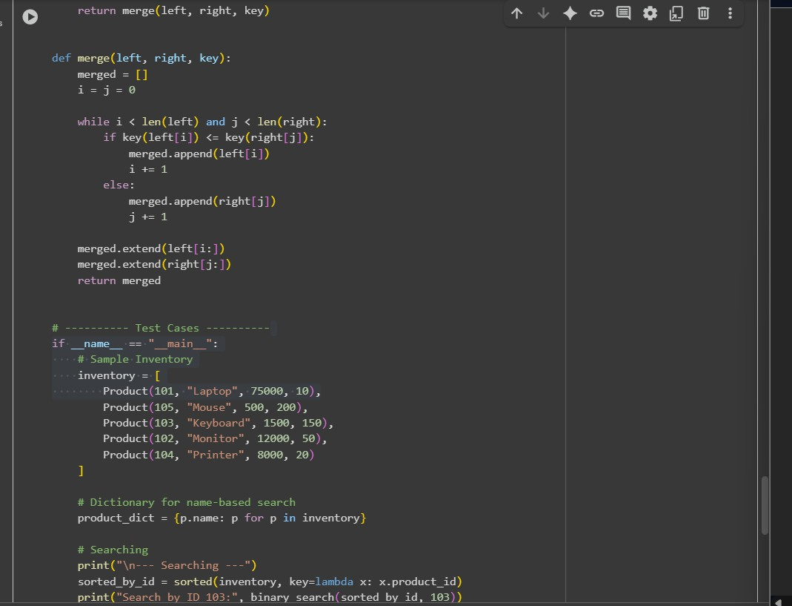  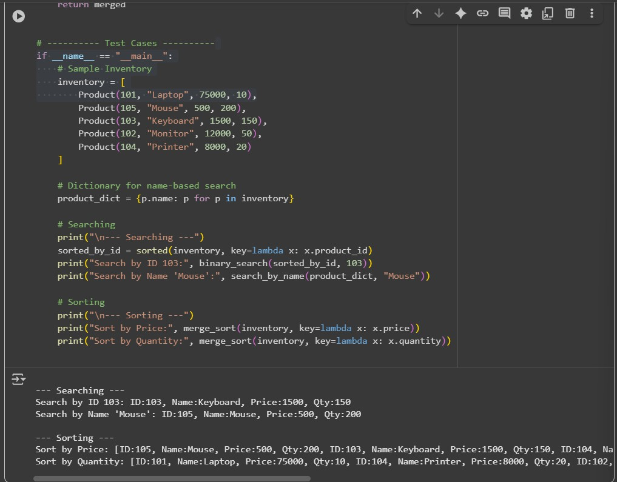  ✅ Deliverables (For All Tasks)  - AI-generated prompts for code and test case generation.  - At least 3 assert test cases for each task.  - AI-generated initial code and execution screenshots.  - Analysis of whether code passes all tests.  - Improved final version with inline comments and explanation.  - Compiled report (Word/PDF) with prompts, test cases, assertions, code, and output. |  |  |  |  |  | Week6 - Monday

