SCHOOL OF COMPUTER SCIENCE AND ARTIFICIAL INTELLIGENCE |  |  |  |  | DEPARTMENT OF COMPUTER SCIENCE ENGINEERING
Program Name: B. Tech |  |  |  | Assignment Type: Lab |  |  | Academic Year:2025-2026
Course Coordinator Name |  |  |  | Venkataramana Veeramsetty
Instructor(s) Name
  Dr. V. Venkataramana (Co-ordinator)
  Dr. T. Sampath Kumar
  Dr. Pramoda Patro
  Dr. Brij Kishor Tiwari
  Dr.J.Ravichander
  Dr. Mohammand Ali Shaik
  Dr. Anirodh Kumar
  Mr. S.Naresh Kumar
  Dr. RAJESH VELPULA
  Mr. Kundhan Kumar
  Ms. Ch.Rajitha
  Mr. M Prakash
  Mr. B.Raju
  Intern 1 (Dharma teja)
  Intern 2 (Sai Prasad)
  Intern 3 (Sowmya)
  NS_2 ( Mounika)
Course Code |  |  | 24CS002PC215 | Course Title |  | AI Assisted Coding
Year/Sem |  |  | II/I | Regulation |  | R24
Date and Day  of Assignment |  |  | Week5 - Monday | Time(s)
Duration |  |  | 2 Hours | Applicable to  Batches
AssignmentNumber: 9.1(Present assignment number)/24(Total number of assignments)
 | Q.No. | Question |  |  |  |  |  | Expected Time  to complete
 | 1 | Lab 9 – Code Review and Quality: Using AI to improve code quality and readability  Lab Objectives  - Inline comments  - Docstrings  - Auto-documentation tools  - AI-assisted summarization  Task Description #1 (AI-Assisted Bug Detection)  Scenario: A junior developer wrote the following Python function to calculate factorials:  def factorial(n):  result = 1  for i in range(1, n):  result = result * i  return result  - Run the code and test it with factorial(5)  (expected output = 120).  - Use AI (prompting) to review this code and identify the bug.  - Ask AI to suggest corrections and rewrite the code.  - Compare AI’s corrected code with your own fix.  Review:  Incorrect loop range was given it should iterate up to n+1  Missing function call in the code the function is defined but the function is never called so it will not generate the output.  AI corrections and rewriting the code:  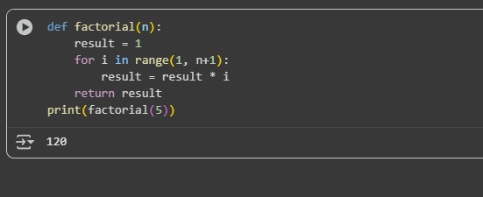  Observation:  I have tried rewriting the code correctly but I failed so I ask AI to correct it for me.  Task Description #2 (Improving Readability & Documentation)  Scenario: The following code works but is poorly written:  def calc(a,b,c):  if c=="add":  return a+b  elif c=="sub":  return a-b  elif c=="mul":  return a*b  elif c=="div":  return a/b  - Use AI to review this code for readability, naming, and documentation issues.  - Prompt AI to rewrite the code with:  - Clear function & variable names.  - Proper docstrings.  - Exception handling for division by zero.  - Compare the before-and-after versions to evaluate AI’s contribution.  AI review:  Readability of the given code is standard, variables are clear and standard for loop is used.  The function name factorial is appropriate and its clearly show what is does.  The code includes good dockstring and it clearly explains what the function does.  Rewrited code by AI:  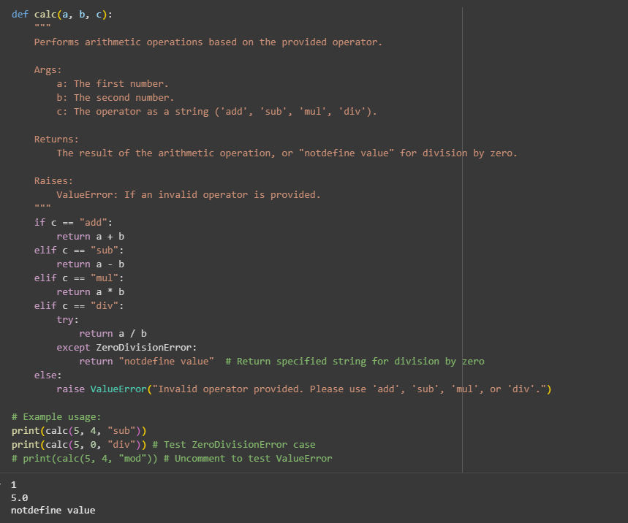  Observation:  In the previous code there was no dockstrin included AI generated code have step wise dockstring which explained every step and it also has a exception handling if we divide a number with zero it will show not defined value.  Task Description #3 (Enforcing Coding Standards)  Scenario: A team project requires following PEP8 style guide. One developer submits:  def Checkprime(n):  for i in range(2,n):  if n%i==0:  return False  return True  - Run this code and verify correctness.  Answer:  The range used in this code is not correct instead of n we need to check it up to n+1 and the function is not called in this code.  - Use AI to perform a code quality review for PEP8 compliance.  Answer:  Cell : this codde has a significant bug. It returns True perematurely in the first iteration of the loop if the number is not divisible by 2, which is incorrect for checking primality. The logic is flawed.  - Prompt AI to return a refactored version with proper indentation, spacing, and naming conventions.  Answer:  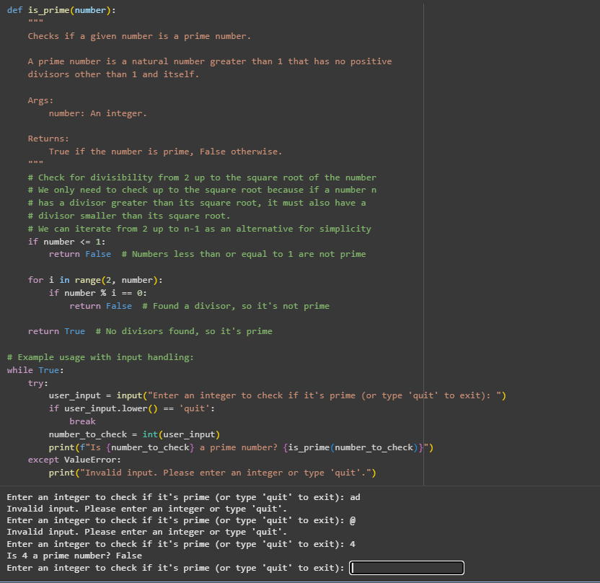  - Discuss how automated AI review can save time in large-scale projects.  Answer:  Faster code analysis Ai can scan vast amount of code very easily and faster than humans.  Task Description #4 (AI as a Code Reviewer in Real Projects)  Scenario: You are part of a GitHub project. A teammate submits this pull request:  def processData(d):  return [x*2 for x in d if x%2==0]  - Review this function manually for readability, reusability, and edge cases.  Answer:  Readability of code is consise due to the use of list comprihension  - Use AI to generate a code review comment, focusing on:  - Naming conventions.  - Input validation (e.g., what if d is not a list?).  - Adding type hints.  - Modify the function based on AI’s suggestions.  Answer:  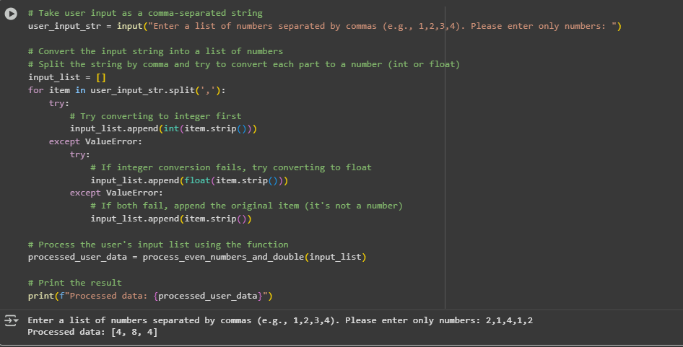  - Write a short reflection: Would you trust AI as a standalone reviewer, or only as a support tool? Why?  Answer:  Yes I trust AI as a standalone reviewer or as a support tool also because it make easy to review a vast information or a vast code without consuming much time than humans and suggest us a right way to tackle it. |  |  |  |  |  | Week5 - Monday

