SCHOOLOF COMPUTER SCIENCE AND ARTIFICIAL INTELLIGENCE |  |  | DEPARTMENTOFCOMPUTER SCIENCE ENGINEERING
Program Name:B. Tech |  | Assignment Type: Lab |  |  | AcademicYear:2026-27
Course Coordinator Name |  | Dr DADI RAMESH
Instructor(s)Name |  | Dr. Ancha Vinod Kumar
Course Code | 24CS312PC310 | Course Title |  | Artificial Intelligence and Deep learning
Year/Sem | III/I | Regulation |  | R24
Date and Day  of Assignment | 03-08-2026 | Time(s)
Duration | 2 Hours | Applicable to  Batches |  | 24BTCAICSB05, 24BTCAICSB06, 24BTCAIAIB03, 24BTCAIAIB04,………………………
AssignmentNumber:1/24
2403A51080
Batch-03
ASSIGNMENT-1

Lab/Exp 1: PyTorch Fundamentals: Tensors and Autograd
Kaggle Dataset Link: https://www.kaggle.com/datasets/muthuj7/weather-dataset

Tasks:
- Load and preprocess the Student Performance dataset/example.
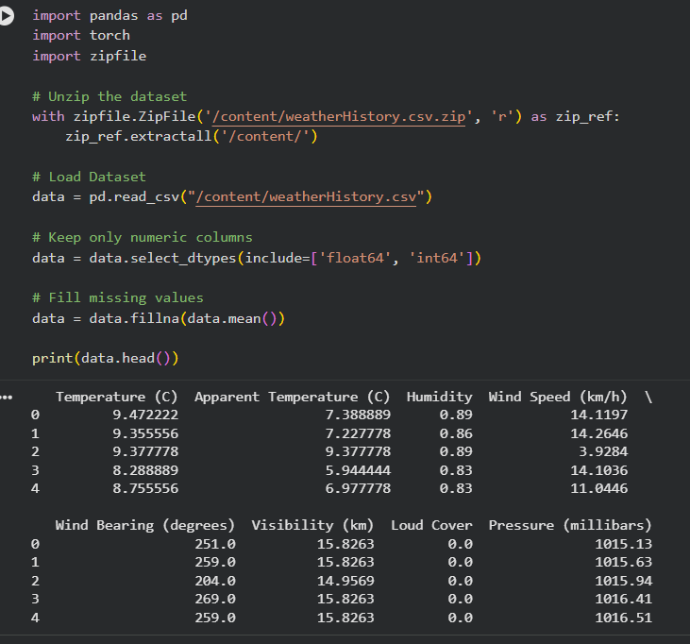
- Build the required PyTorch model/program.
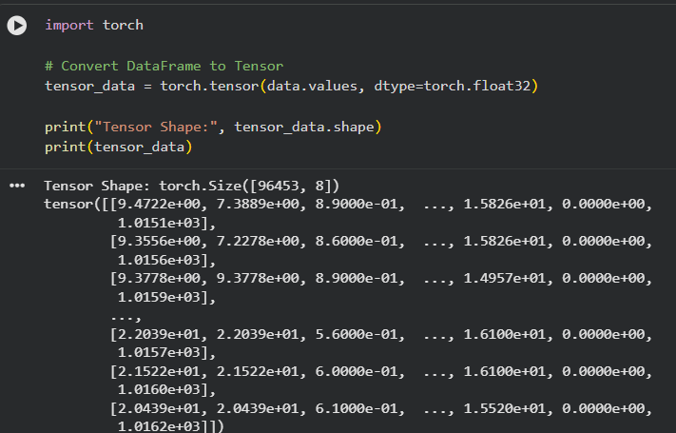
- Train/execute the model.
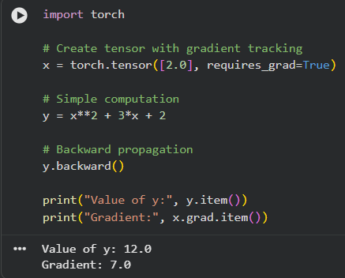
- Evaluate using suitable metrics.
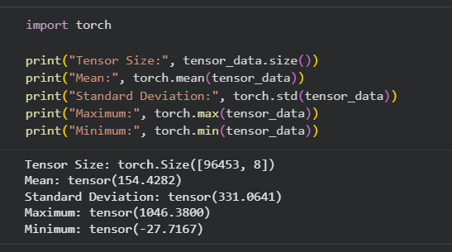

- Visualize results using plots where applicable.
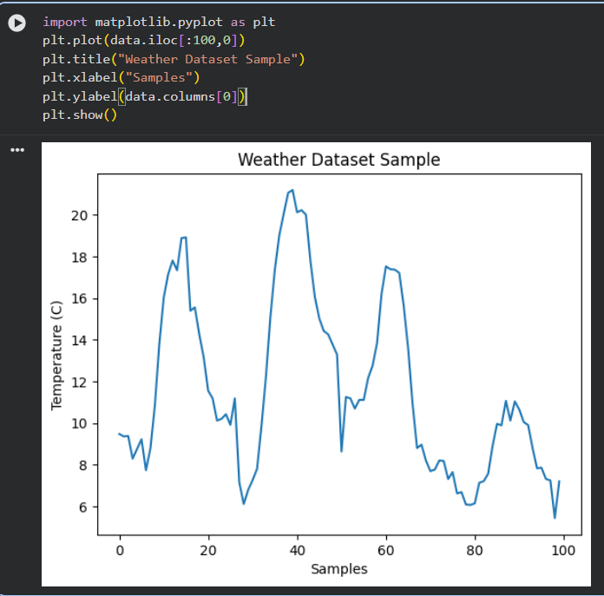
- Write a brief conclusion comparing observations.
• Successfully loaded the Weather dataset.
• Converted data into PyTorch tensors.
• Demonstrated tensor operations and Autograd.
• Evaluated tensor statistics (mean, standard deviation, minimum, and maximum).
• Visualized the dataset using a line plot.
• PyTorch tensors and Autograd make numerical computation and gradient calculation efficient.

