SCHOOLOF COMPUTER SCIENCE AND ARTIFICIAL INTELLIGENCE |  |  | DEPARTMENTOFCOMPUTER SCIENCE ENGINEERING
Program Name:B. Tech |  | Assignment Type: Lab |  |  | AcademicYear:2026-27
Course Coordinator Name |  | Dr DADI RAMESH
Instructor(s)Name |  | Dr. Ancha Vinod Kumar
Course Code | 24CS312PC310 | Course Title |  | Artificial Intelligence and Deep learning
Year/Sem | III/I | Regulation |  | R24
Date and Day  of Assignment | 03-08-2026 | Time(s)
Duration | 2 Hours | Applicable to  Batches |  | 24BTCAICSB05, 24BTCAICSB06, 24BTCAIAIB03, 24BTCAIAIB04,………………………
AssignmentNumber:2/24
2403A51080
Batch-03

ASSIGNMENT-2

Lab/Exp 2: Building a Simple Linear Regression Model in PyTorch
Kaggle Dataset Link: https://www.kaggle.com/datasets/mosapabdelghany/medical-insurance-cost-dataset

-
Tasks:
- Load and preprocess the Salary Prediction dataset/example.
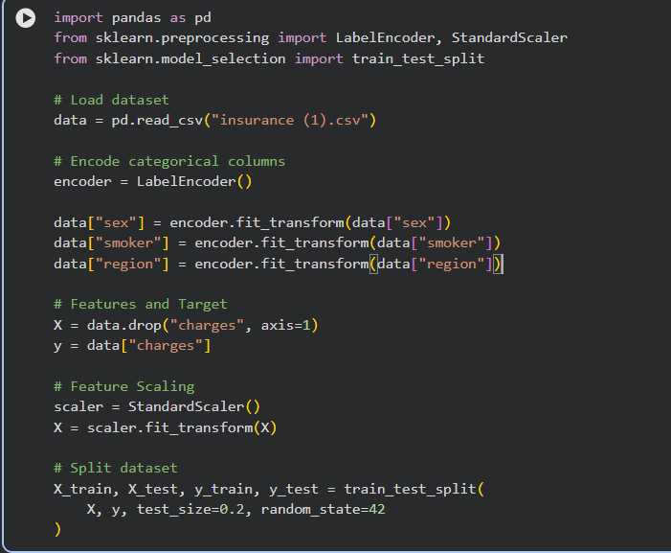
- Build the required PyTorch model/program.
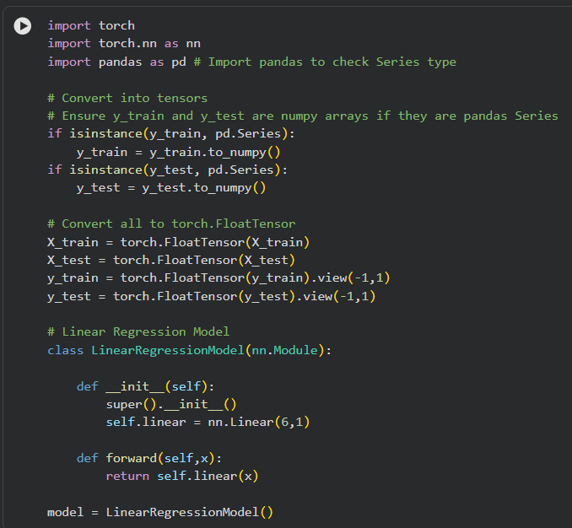
- Train/execute the model.
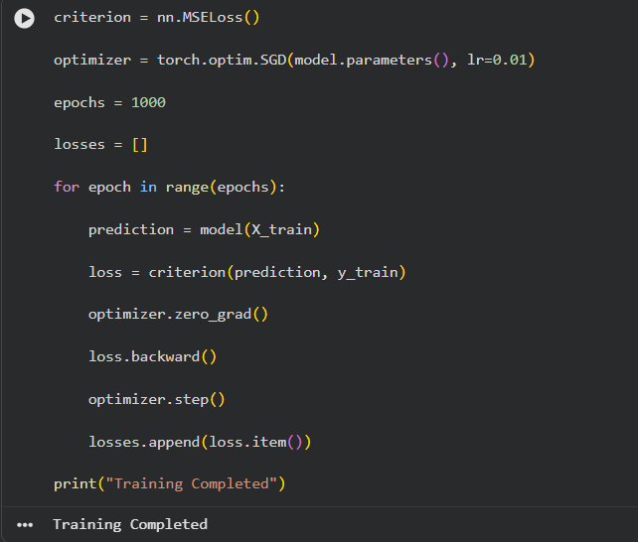
- Evaluate using suitable metrics.
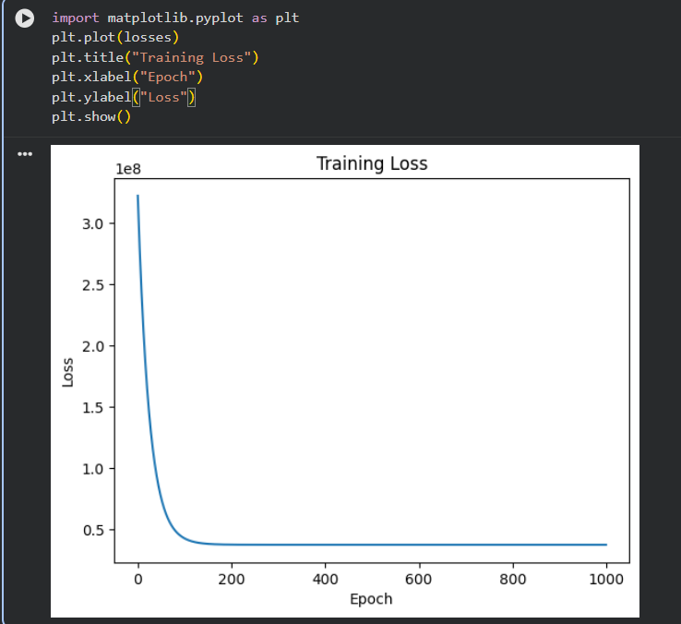

- Visualize results using plots where applicable.
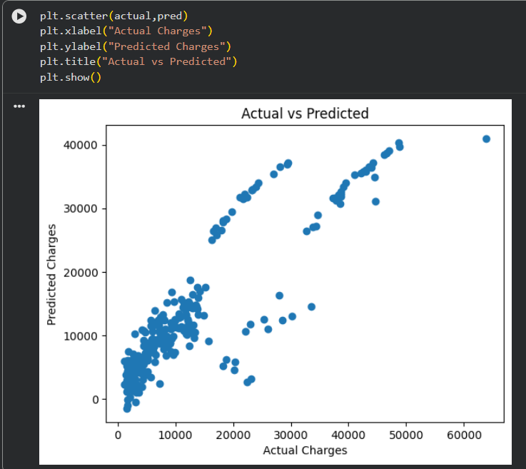
- Write a brief conclusion comparing observations.
- The dataset was successfully loaded and preprocessed.
- Categorical attributes were encoded into numerical values.
- Feature scaling improved the learning process.
- A Simple Linear Regression model was implemented using PyTorch.
- The model was trained using Mean Squared Error (MSE) loss and the SGD optimizer.
- Performance was evaluated using MSE, MAE, RMSE, and R² Score.
- The training loss decreased over epochs, indicating effective learning.
- The Actual vs Predicted plot showed that predicted insurance charges closely followed the actual values, although some deviations remained because a simple linear model cannot capture all complex relationships. Overall, the model demonstrated the basic implementation of linear regression in PyTorch and provided a reasonable prediction of medical insurance charges.

