SCHOOL OF COMPUTER SCIENCE AND ARTIFICIAL INTELLIGENCE |  |  |  |  | DEPARTMENT OF COMPUTER SCIENCE ENGINEERING
Program Name: B. Tech |  |  |  | Assignment Type: Lab |  |  | Academic Year:2025-2026
Course Coordinator Name |  |  |  | Venkataramana Veeramsetty
Instructor(s) Name
  Dr. V. Venkataramana (Co-ordinator)
  Dr. T. Sampath Kumar
  Dr. Pramoda Patro
  Dr. Brij Kishor Tiwari
  Dr.J.Ravichander
  Dr. Mohammand Ali Shaik
  Dr. Anirodh Kumar
  Mr. S.Naresh Kumar
  Dr. RAJESH VELPULA
  Mr. Kundhan Kumar
  Ms. Ch.Rajitha
  Mr. M Prakash
  Mr. B.Raju
  Intern 1 (Dharma teja)
  Intern 2 (Sai Prasad)
  Intern 3 (Sowmya)
  NS_2 ( Mounika)
Course Code |  |  | 24CS002PC215 | Course Title |  | AI Assisted Coding
Year/Sem |  |  | II/I | Regulation |  | R24
Date and Day  of Assignment |  |  | Week10 - Monday | Time(s)
Duration |  |  | 2 Hours | Applicable to  Batches
AssignmentNumber:20.1(Present assignment number)/24(Total number of assignments)
 | Q.No. | Question |  |  |  |  |  | Expected Time  to complete
 | 1 | Lab 20 – Security Testing: Identifying Vulnerabilities in AI-Generated Code  Lab Objectives:  - Understand how to test AI-generated code for common security vulnerabilities.  - Learn to apply secure coding principles while analyzing AI outputs.  - Practice detecting risks such as SQL injection, XSS, hardcoded credentials, and weak encryption.  - Enhance code reliability and safety by using AI for secure refactoring.  Task 1 – Input Validation Check  Task:  Analyze an AI-generated Python login script for input validation vulnerabilities.  Instructions:  - Prompt AI to generate a simple username-password login program.  - Review whether input sanitization and validation are implemented.  - Suggest secure improvements (e.g., using re for input validation).  Expected Output:  - A secure version of the login script with proper input validation.  Prompt:  Write a single Python script that implements a secure login demo: create demo users with bcrypt-hashed passwords, validate the username (3–15 letters/numbers/_), validate the password format (8–32 allowed characters), hide password input using getpass, allow 3 login attempts before a short lockout, and show clear success/failure messages  Code:  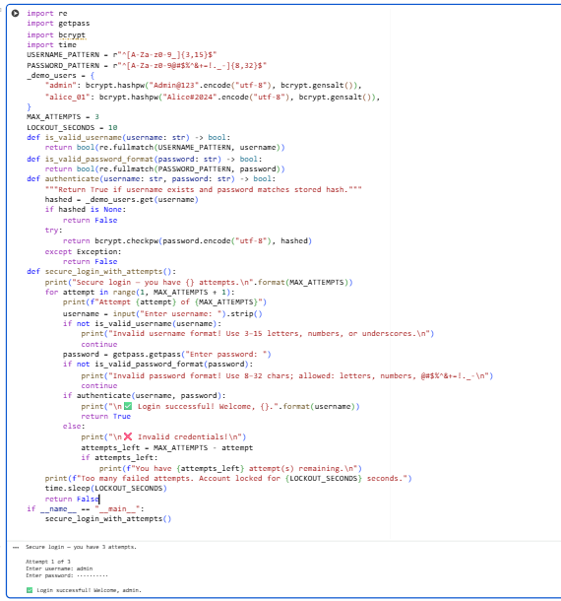  Task 2 – SQL Injection Prevention  Task:  Test an AI-generated script that performs SQL queries on a database.  Instructions:  - Ask AI to generate a Python script using SQLite/MySQL to fetch user details.  - Identify if the code is vulnerable to SQL injection (e.g., using string concatenation in queries).  - Refactor using parameterized queries (prepared statements).  Expected Output:  - A secure database query script resistant to SQL injection.  Prompt:  - Short, self-contained Python script using an in-memory SQLite DB.  - Create a users table and insert ≥2 sample users (include admin).  - Add a vulnerable lookup that concatenates user input into SQL, print the exact SQL, and run it with admin and admin' OR '1'='1.  - Add a secure lookup using parameterized queries, run it with the same two inputs to show the injection fails.  - Print clear, labeled console output for every step (table creation, inserted rows, executed SQL, and results) and structure the demo “in another way” (e.g., tiny class, context manager, or short orchestrator function); keep it runnable.  Code:  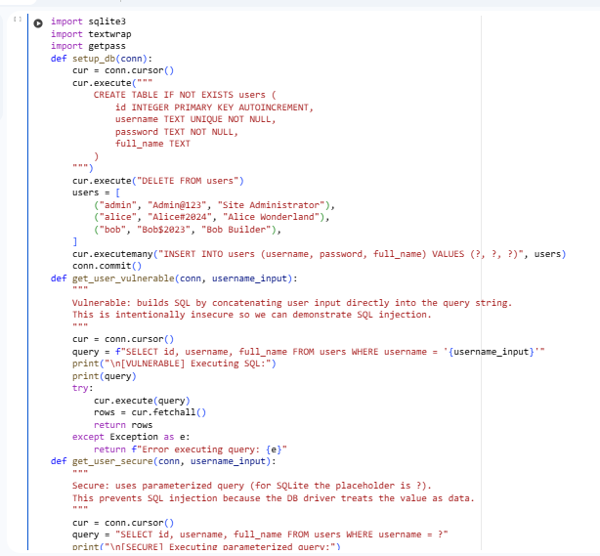  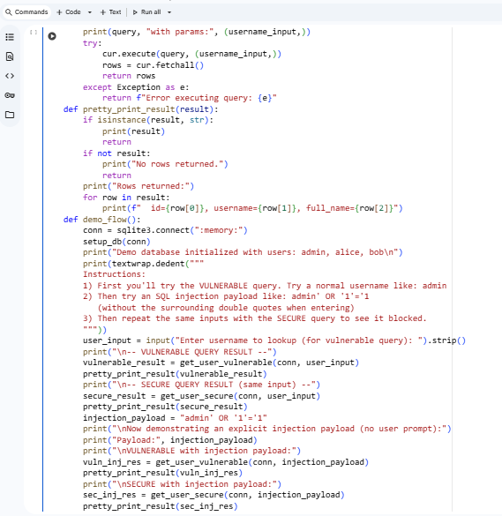  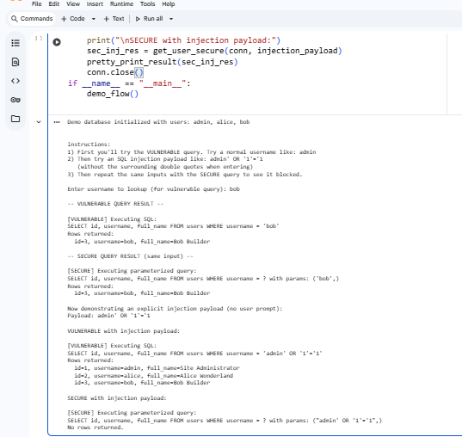  Task 3 – Cross-Site Scripting (XSS) Check  Task:  Evaluate an AI-generated HTML form with JavaScript for XSS vulnerabilities.  Instructions:  - Ask AI to generate a feedback form with JavaScript-based output.  - Test whether untrusted inputs are directly rendered without escaping.  - Implement secure measures (e.g., escaping HTML entities, using CSP).  Expected Output:  - A secure form that prevents XSS attacks.  Prompt:  Write a simple HTML feedback form with name and feedback fields. First show an insecure version, list the security issues (e.g., missing validation, XSS risk, unsafe output). Then show a secure version using best practices (input validation, escaping, POST, CSRF token). Finally, compare the insecure and secure versions in a short list  Code:  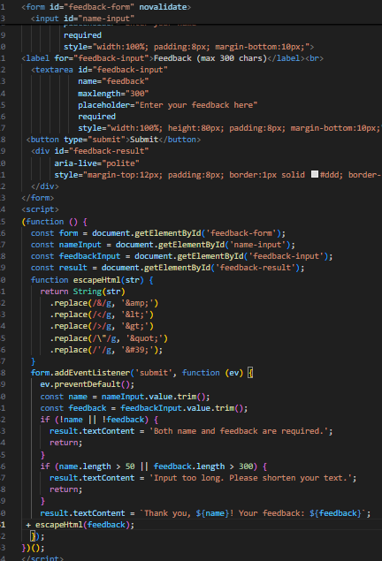  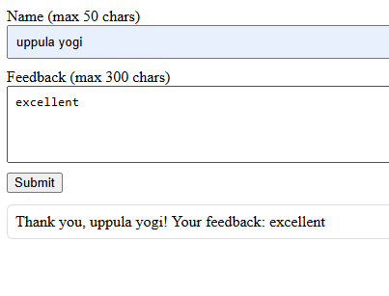  Comparison:  Insecure:  Takes user input directly and displays it without validation, allowing XSS attacks.  Secure:  Validates and sanitizes input before displaying, preventing XSS and ensuring safe feedback handling.  Task 4 – Real-Time Application: Security Audit of AI-Generated Code  Scenario:  Students pick an AI-generated project snippet (e.g., login form, API integration, or file upload).  Instructions:  - Perform a security audit to detect possible vulnerabilities.  - Prompt AI to suggest secure coding practices to fix issues.  - Compare insecure vs secure versions side by side.  Expected Output:  - A security-audited code snippet with documented vulnerabilities and fixes.  Prompt:  Create a short insecure HTML+JS login form, list its security flaws (XSS, unsafe storage, weak validation), then show a secure version using best practices (POST, no inline JS, no client-side password storage, escaping). End with a brief Before vs After comparison  Secure version code:  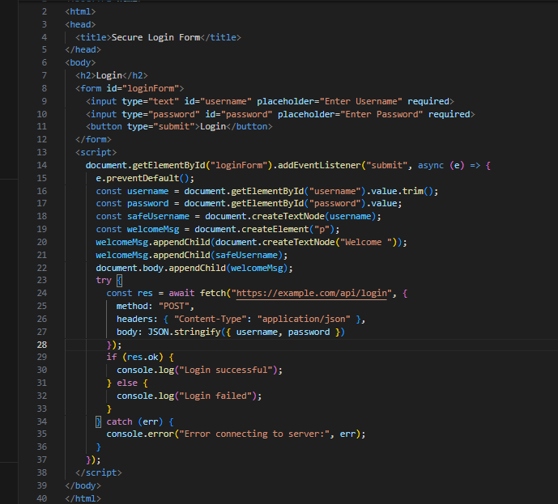  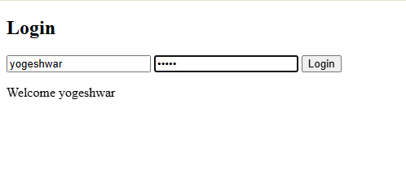  Comparison:  • Insecure Version: Directly injects user input into the DOM, exposing to XSS attacks and sends passwords in plain text via URL.  • Secure Version: Sanitizes input, uses POST with JSON payload, requires HTTPS, and avoids unsafe DOM manipulation.  ✅ Deliverables (For All Tasks)  - AI-generated prompts for code and test case generation.  - At least 3 assert test cases for each task.  - AI-generated initial code and execution screenshots.  - Analysis of whether code passes all tests.  - Improved final version with inline comments and explanation.  - Compiled report (Word/PDF) with prompts, test cases, assertions, code, and output. |  |  |  |  |  | Week10 - Monday

