SCHOOL OF COMPUTER SCIENCE AND ARTIFICIAL INTELLIGENCE |  |  |  |  | DEPARTMENT OF COMPUTER SCIENCE ENGINEERING
Program Name: B. Tech |  |  |  | Assignment Type: Lab |  |  | Academic Year:2025-2026
Course Coordinator Name |  |  |  | Venkataramana Veeramsetty
Instructor(s) Name |  |  |  | Dr. V. Venkataramana (Co-ordinator)
 |  |  |  | Dr. T. Sampath Kumar
 |  |  |  | Dr. Pramoda Patro
 |  |  |  | Dr. Brij Kishor Tiwari
 |  |  |  | Dr.J.Ravichander
 |  |  |  | Dr. Mohammand Ali Shaik
 |  |  |  | Dr. Anirodh Kumar
 |  |  |  | Mr. S.Naresh Kumar
 |  |  |  | Dr. RAJESH VELPULA
 |  |  |  | Mr. Kundhan Kumar
 |  |  |  | Ms. Ch.Rajitha
 |  |  |  | Mr. M Prakash
 |  |  |  | Mr. B.Raju
 |  |  |  | Intern 1 (Dharma teja)
 |  |  |  | Intern 2 (Sai Prasad)
 |  |  |  | Intern 3 (Sowmya)
 |  |  |  | NS_2 ( Mounika)
Course Code |  |  | 24CS002PC215 | Course Title |  | AI Assisted Coding
Year/Sem |  |  | II/I | Regulation |  | R24
Date and Day of Assignment |  |  | Week10 - Thursday | Time(s)
Duration |  |  | 2 Hours | Applicable to Batches
AssignmentNumber:19.4(Present assignment number)/24(Total number of assignments)
 | Q.No. | Question |  |  |  |  |  |  | Expected Time  to  complete
 | 1 | Lab 19 – Code Translation: Converting Between Programming Languages  Lab Objectives:  - Understand how AI tools can assist in translating code between different programming languages. |  |  |  |  |  |  | Week10 -  Thursday

- Learn to verify correctness and functionality after translation.
- Explore syntactic and semantic differences between languages (e.g., Python, Java, C++).
- Practice debugging and optimizing AI-translated code.
Task 1: Translate a Simple Program (Python → JavaScript)
- Instructions:
  - Write a Python function print_numbers() that prints the first 10 natural numbers using a loop.
  - Translate the function into JavaScript as a reusable function printNumbers().
  - Call the function in both languages to display results.
- Expected Output:
- 1
- 2
- 3
- ...10
Prompt:
Write a program to Print first 10 natural numbers in both Python and JavaScript
Code:
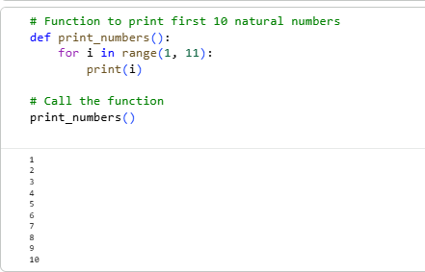
JS CODE:

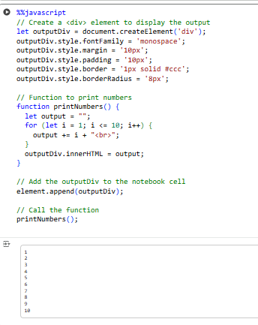
Task 2: Convert Conditional Statements (Java → Python)
- Instructions:
  - Write a Java method checkNumber(int num) that checks if a number is positive, negative, or zero.
  - Translate the method into a Python function check_number(num).
  - Call the function/method with different inputs and compare outputs.
- Expected Output:
- Input: -5 → Output: The number is negative
- Input: 0 → Output: The number is zero
- Input: 7 → Output: The number is positive
Prompt:

Write programs in Java and Python to check if a number is positive, negative, or zero using a separate function or method (checkNumber / check_number), but do it in another way JS CODE:

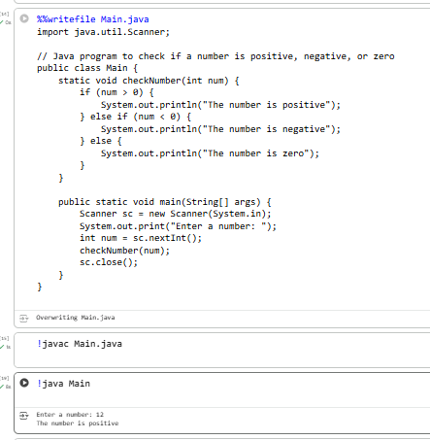

PYTHON CODE

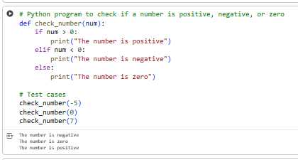

Task 3: Translate Recursive Function (Python → C++)
- Instructions:
  - Write a Python function factorial(n) that calculates factorial of a number using recursion.

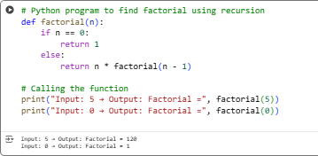
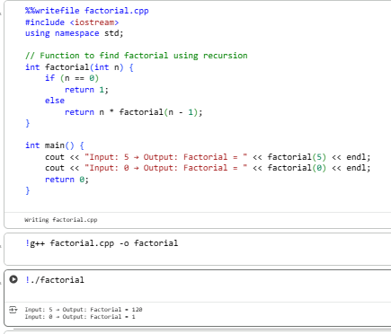
- Translate the same into a C++ function int factorial(int n).
- Call the function in both languages with inputs 5 and 0.
- Expected Output:
  - Input: 5 → Output: Factorial = 120
  - Input: 0 → Output: Factorial = 1
Prompt:

Write programs in Python and C++ to calculate the factorial of a number using recursion.Define a function (factorial).

PYTHON CODE:

.C++ CODE:

Task 4: Data Structures with Functions (JavaScript → Python)
- Instructions:
  - Write a JavaScript function printStudents(students) that takes an array of student names and prints each name.
  - Translate it into a Python function print_students(students) using a list.
  - Test both functions with sample student names.
- Expected Output:
- Student List:
- Alice
- Bob
- Charlie
PROMPT:

Write a JavaScript function printStudents(students) that takes an array of student names and prints each name. Translate it into a Python function print_students(students) using a list.
JSCODE:

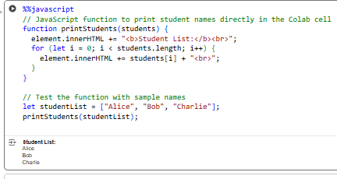
PYTHON CODE:

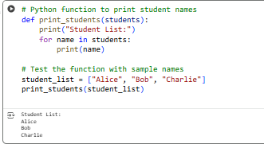

Task 5: Class & Object Translation (Python → Java)
- Instructions:
  - Write a Python class Car with attributes: brand, model, year.
  - Add a method display_details() that prints car details.
  - Translate the same into a Java class Car with attributes and a method displayDetails().
  - Create an object in both languages and call the method.
- Expected Output:
- Car Details:
- Brand: Toyota
- Model: Corolla Year: 2020
PROMPT:
Write a Python class Car with attributes: brand, model, year.Add a method display_details() that prints car details. Translate the same into a Java class Car with attributes and a method displayDetails().
PYTHON CODE:
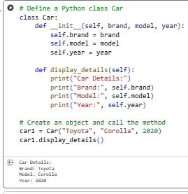
JS CODE:

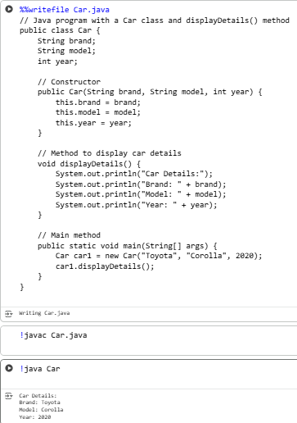

⬛ Deliverables (For All Tasks)
- AI-generated prompts for code and test case generation.
- At least 3 assert test cases for each task.
- AI-generated initial code and execution screenshots.
- Analysis of whether code passes all tests.
- Improved final version with inline comments and explanation.
- Compiled report (Word/PDF) with prompts, test cases, assertions, code, and output.

