SCHOOLOFCOMPUTER SCIENCE AND ARTIFICIAL INTELLIGENCE |  |  |  |  | DEPARTMENTOFCOMPUTER SCIENCE ENGINEERING
ProgramName:B. Tech |  |  |  | AssignmentType: Lab |  |  | AcademicYear:2025-2026
CourseCoordinatorName |  |  |  | Venkataramana Veeramsetty
Instructor(s)Name
  Dr. V. Venkataramana (Co-ordinator)
  Dr. T. Sampath Kumar
  Dr. Pramoda Patro
  Dr. Brij Kishor Tiwari
  Dr.J.Ravichander
  Dr. Mohammand Ali Shaik
  Dr. Anirodh Kumar
  Mr. S.Naresh Kumar
  Dr. RAJESH VELPULA
  Mr. Kundhan Kumar
  Ms. Ch.Rajitha
  Mr. M Prakash
  Mr. B.Raju
  Intern 1 (Dharma teja)
  Intern 2 (Sai Prasad)
  Intern 3 (Sowmya)
  NS_2 ( Mounika)
CourseCode |  |  | 24CS002PC215 | CourseTitle |  | AI Assisted Coding
Year/Sem |  |  | II/I | Regulation |  | R24
DateandDay  of Assignment |  |  | Week7 - WednesDay | Time(s)
Duration |  |  | 2 Hours | Applicableto  Batches
AssignmentNumber:13.3(Presentassignmentnumber)/24(Totalnumberofassignments)
 | Q.No. | Question |  |  |  |  |  | ExpectedTime  to complete
 | 1 | Lab 13 – Code Refactoring: Improving Legacy Code with AI Suggestions  Lab Objectives  - To introduce the concept of code refactoring and why it matters (readability, maintainability, performance).  - To practice using AI tools for identifying and suggesting improvements in legacy code.  - To evaluate the before vs. after versions for clarity, performance, and correctness.  - To reinforce responsible AI-assisted coding practices (avoiding over-reliance, validating outputs).  Learning Outcomes  After completing this lab, students will be able to:  - Use AI to analyze and refactor poorly written Python code.  - Improve code readability, efficiency, and error handling.  - Document AI-suggested improvements through comments and explanations.  - Apply refactoring strategies without changing functionality.  - Critically reflect on AI’s refactoring suggestions.  Task Description #1 – Remove Repetition  Task: Provide AI with the following redundant code and ask it to refactor  Python Code  def calculate_area(shape, x, y=0):  if shape == "rectangle":  return x * y  elif shape == "square":  return x * x  elif shape == "circle":  return 3.14 * x * x  Expected Output  - Refactored version with dictionary-based dispatch or separate functions.  - Cleaner and modular design.  Prompt:  Refactor the given Python code to eliminate repetition and improve readability.  Use a dictionary-based approach or break the logic into separate functions to make it cleaner and more maintainable..  Code:  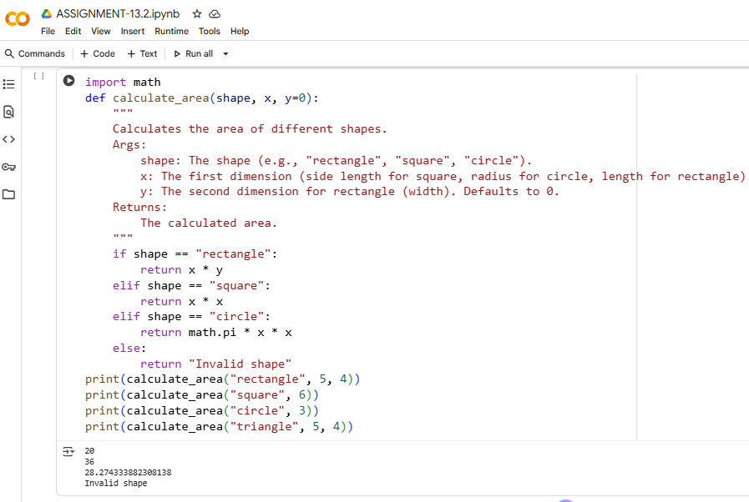  Observations:  - The same formulas are written over and over for different shapes, which makes the code repetitive.  - Adding a new shape means editing multiple parts of the code — it’s not very flexible.  - The code could be simplified and made easier to read.  - Organizing the logic using a dictionary or separate functions would make it much cleaner and easier to manage.  Task Description #2 – Error Handling in Legacy Code  Task: Legacy function without proper error handling  Python Code  def read_file(filename):  f = open(filename, "r")  data = f.read()  f.close()  return data  Expected Output:  AI refactors with with open() and try-except:  Prompt:  Improve the given Python code by adding proper error handling.Use with open() for safe file access and wrap the logic in try-except blocks to catch potential errors like missing files or read/write issues.  Code:  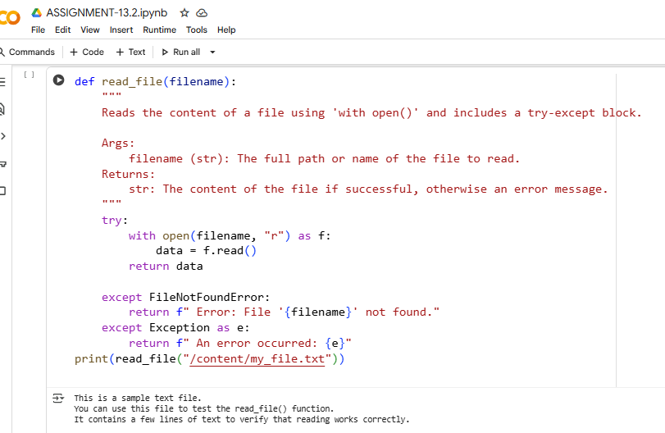  Observations:  - If the file isn’t there, the code crashes because it doesn’t handle that error.  - If something goes wrong, the file might stay open — which isn’t ideal.  - Using with open() makes sure the file closes properly, even if there’s an issue.  - Wrapping the code in a try-except block helps catch problems and keeps things running smoothly.  Task Description #3 – Complex Refactoring  Task: Provide this legacy class to AI for readability and modularity improvements:  Python Code  class Student:  def __init__(self, n, a, m1, m2, m3):  self.n = n  self.a = a  self.m1 = m1  self.m2 = m2  self.m3 = m3  def details(self):  print("Name:", self.n, "Age:", self.a)  def total(self):  return self.m1+self.m2+self.m3  Expected Output:  - AI improves naming (name, age, marks).  - Adds docstrings.  - Improves print readability.  - Possibly uses sum(self.marks) if marks stored in a list.  Prompt:  Take a look at this Python class and clean it up to make it easier to understand and work with.  Use better variable names, add helpful docstrings, and break things into smaller parts if needed so the code is more organized and readable.  Code:  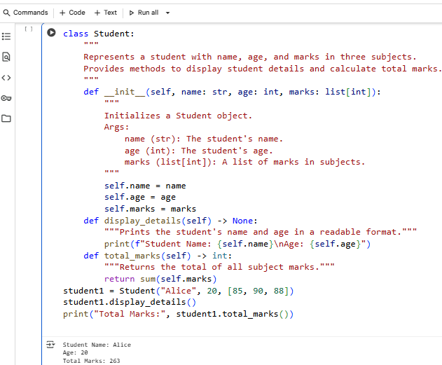  Observations:  - The variable names are too short and don’t clearly show what they represent.  - There’s no explanation for what the class or its methods do — adding docstrings would help.  - The printed output could be formatted better to make it easier to read.  - Instead of separate variables, storing marks in a list would simplify the code.  - Using sum(self.marks) is a cleaner and more efficient way to calculate the total.  - If you’re refactoring a student or grading class, I can help rewrite it with these improvements.  Task Description #4 – Inefficient Loop Refactoring  Task: Refactor this inefficient loop with AI help  Python Code  nums = [1,2,3,4,5,6,7,8,9,10]  squares = []  for i in nums:  squares.append(i * i)  Expected Output: AI suggested a list comprehension  Prompt:  Refactor the following Python code to make it more efficient using list comprehension.  Code:  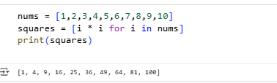  Observations:  - The loop is doing something simple but takes up too much space.  - You can replace it with a single, compact line of code.  - Using list comprehension makes the code neater and runs faster.  - It’s also easier for others to read and quickly understand what’s happening. |  |  |  |  |  | Week5 - Monday

