SCHOOL OF COMPUTER SCIENCE AND ARTIFICIAL INTELLIGENCE |  |  |  | DEPARTMENT OF COMPUTER SCIENCE ENGINEERING
Program Name: B. Tech |  |  | Assignment Type: Lab |  |  | Academic Year:2025-2026
Course Coordinator Name |  |  | Venkataramana Veeramsetty
Instructor(s)Name |  |  | 1. Dr. Mohammed Ali Shaik  2. Dr. T Sampath Kumar  3. Mr. S Naresh Kumar  4. Dr. V. Rajesh  5. Dr. Brij Kishore  6. Dr Pramoda Patro  7. Dr. Venkataramana  8. Dr. Ravi Chander  9. Dr. Jagjeeth Singh
Course Code |  | 24CS002PC215 | Course Title |  | AI Assisted Coding
Year/Sem |  | II/I | Regulation |  | R24
Date and Day of Assignment |  | 06-08-2025 | Time(s)
Duration |  | 2 Hours | Applicable to  Batches
AssignmentNumber:6.5(Present assignment number)/24(Total number of assignments)
Q.No. | Question |  |  |  |  |  | ExpectedTime  to complete
1 | Lab 6: AI-Based Code Completion: Working with suggestions for classes, loops,  conditionals  Lab Assignment 1: Intelligent Code Completion for Object-Oriented Programming  Objective: To explore AI-powered code assistants for writing Python classes,  constructors, and methods through intelligent suggestions.  Suppose that you are hired as an intern at a tech company that develops inventory  management systems. Your manager asks you to create a Product class and a  Warehouse class with some basic methods. You have decided to use AI-powered code  suggestions to help speed up development and reduce syntax errors.  Tasks to be completed are as below  1. Setup AI Coding Tool:  • Install and configure GitHub Copilot or Kite with VS Code or JetBrains IDE.  • Enable real-time code suggestions.  2. Class Design Using AI Assistance:  • Begin defining a Product class with attributes: name, price, quantity.  • Use the AI suggestion feature to automatically complete the __init__() method.  • Add a method calculate_value() to return price * quantity.  • Prompt: Write a Python class named Product with attributes name, price, and  quantity. Use a constructor (__init__) to initialize these values, and add a method calculate_value() that returns price * quantity. |  |  |  |  |  | 15.08.2025 EOD

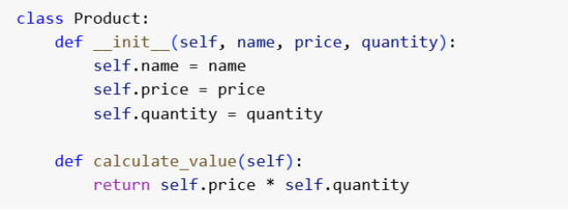
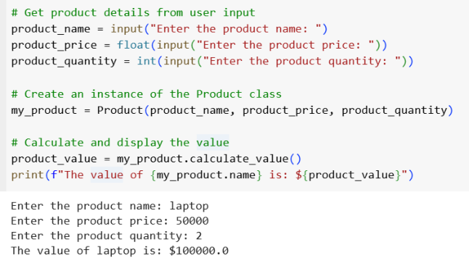
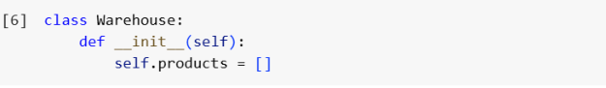
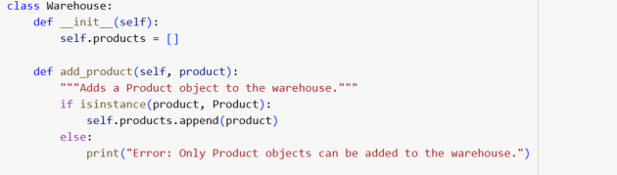

3. Create Another Class:
• Define a Warehouse class with a list of Product objects.
• Use code completion to help implement:
o A method to add a product.
o A method to display the most valuable product.
Prompt: Write a Python program with a Warehouse class that stores Product
objects. The Warehouse should have methods to add a product and to find the product
with the highest total value (price * quantity). Ask the user to enter details for at least
three products, add them to the Warehouse, and then print the most valuable product’s
name and value.

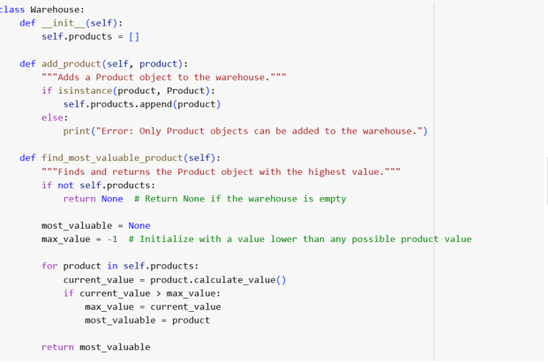
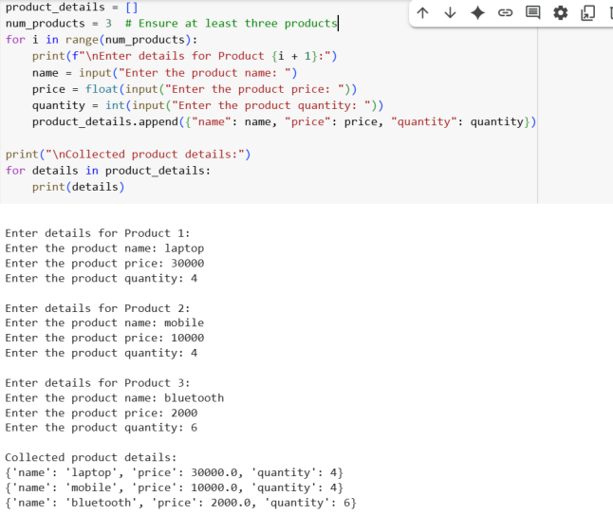

4. Reflection:
• Identify how much of the code was completed by AI and what manual edits
were needed.
• Comment on the relevance and accuracy of AI suggestions.
Product class:
• AI quickly suggested the __init__() constructor with attributes.
• Suggested the calculate_value() method correctly (price * quantity).
• Very little manual editing was required.
Warehouse class:
• AI suggested the __init__() method with a product list.
• Suggested correct code for add_product() using append().
• For most_valuable_product(), AI suggested using max() with a lambda, but I
edited it to return the product itself.

Testing part:
• AI suggested hardcoded product objects.
• I changed it to take user input (name, price, quantity).
• This showed AI often provides generic solutions that need human adjustment. Overall experience:
• About 70% AI-generated, 30% manually edited.
• Suggestions were mostly accurate and helpful.
• AI sped up coding and reduced syntax errors.
• Human judgment was still necessary to meet assignment requirements.

