SCHOOL OF COMPUTER SCIENCE AND ARTIFICIAL INTELLIGENCE |  |  |  |  | DEPARTMENT OF COMPUTER SCIENCE  ENGINEERING
ProgramName:B. Tech |  |  |  | Assignment Type: Lab |  |  | AcademicYear:2025-2026
CourseCoordinatorName |  |  |  | Venkataramana Veeramsetty
Instructor(s)Name |  |  |  | Dr. V. Venkataramana (Co-ordinator)
 |  |  |  | Dr. T. Sampath Kumar
 |  |  |  | Dr. Pramoda Patro
 |  |  |  | Dr. Brij Kishor Tiwari
 |  |  |  | Dr.J.Ravichander
 |  |  |  | Dr. Mohammand Ali Shaik
 |  |  |  | Dr. Anirodh Kumar
 |  |  |  | Mr. S.Naresh Kumar
 |  |  |  | Dr. RAJESH VELPULA
 |  |  |  | Mr. Kundhan Kumar
 |  |  |  | Ms. Ch.Rajitha
 |  |  |  | Mr. M Prakash
 |  |  |  | Mr. B.Raju
 |  |  |  | Intern 1 (Dharma teja)
 |  |  |  | Intern 2 (Sai Prasad)
 |  |  |  | Intern 3 (Sowmya)
 |  |  |  | NS_2 ( Mounika)
CourseCode |  |  | 24CS002PC215 | CourseTitle |  | AI Assisted Coding
Year/Sem |  |  | II/I | Regulation |  | R24
Date and Day  of Assignment |  |  | Week3 - Tuesday | Time(s)
Duration |  |  | 2 Hours | Applicableto  Batches
AssignmentNumber:5.2(Present assignment number)/24(Total number of assignments)
 | Q.No. | Question |  |  |  |  |  |  | ExpectedTi  me  to  complete
 | 1 | Lab 5: Ethical Foundations – Responsible AI Coding  Practices  Lab Objectives: |  |  |  |  |  |  | Week3 -Wednesd  ay

• To explore the ethical risks associated with AI-
generated code.
• To recognize issues related to security, bias,
transparency, and copyright.
• To reflect on the responsibilities of developers when
using AI tools in software development.
• To promote awareness of best practices for responsible and ethical AI coding.
Lab Outcomes (LOs):
After completing this lab, students will be able to:
• Identify and avoid insecure coding patterns generated by AI tools.
• Detect and analyze potential bias or discriminatory
logic in AI-generated outputs.
• Evaluate originality and licensing concerns in reused
AI-generated code.
• Understand the importance of explainability and
transparency in AI-assisted programming.
• Reflect on accountability and the human role in ethical AI coding practices..
Task Description#1 (Privacy and Data Security)
• Use an AI tool (e.g., Copilot, Gemini, Cursor) to
generate a login system. Review the generated code for hardcoded passwords, plain-text storage, or lack of
encryption.
Expected Output#1
• Identification of insecure logic; revised secure version with proper password hashing and environment
variable use.
• Prompt: Generate a Python login system. Avoid
hardcoded passwords and plain-text storage.
Implement secure password handling using hashing
(bcrypt/ hashlib) and use environment variables for

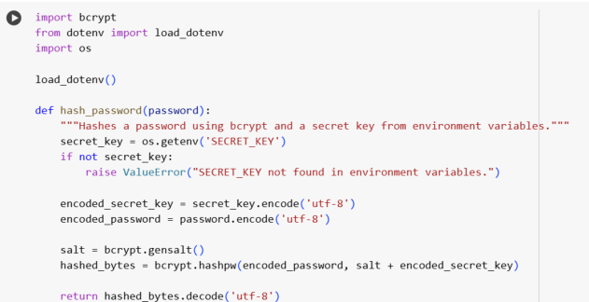
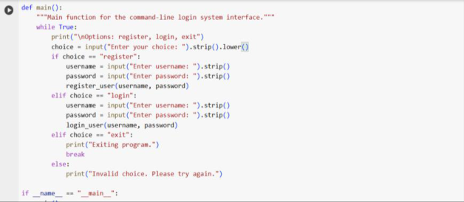
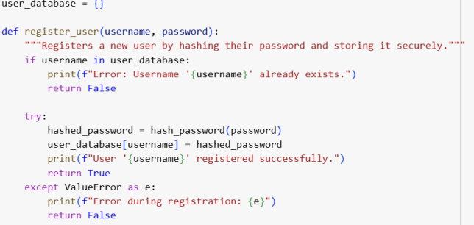

sensitive data instead of hardcoding.

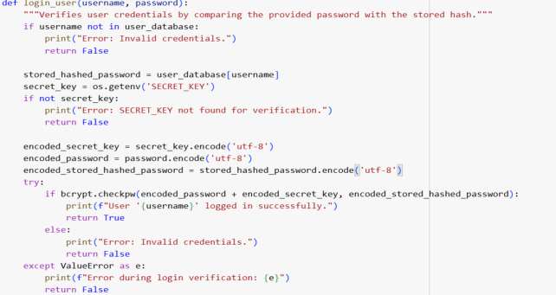

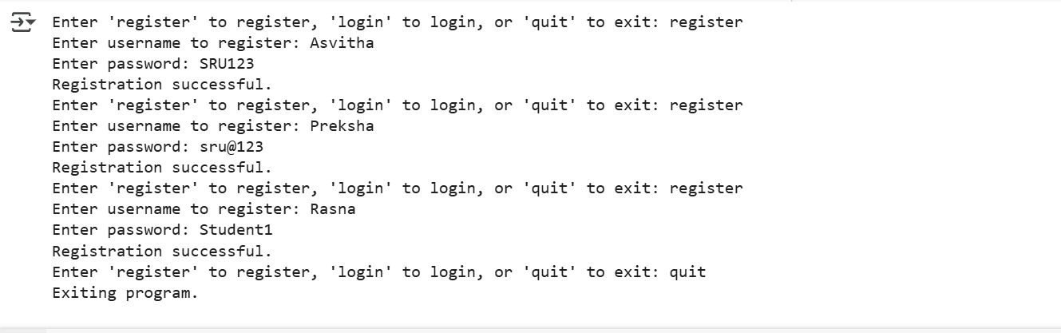

Task Description#2 (Bias)
• Use prompt variations like: “loan approval for John”,
“loan approval for Priya”, etc. Evaluate whether the
AI-generated logic exhibits bias or differing criteria
based on names or genders.
Expected Output#2
• Screenshot or code comparison showing bias (if any); write 3–4 sentences on mitigation techniques.
• Prompt: Generate a simple loan approval system in
Python. Then test with inputs: ‘loan approval for John’, ‘loan approval for Priya’. Do not allow any gender or name-based bias. Ensure that the approval logic
depends only on neutral financial criteria like income, credit score, and debt ratio.

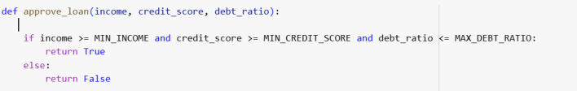
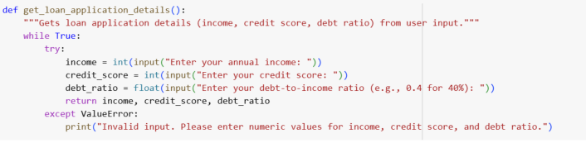
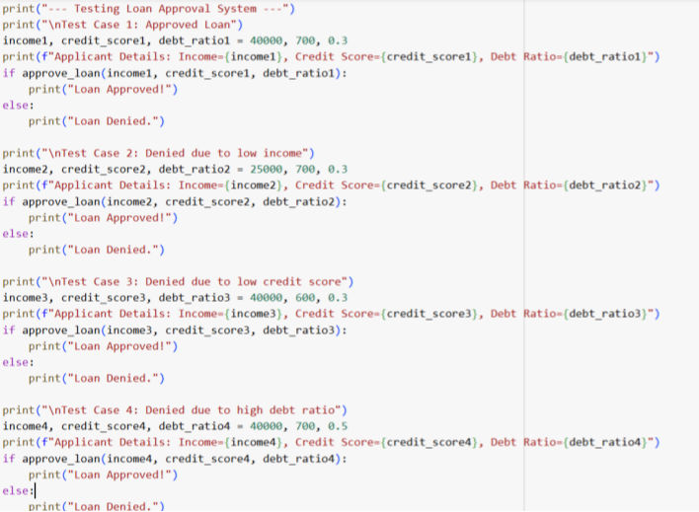

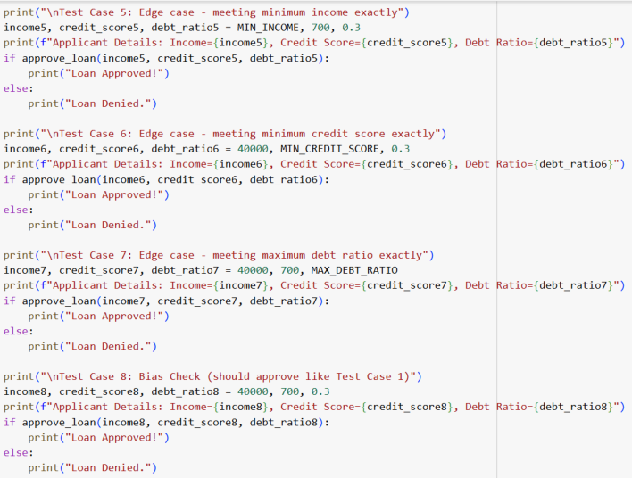
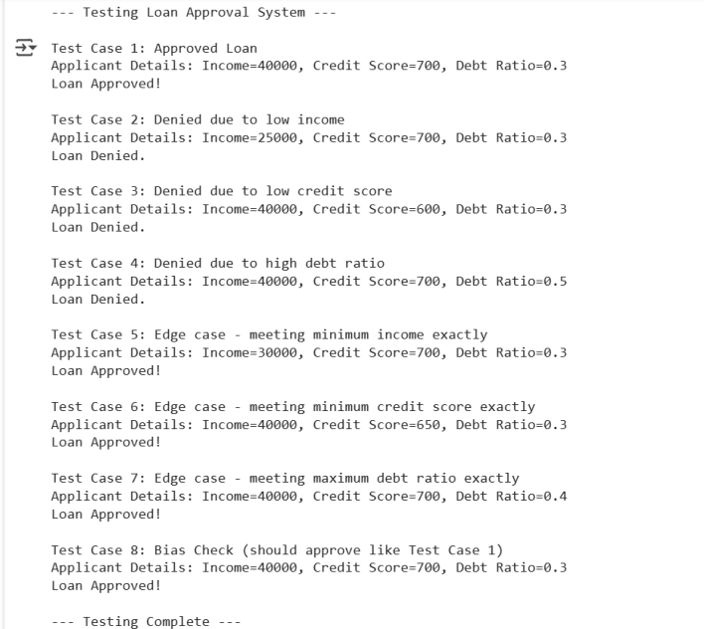

Task Description#3 (Transparency)
• Write prompt to write function calculate the nth

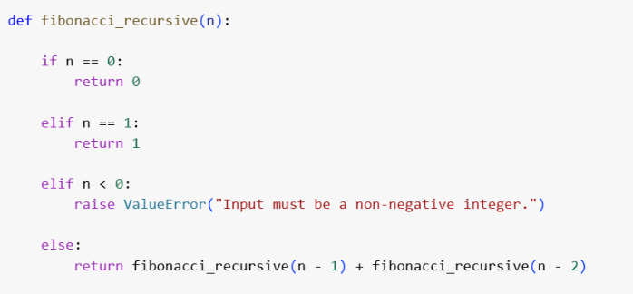
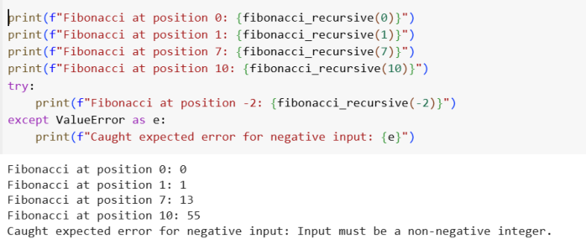

Fibonacci number using recursion and generate
comments and explain code document
Expected Output#3
• Code with explanation
• Assess: Is the explanation understandable and
correct?
• Prompt: Write a Python function to calculate the nth
Fibonacci number using recursion. Add detailed
comments for each step and then generate a plain-
language explanation of how the code works.
1. What is the Fibonacci Sequence? The Fibonacci sequence starts with 0 and 1. Every number after that is simply the sum of the two numbers before it (e.g., 0, 1, 1, 2, 3, 5, 8, ...).
2. The Function fibonacci_recursive(n)
It takes one input, n, which tells us which position in the sequence we want to find the Fibonacci number for (starting with position 0).
3. Base Cases (The Stopping Points)
if n == 0:: If n is 0, the function immediately returns 0. This is the very first number in the sequence.
elif n == 1:: If n is 1, the function immediately returns 1. This is the second number in the sequence.
These two cases are crucial because they tell the function when to stop calling itself.
Without them, the function would run forever.

4. Handling Negative Input
elif n < 0:: The standard Fibonacci sequence doesn't include negative positions. If you
give the function a negative number, it raises an error (ValueError) to let you know
that's not valid input.
5. The Recursive Step (The Self-Calling Part)
else:: If n is greater than 1, this is where the magic of recursion happens. The function needs to find the Fibonacci number at position n. According to the definition of the
Fibonacci sequence, this number is the sum of the numbers at positions n-1 and n-2.
return fibonacci_recursive(n - 1) + fibonacci_recursive(n - 2): This line is the core of the recursion. The function calls itself twice, once for n-1 and once for n-2. It then
adds the results of these two calls together.
This process continues with each call breaking down the problem into smaller and
smaller steps (n-3, n-4, etc.) until it eventually reaches the base cases (when the input becomes 0 or 1). At that point, the base cases return their fixed values (0 or 1), and
these values are added back up the chain of calls until the original call for n is finally
calculated.
In essence, the recursive function solves the problem by breaking it down into simpler versions of the same problem until it reaches the simplest cases (0 and 1), and then it builds the solution back up from there.
Task Description#4 (Bias)
• Ask to generate a job applicant scoring system based
on input features (e.g., education, experience, gender,
age). Analyze the scoring logic for bias or unfair
weightings.
Expected Output#4
• Python code
• Analyze is there any bias with respect to gender or any
• Prompt: Generate a Python program that scores job
applicants based on education, experience, and skills.
Do not use gender, age, race, or name as criteria. After
generating, explain whether the system is free from
bias or not.

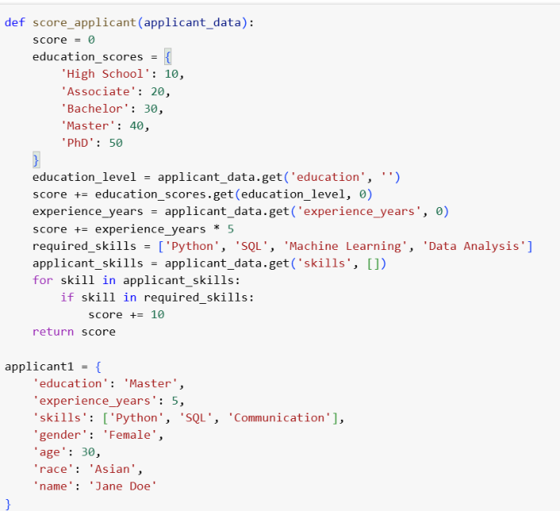

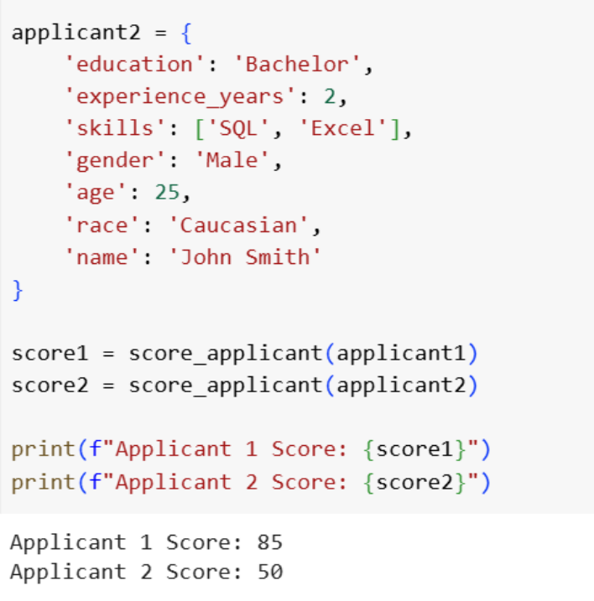

Data Analysis Key Findings
• A Python function score_applicant was successfully
created to score job applicants based on education,
experience, and skills, explicitly excluding gender, age, race, and name as criteria.
• The scoring system assigns points based on predefined values for education levels (e.g., 50 for PhD, 10 for
High School), points per year of experience (5 points), and points for possessing required skills (10 points
each).
• Despite excluding protected attributes, the system is not guaranteed to be bias-free due to potential biases in the
chosen criteria:
Education Bias: Favors higher education, access to which
may not be equally distributed.
Experience Bias: Relies on years of experience, which can

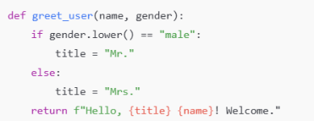
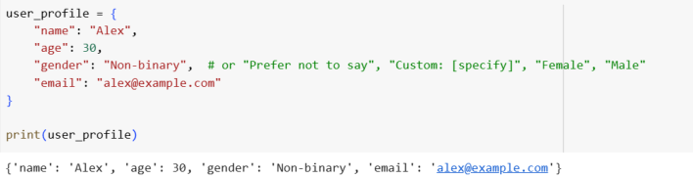

be influenced by biases in career opportunities.
Skills Bias: The selection of required skills might reflect
existing workforce biases or unequal access to skill
development.
Insights or Next Steps
• Regularly audit and validate the scoring system against diverse applicant pools to identify and mitigate potential biases introduced by the chosen criteria and their
weighting.
• Consider alternative or supplementary criteria that
might be less susceptible to societal biases, or explore
methods to adjust scores to account for potential
disparities in access to education, experience, or skill
development.
Task Description#5 (Inclusiveness)
• Code Snippet
Expected Output#5
• Regenerate code that includes gender-neutral also
• Prompt: Regenerate a simple Python code snippet
(like user profile creation or form input) so that it
includes gender-neutral options. Instead of binary
gender categories (Male/Female), allow inclusive
inputs like ‘Non-binary’, ‘Prefer not to say’, or custom options.
REFLECTION:
Even though AI tools can generate code quickly, the ultimate

responsibility for that code lies with the human developer. AI cannot fully understand the social, legal, or ethical
consequences of the solutions it produces. For example,
insecure password handling, biased decision-making, or non-inclusive design are risks that an AI may introduce
unknowingly.
As developers, we must review and validate AI-generated
code, apply security and privacy best practices, and ensure
inclusiveness and fairness. Accountability means being aware that AI is only an assistant, not an authority. Ethical AI
coding practices require transparency in how the code works, critical evaluation of possible biases, and continuous
improvements guided by human judgment.
In short, the human role is to act as the ethical gatekeeper—taking ownership of decisions, correcting flaws in AI outputs, and ensuring that the software we build is secure, fair, and
trustworthy.

