SCHOOL OF COMPUTER SCIENCE AND ARTIFICIAL INTELLIGENCE |  |  |  |  | DEPARTMENT OF COMPUTER SCIENCE ENGINEERING
Program Name: B. Tech |  |  |  | Assignment Type: Lab |  |  | Academic Year:2025-2026
Course Coordinator Name |  |  |  | Venkataramana Veeramsetty
Instructor(s) Name |  |  |  | Dr. V. Venkataramana (Co-ordinator)  Dr. T. Sampath Kumar  Dr. Pramoda Patro  Dr. Brij Kishor Tiwari  Dr.J.Ravichander  Dr. Mohammand Ali Shaik  Dr. Anirodh Kumar  Mr. S.Naresh Kumar  Dr. RAJESH VELPULA  Mr. Kundhan Kumar  Ms. Ch.Rajitha  Mr. M Prakash  Mr. B.Raju  Intern 1 (Dharma teja)  Intern 2 (Sai Prasad)  Intern 3 (Sowmya)  NS_2 ( Mounika)
Course Code |  |  | 24CS002PC215 | Course Title |  | AI Assisted Coding
Year/Sem |  |  | II/I | Regulation |  | R24
Date and Day  of Assignment |  |  | Week11 - Monday | Time(s)
Duration |  |  | 2 Hours | Applicable to  Batches
AssignmentNumber:21.1(Present assignment number)/24(Total number of assignments)
 | Q.No. | Question |  |  |  |  |  | Expected Time  to complete
 | 1 | Lab 21 – Collaborative AI Coding: Pair Programming and Version Control Integration  Lab Objectives:  - Learn to use AI as a pair programmer for writing, reviewing, and optimizing code.  - Understand how to integrate AI-generated code into version control systems (Git).  - Practice collaborative workflows such as commit messages, branching, and merging.  Task 1 – AI-Assisted Pair Programming  - Use AI to generate an initial program (e.g., a simple To-Do List Manager).  - Ask AI to suggest enhancements (such as error handling, additional features, or refactoring).  - Compare the original and improved versions to understand the role of AI in collaboration.  Prompt:  "Create a Python-based To-Do List Manager that supports adding, viewing, and deleting tasks, includes input validation and error handling, and saves tasks to a file for persistence.  CODE:  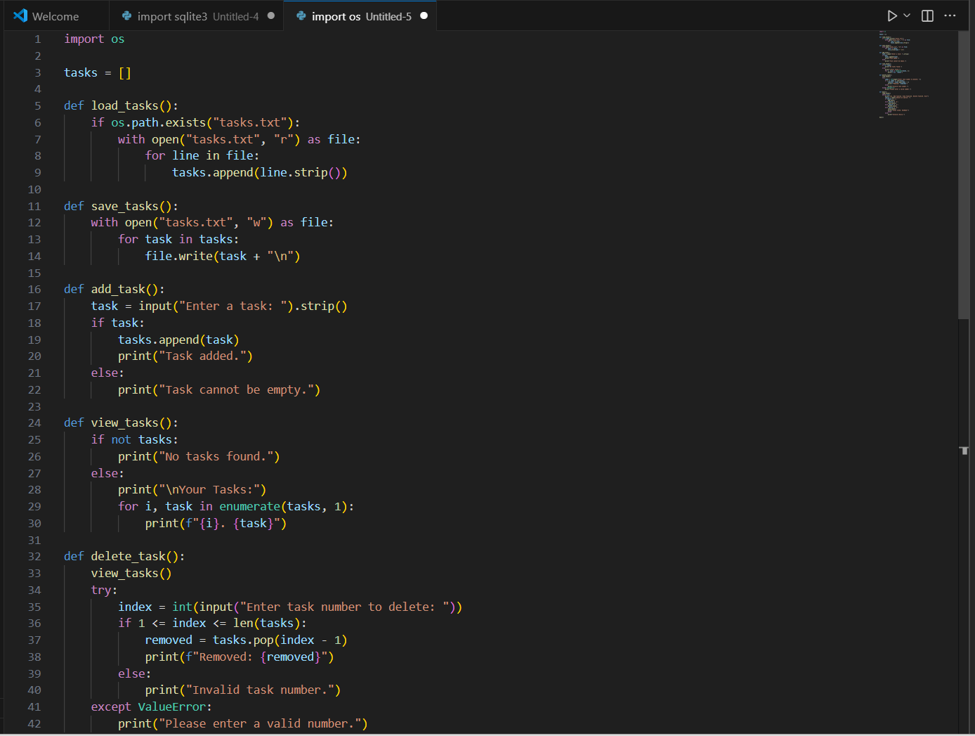  OBSERVATION:  The To-Do List Manager allows users to add, view, and delete tasks through a simple command-line interface. It validates user input, handles errors gracefully, and stores tasks in a local text file to maintain persistence across sessions. The program loads existing tasks at startup and saves changes upon exit, making it both user-friendly and reliable for basic task management.  Task 2 – Version Control Integration  - Initialize a Git repository for your project.  - Perform the following steps:  - Create and switch to a new branch.  - Add AI-assisted modifications.  - Commit with a meaningful message.  - Merge changes back into the main branch.  - Reflect on how version control supports collaborative development with AI assistance.  PROMPT:  "Show how to use Git for version control in a Python project. Include steps to create a branch, apply AI-assisted changes, commit with a message, and merge back to main. Reflect on how Git supports collaboration with AI.  CODE:  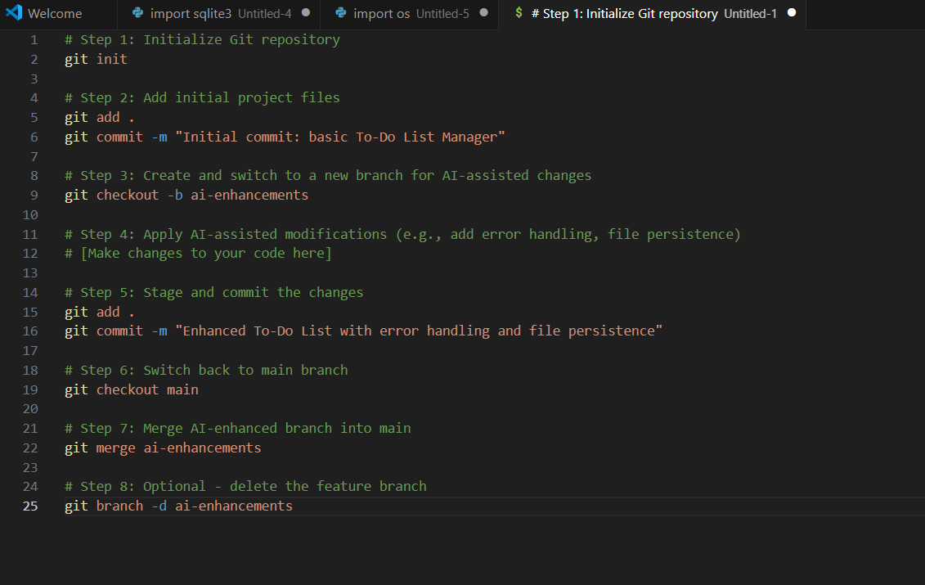  OBSERVATION:  This workflow demonstrates how Git enables structured collaboration between developers and AI tools. By creating a separate branch for AI-assisted enhancements, developers can safely experiment with new features and improvements without affecting the main codebase. Meaningful commit messages document the evolution of the project, and merging ensures that validated changes are integrated smoothly. Version control not only tracks progress but also supports iterative development, making AI a reliable coding partner in collaborative environments.  Task 3 – AI for Commit Message Generation  - Use AI to generate concise, meaningful commit messages based on the changes made.  - Compare AI-generated messages with human-written ones.  - Discuss how AI can improve documentation and traceability in Git history.  PROMPT:  "Generate a concise and meaningful Git commit message for a Python To-Do List program that adds error handling, task deletion, and file saving features."  CODE:  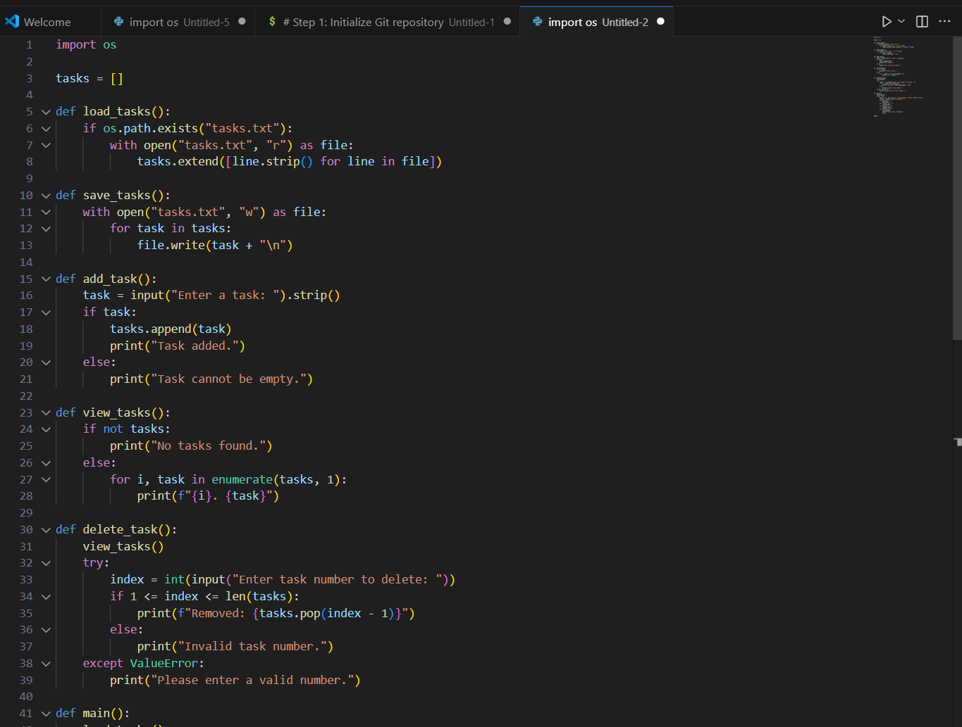  OBSERVATION:  This task shows how AI can generate clear and concise commit messages that summarize code changes effectively. Compared to human-written messages, AI-generated messages are consistent and help maintain a clean Git history. This improves documentation, traceability, and collaboration in software development projects.  Task 4 – Pair Programming Simulation  - Student A writes the initial version of a program.  - Student B, with AI assistance, suggests improvements or adds features.  - Both students collaborate using Git branching and merging to integrate their work.  PROMPT:  "Simulate a pair programming session where Student A writes a basic Python To-Do List app, and Student B uses AI to enhance it with error handling, task deletion, and file saving. Show how they use Git branching and merging to collaborate.”  CODE:  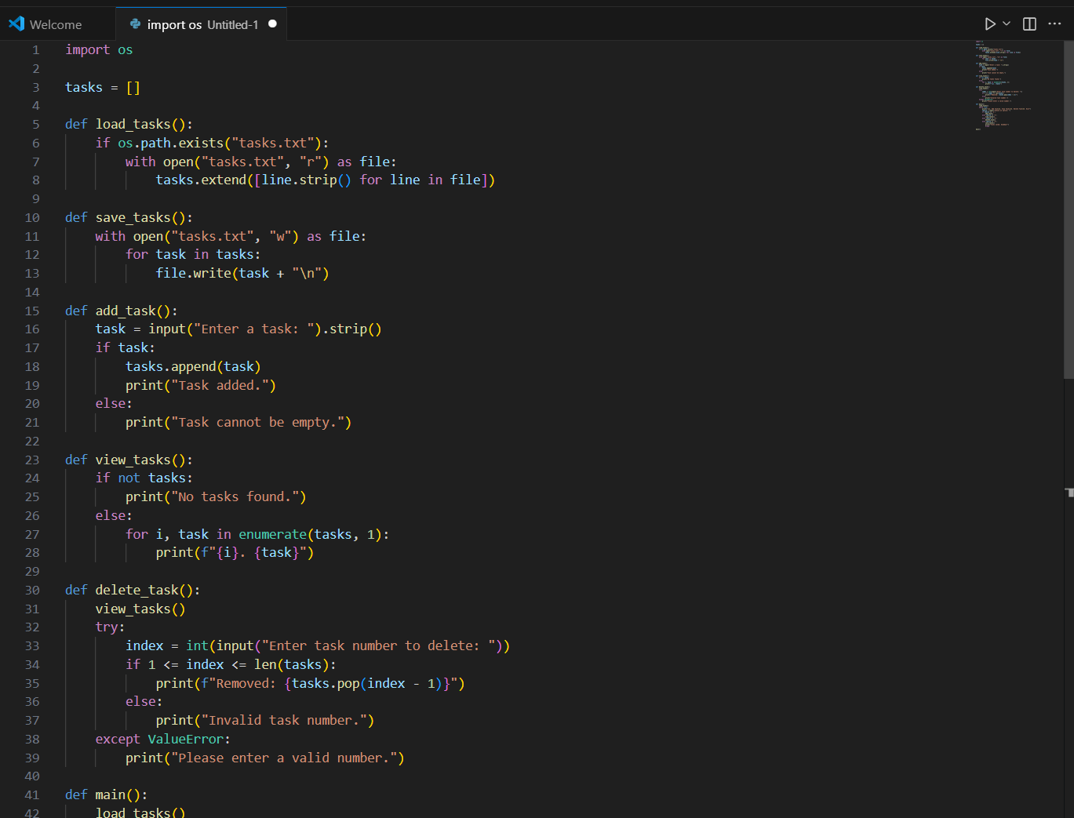  OBSERVATION:  This simulation shows how AI can assist Student B in improving code quality and adding features efficiently. Git branching allows each student to work independently, while merging ensures smooth integration. AI enhances collaboration by suggesting secure, maintainable improvements, and version control keeps the development process organized and traceable.  ✅ Deliverables (For All Tasks)  - AI-generated prompts for code and test case generation.  - At least 3 assert test cases for each task.  - AI-generated initial code and execution screenshots.  - Analysis of whether code passes all tests.  - Improved final version with inline comments and explanation.  - Compiled report (Word/PDF) with prompts, test cases, assertions, code, and output. |  |  |  |  |  | Week11 - Monday

-

