SCHOOL OF COMPUTER SCIENCE AND ARTIFICIAL INTELLIGENCE |  |  |  |  | DEPARTMENT OF COMPUTER SCIENCE ENGINEERING
ProgramName:B. Tech |  |  |  | Assignment Type: Lab |  |  | AcademicYear:2025-2026
CourseCoordinatorName |  |  |  | Venkataramana Veeramsetty
Instructor(s)Name |  |  |  | Dr. V. Venkataramana (Co-ordinator)  Dr. T. Sampath Kumar  Dr. Pramoda Patro  Dr. Brij Kishor Tiwari  Dr.J.Ravichander  Dr. Mohammand Ali Shaik  Dr. Anirodh Kumar  Mr. S.Naresh Kumar  Dr. RAJESH VELPULA  Mr. Kundhan Kumar  Ms. Ch.Rajitha  Mr. M Prakash  Mr. B.Raju  Intern 1 (Dharma teja)  Intern 2 (Sai Prasad)  Intern 3 (Sowmya)  NS_2 ( Mounika)
CourseCode |  |  | 24CS002PC215 | CourseTitle |  | AI Assisted Coding
Year/Sem |  |  | II/I | Regulation |  | R24
Date and Day  of Assignment |  |  | Week4 - Wednesday | Time(s)
Duration |  |  | 2 Hours | Applicableto  Batches
AssignmentNumber:9.3(Present assignment number)/24(Total number of assignments)
 | Q.No. | Question |  |  |  |  |  | ExpectedTime  to complete
 | 1 | Lab 8: Documentation Generation: Automatic documentation and code comments  Lab Objectives:  - To understand the importance of documentation and code comments in software development.  - To explore how AI-assisted coding tools can generate meaningful documentation and inline comments.  - To practice generating function-level and module-level docstrings automatically.  - To evaluate the quality, accuracy, and limitations of AI-generated documentation.  - To develop a small automated tool for documentation generation in Python..  Lab Outcomes (LOs):  After completing this lab, students will be able to:  - Apply AI-assisted coding tools to generate docstrings and inline comments for Python code.  - Critically analyze AI-generated documentation for correctness, completeness, and readability.  - Create structured documentation (function-level, module-level) following standard formats.  - Design and implement a mini documentation generator tool to automate code commenting and docstring creation.  Task Description#1 Basic Docstring Generation  - Write python function to return sum of even and odd numbers in the given list.  - Incorporate manual docstring in code with Google Style  - Use an AI-assisted tool (e.g., Copilot, Cursor AI) to generate a docstring describing the function.  - Compare the AI-generated docstring with your manually written one  Prompt.  genrate a python code in the list format to return sum of even and odd numbers  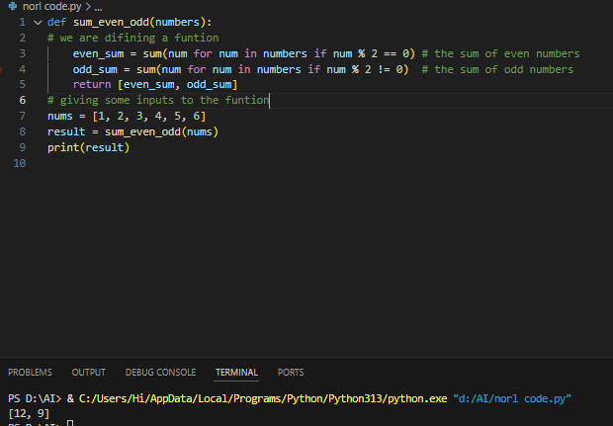  Prompt.  Write a python code in the list format to return sum of even and odd numbers and give some comments for that code  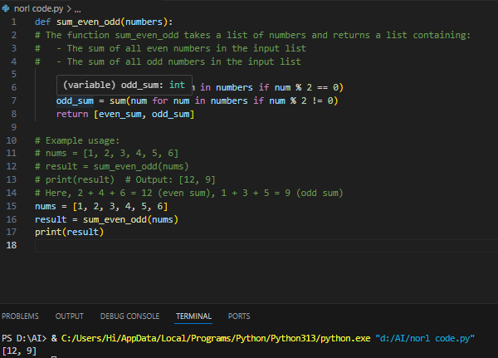  Expected Outcome#1: Students understand how AI can produce function-level documentation.  Observation;  AI-generated docstrings typically exhibit a structured and standardized format, aligning well with widely accepted Python documentation practices. They often include a clear summary of the function’s intent, detailed parameter descriptions with type annotations, and a concise explanation of the return value. This consistency makes them especially suitable for collaborative development and large-scale projects.  On the other hand, manually written docstrings can vary significantly depending on the developer’s experience, habits, or time constraints. They may be brief, informal, or lack technical precision—sometimes omitting type hints or return details altogether. However, manual docstrings can offer richer context or tailored examples when written thoughtfully.  Task Description#2 Automatic Inline Comments  - Write python program for sru_student class with attributes like name, roll no., hostel_status and fee_update method and display_details method.  - Write comments manually for each line/code block  - Ask an AI tool to add inline comments explaining each line/step.  - Compare the AI-generated comments with your manually written one.  Prompt  generate a python program for sru_student class with attributes like name, roll no., hostel_status and fee_update method and display_details  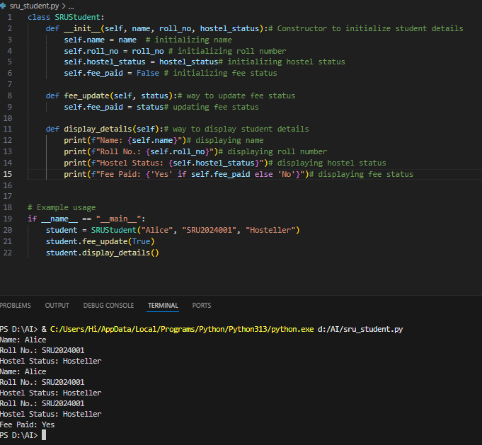  Prompt  generate a python program for sru_student class with attributes like name, roll no., hostel_status and fee_update method and display_details and give some comments for the code  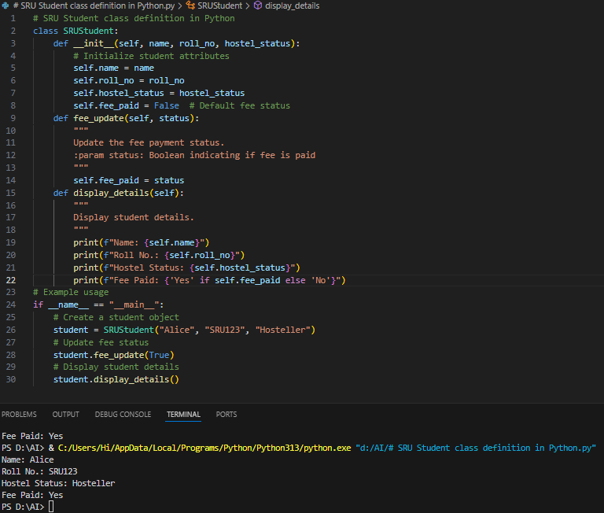  Expected Output#2: Students critically analyze AI-generated code comments.  Observation  Manual comments bring human intuition and flexibility, while AI-generated comments offer clarity, consistency, and professionalism. The best approach? Combine both: use AI to scaffold clean documentation, and refine it manually to reflect deeper logic or project-specific nuances  Task Description#3  - Write a Python script with 3–4 functions (e.g., calculator: add, subtract, multiply, divide).  - Incorporate manual docstring in code with NumPy Style  - Use AI assistance to generate a module-level docstring + individual function docstrings.  - Compare the AI-generated docstring with your manually written one.  Prompt  give me a code of python for basic simple calculator  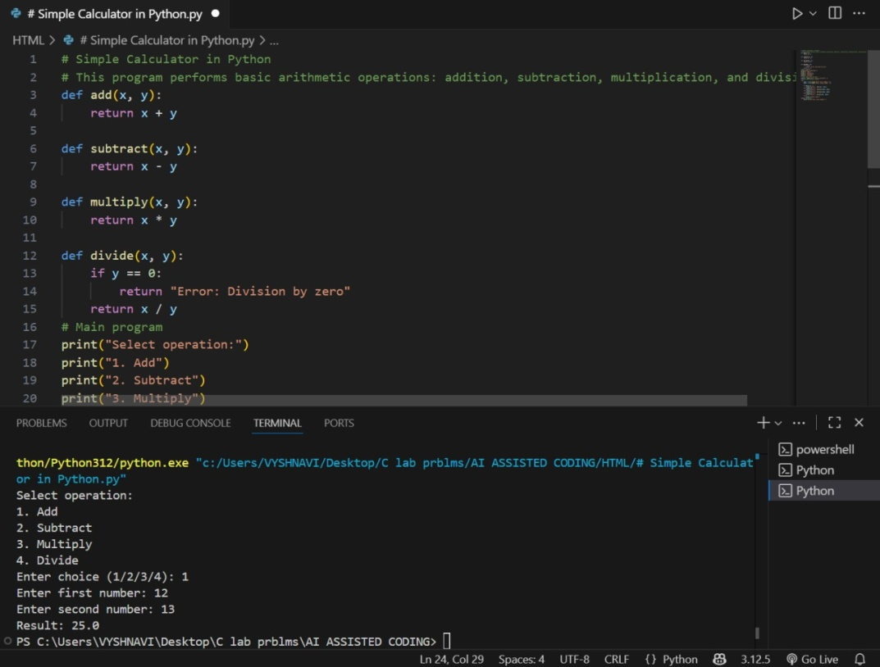  Prompt  using numpy style give me same code with some comments also  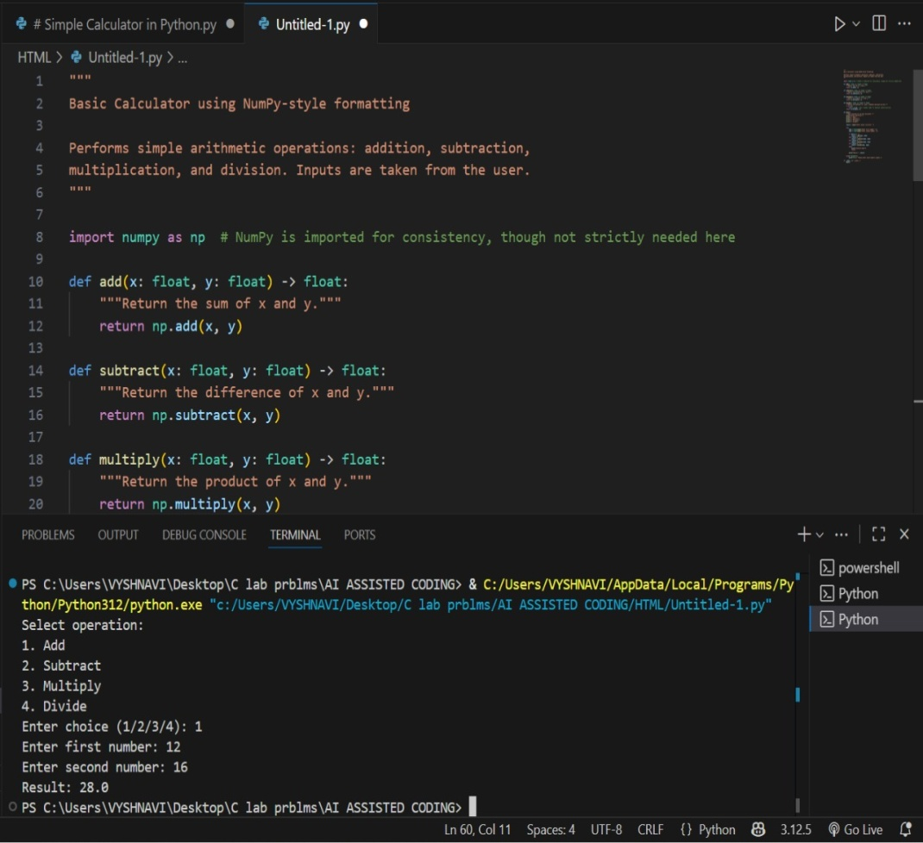  Observation  AI-generated docstrings are quick and follow a standard format, making them useful for basic documentation. They describe what the function does, its inputs, and outputs, but may miss deeper context or special cases. Manually written docstrings, on the other hand, are more detailed and personalized. They reflect the developer’s understanding and can explain complex logic more clearly. While AI saves time, manual docstrings offer better clarity and accuracy when needed.  Expected Output#3: Students learn structured documentation for multi-function scripts  Push documentation whole workspace as .md file in GitHub Repository  Note: Report should be submitted a word document for all tasks in a single document with prompts, comments & code explanation, and output and if required, screenshots |  |  |  |  |  | Week4 - Wednesday

