SCHOOL OF COMPUTER SCIENCE AND ARTIFICIAL INTELLIGENCE |  |  |  |  | DEPARTMENT OF COMPUTER SCIENCE ENGINEERING
Program Name: B. Tech |  |  |  | Assignment Type: Lab |  |  | Academic Year:2025-2026
Course Coordinator Name |  |  |  | Venkataramana Veeramsetty
Instructor(s) Name |  |  |  | Dr. V. Venkataramana (Co-ordinator)
 |  |  |  | Dr. T. Sampath Kumar
 |  |  |  | Dr. Pramoda Patro
 |  |  |  | Dr. Brij Kishor Tiwari
 |  |  |  | Dr.J.Ravichander
 |  |  |  | Dr. Mohammand Ali Shaik
 |  |  |  | Dr. Anirodh Kumar
 |  |  |  | Mr. S.Naresh Kumar
 |  |  |  | Dr. RAJESH VELPULA
 |  |  |  | Mr. Kundhan Kumar
 |  |  |  | Ms. Ch.Rajitha
 |  |  |  | Mr. M Prakash
 |  |  |  | Mr. B.Raju
 |  |  |  | Intern 1 (Dharma teja)
 |  |  |  | Intern 2 (Sai Prasad)
 |  |  |  | Intern 3 (Sowmya)
 |  |  |  | NS_2 ( Mounika)
Course Code |  |  | 24CS002PC215 | Course Title |  | AI Assisted Coding
Year/Sem |  |  | II/I | Regulation |  | R24
Date and Day of Assignment |  |  | Week6 - Monday | Time(s)
Duration |  |  | 2 Hours | Applicable to Batches
AssignmentNumber:11.1(Present assignment number)/24(Total number of assignments)
 | Q.No. | Question |  |  |  |  |  |  | Expected Time  to  complete
 | 1 | Lab 11 – Data Structures with AI: Implementing Fundamental Structures Lab Objectives  - Use AI to assist in designing and implementing fundamental data structures in Python.  - Learn how to prompt AI for structure creation, optimization, and documentation.  - Improve understanding of Lists, Stacks, Queues, Linked Lists, Trees,  Graphs, and Hash Tables. |  |  |  |  |  |  | Week6 - Monday

- Enhance code quality with AI-generated comments and performance suggestions.
Task Description #1 – Stack Implementation
Task: Use AI to generate a Stack class with push, pop, peek, and is_empty methods.
Sample Input Code:
class Stack: pass
Expected Output:
- A functional stack implementation with all required methods and docstrings.
PROMPT:
"Generate a Stack class in Python with the following methods: push, pop, peek, and is_empty. Include comments explaining each method." SCREENSHOT:
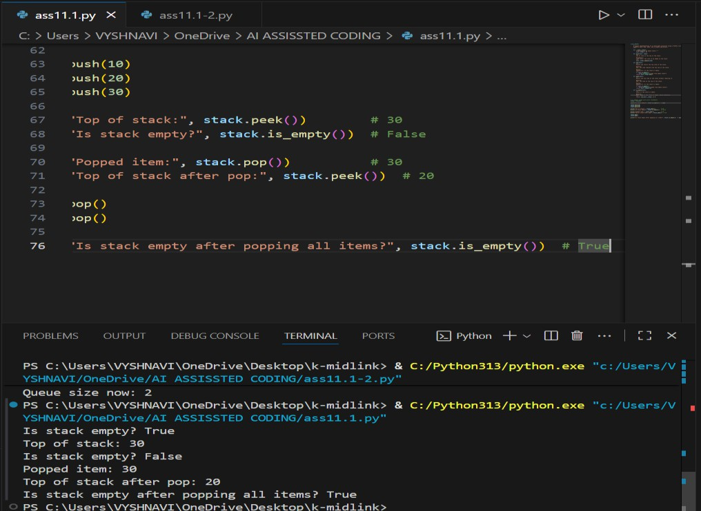

Task Description #2 – Queue Implementation
Task: Use AI to implement a Queue using Python lists. Sample Input Code:
class Queue: pass
Expected Output:

- FIFO-based queue class with enqueue, dequeue, peek, and size methods.
PROMPT:
"Write a Python class called Queue that uses a list to implement.”
SCREENSHOT:

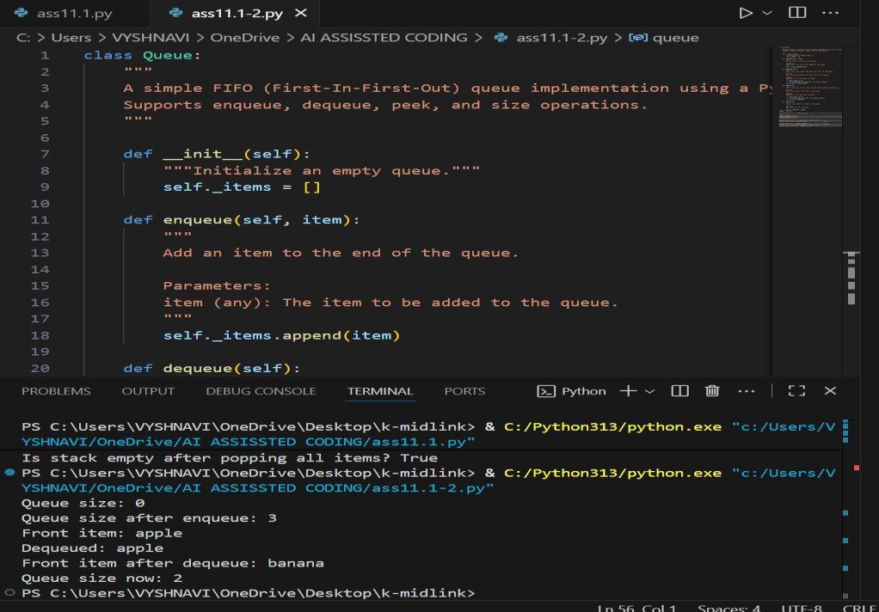

Task Description #3 – Linked List
Task: Use AI to generate a Singly Linked List with insert and display methods. Sample Input Code:
class Node: pass

class LinkedList: pass
Expected Output:
- A working linked list implementation with clear method documentation.
PROMPT:
"Write a Python class for a Singly Linked List with two methods: insert to add a node at the end, and display to print all node values. Include comments explaining each part of the code."
SCREENSHOT:

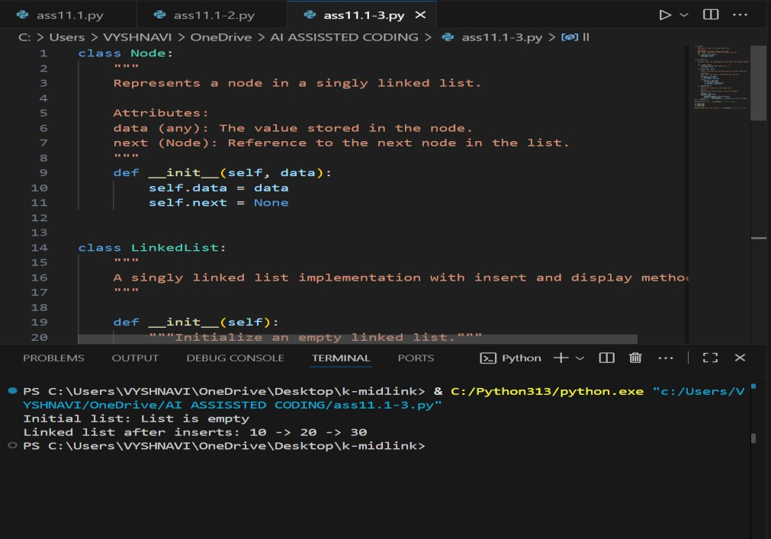
Task Description #4 – Binary Search Tree (BST)
Task: Use AI to create a BST with insert and in-order traversal methods. Sample Input Code:
class BST: pass
Expected Output:
- BST implementation with recursive insert and traversal methods.
PROMPT:
"Write a Python class for a Binary Search Tree with two methods: insert to add nodes, and in_order_traversal to print the tree in sorted order. Include comments explaining each method."
SCREENSHOT:

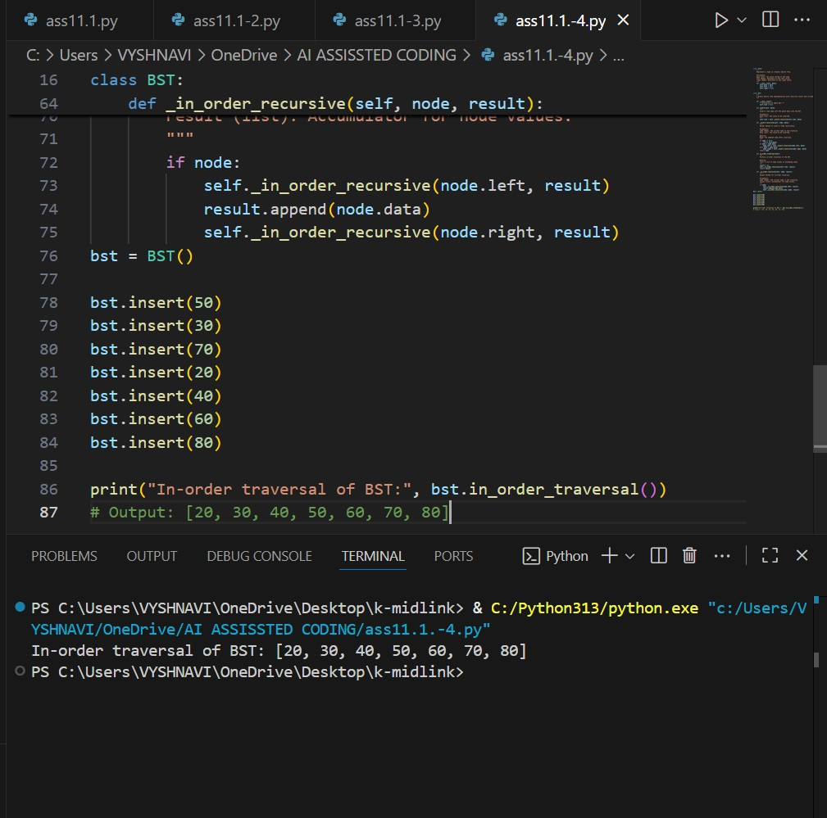
Task Description #5 – Hash Table
Task: Use AI to implement a hash table with basic insert, search, and delete methods.
Sample Input Code:
class HashTable: pass
Expected Output:
- Collision handling using chaining, with well-commented methods.
PROMPT:
"Write a Python class for a hash table using lists. Include methods for insert, search, and delete. Add comments explaining each method." SCREENSHOT:

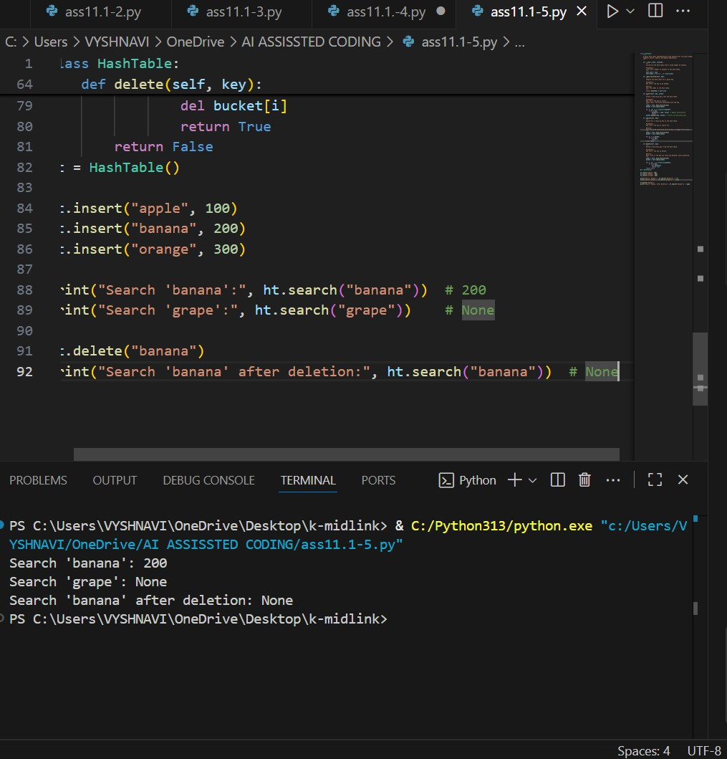
Task Description #6 – Graph Representation
Task: Use AI to implement a graph using an adjacency list. Sample Input Code:
class Graph: pass
Expected Output:
- Graph with methods to add vertices, add edges, and display connections.
PROMPT:
"Write a Python class to represent a graph using an adjacency list. Include methods to add vertices, add edges, and display the graph. Add comments explaining each method."
SCREENSHOT:

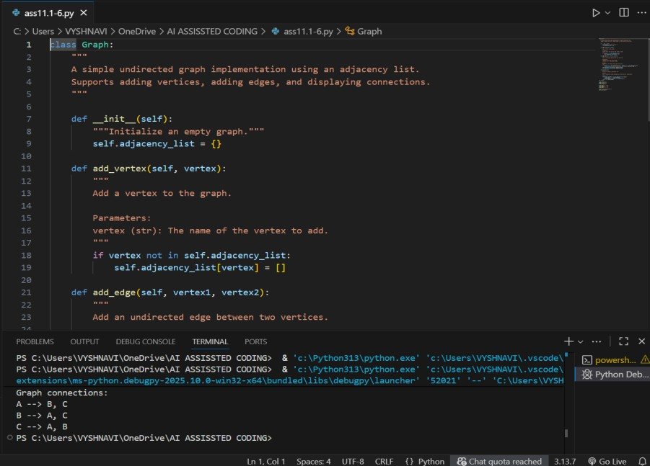
Task Description #7 – Priority Queue
Task: Use AI to implement a priority queue using Python’s heapq module.
Sample Input Code:
class PriorityQueue: pass
Expected Output:
- Implementation with enqueue (priority), dequeue (highest priority), and display methods.
PROMPT:
"Write a Python class for a priority queue using the heapq module. Include methods to insert items with priority, remove the highest priority item, and peek at the highest priority item. Add comments explaining each method."
SCREENSHOT:

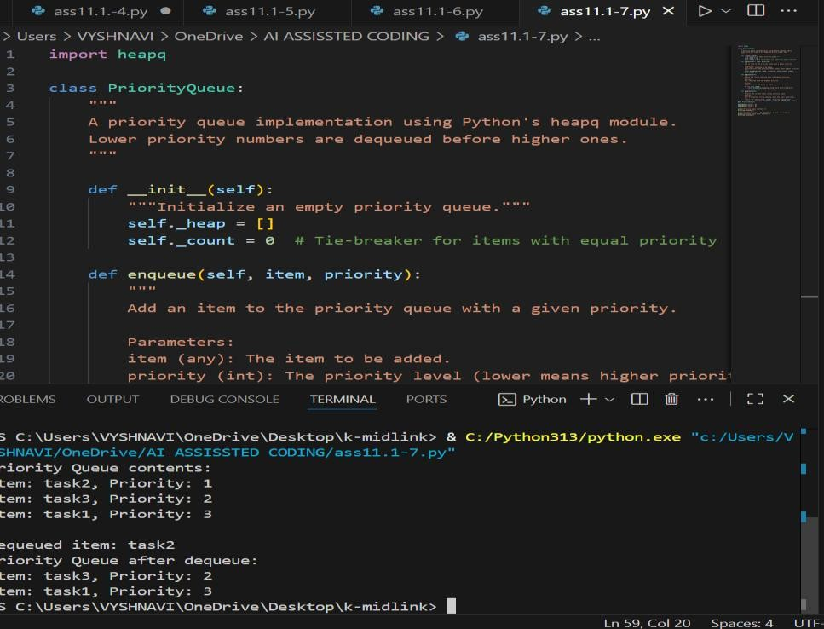
Task Description #8 – Deque
Task: Use AI to implement a double-ended queue using collections.deque. Sample Input Code:
class DequeDS: pass
Expected Output:
- Insert and remove from both ends with docstrings.
PROMPT:
"Write a Python class that wraps collections.deque to implement a double- ended queue. Include methods to add and remove elements from both ends, and display the current state. Add comments explaining each method."
SCREENSHOT:

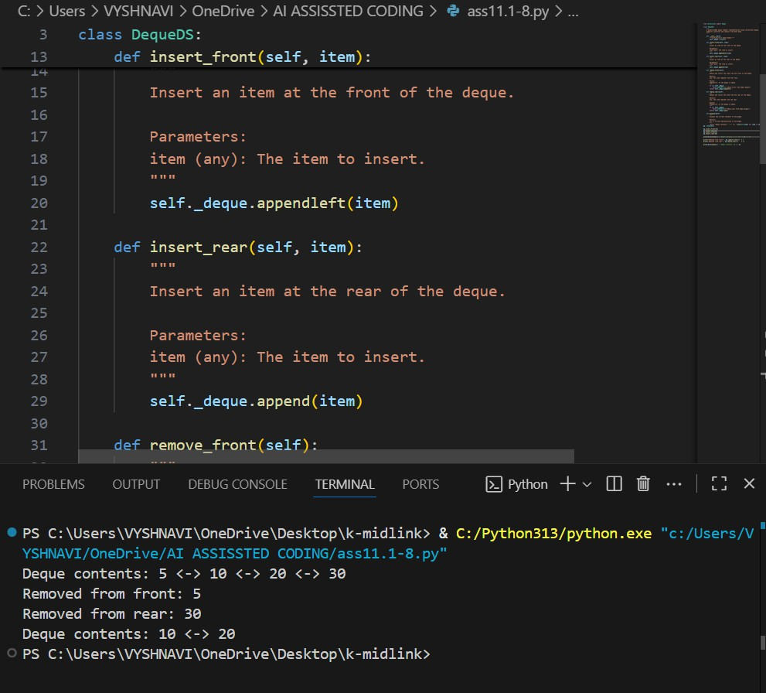
Task Description #9 – AI-Generated Data Structure Comparisons
Task: Use AI to generate a comparison table of different data structures (stack, queue, linked list, etc.) including time complexities.
Sample Input Code:
# No code, prompt AI for a data structure comparison table Expected Output:
- A markdown table with structure names, operations, and complexities.

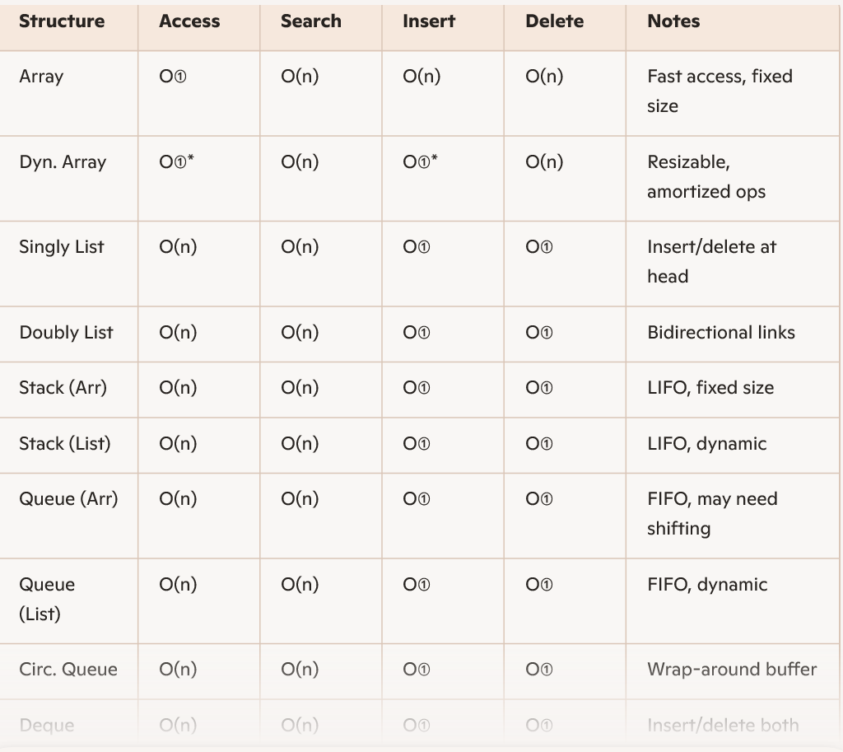
Task Description #10 Real-Time Application Challenge – Choose the Right Data Structure
Scenario:
Your college wants to develop a Campus Resource Management System that handles:
- Student Attendance Tracking – Daily log of students entering/exiting the campus.
- Event Registration System – Manage participants in events with quick search and removal.
- Library Book Borrowing – Keep track of available books and their due dates.
- Bus Scheduling System – Maintain bus routes and stop connections.
- Cafeteria Order Queue – Serve students in the order they arrive. Student Task:
  - For each feature, select the most appropriate data structure from the list below:
    - Stack
    - Queue
    - Priority Queue
    - Linked List
    - Binary Search Tree (BST)
    - Graph
    - Hash Table
    - Deque

- Justify your choice in 2–3 sentences per feature.
- Implement one selected feature as a working Python program with AI- assisted code generation.
Expected Output:
- A table mapping feature → chosen data structure → justification.
- A functional Python program implementing the chosen feature with comments and docstrings.
PROMPT:
Choose the best data structure for each campus system feature (attendance, events, library, buses, cafeteria) from a given list. Justify each choice in 2–3 sentences. Then, implement one feature in Python with clear comments and docstrings.
SCREENSHOT:
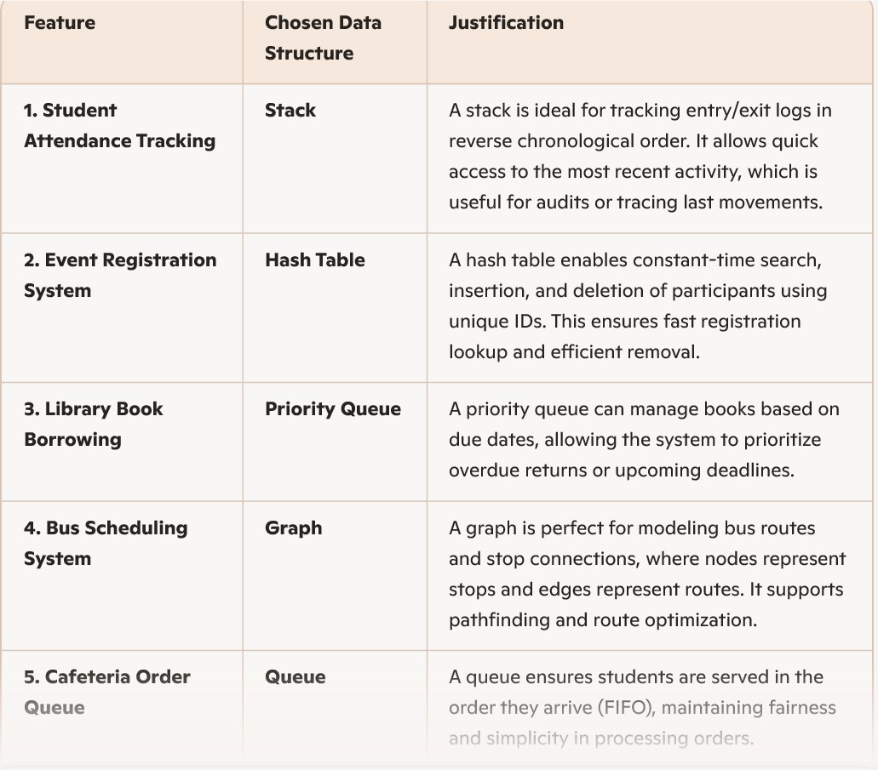
CODE:

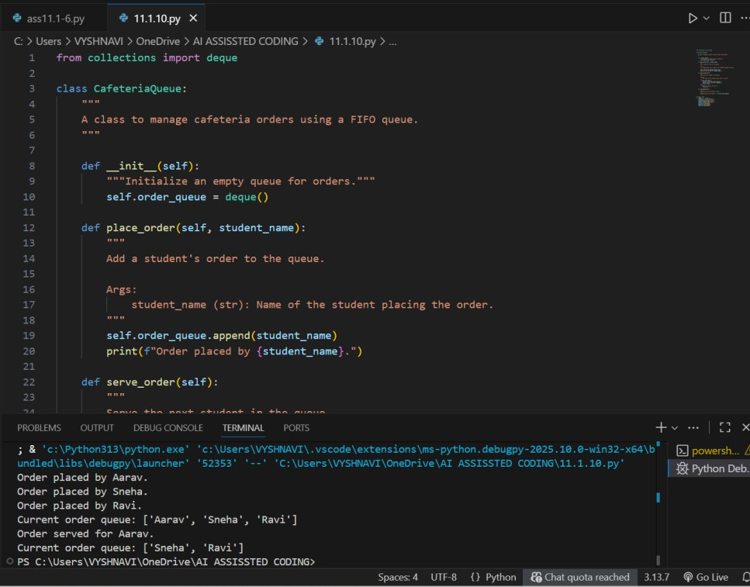

⬛ Deliverables (For All Tasks)
- AI-generated prompts for code and test case generation.
- At least 3 assert test cases for each task.
- AI-generated initial code and execution screenshots.
- Analysis of whether code passes all tests.
- Improved final version with inline comments and explanation.
- Compiled report (Word/PDF) with prompts, test cases, assertions, code, and output.

