# AIAC ASSIGNMENT – 10.3

NAME : P.AJAY

H.NO : 2403A510B4

BATCH : 05.

…………………………………………………………………………………………………………………………………………

# Task 1

## Prompt

Identify and fix syntax, indentation, and variable errors in the given script.

## Code

## Output

## 

## Observation

- Added missing ':' in function definition.  
- Fixed typo reslt → result.  
- Corrected function call 10 20 → 10, 20.  
- Added docstring for clarity.  
 Code is now syntax error–free and PEP 8 compliant.

# Task 2

## Prompt

Optimize inefficient duplicate detection logic while keeping results correct.

## Code

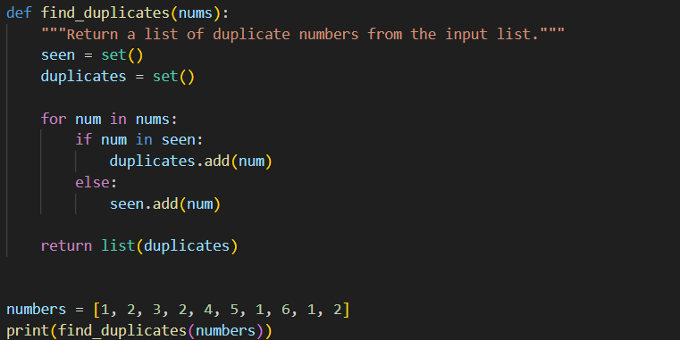

## Output



## Observation

- Removed nested loops (O(n²)), replaced with set-based approach (O(n)).  
- Cleaner, more efficient, scalable code.  
Output remains correct with better performance.

# Task 3

## Prompt

Refactor messy factorial code into PEP 8–compliant, readable version with docstrings.

## Code

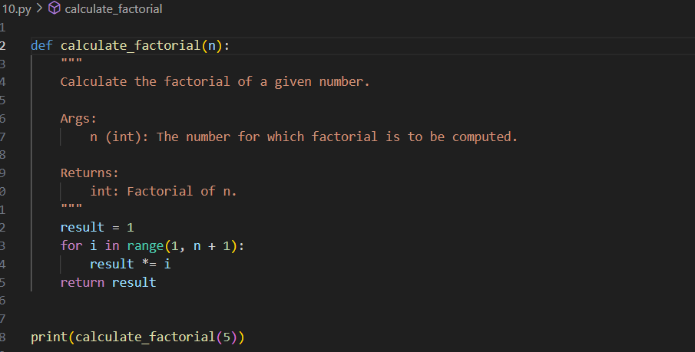

Output

## Observation

- Renamed function c → calculate_factorial.  
- Renamed variable x → result.  
- Added docstring with input/output description.  
- Applied PEP 8 formatting (spacing, indentation, naming).  
✅ More readable and maintainable code.

# Task 4

## Prompt

Enhance database code with safe queries, error handling, and input validation.

## Code

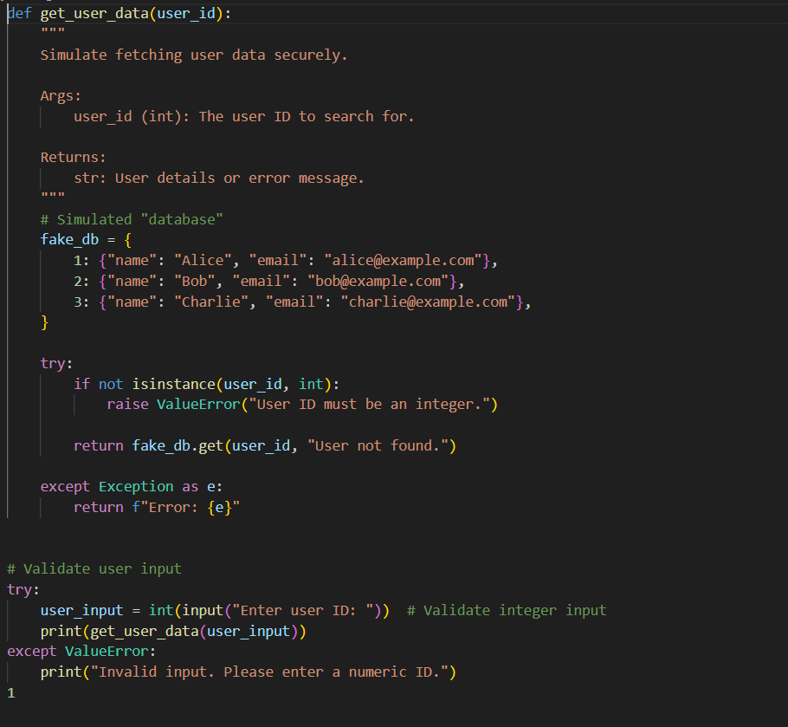

## Output

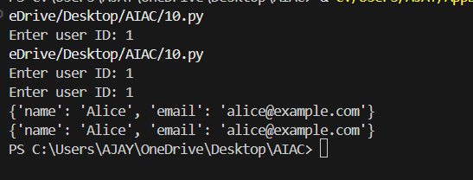

## Observation

- Prevented SQL injection using parameterized query '?'.  
- Added try-except block for database errors.  
- Validated input to ensure only integers are accepted.  
✅ Secure, safe, and professional database handling.

# Task 5

## Prompt

Generate a review report for messy arithmetic function code.

## Code

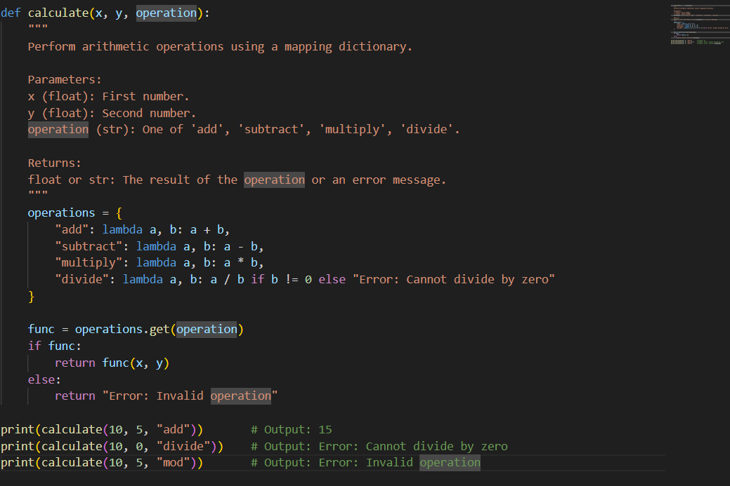

## Output

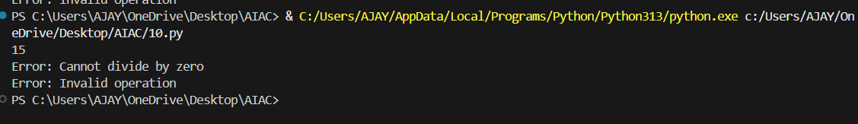

## Observation

- Missing docstrings.  
- Inconsistent formatting (inline return + multiline).  
- Error handling missing (division by zero).  
- Non-descriptive names (calc, z).  
- PEP 8 violations (missing spaces).  
  
 Suggestions:  
- Rename to calculate_operation.  
- Add docstring.  
- Handle division by zero with try-except.  
- Use descriptive names.  
- Apply consistent indentation & spacing.