ASSIGNMENT -11.1

NAME :P.AJAY

HALL.NO:2403A510B4

BATCH:05

# Task 1: Stack Implementation

Prompt: Generate a Stack class with push, pop, peek, and is_empty methods.

Code: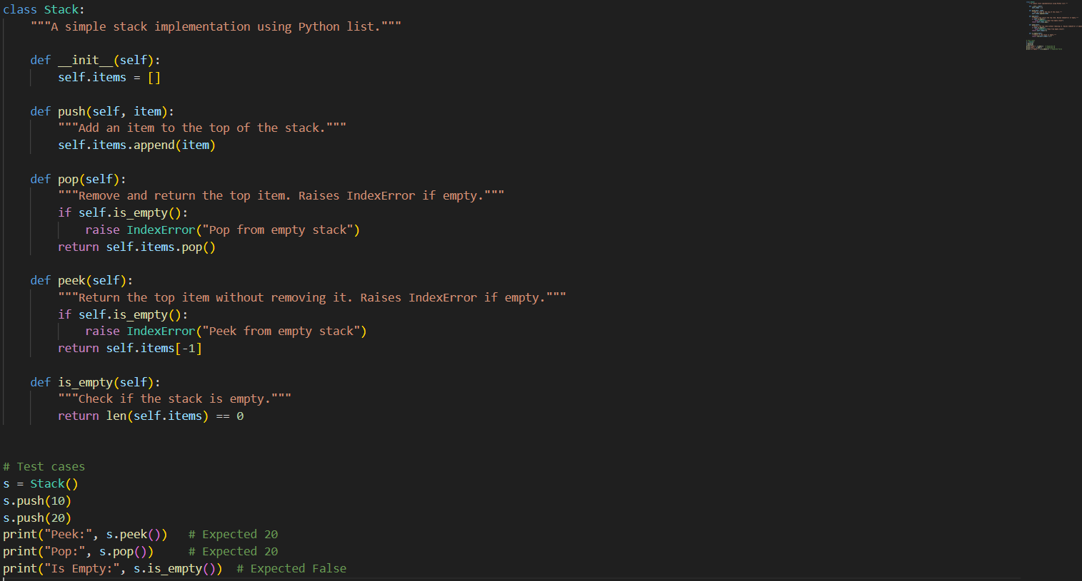

Output: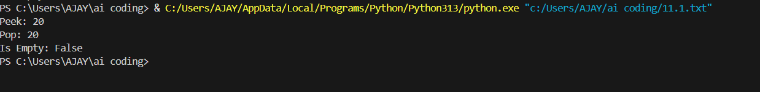

Observation:

(Analysis and AI suggestions for Stack Implementation)

# Task 2: Queue Implementation

Prompt: Implement a Queue using Python lists.

Code:

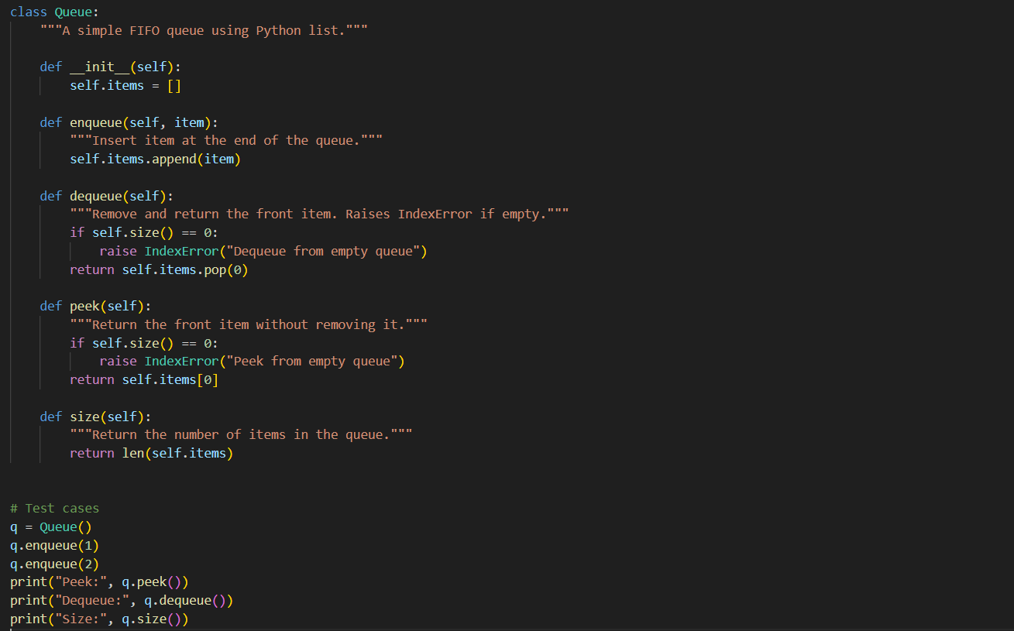

Output: 

Observation:

(Analysis and AI suggestions for Queue Implementation)

# Task 3: Linked List

Prompt: Generate a Singly Linked List with insert and display methods.

Code: 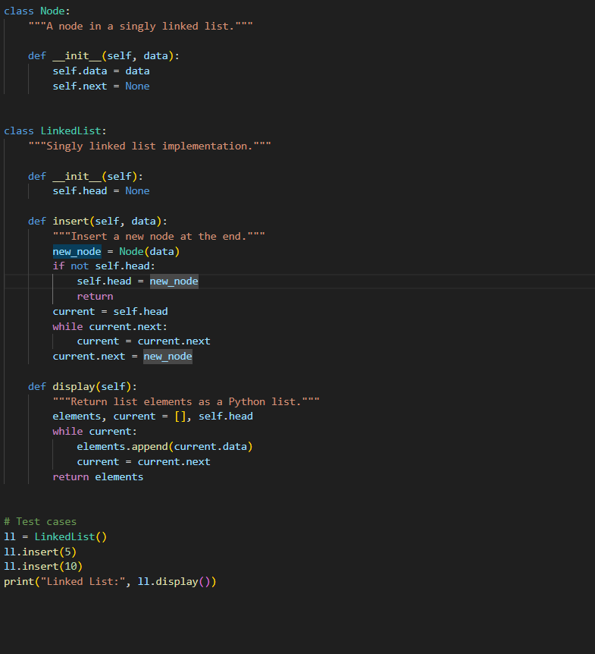

Output: 

Observation:

(Analysis and AI suggestions for Linked List)

# Task 4: Binary Search Tree (BST)

Prompt: Create a BST with insert and in-order traversal methods.

Code: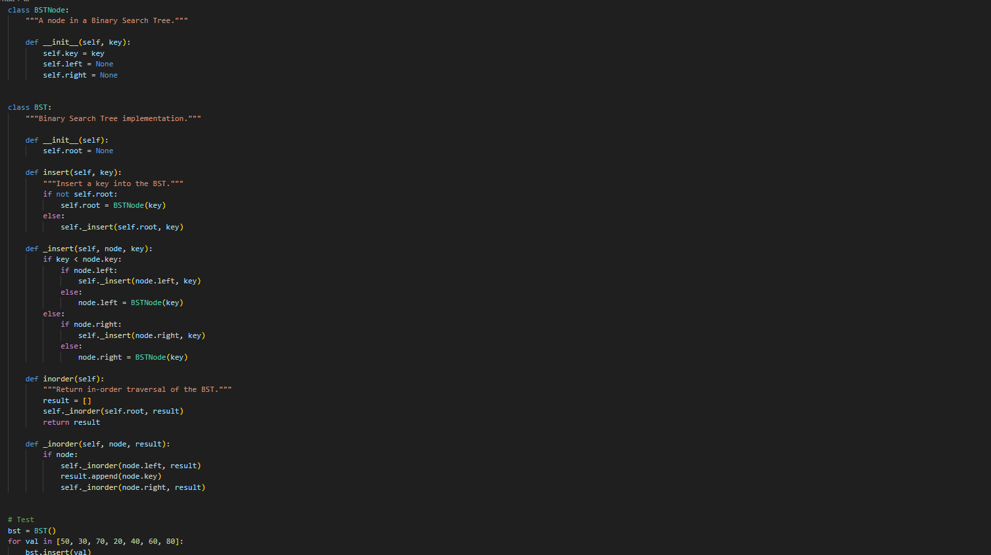

Output: 

Observation:

(Analysis and AI suggestions for Binary Search Tree (BST))

# Task 5: Hash Table

Prompt: Implement a hash table with insert, search, and delete methods with chaining.

Code: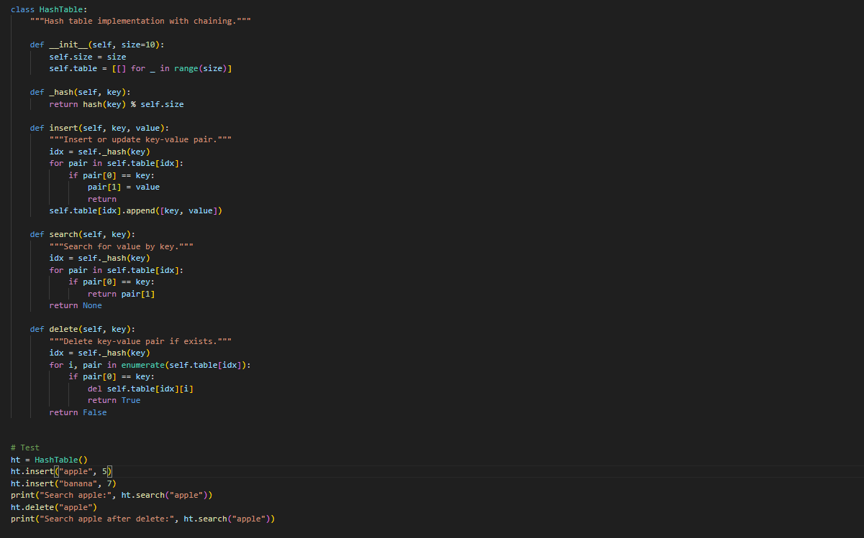

Output:

Observation:

(Analysis and AI suggestions for Hash Table)

# Task 6: Graph Representation

Prompt: Implement a graph using an adjacency list.

Code: 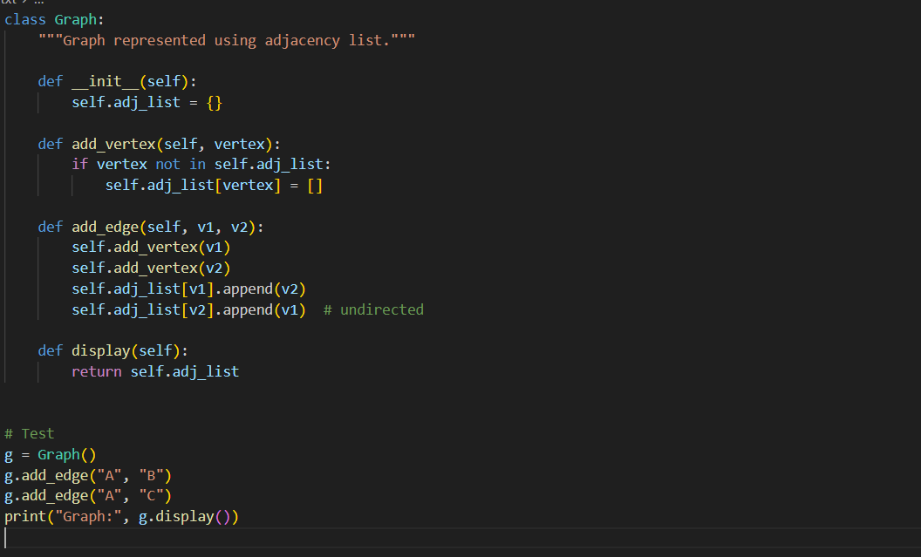

Output: 

Observation:

(Analysis and AI suggestions for Graph Representation)

# Task 7: Priority Queue

Prompt: Implement a priority queue using Python’s heapq module.

Code: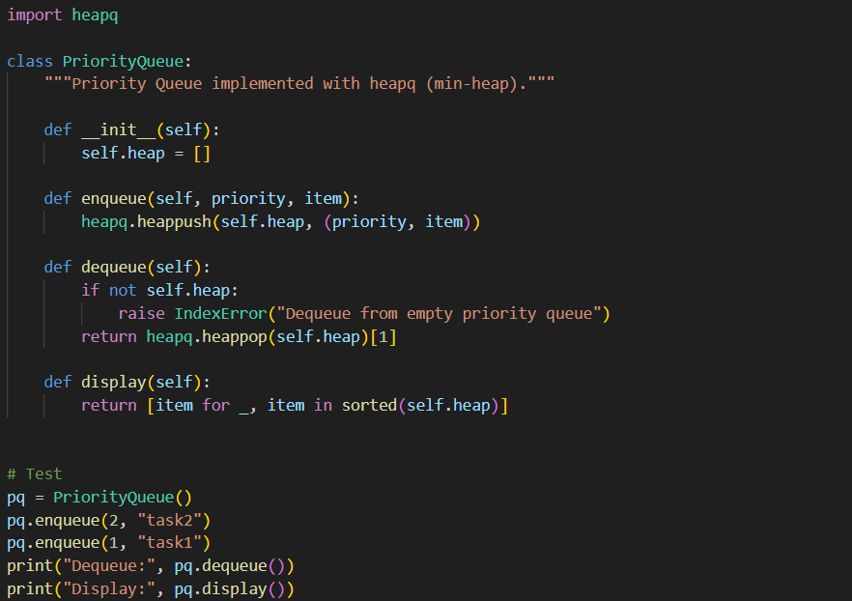

Output:

Observation:

(Analysis and AI suggestions for Priority Queue)

# Task 8: Deque

**Prompt:** Implement a double-ended queue using collections.deque.

Code: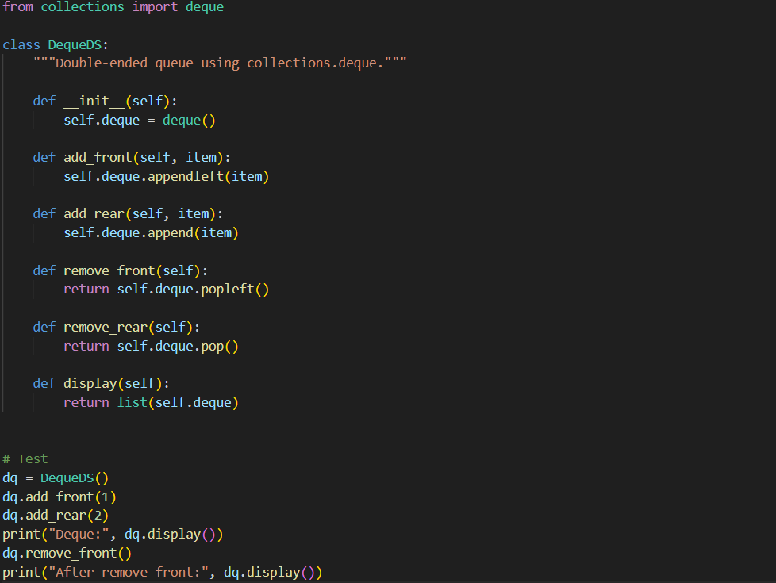

Output: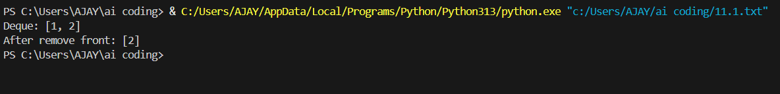

Observation:

(Analysis and AI suggestions for Deque)

# Task 9: Data Structure Comparisons

Prompt: Generate a comparison table of data structures with time complexities.

TABLE:

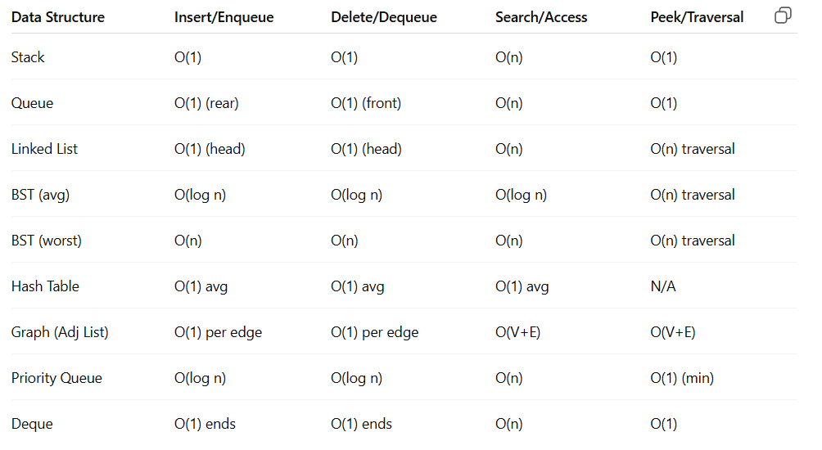

Observation:

(Analysis and AI suggestions for Data Structure Comparisons)

# Task 10: Real-Time Application Challenge

Prompt: Choose appropriate data structures for given campus system features.

Code: 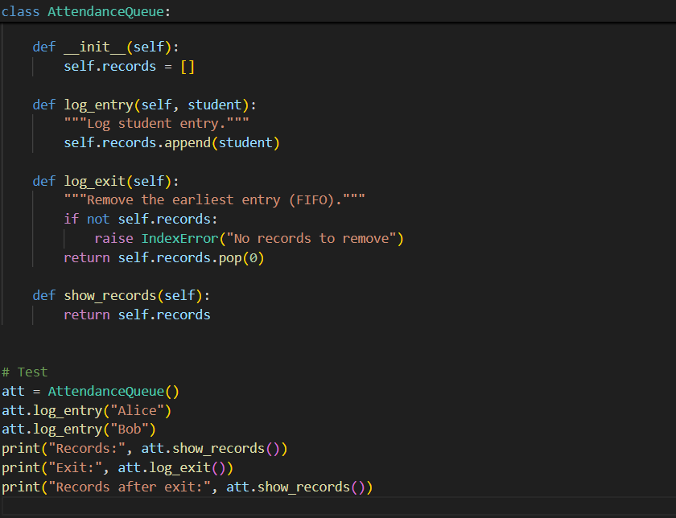

Output:

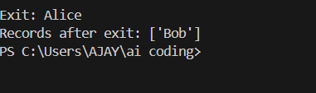

Observation:

(Analysis and AI suggestions for Real-Time Application Challenge)