SCHOOL OF COMPUTER SCIENCE AND ARTIFICIAL INTELLIGENCE |  |  |  |  | DEPARTMENT OF COMPUTER SCIENCE ENGINEERING
Program Name: B. Tech |  |  |  | Assignment Type: Lab |  |  | Academic Year:2025-2026
Course Coordinator Name |  |  |  | Venkataramana Veeramsetty
Instructor(s) Name
  Dr. V. Venkataramana (Co-ordinator)
  Dr. T. Sampath Kumar
  Dr. Pramoda Patro
  Dr. Brij Kishor Tiwari
  Dr.J.Ravichander
  Dr. Mohammand Ali Shaik
  Dr. Anirodh Kumar
  Mr. S.Naresh Kumar
  Dr. RAJESH VELPULA
  Mr. Kundhan Kumar
  Ms. Ch.Rajitha
  Mr. M Prakash
  Mr. B.Raju
  Intern 1 (Dharma teja)
  Intern 2 (Sai Prasad)
  Intern 3 (Sowmya)
  NS_2 ( Mounika)
Course Code |  |  | 24CS002PC215 | Course Title |  | AI Assisted Coding
Year/Sem |  |  | II/I | Regulation |  | R24
Date and Day  of Assignment |  |  | Week10 - Monday | Time(s)
Duration |  |  | 2 Hours | Applicable to  Batches
AssignmentNumber:20.1(Present assignment number)/24(Total number of assignments)
 | Q.No. | Question |  |  |  |  |  | Expected Time  to complete
 | 1 | Lab 20 – Security Testing: Identifying Vulnerabilities in AI-Generated Code  Lab Objectives:  - Understand how to test AI-generated code for common security vulnerabilities.  - Learn to apply secure coding principles while analyzing AI outputs.  - Practice detecting risks such as SQL injection, XSS, hardcoded credentials, and weak encryption.  - Enhance code reliability and safety by using AI for secure refactoring.  Task 1 – Input Validation Check  Task:  Analyze an AI-generated Python login script for input validation vulnerabilities.  Instructions:  - Prompt AI to generate a simple username-password login program.  - Review whether input sanitization and validation are implemented.  - Suggest secure improvements (e.g., using re for input validation).  Expected Output:  - A secure version of the login script with proper input validation.  PROMPT: GIVE ME A PYTHON CODE TO USERNAME-PASSWORD LOGIN PROGRAM.  CODE:  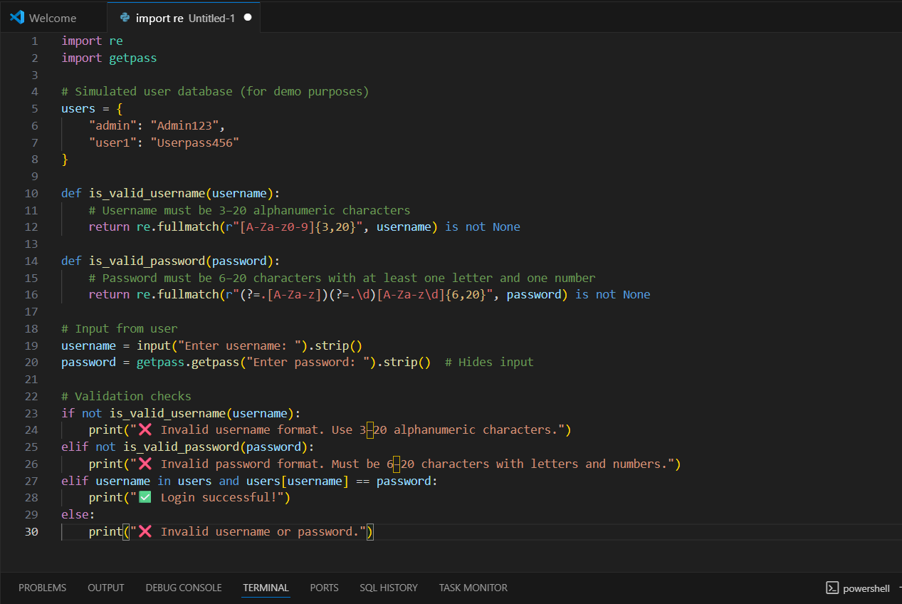  OBSERVATION:  The login script now includes input sanitization and validation using regular expressions to ensure usernames and passwords follow secure formatting rules. It trims whitespace, hides password input with getpass, and checks for proper length and character requirements. These improvements help prevent malformed input and enhance overall security.  Task 2 – SQL Injection Prevention  Task:  Test an AI-generated script that performs SQL queries on a database.  Instructions:  - Ask AI to generate a Python script using SQLite/MySQL to fetch user details.  - Identify if the code is vulnerable to SQL injection (e.g., using string concatenation in queries).  - Refactor using parameterized queries (prepared statements).  Expected Output:  - A secure database query script resistant to SQL injection.  Prompt:  "Write a secure Python script using SQLite to fetch user details based on username input, ensuring protection against SQL injection by using parameterized queries."  CODE:  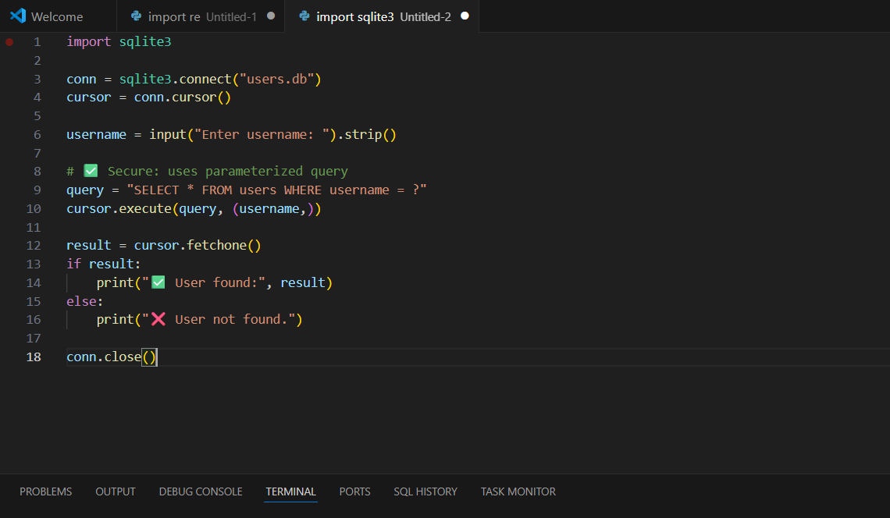  OBSERVATION:  The script securely connects to a SQLite database and fetches user details using a parameterized query, which effectively prevents SQL injection attacks. It uses input().strip() to sanitize the username input and avoids unsafe string concatenation in the SQL statement. By using cursor.execute(query, (username,)), the script ensures that user input is treated as data, not executable SQL code. This is a recommended practice for secure database interactions. For further security, input validation (e.g., using regular expressions) and password hashing should be considered if authentication is involved.  Task 3 – Cross-Site Scripting (XSS) Check  Task:  Evaluate an AI-generated HTML form with JavaScript for XSS vulnerabilities.  Instructions:  - Ask AI to generate a feedback form with JavaScript-based output.  - Test whether untrusted inputs are directly rendered without escaping.  - Implement secure measures (e.g., escaping HTML entities, using CSP).  Expected Output:  - A secure form that prevents XSS attacks.  Prompt:  "Create a secure HTML feedback form that uses JavaScript to display user input without allowing XSS. The form should escape HTML entities in user input and include a Content Security Policy (CSP) to prevent script injection."  CODE:  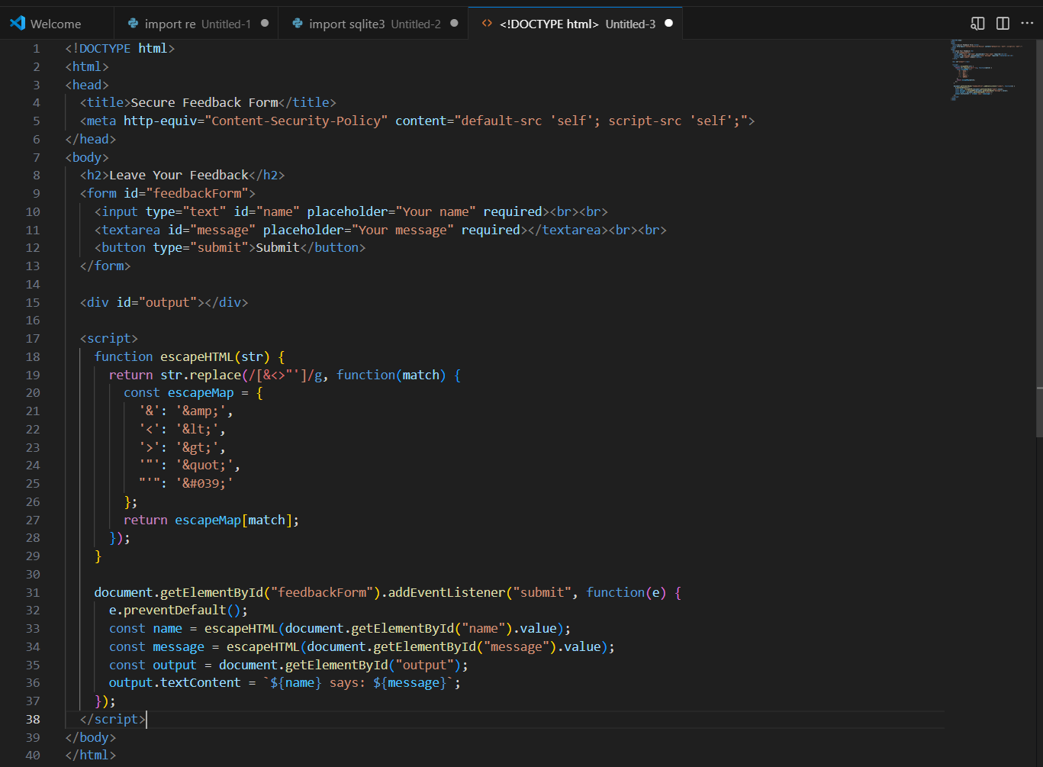  OBSERVATION:  The provided HTML feedback form securely handles user input by escaping HTML entities through a custom escapeHTML() function and rendering output using textContent, which prevents execution of malicious scripts. Additionally, the inclusion of a Content Security Policy (CSP) restricts script sources to 'self', offering strong protection against XSS attacks. These measures ensure that untrusted input is safely displayed without compromising browser security.  Task 4 – Real-Time Application: Security Audit of AI-Generated Code  Scenario:  Students pick an AI-generated project snippet (e.g., login form, API integration, or file upload).  Instructions:  - Perform a security audit to detect possible vulnerabilities.  - Prompt AI to suggest secure coding practices to fix issues.  - Compare insecure vs secure versions side by side.  Expected Output:  - A security-audited code snippet with documented vulnerabilities and fixes.  Prompt:  "Build a secure Python login system using SQLite with input validation, password hashing, and safe SQL queries."  CODE:  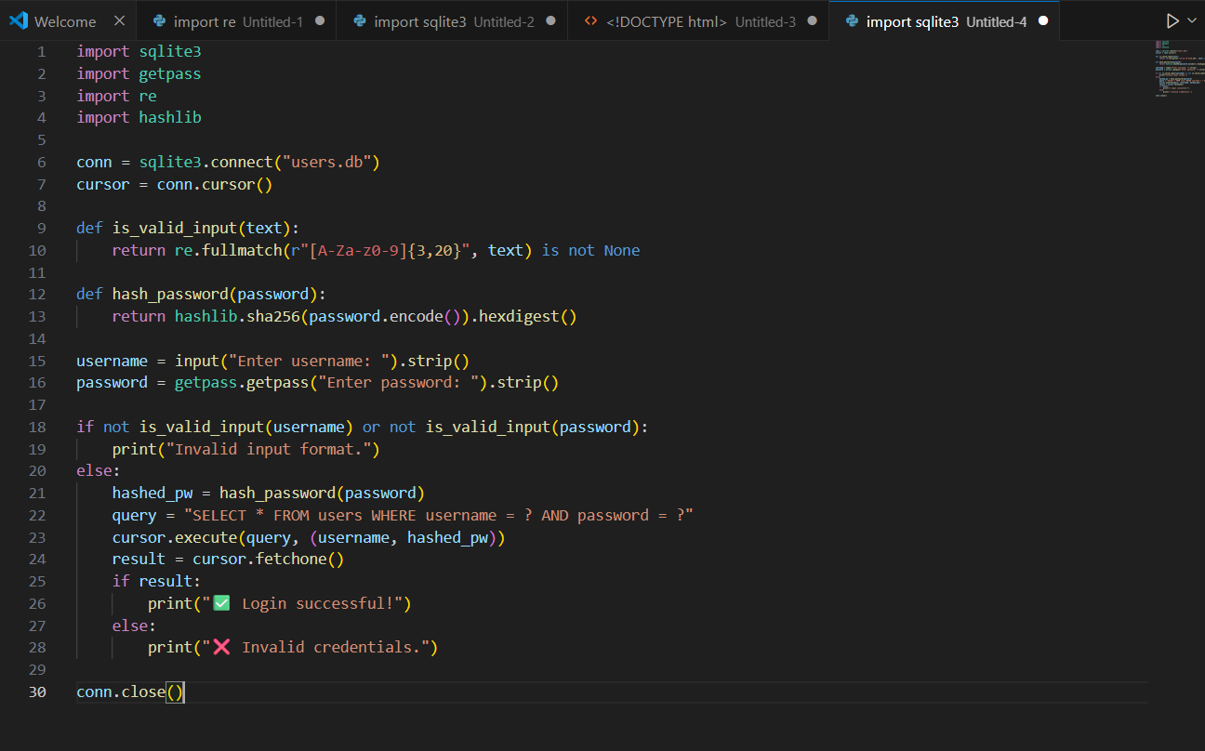  OBSERVATION:  The secure version of the login script addresses multiple vulnerabilities found in the original AI-generated code. It replaces unsafe string concatenation with parameterized SQL queries to prevent injection attacks, uses SHA-256 hashing to protect passwords instead of storing them in plain text, and validates user input using regular expressions to ensure proper formatting. Additionally, it hides password input using the getpass module to enhance privacy. These improvements collectively strengthen the authentication process and safeguard against common security threats.  ✅ Deliverables (For All Tasks)  - AI-generated prompts for code and test case generation.  - At least 3 assert test cases for each task.  - AI-generated initial code and execution screenshots.  - Analysis of whether code passes all tests.  - Improved final version with inline comments and explanation.  - Compiled report (Word/PDF) with prompts, test cases, assertions, code, and output. |  |  |  |  |  | Week10 - Monday

