**AI ASSISTED CODING**

NAME:

CHANDA HARINI

ROLL NO:2403A510E1

ASSIGNMENT : 8.3

1

**Task Description#1**

Use AI to generate test cases for is_valid_email(email) and then implement the

validator function.

**Requirements:**

•

Must contain @ and . characters.

•

Must not start or end with special characters.

•

Should not allow multiple @.

**Expected Output#1**

•

Email validation logic passing all test cases

**PROMPT:**

write a python function using to generate gmail

Adress

code

is_valid_email(email) and then implement

the

validator function.

Requirements:

• Must contain @ and . characters.

• Must not start or end with special characters.

• Should not allow multiple @.

**CODE:**

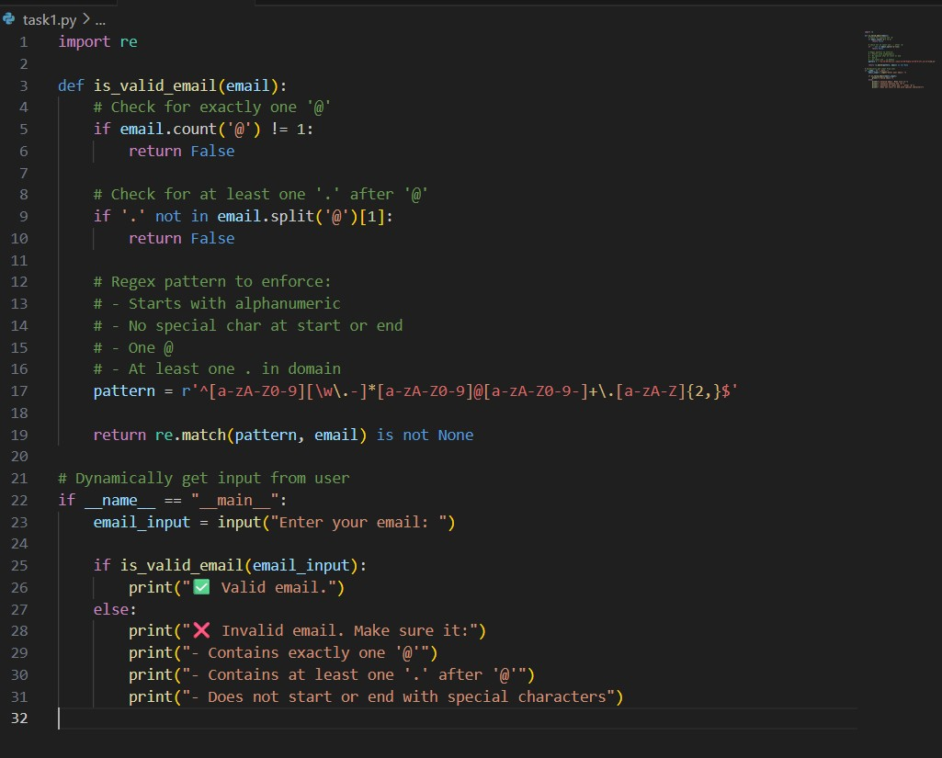

|  |  |  |
| --- | --- | --- |
|  | **OUTPUT:**      **Task Description#2 (Loops)**   * Ask AI to generate test cases for assign_grade(score) function. Handle boundary and invalid inputs.   **Requirements**   * AI should generate test cases for assign_grade(score) where: 90-100: A, 80-89: B, 7079: C, 60-69: D, <60: F * Include boundary values and invalid inputs (e.g., -5, 105, "eighty").     **Expected Output#2**  Grade assignment function passing test suite      **PROMT:**  write a python code for assign_grade(score) function. Handle boundary and invalid inputs.  Requirements   * AI should generate test cases for assign_grade(score) where: 90100: A, 80-89: B, 70-79: C, 60-69: D, <60: F * Include boundary values and invalid inputs (e.g., -5, 105, "eighty").   **CODE:** |  |

|  |  |  |
| --- | --- | --- |
|  | **OUTPUT:** |  |

|  |  |  |
| --- | --- | --- |
|  | **Task Description#3**   * Generate test cases using AI for is_sentence_palindrome(sentence). Ignore case, punctuation, and spaces     **Requirement**   * Ask AI to create test cases for is_sentence_palindrome(sentence) (ignores case, spaces, and punctuation).      * Example:   "A man a plan a canal Panama" → True  **Expected Output#3**   * Function returns True/False for cleaned sentences• Implement the function to pass AI-generated tests.       **PROMPT:**  Write a python code for is_sentence_palindrome(sentence). Ignore case, punctuation, and spaces    Requirement   * Ask AI to create test cases for is_sentence_palindrome(sentence) (ignores case, spaces, and punctuation).      * Example:   "A man a plan a canal Panama" → True.  **CODE:** |  |

|  |  |  |
| --- | --- | --- |
|  | **OUTPUT:**        **Task Description#4**   * Let AI fix itPrompt AI to generate test cases for a ShoppingCart class (add_item, remove_item, total_cost).     **Methods:**  Add_item(name,orice)  Remove_item(name)  Total_cost()    **Expected Output#4**   * Full class with tested functionalities |  |

|  |  |  |
| --- | --- | --- |
|  | **PROMPT:**  Write a python program to generate test cases for a ShoppingCart class (add_item, remove_item, total_cost).    **Methods:**  Add_item(name,orice)  Remove_item(name)  Total_cost() . give the code dynamically  **CODE:** |  |

|  |  |  |
| --- | --- | --- |
|  | **OUTPUT:**      **Task Description#5**  • Use AI to write test cases for convert_date_format(date_str) to switch from "YYYYMM-DD" to "DD-MM-YYYY".  **Example:"2023-10-15" → "15-10-2023"**    **Expected Output#5** |  |

|  |  |  |  |  |  |
| --- | --- | --- | --- | --- | --- |
|  | • Function converts input format correctly for all test cases  **PROMPT:**  Write a python program to generate convert_date_format(date_str) to switch from "YYYY-MM-DD" to "DD-MM-YYYY".  Example: "2023-10-15" → "15-10-2023". give code dynamically    **CODE:**    **OUTPUT:** | | | |  |
|  | | **Note: Report should be submitted a word document for all tasks in a single document with prompts, comments & code explanation, and output and if required, screenshots**      **Evaluation Criteria:** | | |  |
| **Criteria** | **Max Marks** |  |
| Task #1  Task #2 | 0.5  0.5 |
| Task #3 | 0.5 |
| Task #4 | 0.5 |
| Task #5 | 0.5 |
| **Total** | **2.5 Marks** |