**AI-ASSISSTED CODING**

**NAME:SANIYA**

**BATCH:05**

**HT.NO:2403A510E7**

**LAB ASSIGNMENT:11.1**

* **TASK -1**

**PROMPT**:

Identify and fix syntax, indentation, and variable errors in the following Python script. Add explanations of what was corrected.

# buggy_code_task1.py

def add_numbers(a, b)

result = a + b

return reslt

print(add_numbers(10 20))

**CODE GENERATED**:

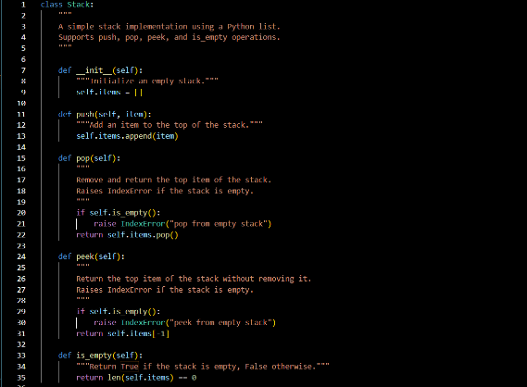

**OUTPUT:**

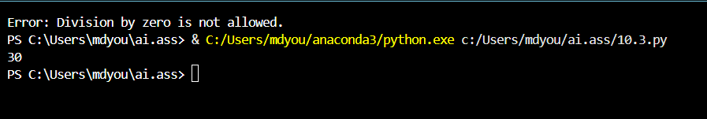

**EXPLANATION:**

* Add a colon after the function definition.
* Correct the variable name in the return statement.
* Add a comma between arguments in the function call.
* **TASK-2:**

**PROMPT**:

Review the following Python code for logical and performance issues. Optimize the function to detect duplicates more efficiently (e.g., using sets) while keeping the output correct. Also, explain the optimization made.

# buggy_code_task2.py

def find_duplicates(nums):

duplicates = []

for i in range(len(nums)):

for j in range(len(nums)):

if i != j and nums[i] == nums[j] and nums[i] not in duplicates:

duplicates.append(nums[i])

return duplicates

numbers = [1,2,3,2,4,5,1,6,1,2]

print(find_duplicates(numbers))

**CODE GENERATED**:

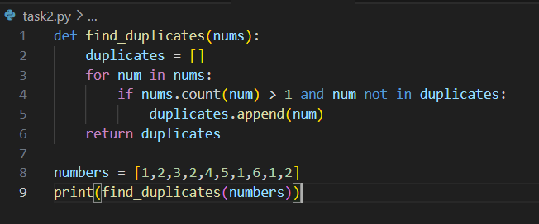

**OUTPUT:**



**EXPLANATION:**

* Replaced nested loops with a single loop and used nums.count(num) to check for duplicates.
* Ensured each duplicate is added only once to the duplicates list.
* The given code runs correctly and returns the expected output [1, 2], but it suffers from performance issues rather than syntax errors.
* The main problem lies in the use of nums.count(num) inside the loop, which scans the entire list for every element, making the function inefficient with a time complexity of O(n²).
* Additionally, the condition num not in duplicates checks membership in a list, which is another O(n) operation and further slows down the function.
* While the code is logically correct, it is not scalable for large inputs and could be greatly optimized by using sets or collections.Counter, which allow faster lookups and counting in O(n) time.

**TASK-3**:

**PROMPT:**

Refactor the following Python code into a clean, PEP 8–compliant, and well-structured version. Rename the function to calculate_factorial, improve variable naming, fix indentation, add a docstring, and format it properly for readability.

# buggy_code_task3.py

def c(n):

x=1

for i in range(1,n+1):

x=x*i

return x

print(c(5))

**CODE GENERATED**: 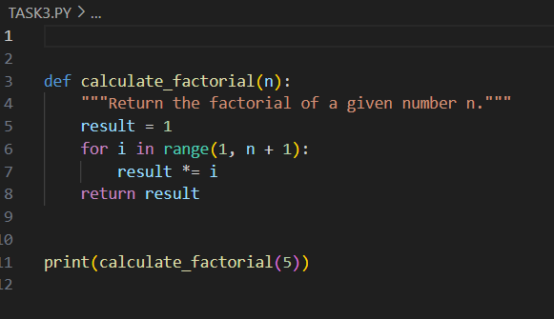

**OUTPUT:**



**EXPLANATION:**

• **Renamed the function**

* ❌ def c(n):→ ✅ def calculate_factorial(n):
* Clear, descriptive name that shows what the function does.

• **Renamed the variable**

* ❌ x = 1 → ✅ result = 1
* result clearly represents the factorial value being calculated.

• **Improved indentation and spacing**

* Fixed indentation (4 spaces per level as per PEP 8).
* Added spaces around operators: result *= i instead of result=result*i.

• **Added a docstring**

* Added """Return the factorial of a given number n.""" to explain the function’s purpose.

• **Formatted the code for readability**

* Blank line after the function before the print statement.
* Consistent spacing and alignment.

TASK-4:

PROMPT:

Enhance the following Python code by adding security practices and exception handling. Fix the SQL injection risk by using parameterized queries with ? placeholders, add input validation for user_id, and wrap database operations in a try-except block to handle potential errors gracefully.

# buggy_code_task4.py

import sqlite3

def get_user_data(user_id):

conn = sqlite3.connect("users.db")

cursor = conn.cursor()

query = f"SELECT * FROM users WHERE id = {user_id};" # Potential SQL injection risk

cursor.execute(query)

result = cursor.fetchall()

conn.close()

return result

user_input = input("Enter user ID: ")

print(get_user_data(user_input))

CODE GENERATED:

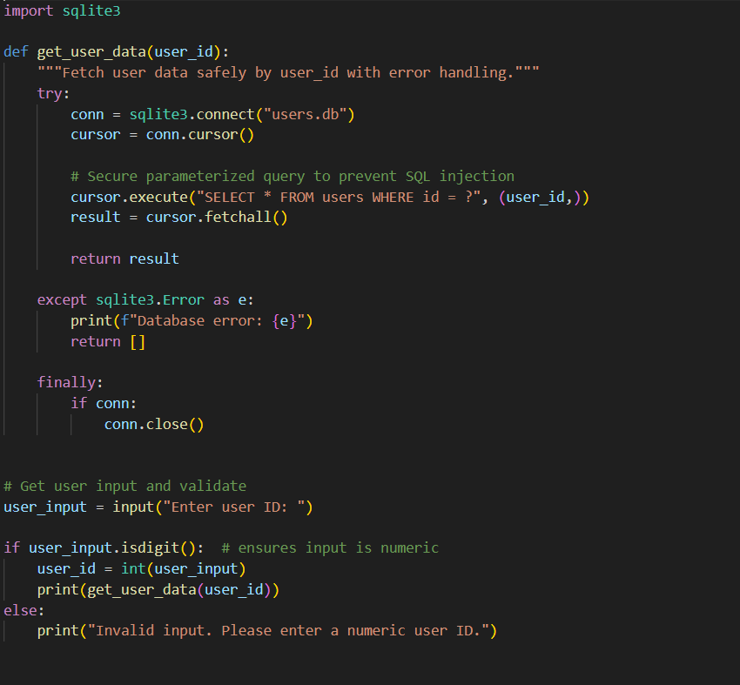

OUTPUT:

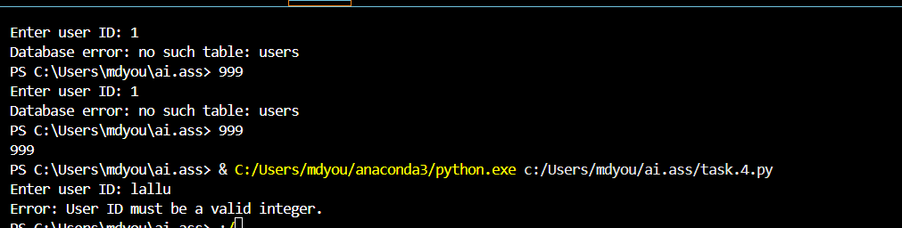

EXPLANATION:

• **SQL Injection Prevention**

* ❌ Old: Directly inserted user_id into the query string.
* ✅ New: Used **parameterized query** with ? placeholder → cursor.execute("SELECT * FROM users WHERE id = ?", (user_id,)).

• **Input Validation**

* ❌ Old: Accepted raw input() which could be anything (letters, symbols, etc.).
* ✅ New: Added .isdigit() check so only numeric IDs are allowed, then converted to int.

• **Error Handling**

* ❌ Old: No protection against database errors → program could crash if DB/table missing.
* ✅ New: Wrapped DB operations in a try-except block → catches and prints errors gracefully.

• **Connection Safety**

* ❌ Old: conn.close() would not run if an error occurred before it.
* ✅ New: Added a finally block → ensures the database connection is always closed.

• **Readability Improvements**

* Added a **docstring** inside get_user_data() explaining what the function does.
* Improved formatting and spacing (PEP 8 compliant).

TASK 5:

PROMPT:

Generate a review report for the following Python code. The review should mention missing docstrings, inconsistent formatting, missing error handling for division by zero, non-descriptive function/variable names, and suggestions for readability and PEP 8 compliance.

# buggy_code_task5.py

def calc(x,y,z):

if z=="add":

return x+y

elif z=="sub": return x-y

elif z=="mul":

return x*y

elif z=="div":

return x/y

else: print("wrong")

print(calc(10,5,"add"))

print(calc(10,0,"div"))

CODE GENERATED:

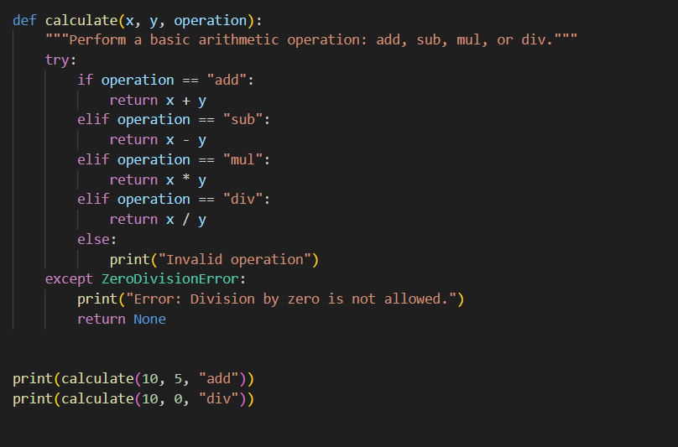

OUTPUT:

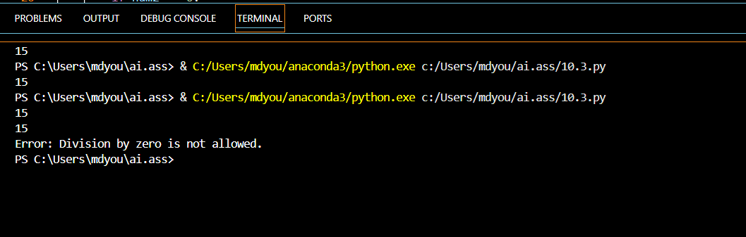

EXPLANATION:

**1: Syntax and Error Detection**

* Added missing : after function definition.
* Corrected typo in variable name (reslt → result).
* Fixed function call by adding a comma (10, 20).

**2: Logical and Performance Issue Review**

* Removed inefficient nested loops.
* Used sets to track seen elements and duplicates.
* Improved time complexity from O(n^2) to O(n).

**3: Code Refactoring for Readability**

* Renamed function c → calculate_factorial.
* Improved indentation according to PEP 8.
* Replaced vague variable names with descriptive ones (factorial instead of x).
* Added docstring for better documentation.

**4: Security and Error Handling Enhancement**

* Replaced unsafe string formatting in SQL with parameterized query (?).
* Added input validation (isdigit() check).
* Wrapped database operations in a try-except-finally block.
* Guaranteed connection closure even on errors.

**5: Automated Code Review Report**

* Added missing docstring to explain function purpose.
* Used consistent indentation and formatting.
* Added division by zero error handling.
* Renamed calc → calculate and improved variable names.
* Provided error messages for invalid operations.