ASSIGNMENT-13.3
NAME:K.RIHTIKA
ROLL NO.:2403A510G9 TASK-1: Remove Repetition PROMPT:
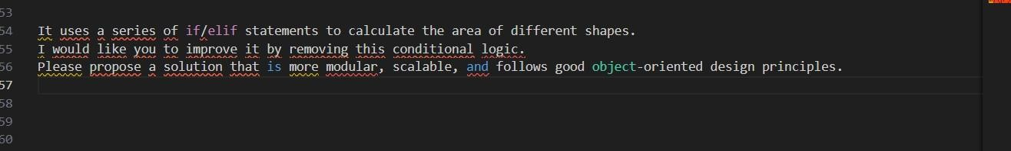
CODE:
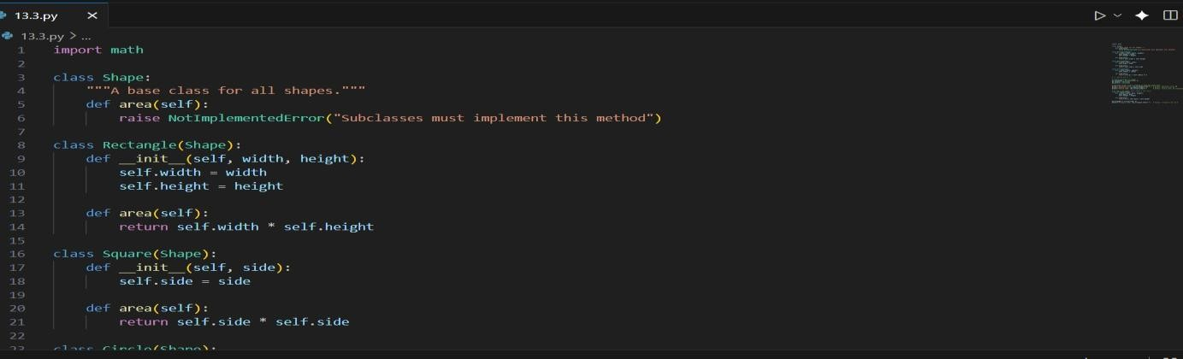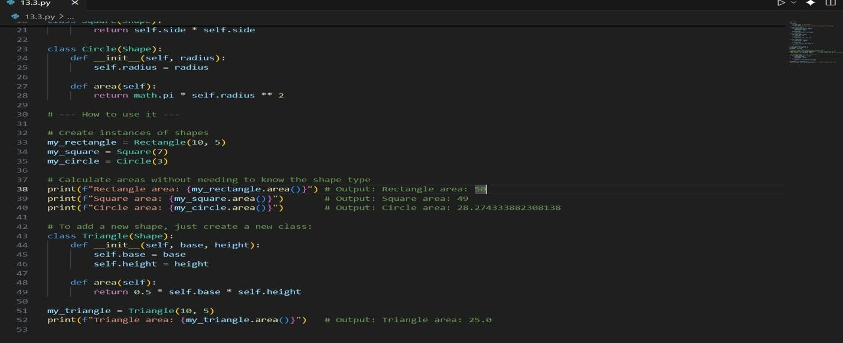
OUTPUT:
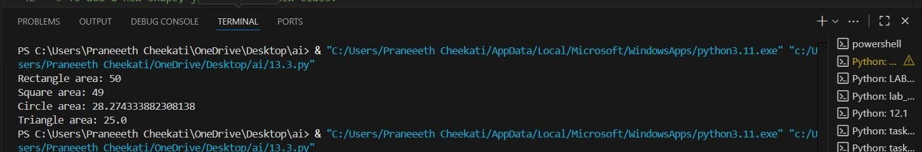
OBSERVATION:
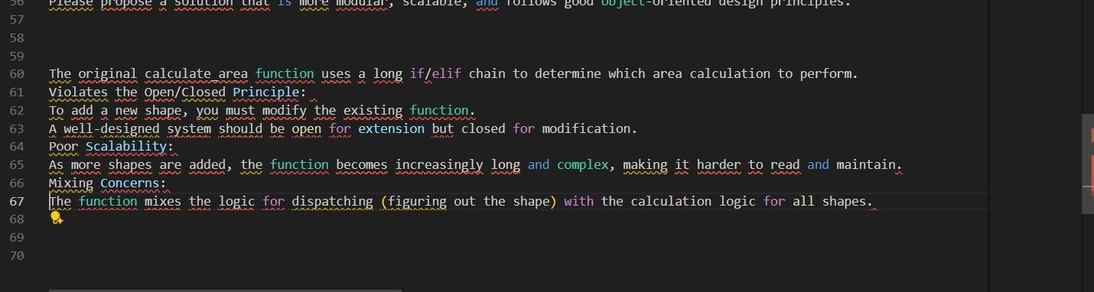
TASK-2: Error Handling in Legacy Code PROMPT:
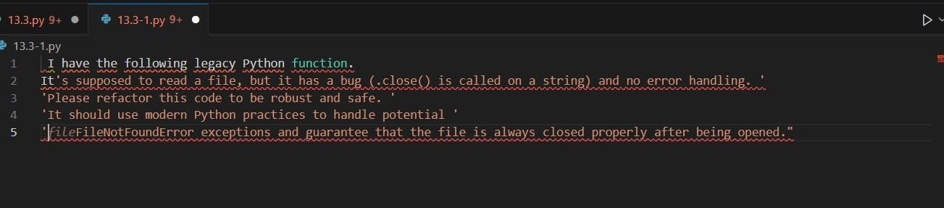
CODE:
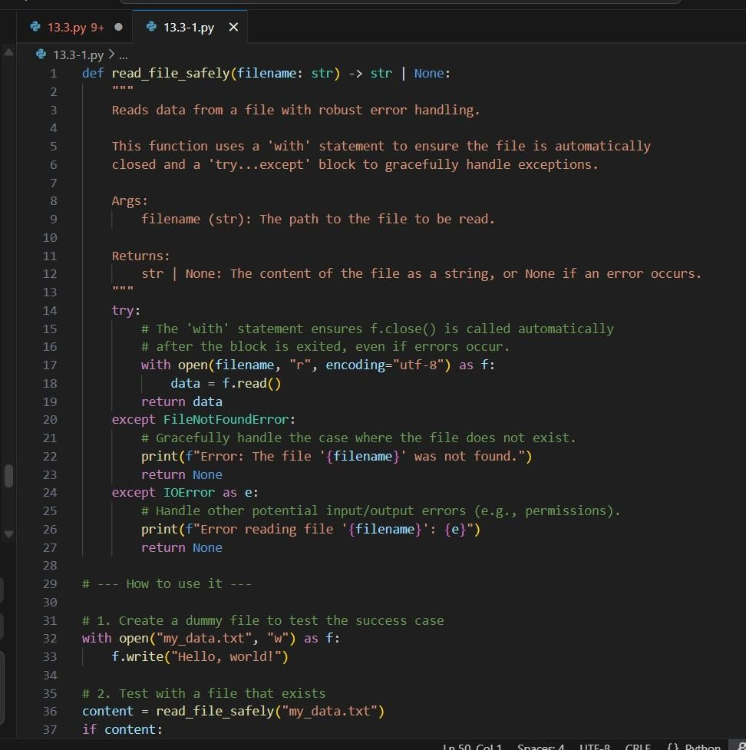
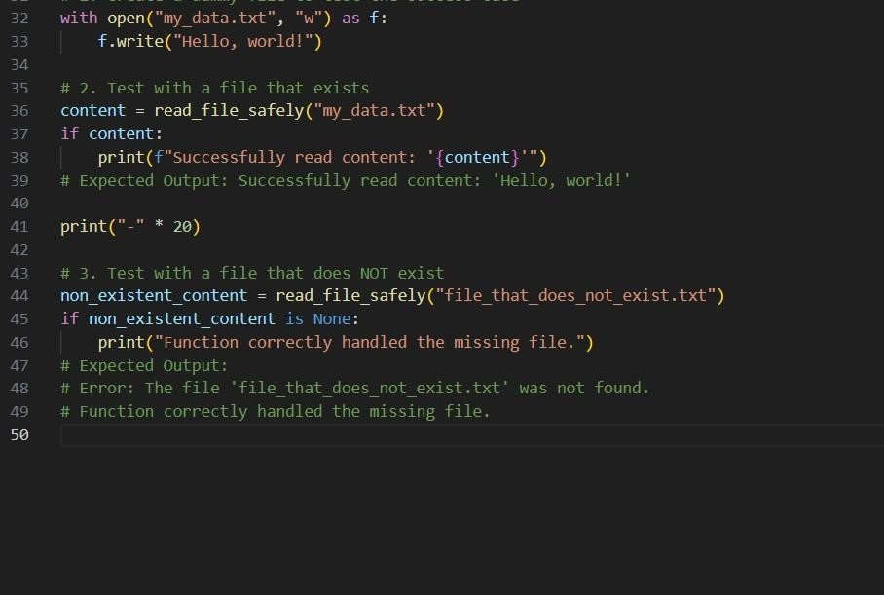
OUTPUT:
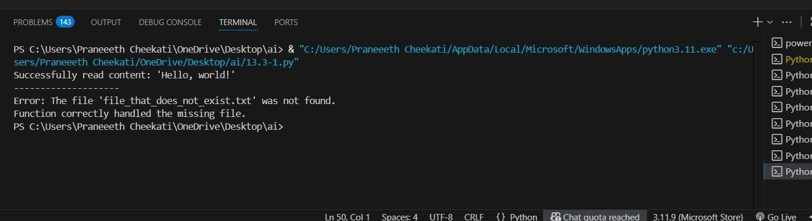
OBSERVATION:
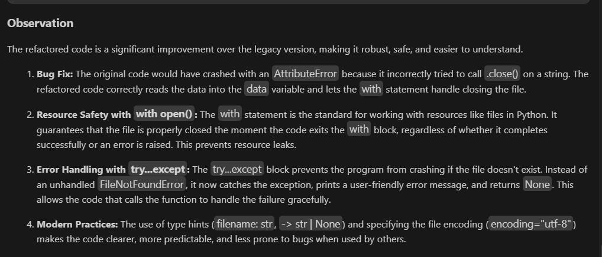
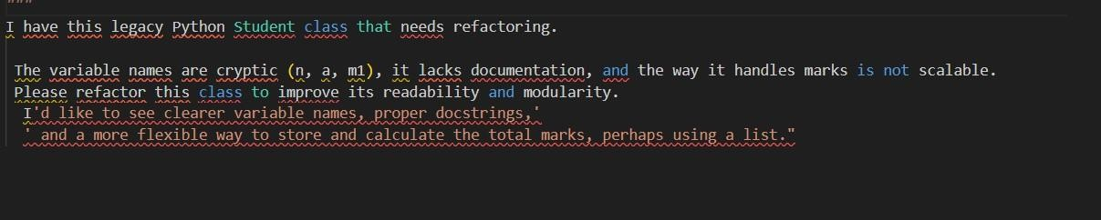
TASK
-
3:

Complex Refactoring PROMPT:

CODE:
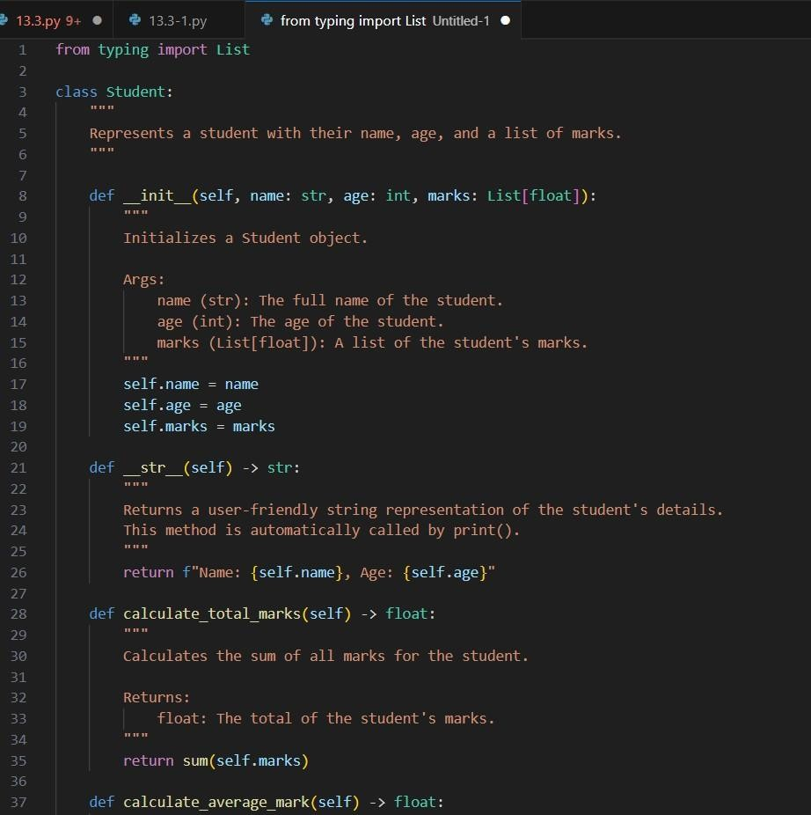
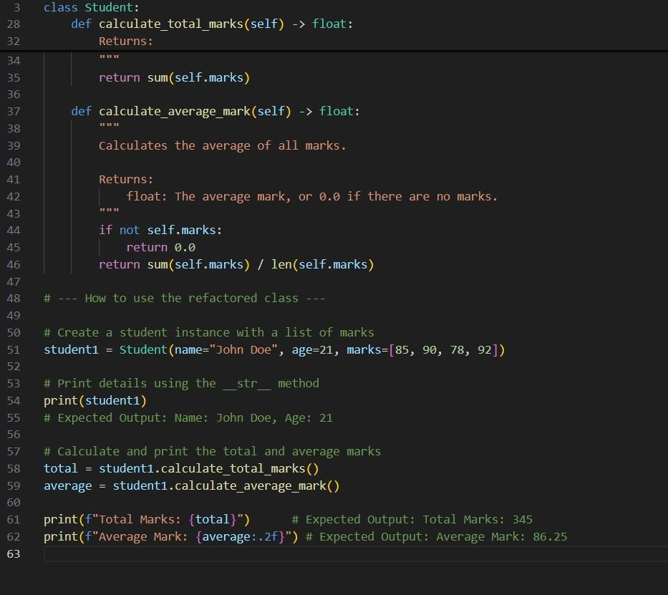
OUTPUT:
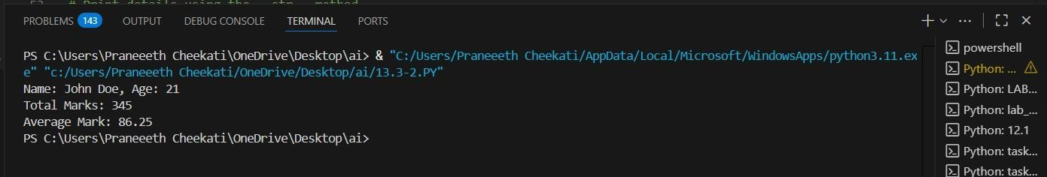
OBSERVATION:
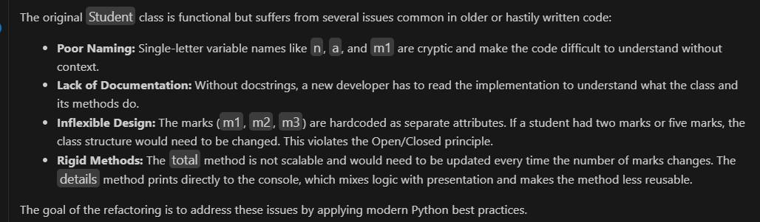
TASK-4: Inefficient Loop Refactoring PROMPT:
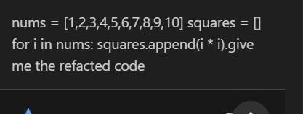

CODE:
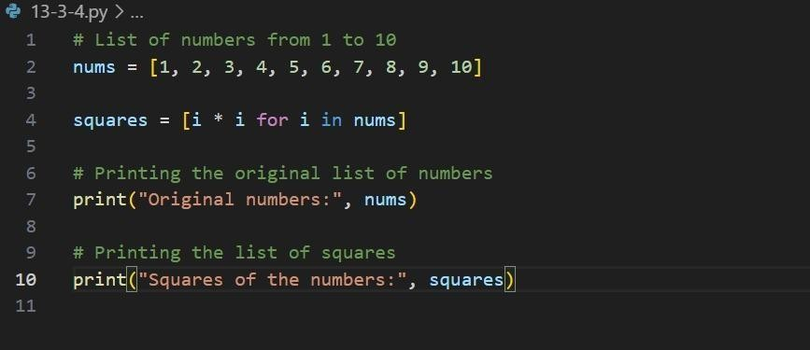
OUTPUT:
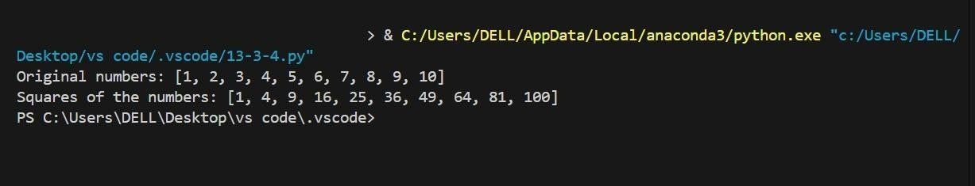
OBSERVATION:
