NAME:KAILASA RITHIKA
ROLL.NO:2403A510G9

ASSIGNMENT-14.1
Task 1 – Portfolio Website Design
You are building a personal portfolio website to showcase your work.
Requirements:
- Create sections for About Me, Projects, and Contact.
- Use AI to:
  - Suggest color palettes and typography.
  - Create a responsive layout with Grid/Flexbox.
  - Add smooth scrolling navigation.
Prompt:
Create a responsive personal portfolio website using HTML, CSS, and JS with these features:
Sections: About Me, Projects, Contact
Design: Use AI to suggest a modern color palette and Google Fonts typography
Layout:Responsive with Flexbox/Grid
Navigation: Sticky navbar + smooth scrolling
Extras: Hover effects, subtle animations, and a scroll-to-top button
Code:
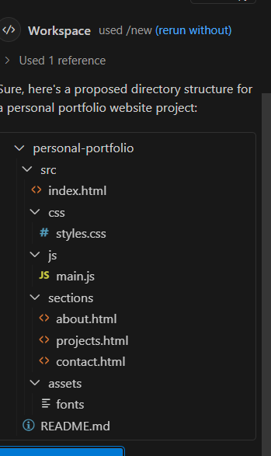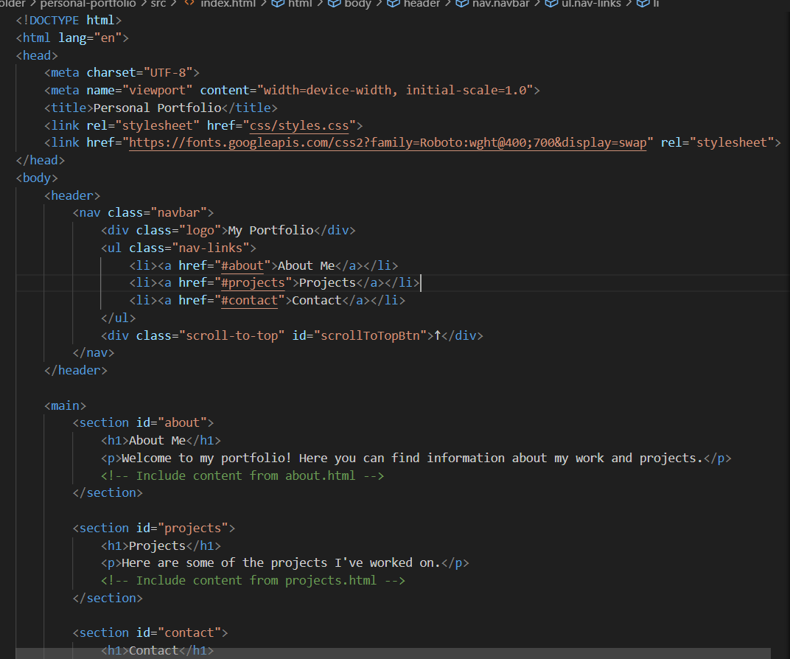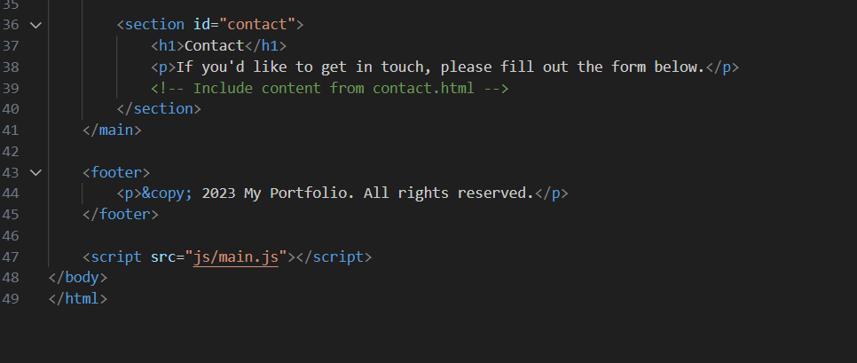
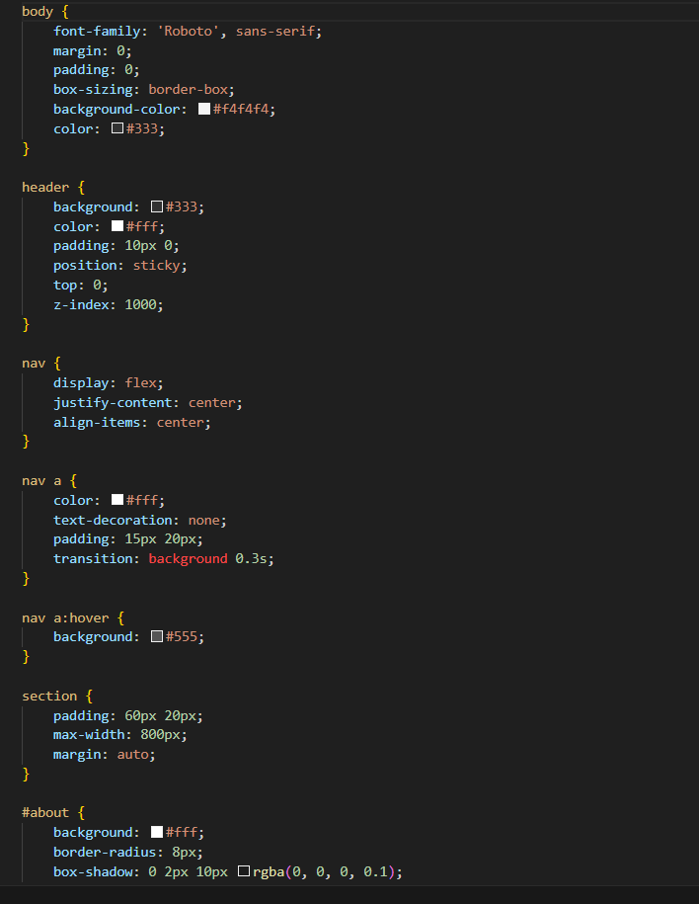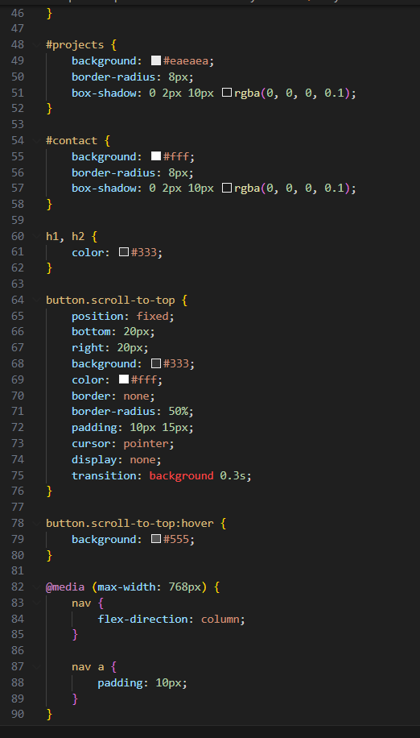
Output:
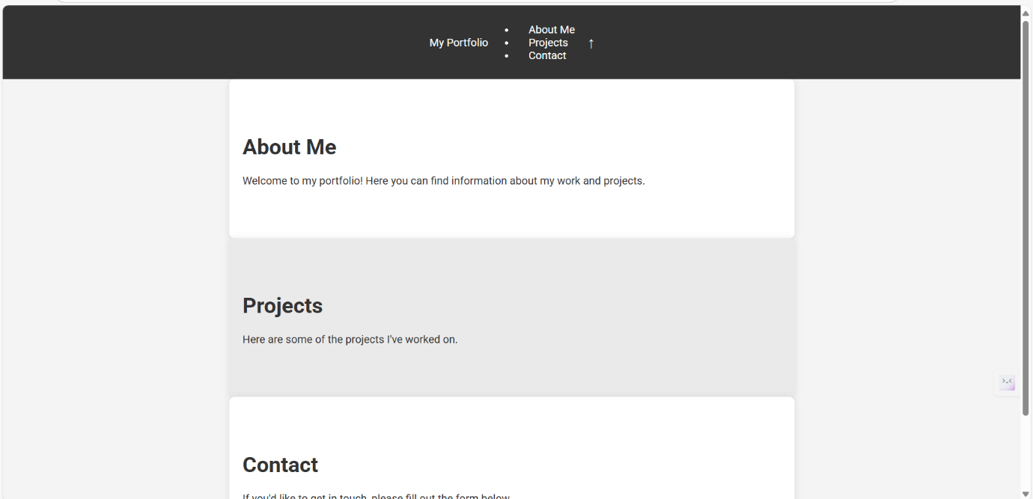

Task 2 – Online Store Product Page
Design a product display page for an online store.
Requirements:
- Display product image, title, price, and "Add to Cart" button.
- Use AI to:
  - Style with BEM methodology.
  - Make layout responsive.
  - Add hover effects and "Add to Cart" alert.
Prompt:
Create a responsive product display page using HTML, CSS, and JavaScript with these requirements:
- Show product image, title, price, and an "Add to Cart" button.
- Use BEM methodology for CSS class naming.
- Make the layout responsive using Flexbox or Grid.
- Add hover effects on the product card.
- When the user clicks “Add to Cart,” show a simple JavaScript alert confirming the action.
- Keep the design modern, clean, and minimal.
Code:
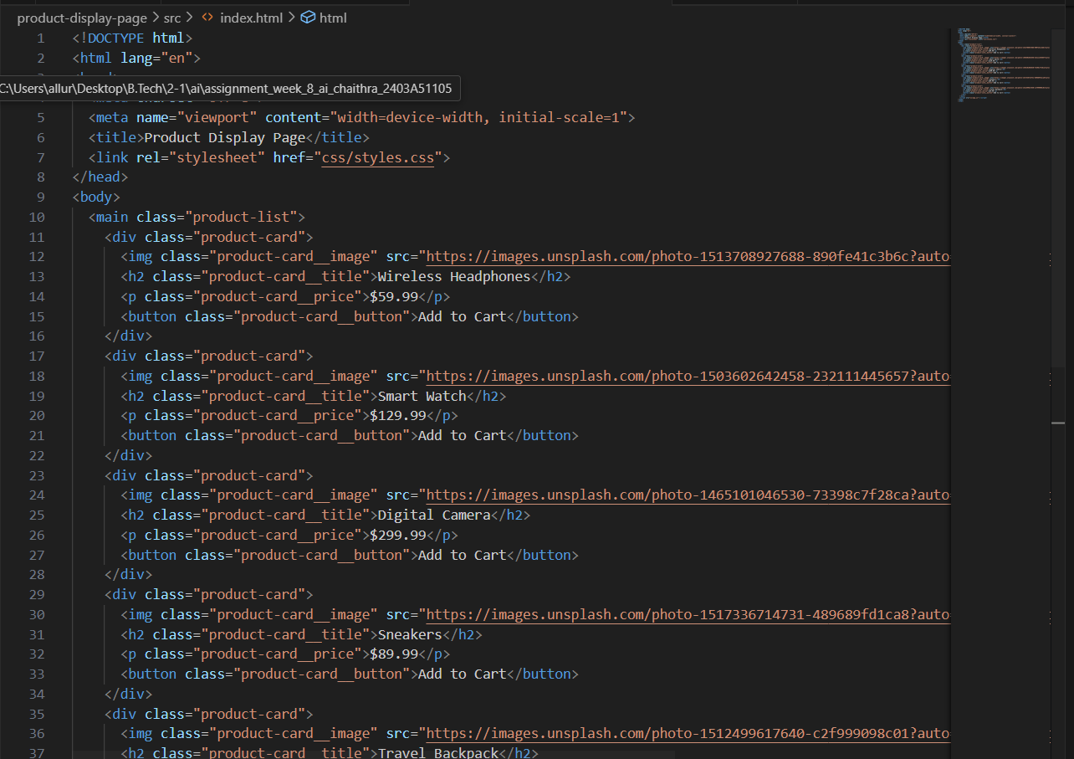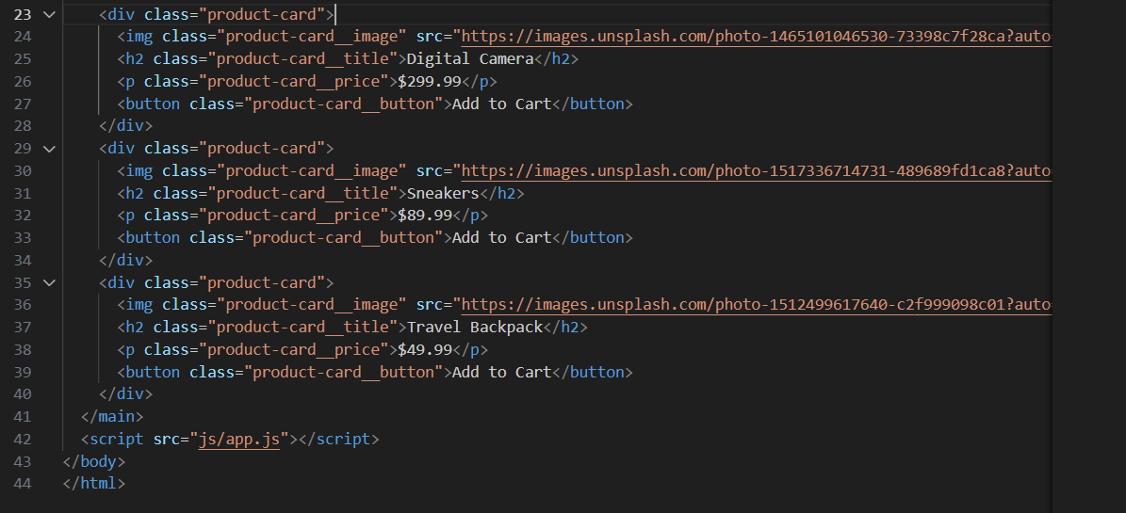
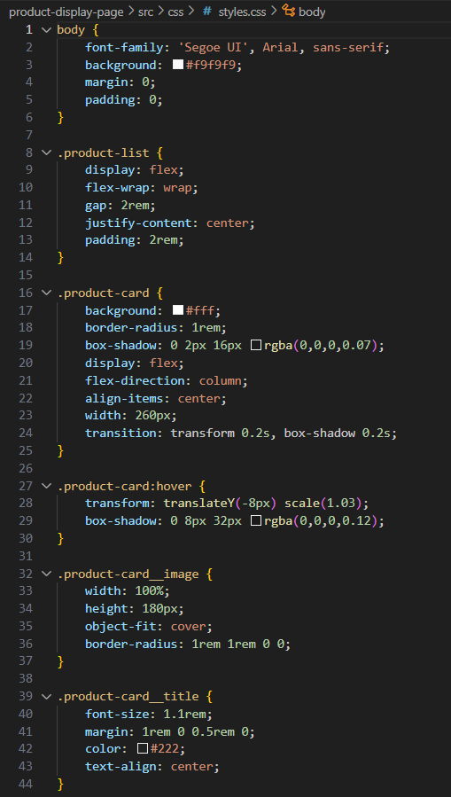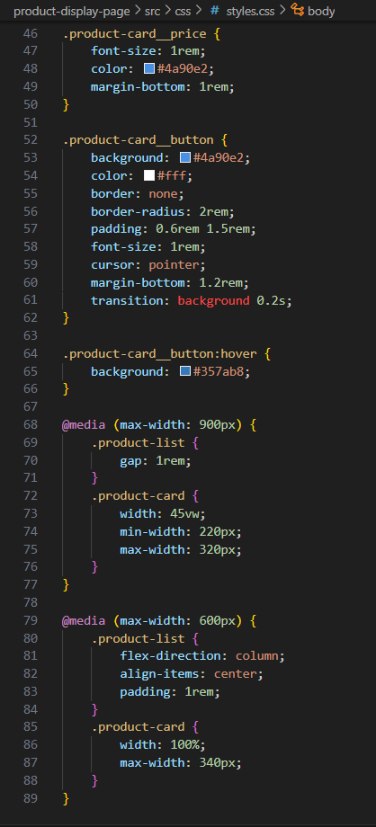
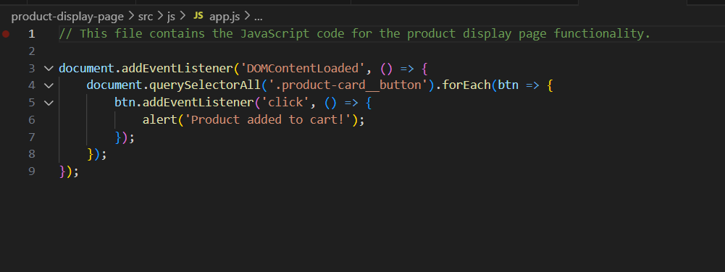
Output: 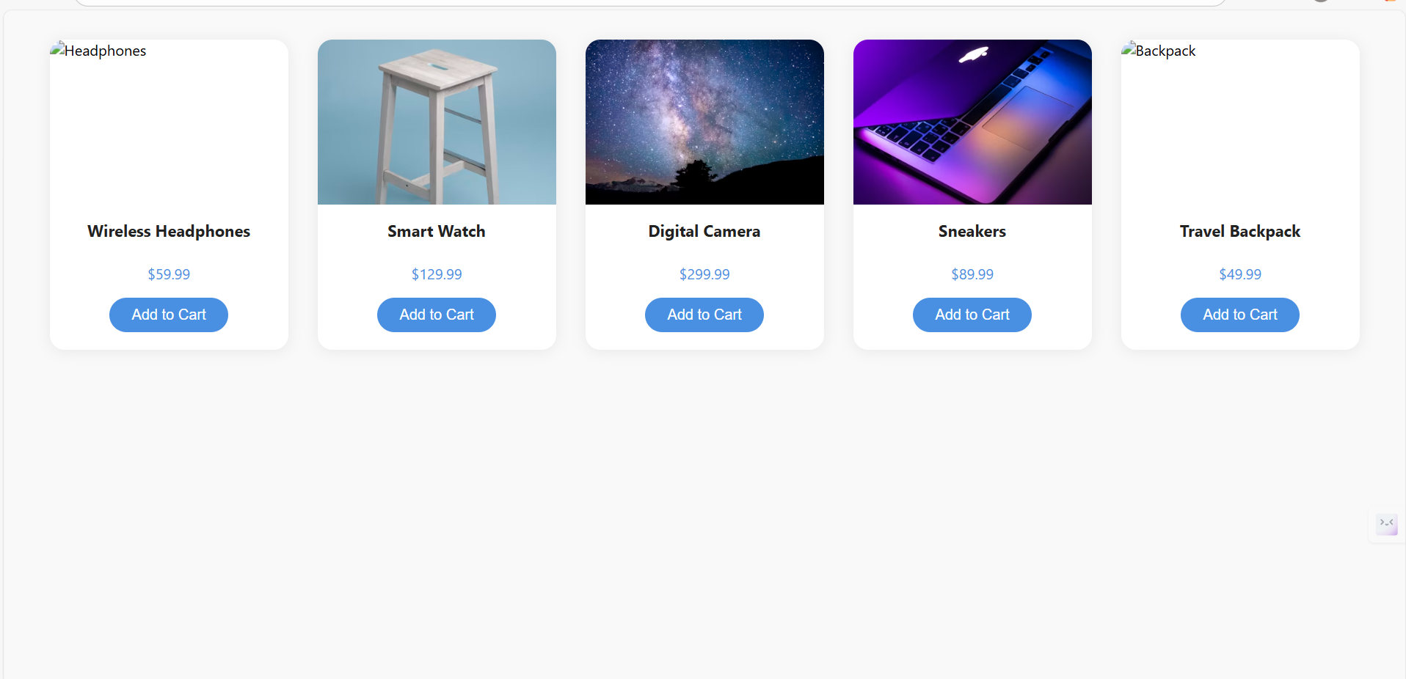
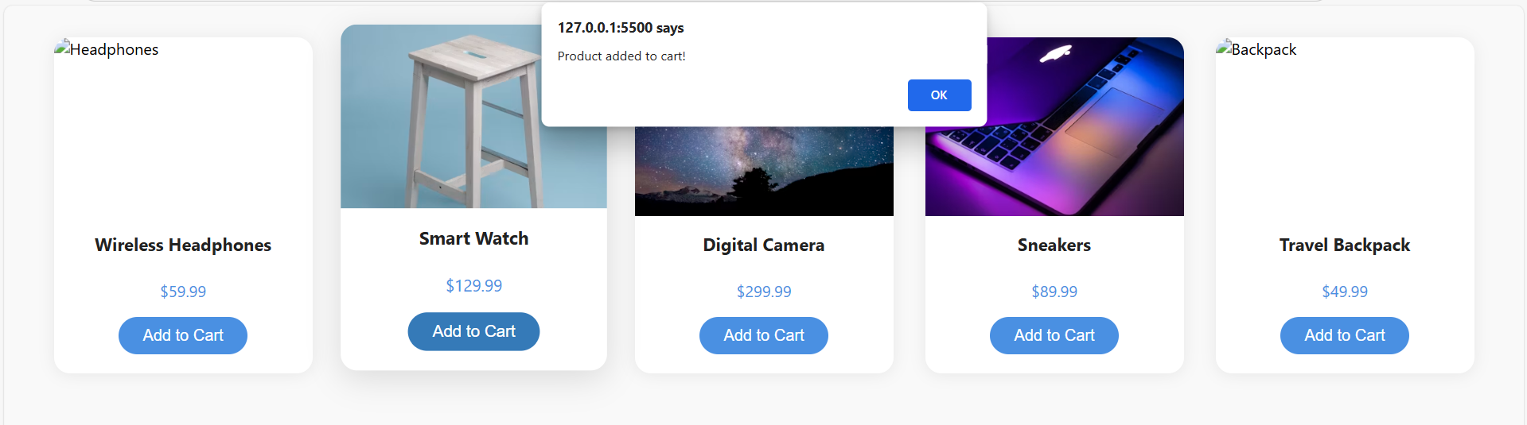Task 3 – Event Registration Form
Build an event registration form for a conference.
Requirements:
- Collect name, email, phone number, and session selection.
- Use AI to:
  - Add form validation with JavaScript.
  - Make the form accessible with labels and ARIA.
  - Style with a professional look.
Prompt:
Create a responsive event registration form for a conference using HTML, CSS, and JavaScript with these features:
Collect Name, Email, Phone Number, and Session Selection (dropdown or checkboxes).
Add JavaScript form validation for required fields and proper formats.
Ensure accessibility with labels, ARIA attributes, and keyboard navigation.
Style it with a clean, professional look (modern colors, spacing, and readable fonts).
Keep the layout responsive and user-friendly.

Code:
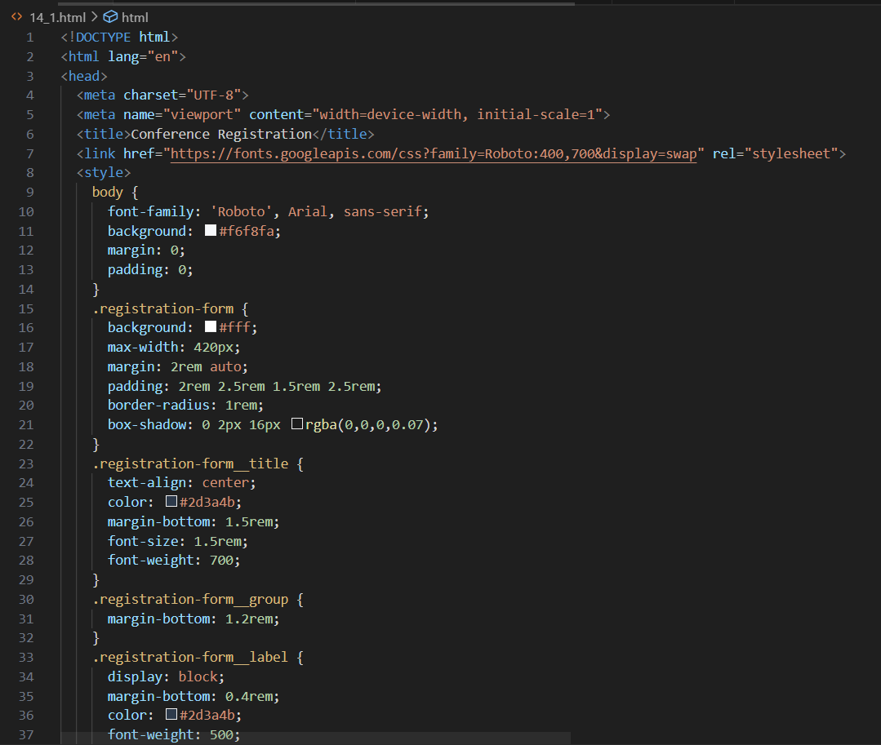
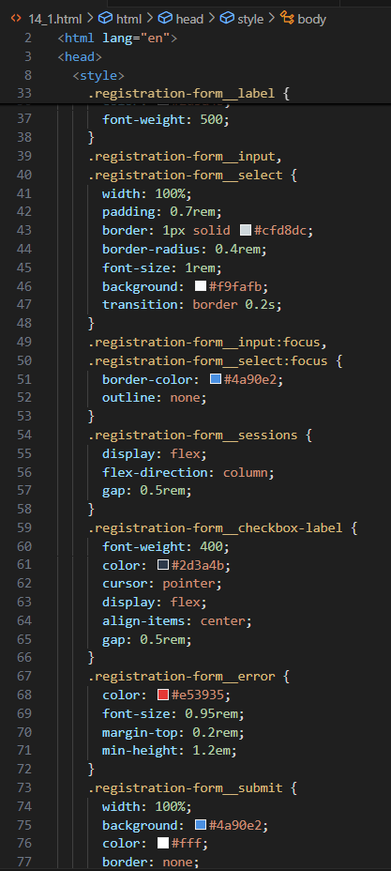
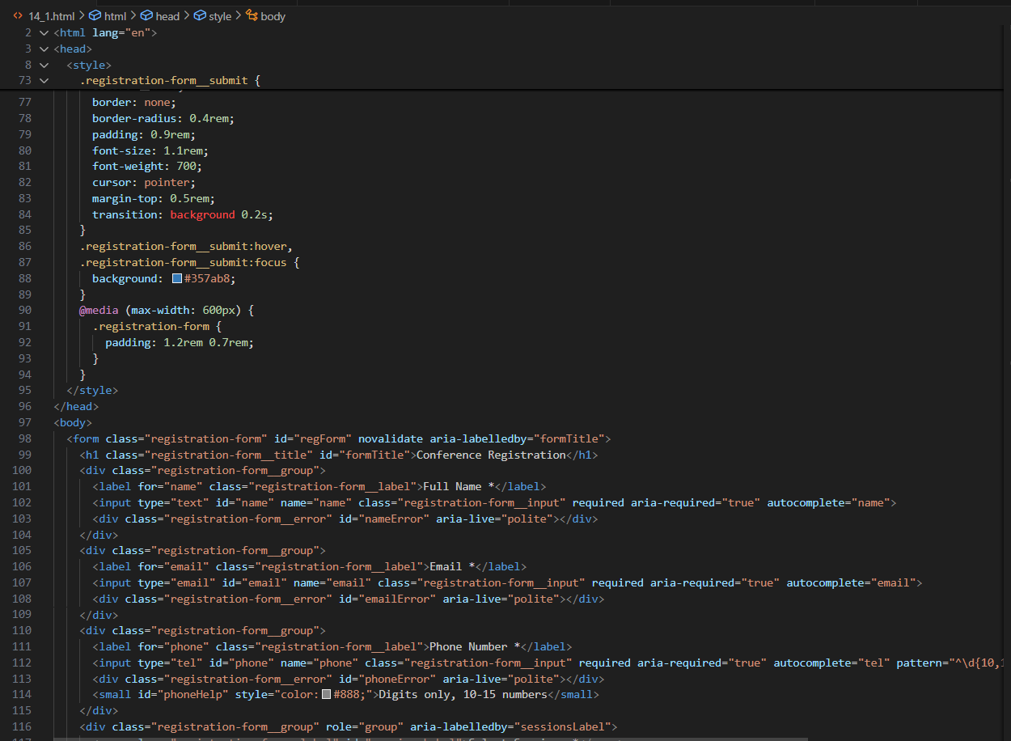
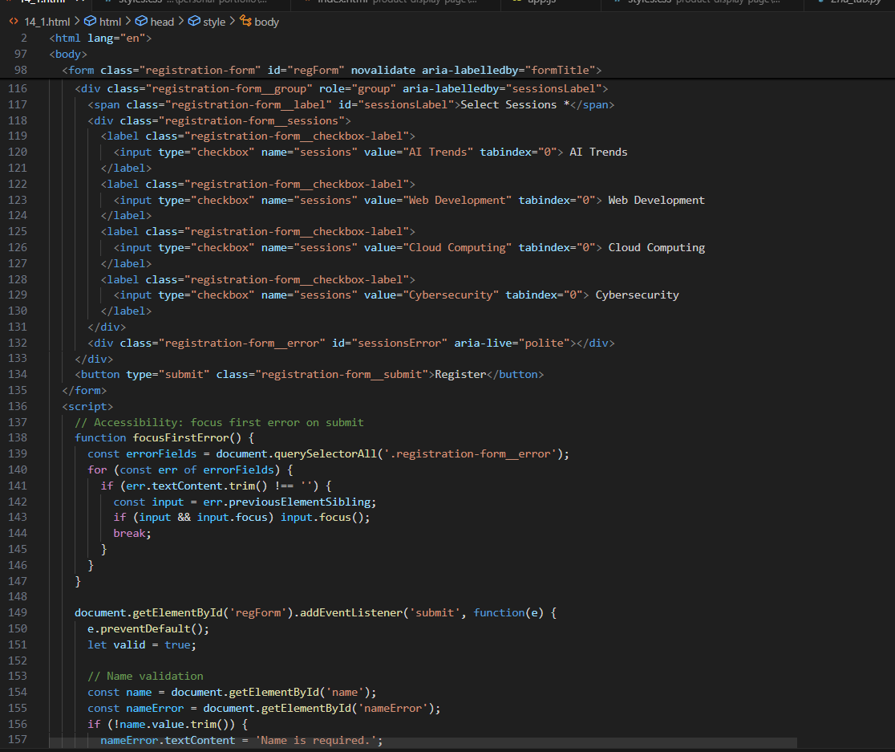
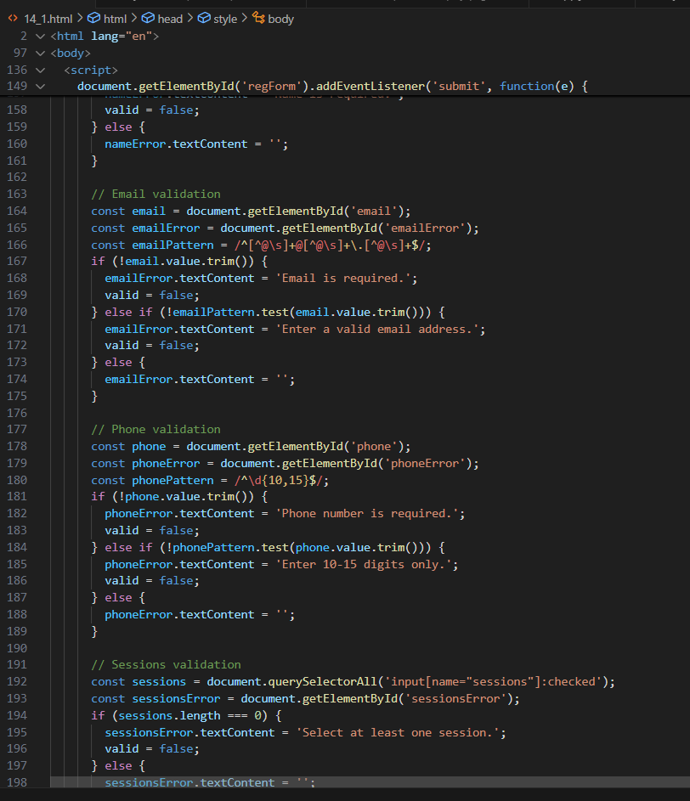
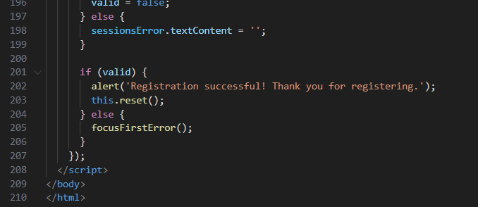
Output:
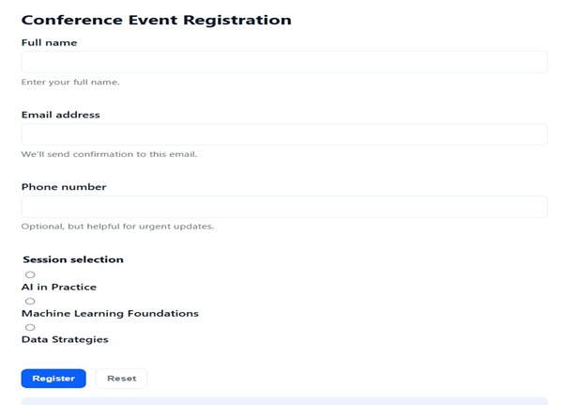

Task Description #4 (Data – Fetch API & Render List with Loading/Error States)
- Task: Fetch JSON from an API and render items to the DOM with loading and error UI.
- Instructions:
  - Ask AI to write fetch() logic, create DOM nodes safely, and add skeleton/loading text.
Prompt:
Create a JavaScript app that:
Uses fetch() to get JSON data from a public API.
Renders items dynamically to the DOM (e.g., titles, images, or names).
Shows a loading state (spinner or “Loading…” text) while fetching.
Displays an error message if the request fails.
Uses safe DOM creation methods (createElement, textContent, etc.).
Style the list with a clean, responsive layout.
Code:
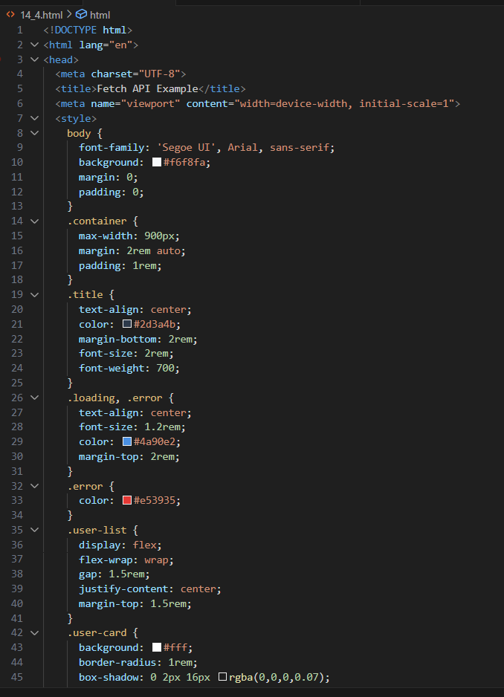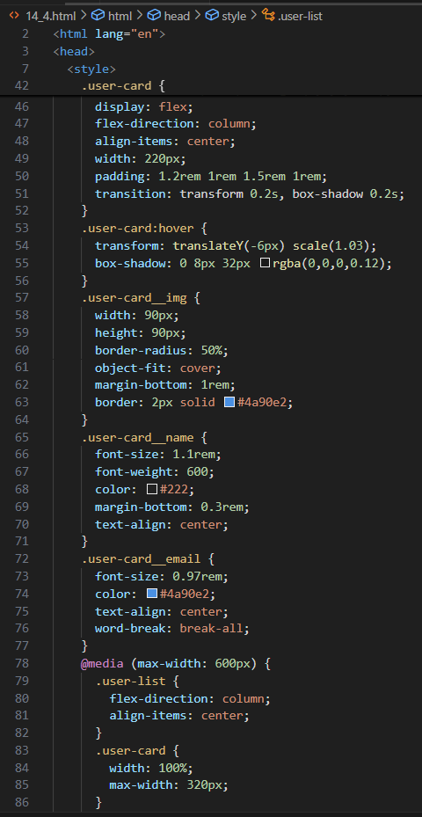
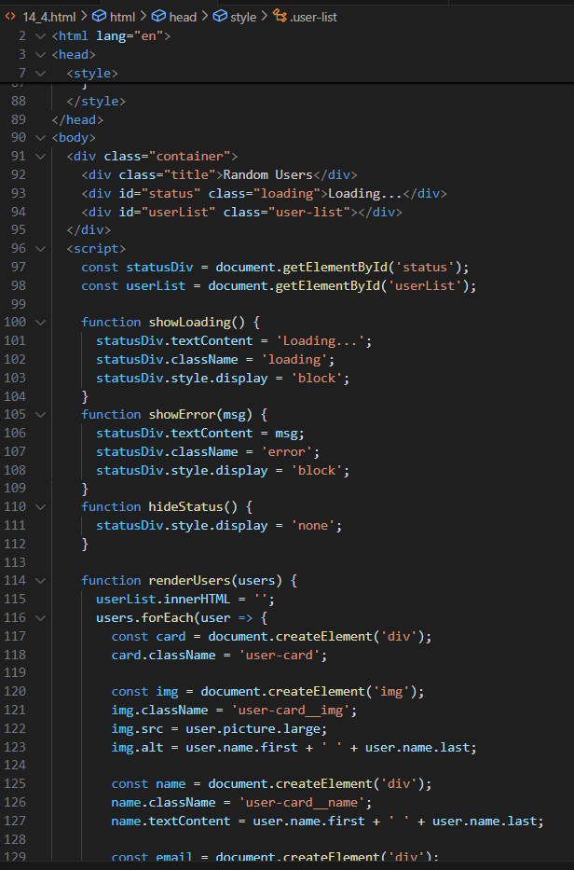
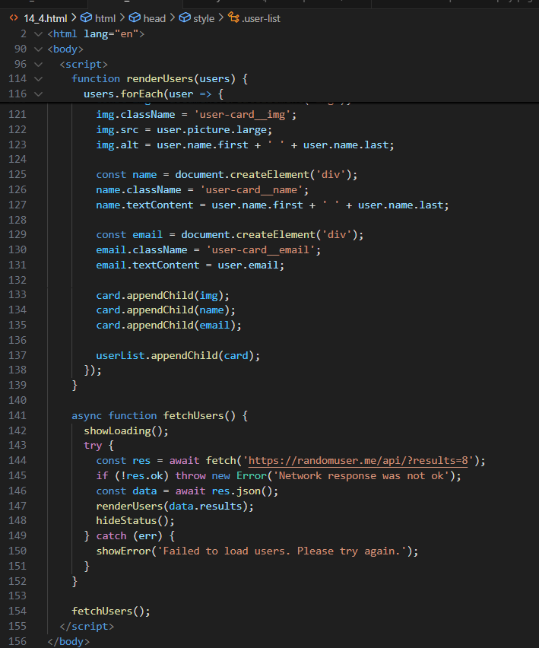
Output:
