AI-Assisted Coding Lab Assignment=15.3
Name: K.RITHIKA
Roll no: 2403A510G9

Task Description #1 – Basic REST API Setup
Task: Ask AI to generate a Flask REST API with one route: GET /hello → returns {"message": "Hello, AI Coding!"} Prompt:
Create a simple REST API using Flask with a single route:
- GET /hello → returns a JSON response: {"message": "Hello, AI Coding!"}.
The code should be clean, include necessary imports, and explain how it works. Code Generated:
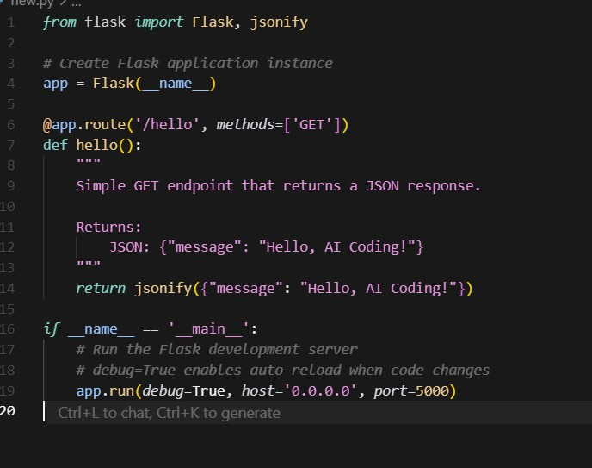
Output:
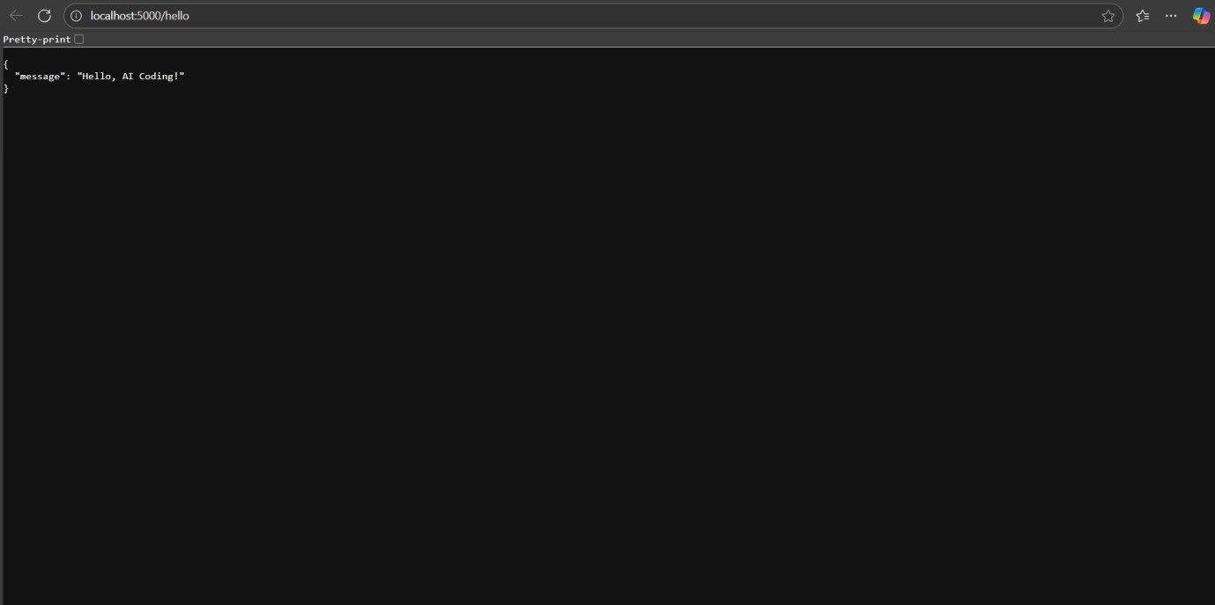
Observation:
- The code creates a Flask web application with one route /hello.
- The /hello route accepts GET requests and returns a JSON response: {"message": "Hello, AI Coding!"}.
- The Flask app runs on all network interfaces (0.0.0.0) at port 5000.
- Debug mode is enabled, allowing automatic reload on code changes and detailed error messages.
- The response is generated using Flask’s jsonify function. Task Description #2 – CRUD Operations (Students API) Task:
Use AI to build REST endpoints for a Student API:
- GET /students → List all students.
- POST /students → Add a new student.
- PUT /students/<id> → Update student details.
- DELETE /students/<id> → Delete a student.
Prompt:
Build a Flask REST API for managing students with the following endpoints:

- GET /students: List all students.
- POST /students: Add a new student. The request body will contain JSON with student details (e.g., name and age).
- PUT /students/<id>: Update the details of a student identified by `id`.
- DELETE /students/<id>: Delete the student with the given `id`.

Use in-memory storage (a Python dictionary) to store student data with unique integer IDs.
Return appropriate JSON responses and HTTP status codes.
Handle errors like missing data or invalid student IDs.
Code Generated:
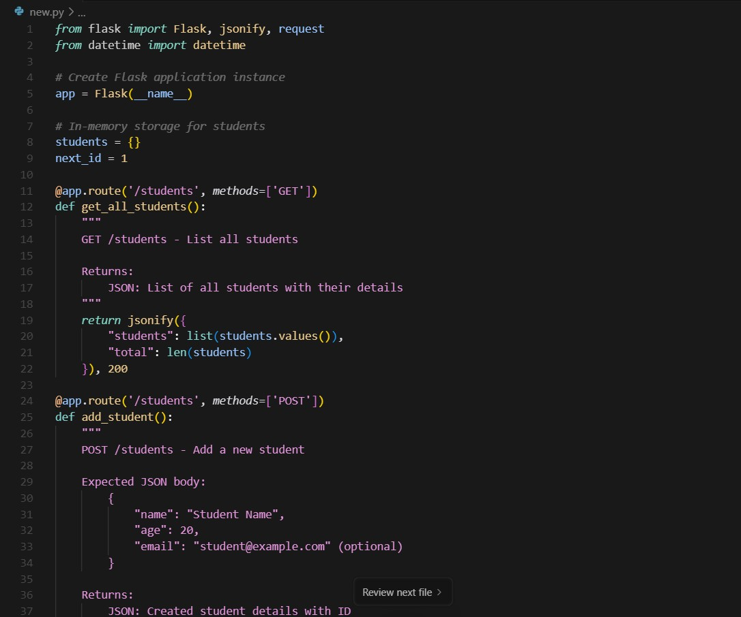
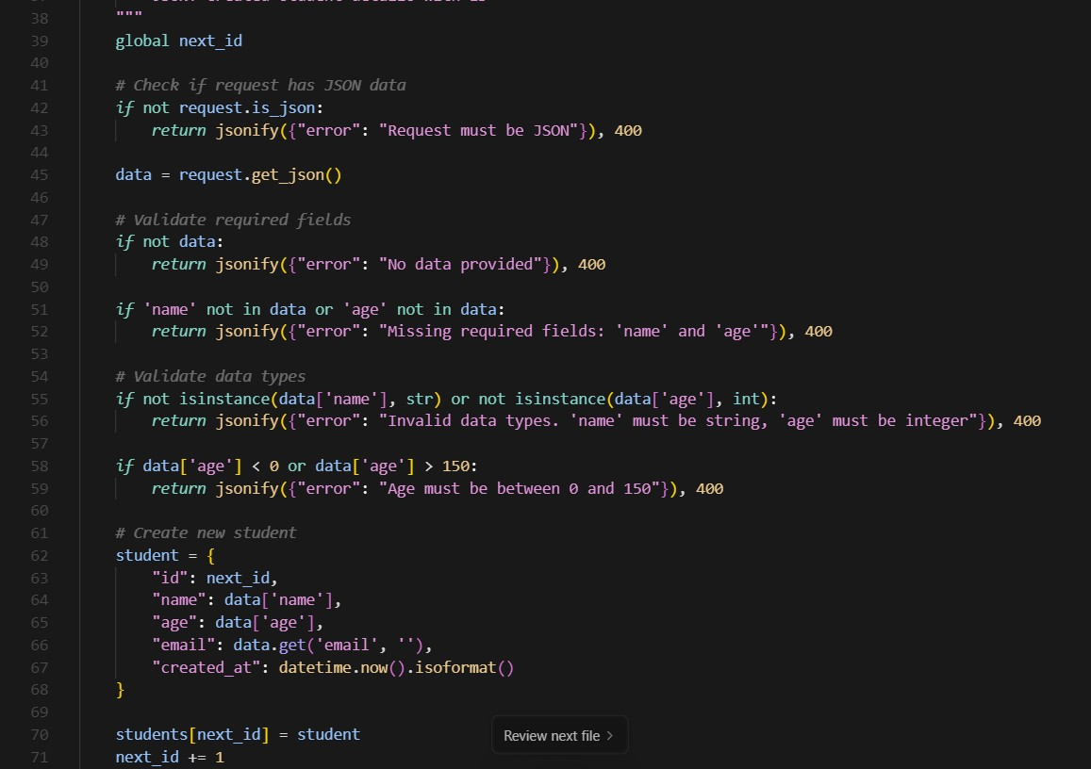
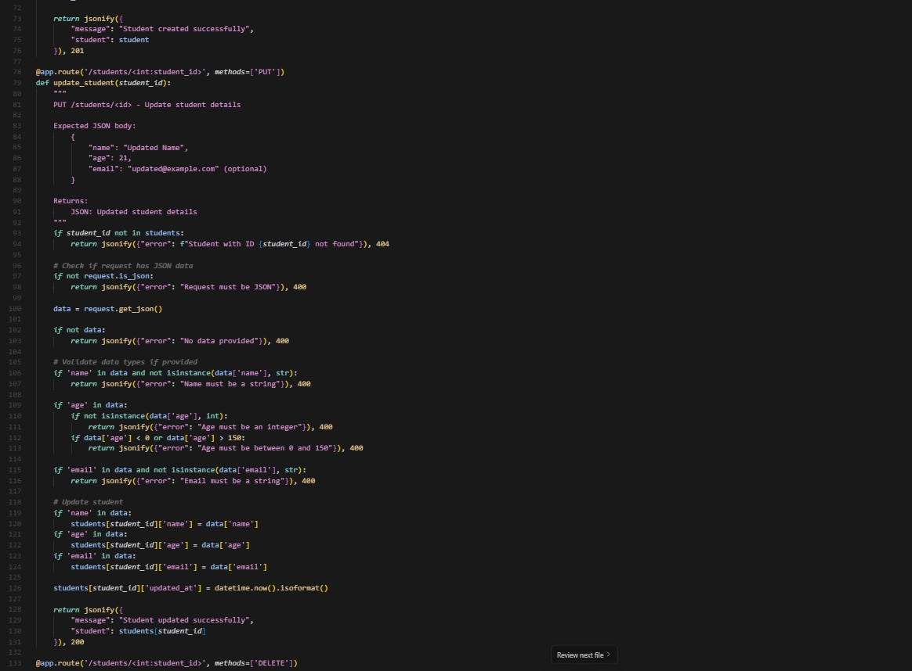
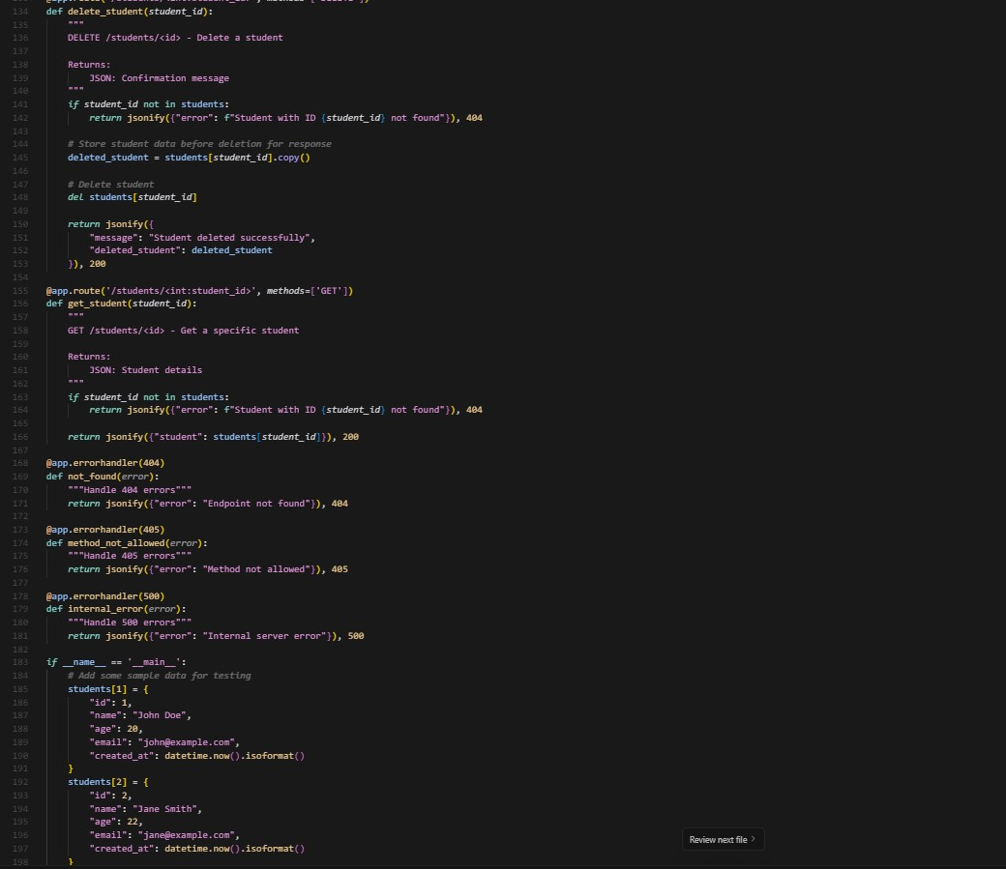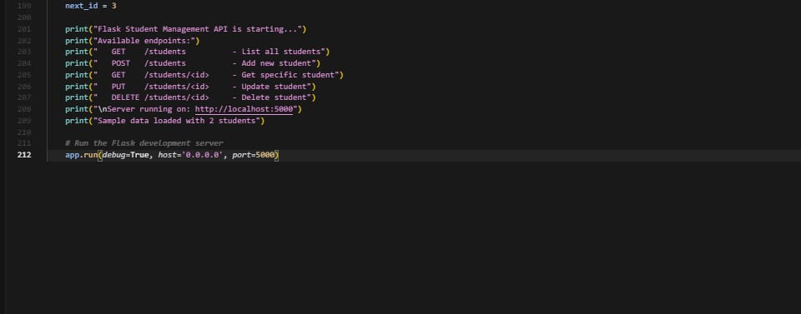
Output:
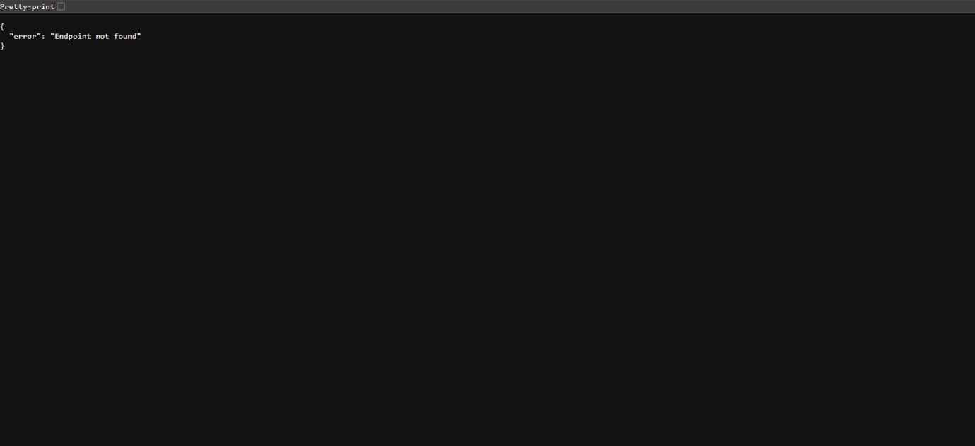
Observation:
  - The API includes four RESTful endpoints corresponding to the CRUD operations for student data.
  - Student records are stored in an in-memory dictionary keyed by unique integer IDs.
  - GET /students returns a JSON list of all stored students.
  - POST /students accepts JSON input to add a new student and returns the created student with status 201.
  - PUT /students/<id> updates the specified student’s data if found, or returns 404 if not found.
  - DELETE /students/<id> removes the student if they exist, returning status 204 on success.
  - Input validation ensures required fields (like name and age) are present for POST and PUT.
  - Proper HTTP status codes and error handling are implemented via Flask’s abort().
  - The API uses JSON for both input and output consistently.
  - The code runs in debug mode suitable for development.

Task Description #3 – API with Query Parameters
Task: Ask AI to generate a REST API endpoint Prompt:
Create a Flask REST API endpoint `/search` that accepts GET requests with query parameters `name` and `age`.
The endpoint should filter a list of students stored in memory based on the provided query parameters:
- If `name` is provided, return students whose names contain the given substring (caseinsensitive).
- If `age` is provided, return students matching the given age.
- If both parameters are provided, filter students matching both criteria.
- If no query parameters are provided, return all students.
Return the filtered list of students as JSON. Code Generated:
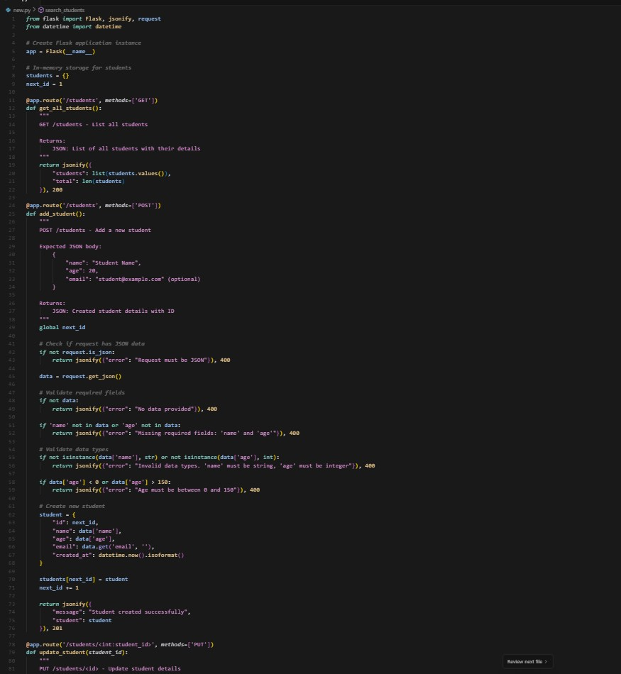
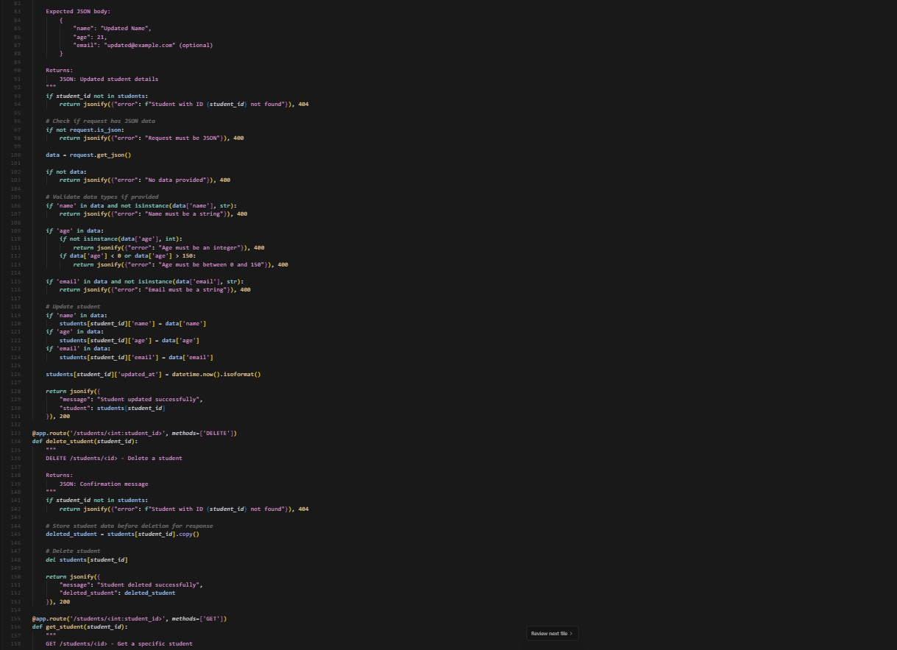
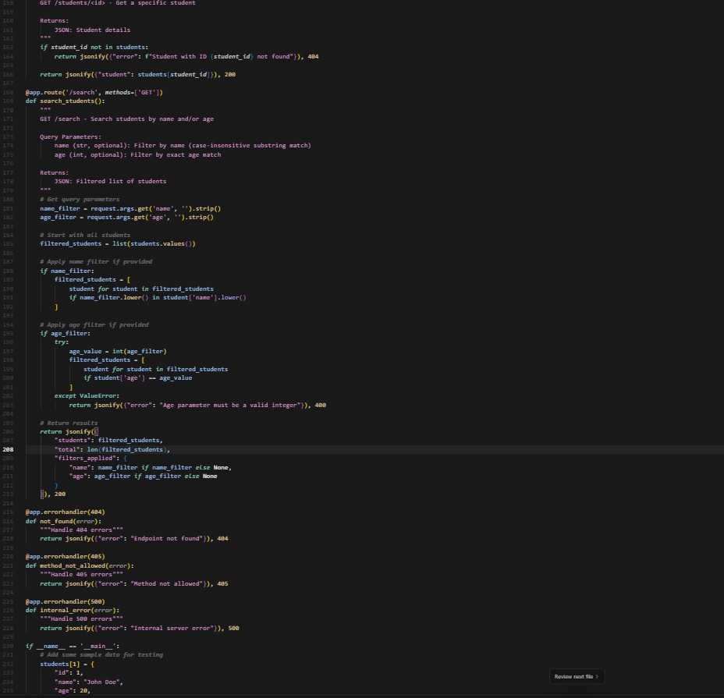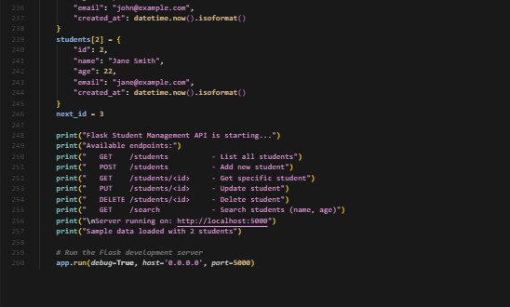

Output:
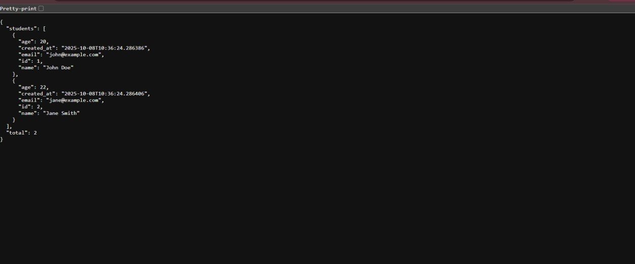
Observation:
  - The endpoint /search is implemented as a GET route accepting query parameters via request.args.
  - Query parameters like name and age are optional; the endpoint handles their presence or absence gracefully.
  - Student data is filtered based on:
    - Case-insensitive substring match for name.
    - Exact match for age (likely converted to an integer).
  - If no parameters are given, the entire student list is returned.
  - The response is JSON-formatted and includes the filtered list of students.
  - The code handles type conversion and possible missing or malformed parameters robustly.
  - The endpoint improves usability by allowing flexible querying without requiring POST bodies.
  - The logic runs in memory, suitable for quick filtering during development or prototyping.
Task Description #4 – Integration & Testing
Task: Ask AI to write test scripts using Python requests module to call APIs created above.
Prompt:
Write Python test scripts using the `requests` module to test the Student API with the following endpoints:

- GET /students → to retrieve all students.
- POST /students → to add a new student with JSON data.
- PUT /students/<id> → to update a student’s details.
- DELETE /students/<id> → to delete a student.

Write tests that:
- Call each endpoint.
- Print the status code and JSON response for GET, POST, and PUT requests.
- Confirm successful deletion via status code for DELETE.
- Handle and print error responses if any.

Assume the API server is running locally at http://localhost:5000. Code Generated:
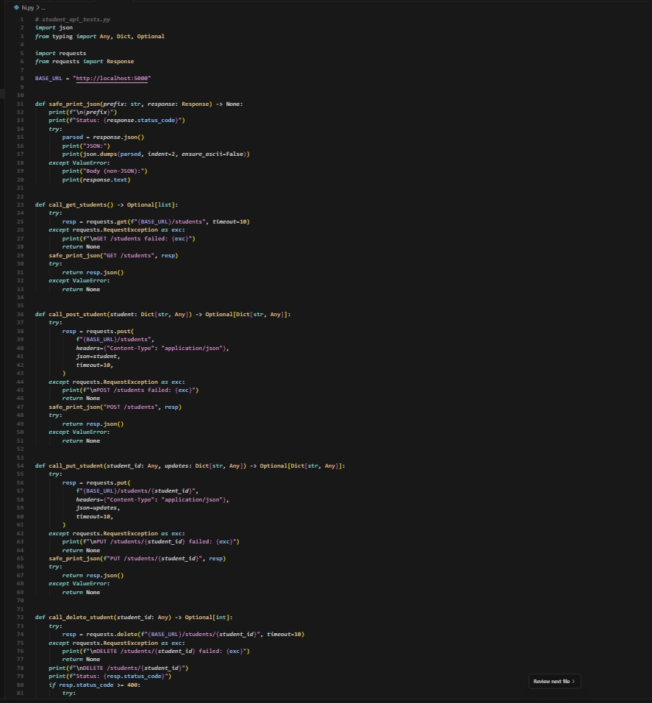
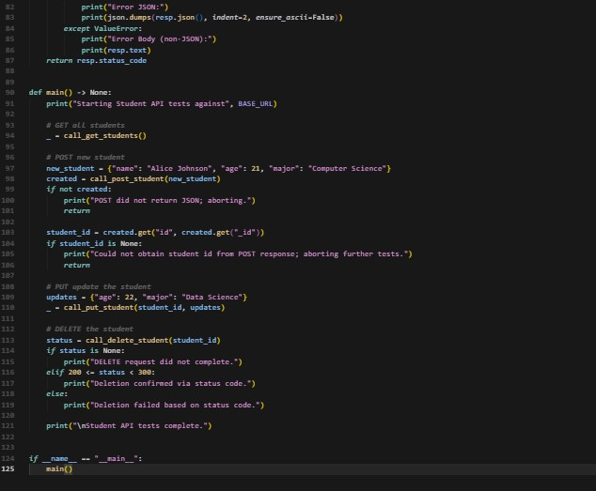
Output:
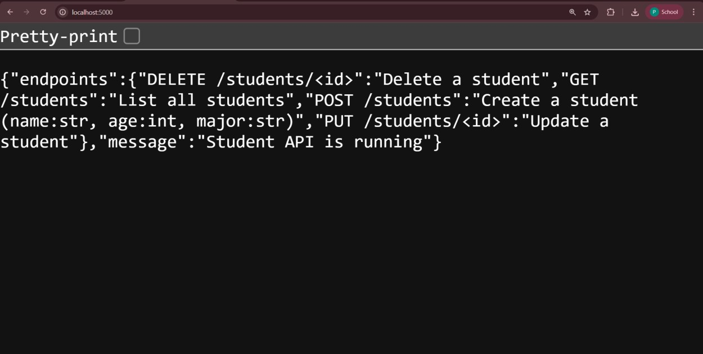
Observation:
Server is running locally at http://127.0.0.1:5000 and responds reliably.
Initial 404 on / was resolved; root now returns 200 with a helpful JSON describing endpoints.
CRUD flow behaves correctly and consistently across multiple cycles:
GET /students: 200 with list (empty after fresh start).
POST /students: 201 with created student and incremental id.
PUT /students/<id>: 200 with updated fields.
DELETE /students/<id>: 204 with no body (expected for successful deletion).
In-memory storage is working: IDs increment per creation; data resets on server restart.
Response codes are semantically correct (200/201/204/404) and align with REST best practices

