Name: BAIKANI SWAPNA

Roll No: 2403A51176

Batch No:09

Assignment 1.2

#Task 1

# Function to check if a string is a valid palindrome (ignoring spaces and case) and allow Copilot to complete it.

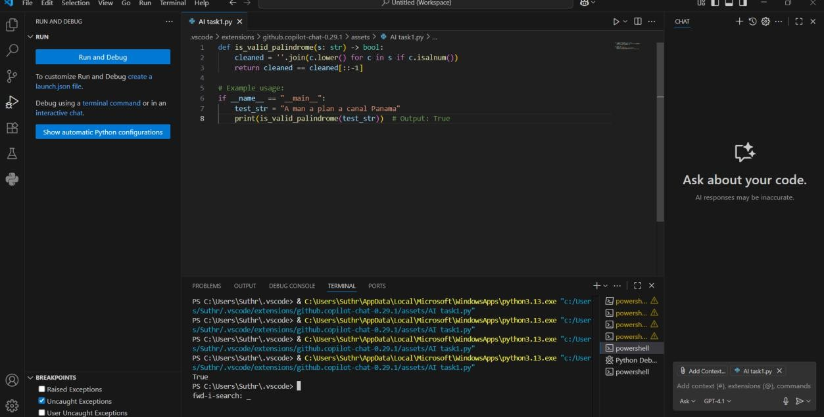

Expected Output#1

* A function that correctly returns True for phrases like "A man a plan a canal Panama"

Output: True

#Task 2

Generate a Python function that returns the Fibonacci sequence up to n terms. Prompt with only a function header and docstring.

Code:

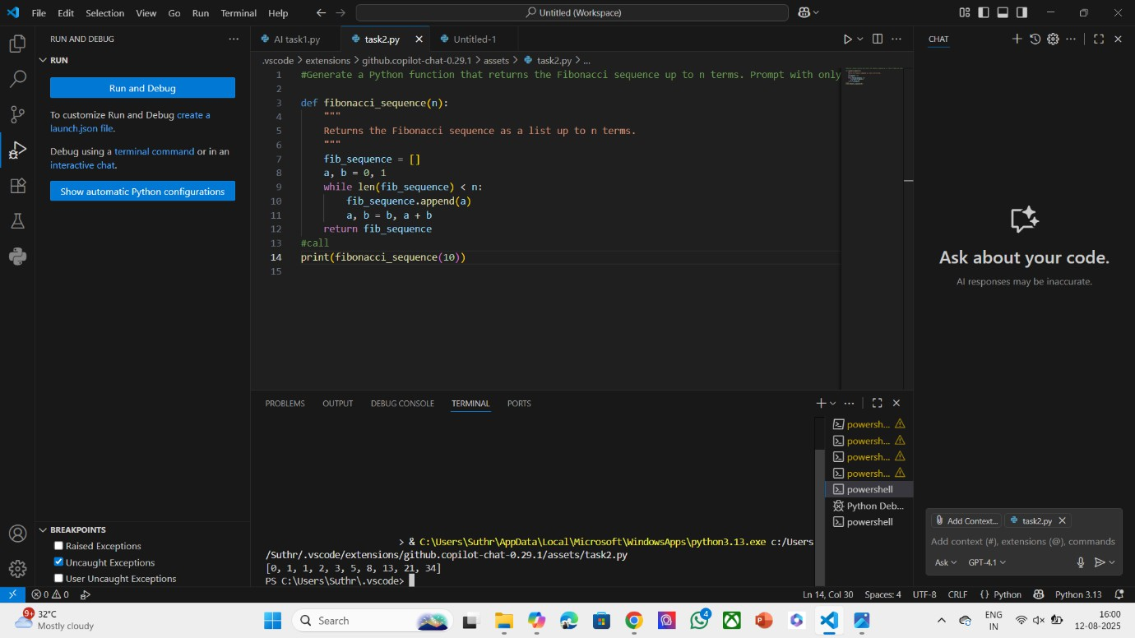

Expected Output#2

* AI completes the function logic using loop or recursion with accurate output Output: [0,1,1,2,3,5,8,13,21,34]

# Task 3

Write a comment like # Function to reverse a string and use Copilot to generate the function.

Code:

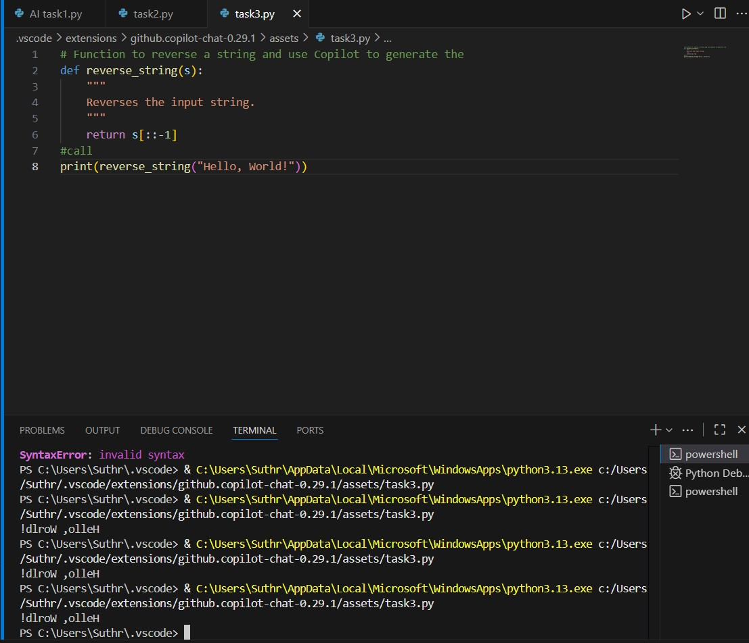

Expected Output#3

* Auto-completed reverse function Output: !dlrow ,olleH

#Task 4

**Generate a program that simulates a basic calculator (add, subtract, multiply,divide).**

**# Simple calculator with 4 operations and let AI complete it.**

**Code:**

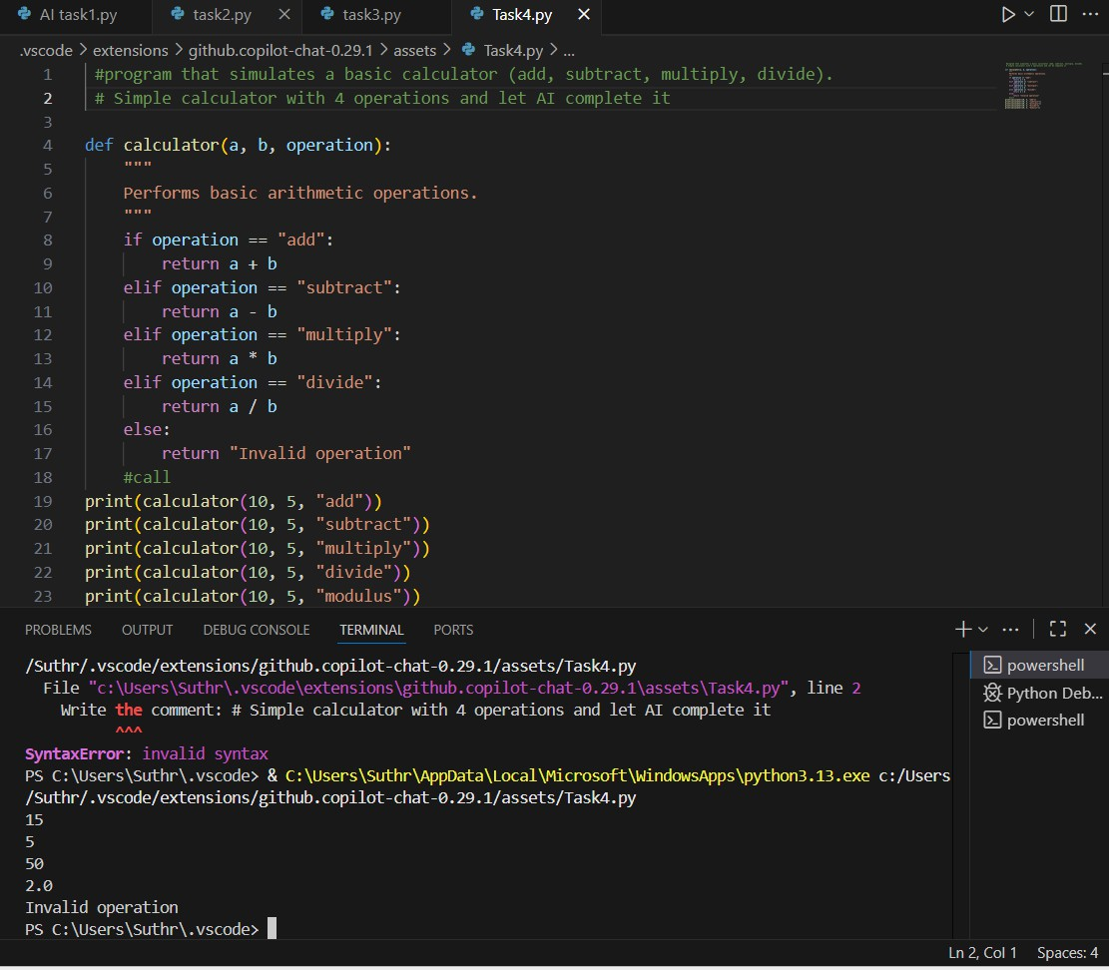

**Expected Output#4**

* **Fully working calculator with input/output and operator selection logic. Output :15**

**5**

**50**

**2.0**

**#Task 5**

**Use a comment to instruct AI to write a function that**

**reads a file and returns the number of lines.. Code:**

**Code:**

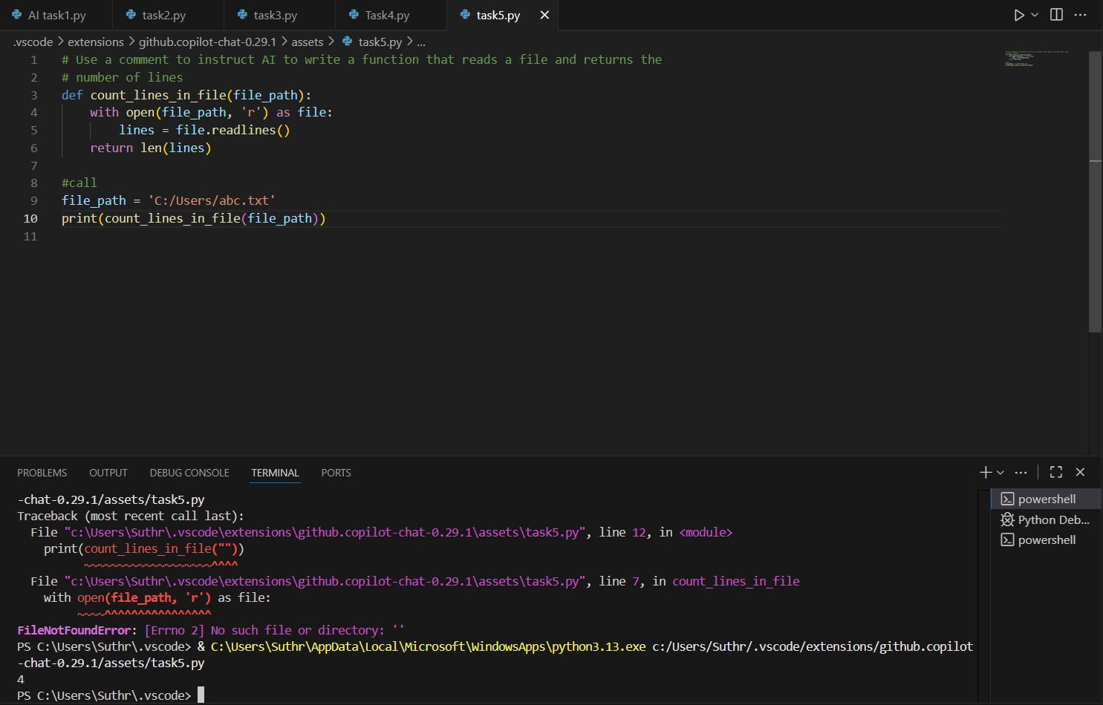

**Expected Output#5**

* **Functional implementation using open() or with open() and readlines() Output: 4**