Name : Suthrapu Anjani

Roll No : 2403A51178

Section :Cs-09

Lab Assigment-1

Task 1: Install python, vscode , github co-pilot

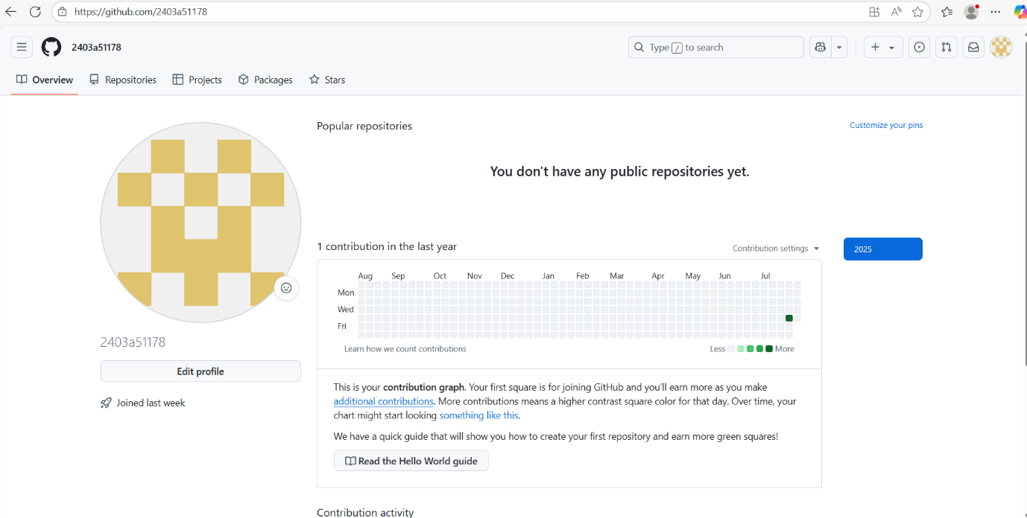

Task 2: Maximum of three numbers

Prompt used:

# write a funtion to find the maximum of three numbers

Code:

Explanation:

The function uses Python’s built-in max() function to

return the largest of the three inputs.

Sample Output:

Maximum is: 12

Task 3: Factorial (Recursive)

Prompt used:

#write a Recursive function to calclate factorial

Code:

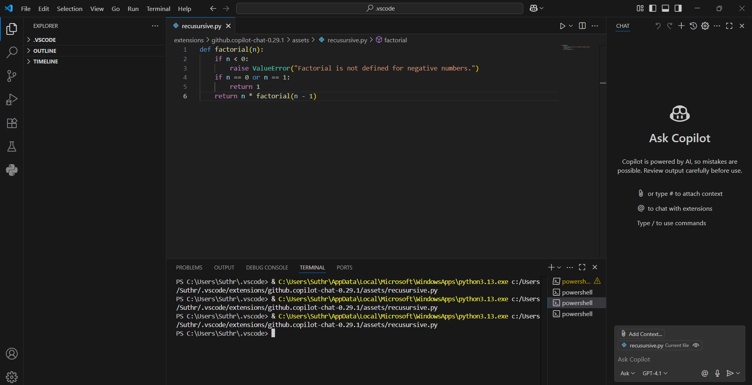

Explanation:

The function calls itself recursively untill n becomes 1 or 0, which is the base case.

Sample Output:

Factorial of 5 is :120

Task 4: Student Class

Prompt used :

# write a prompt to define a class student with name,

Roll_no,marks and display method

Code:

Explanation:

This class defines a constructor (__init__) and a

Method display() to print the details of a student object.

Sample output:

Name : Suthrapu Anjani

Roll No: 2403A51178

Marks : 89

Task 5 : Word Frequency

Prompt used:# Function to return word frequncy from a given string

Code:

Explanation:The function splits the input string into words , converts them to lowercase, and uses a dictionary to count how many times each word appears.

Sample Output:

{‘ai’:2,’makes ’:1, ‘coding’: 2, ‘easier’:1, ‘is’:1, ‘fun’: 1,

‘with’:1}