AI Assisted Coding

# Assignment-4.5

## K.Sindhu meenan(2403A51250)-Batch11

**10 Sample Emails (dataset / examples):**

These are short emails that you prepare yourself to cover the 4 categories.

**Billing (3 emails)**

1. "I was double charged for my subscription this month."
2. "Can you please send me a copy of the invoice for July?"
3. "I updated my payment method but the system still shows my old credit card."

**Technical Support (3 emails)**

4. "I can’t log into my account since yesterday."

5. "The website crashes whenever I try to upload a file."

6. "My mobile app keeps freezing on the checkout page."

**Feedback (2 emails)**

1. "Your support team was very helpful, thank you!"
2. "The new dashboard design is confusing and hard to navigate."

**Others (2 emails)**

1. "Can you confirm the date of the upcoming webinar?"
2. "Do you have any job openings in the marketing department?"

**5 Test Emails (for evaluation):**

Here are the **5 test emails**:

1. "Please cancel my subscription immediately." *→ Billing*
2. "I forgot my password and need to reset it." *→ Technical Support*
3. "Great service overall, but delivery could be faster." *→ Feedback*
4. "Can you share your company’s office address?" *→ Others*
5. "I was charged even after canceling my plan last week." *→ Billing*

**First Test Email:**

“Please cancel my subscription immediately.”- Billing

**Zero-short:**

Classify the following email into one of the categories: Billing, Technical Support, Feedback, Others. Email: "Please cancel my subscription immediately."

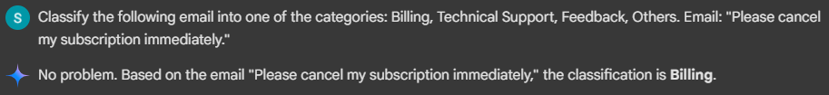

**One-short:**

Example: Email: "Can you please send me a copy of the invoice for July?" Category: Billing Now classify the following email: Email: "Please cancel my subscription immediately."

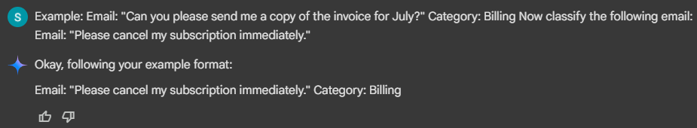

**Few-short:**

Examples: Email: "I was double charged for my subscription this month." Category: Billing Email: "The website crashes whenever I try to upload a file." Category: Technical Support Email: "The new dashboard design is confusing and hard to navigate." Category: Feedback Now classify the following email: Email: "Please cancel my subscription immediately."

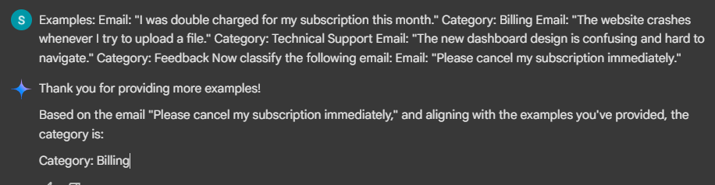

**Second Test Email:**

**“I forgot my password need to reset it.”- Technical support**

**Zero-shot:**

Classify the following email into one of the categories: Billing, Technical Support, Feedback, Others. Email: "I forgot my password and need to reset it."

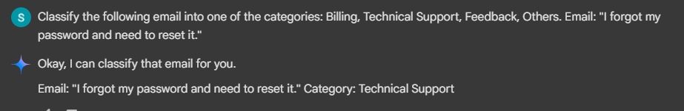

**One-shot:**

Example: Email: "Can you please send me a copy of the invoice for July?" Category: Billing Now classify the following email: Email: "I forgot my password and need to reset it."

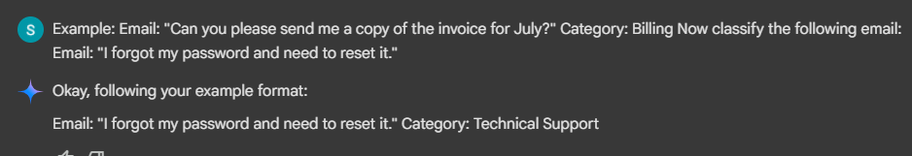

**Few-shot:**

Examples: Email: "I was double charged for my subscription this month." Category: Billing Email: "The website crashes whenever I try to upload a file." Category: Technical Support Email: "The new dashboard design is confusing and hard to navigate." Category: Feedback Now classify the following email: Email: "I forgot my password and need to reset it."

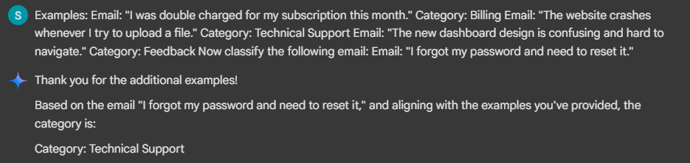

**Third Test Email:**

**“Great service overall, but delivery could be faster.”- Feedback**

**Zero-shot:**

Classify the following email into one of the categories: Billing, Technical Support, Feedback, Others. Email: "Great service overall, but delivery could be faster."

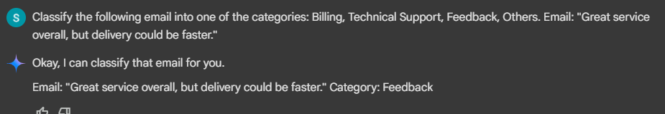

**One-shot:**

Example: Email: "Can you please send me a copy of the invoice for July?" Category: Billing Now classify the following email: Email: "Great service overall, but delivery could be faster."

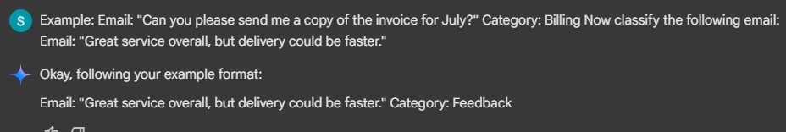

**Few-shot:**

Examples: Email: "I was double charged for my subscription this month." Category: Billing Email: "The website crashes whenever I try to upload a file." Category: Technical Support Email: "The new dashboard design is confusing and hard to navigate." Category: Feedback Now classify the following email: Email: "Great service overall, but delivery could be faster."

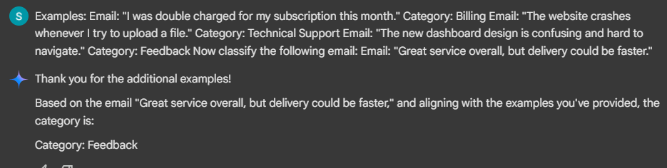

**Fourth Test Email:**

**“Can you share your company’s office address?”- Others**

**Zero-shot:**

Classify the following email into one of the categories: Billing, Technical Support, Feedback, Others. Email: "Can you share your company’s office address?"

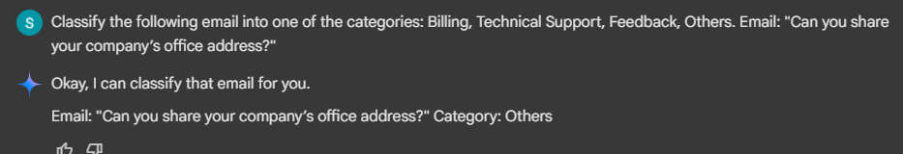

**One-shot:**

Example: Email: "Can you please send me a copy of the invoice for July?" Category: Billing Now classify the following email: Email: "Can you share your company’s office address?"

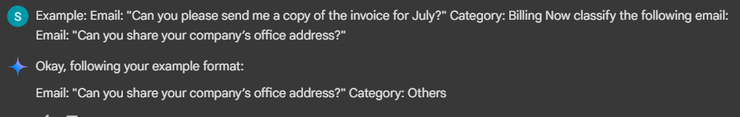

**Few-shot:**

Examples: Email: "I was double charged for my subscription this month." Category: Billing Email: "The website crashes whenever I try to upload a file." Category: Technical Support Email: "The new dashboard design is confusing and hard to navigate." Category: Feedback Now classify the following email: Email: "Can you share your company’s office address?"

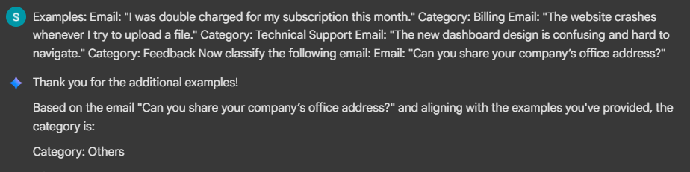

**Five Test Email:**

**“I was charged even after canceling my plan last week.”- Billing**

**Zero-shot:**

Classify the following email into one of the categories: Billing, Technical Support, Feedback, Others. Email: "I was charged even after canceling my plan last week."

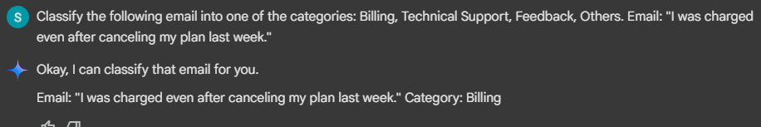

**One-shot:**

Example: Email: "Can you please send me a copy of the invoice for July?" Category: Billing Now classify the following email: Email: "I was charged even after canceling my plan last week."

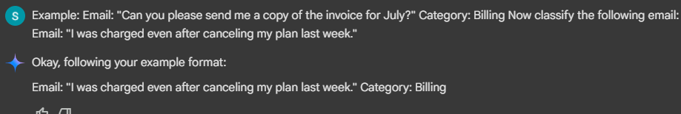

**Few-shot:**

Examples: Email: "I was double charged for my subscription this month." Category: Billing Email: "The website crashes whenever I try to upload a file." Category: Technical Support Email: "The new dashboard design is confusing and hard to navigate." Category: Feedback Now classify the following email: Email: "I was charged even after canceling my plan last week."

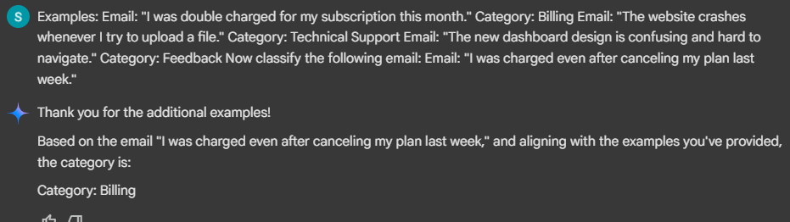

|  |  |  |  |  |
| --- | --- | --- | --- | --- |
| **Test Email** | **Correct Category** | **Zero-shot** | **One-shot** | **Few-shot** |
| Please cancel my subscription immediately. | Billing | Billing | Billing | Billing |
| I forgot my password and need to reset it. | Technical Support | Technical Support | Technical Support | Technical Support |
| Great service overall, but delivery could be faster. | Feedback | Feedback | Feedback | Feedback |
| Can you share your company’s office address? | Others | Others | Others | Others |
| I was charged even after canceling my plan last week. | Billing | Billing | Billing | Billing |

**Evaluation Summary:**

* **Accuracy:**  
  All three methods (Zero-shot, One-shot, Few-shot) correctly classified the 5 test emails into their respective categories. Accuracy was 100% across the board.
* **Clarity:**  
  Zero-shot sometimes included slightly longer explanations, but still identified the right category. One-shot and Few-shot were clearer, usually giving only the category name as the output.
* **Comparison:**Since all methods gave correct results, the main difference was in clarity. Zero-shot worked well but was less direct, while Few-shot gave the most consistent and concise responses.

**Conclusion:**  
In this experiment, Zero-shot, One-shot, and Few-shot all achieved full accuracy. However, Few-shot prompting provided the clearest and most confident classifications, making it the best method overall.