AI Assisted Coding

# Lab Exam

## K.Sindhu meenan(2403A51250)-Batch11

**Task-1:**

Write a Python code to calculate the sum of odd and even numbers in a given list using GitHub Copilot along with VS Code. Use zero shot prompting.

**Prompt:**

Write a Python code to calculate the sum of odd and even numbers in a given list.

**Code:**

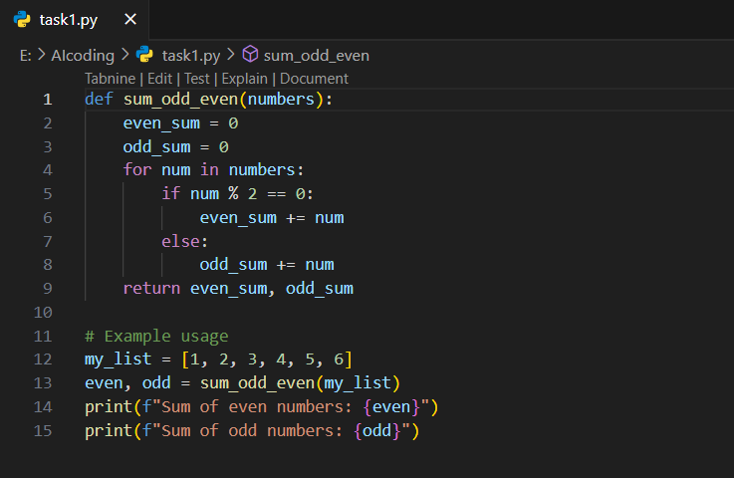

**Output:**

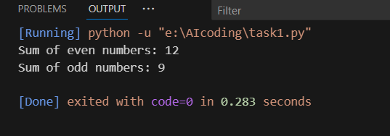

**Task-2:**

Write a Python code for given a list of integers, remove duplicates and print the sorted result. GitHub Copilot along with VS Code. Use one shot prompting.

**Prompt:**

Write a Python code for given a list of integers, remove duplicates, and print the sorted result.  
for example input: [4, 2, 7, 2, 4, 9, 1] and after removing duplicates and sorting the list the output: [1, 2, 4, 7, 9]

**Code:**

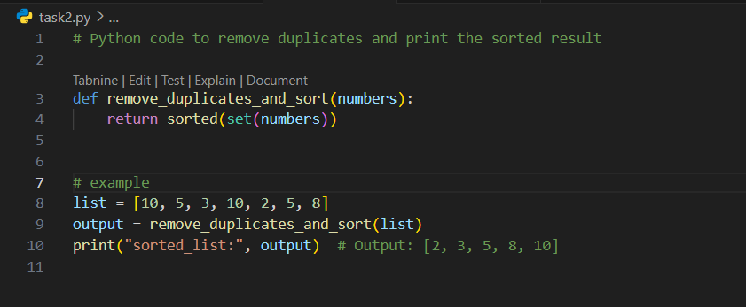

**Output:**

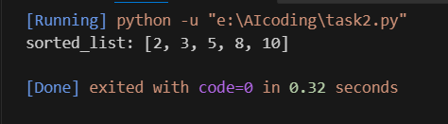

**Task-3:**

Write a Python function that converts the temperature between Celsius, Fahrenheit, and Kelvin based on user choice. Use the Cursor AI tool. Use few shot prompting.

**Prompt:**

Write a Python function that converts the temperature between Celsius, Fahrenheit, and Kelvin based on the user’s choice.

Example 1:

User input:

Enter temperature value: 0

Enter source unit (C/F/K): C

Enter target unit (C/F/K): F

Output:

0 C = 32.0 F

Example 2:

User input:

Enter temperature value: 100

Enter source unit (C/F/K): C

Enter target unit (C/F/K): K

Output:

100 C = 373.15 K

Example 3:

User input:

Enter temperature value: 32

Enter source unit (C/F/K): F

Enter target unit (C/F/K): C

Output:

32 F = 0.0 C

Now implement the function and interactive user input.

**Code:**

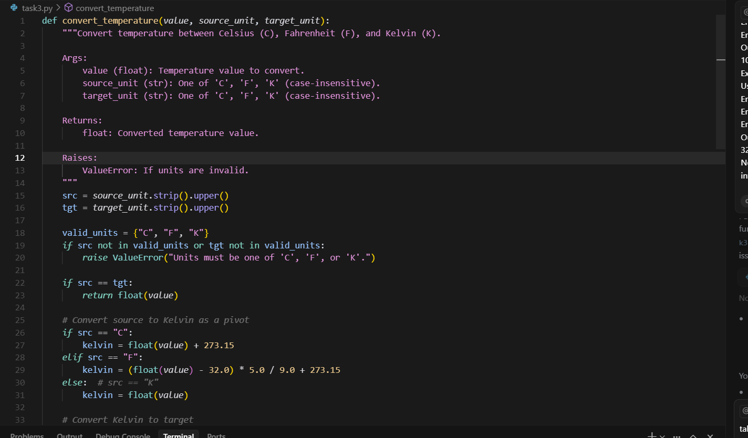

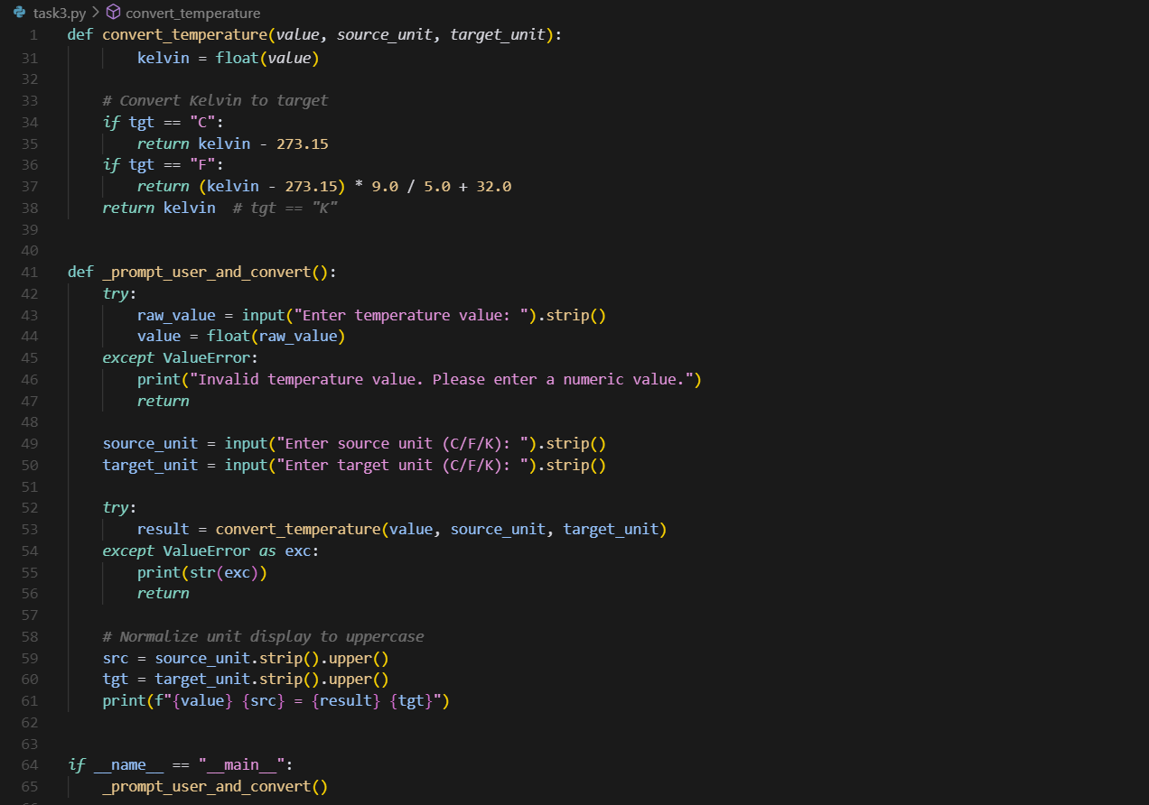

**Output:**

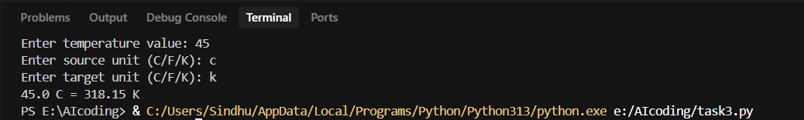

**Task-4:**

Write a Python function to remove punctuation, convert to lowercase, and remove stop words from a given text. Use the Cursor AI tool. Use zero shot prompting.

**Prompt:**

Write a Python function to remove punctuation, convert to lowercase, and remove stop words from a given text.

**Code:**

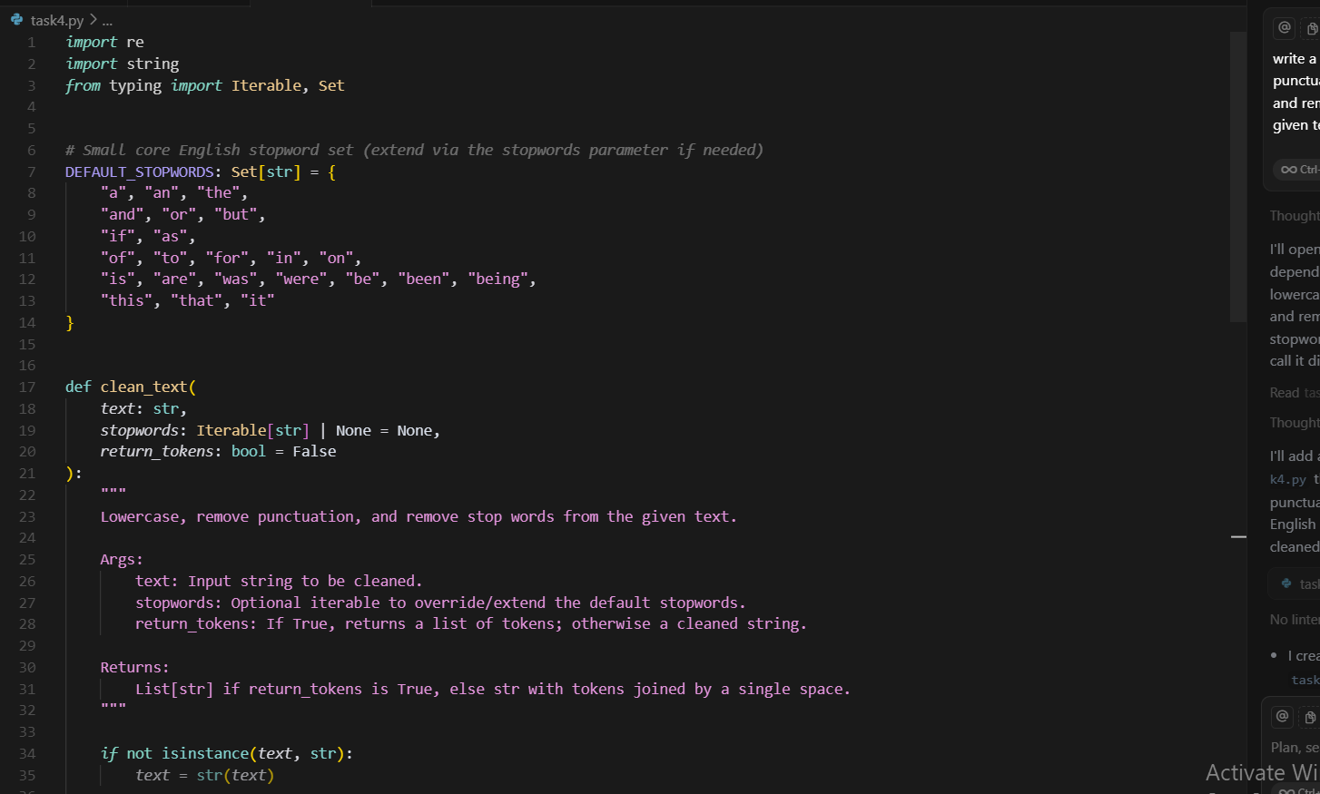

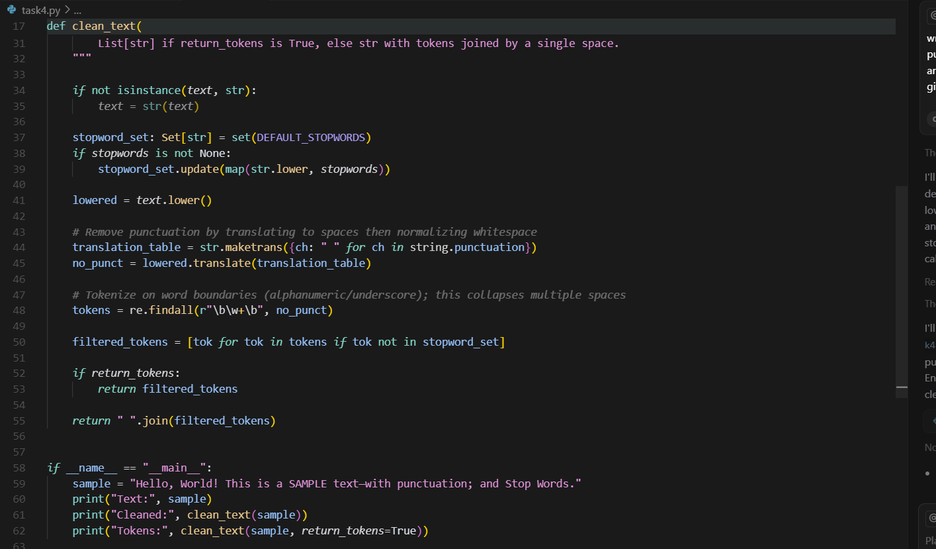

**Output:**

