AI Assisted Coding

**AssignmentNumber: 2.3**

# K.Sindhu meenan (2403A51250)-Batch-11

Task Description#1:

Use Google Gemini in Colab to write a function that reads a CSV file and calculates mean, min, max

Expected output:

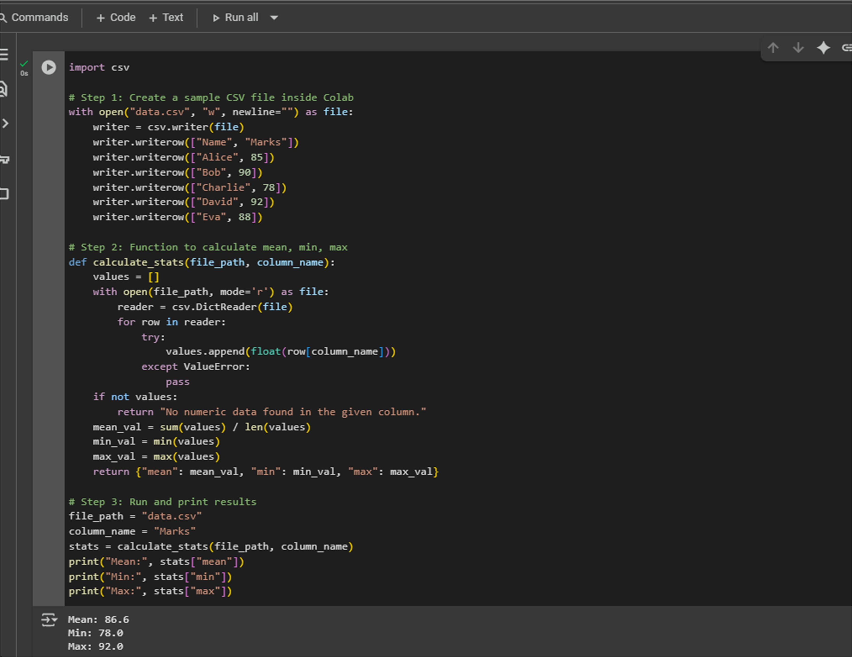

Task Description#2:

Compare Gemini and Copilot outputs for a palindrome check function Expected output:

Gemini colab code:

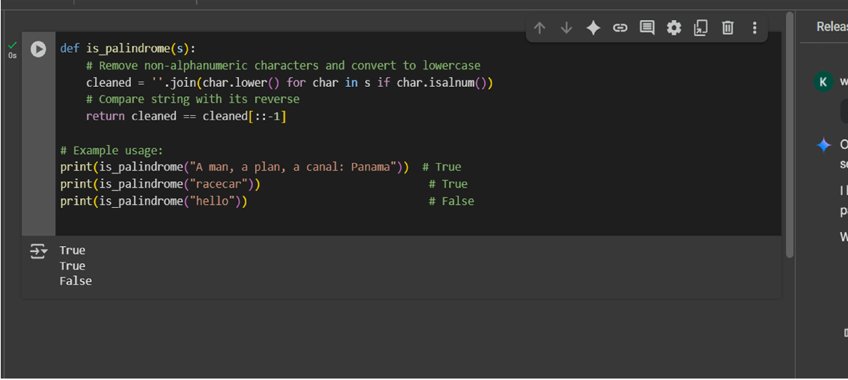

Copilot code:

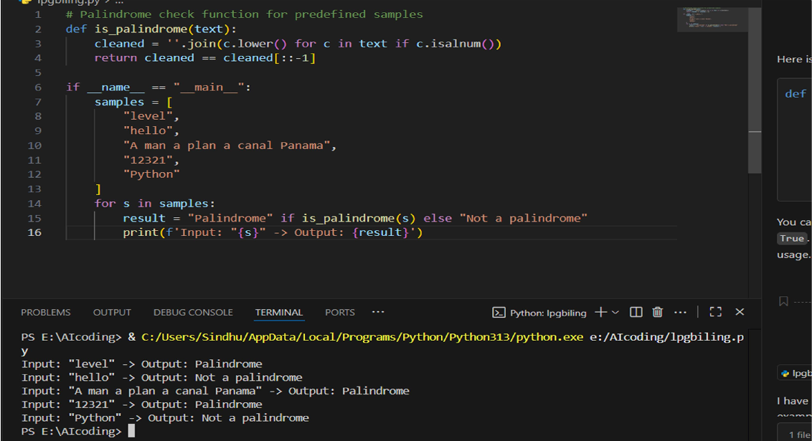

Side-by-side comparision and observation:

Both versions perform the same steps:

1. Remove non-alphanumeric characters.
2. Convert to lowercase.
3. Compare the cleaned string to its reverse.

# Key Differences

* + **Naming**: Colab uses s, Copilot uses text (more descriptive).
  + **Logic**: Identical cleaning and reverse-check methods.
  + **Output**: Colab prints True/False; Copilot prints "Palindrome" or "Not a palindrome".
  + **Examples**: Colab tests 3 strings; Copilot tests 5, including numbers.
  + **Comments**: Colab has clearer inline explanations; Copilot has minimal comments.
  + **Structure**: Colab runs interactively; Copilot uses if name == " main ": for script-style execution.

# Summary

Colab is simpler and better for quick learning; Copilot is more structured and tests more cases. A merged version could combine Colab’s comments with Copilot’s varied examples and execution style.

Task Description#3:

Ask Gemini to explain a Python function (to calculate area of various shapes) line by line

Expected output: Code:

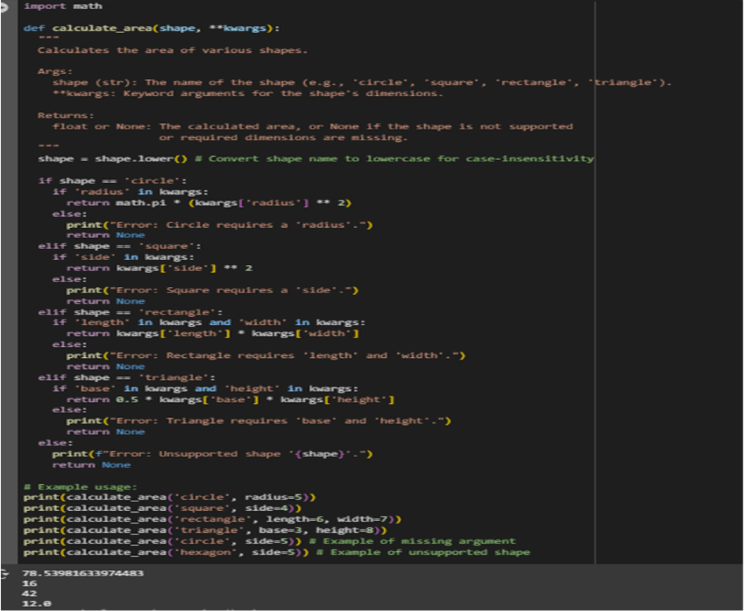

Detailed explanation with code snippet:

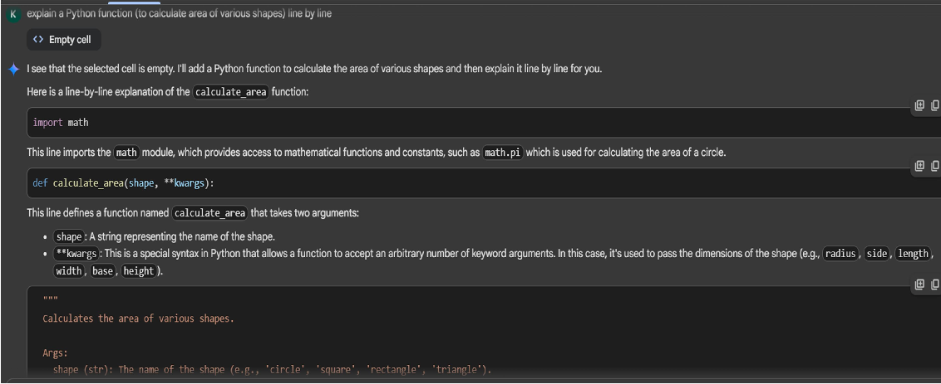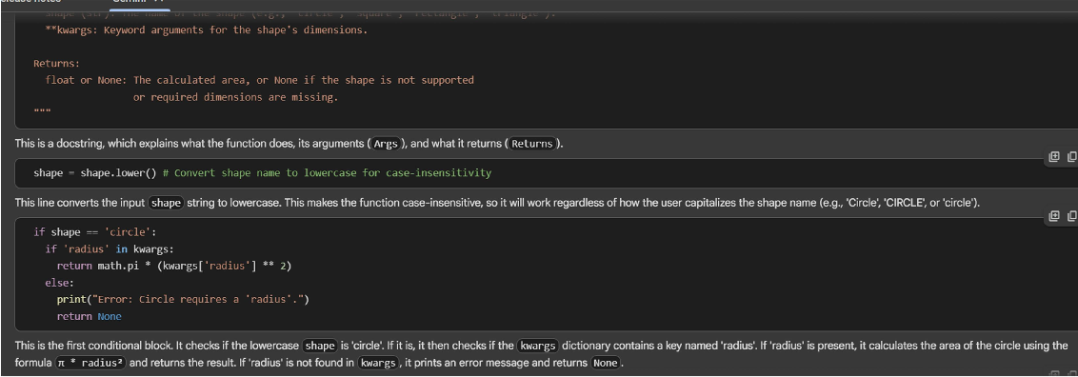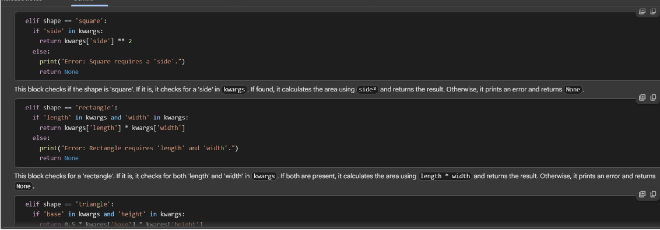

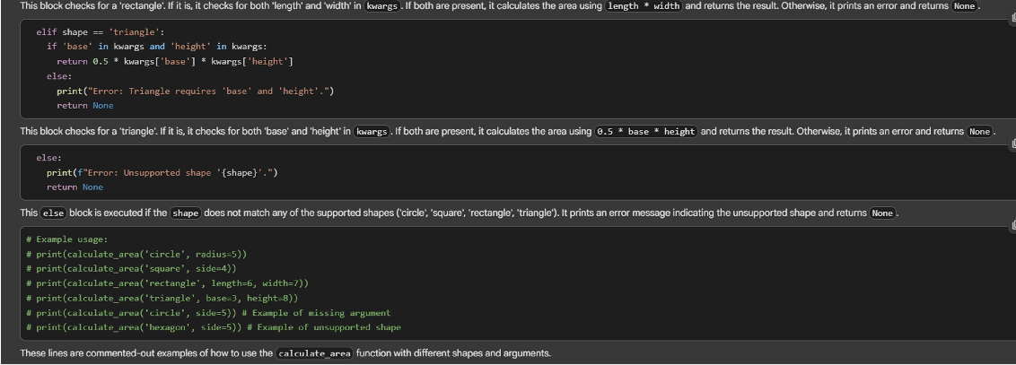

Task Description#4:

Install and configure Cursor AI. Use it to generate a Python function (e.g., sum of squares)

Expected Output:

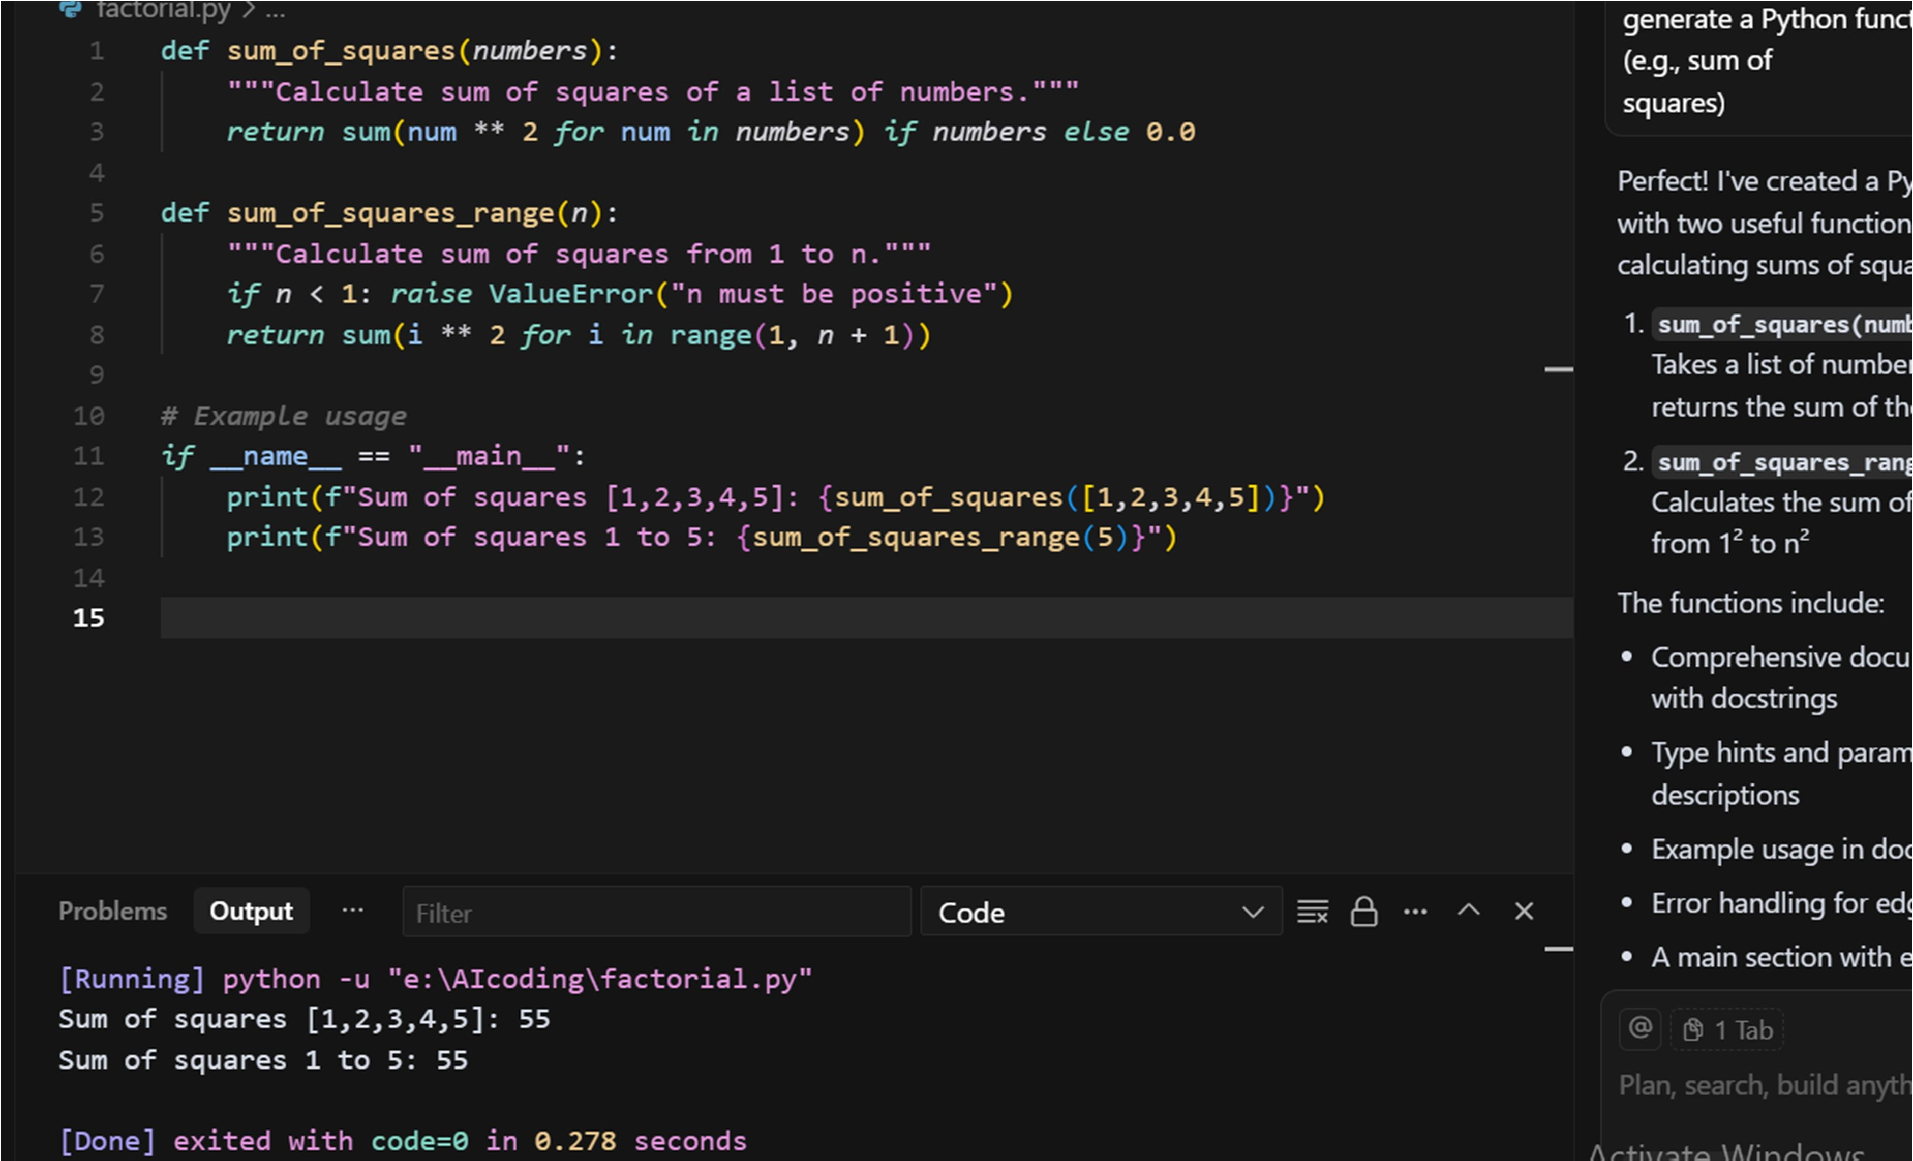

Task Description#5:

Student need to write code to calculate sum of add number and even numbers in the list

Expected Output:

Student written code:

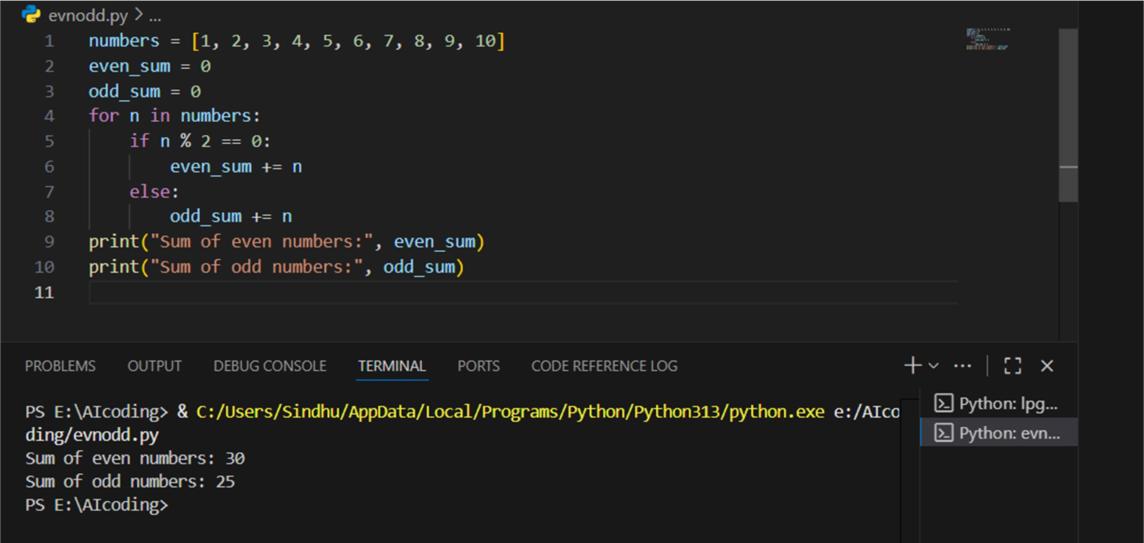

Refactored code written by student with improved logic:

