**AI ASSISTED CODING:**

**LAB EXAM-1**

**MANCHENA KEERTHANA**

**2403A51259**

**BATCH-11(CSE-GEN)**

**DATE:29-08-2025**

**Q1)**Write a python code to calculate the sum of odd and even numbers in a given list using github copilot along with Vs code.Use zero-short prompting?

**PROMPT:**

write a python code to calculate the sum of odd and even numbers in the list by using zero shot prompting .

**CODE:**

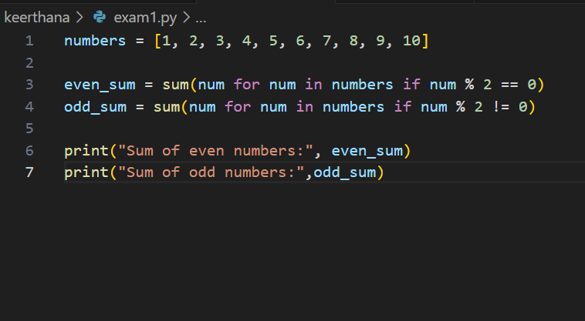

**OUTPUT:**

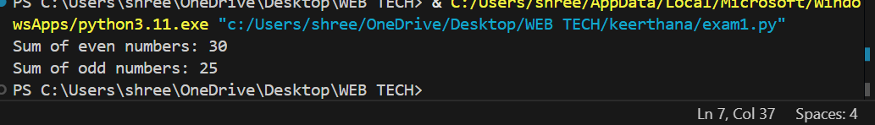

**Q2)**Write a python code for given a list of integers, remove duplicates and print the sorted result. Github copilot along with vs code .use one short prompting.

**PROMPT:**

Given a list of integers, remove any duplicates and print the sorted list. For example, for the input [3, 1, 4, 4, 5, 1, 6, 2, 3], the output should be [1, 2, 3, 4, 5, 6].

**CODE:**

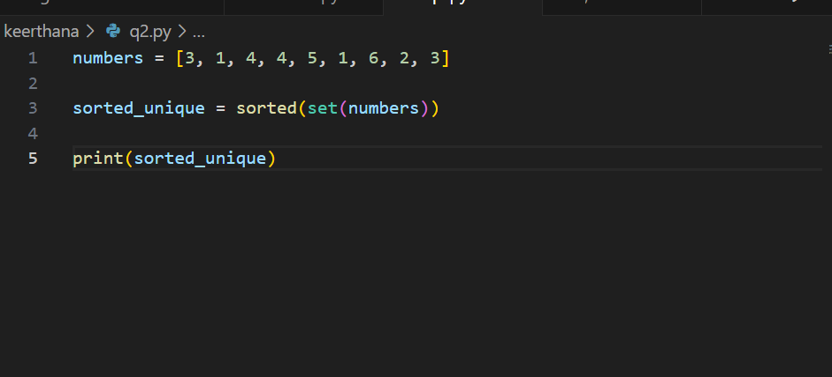

**OUTPUT:**

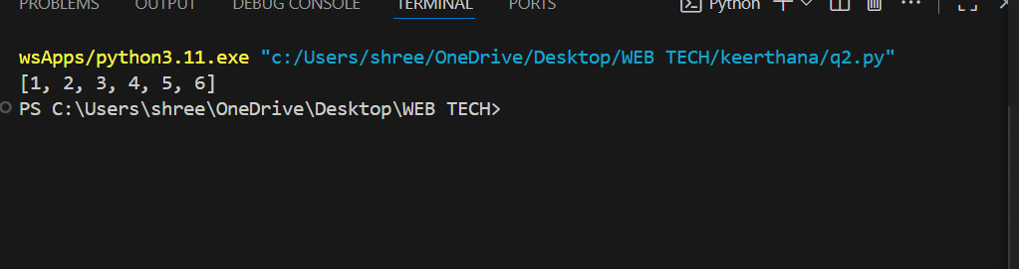

**Q3)**Write a python function that converts temperature between Celsius, Fahrenheit ,and kelvin based on user choice use the cursor-AI tool .Use few shot prompting.

**PROMPT:**

Write a Python function that converts temperatures between Celsius, Fahrenheit, and Kelvin. The function should take a temperature value, the unit of the value (Celsius, Fahrenheit, or Kelvin), and the desired target unit. Here are some examples:

**Example 1:**Input:  
convert_temperature(100, 'Celsius', 'Fahrenheit')  
Output:  
212.0 Fahrenheit

Example 2:  
Input:  
convert_temperature(32, 'Fahrenheit', 'Celsius')  
Output:  
0.0 Celsius

Example 3:  
Input:  
convert_temperature(300, 'Kelvin', 'Celsius')  
Output:  
26.85 Celsius"

**CODE:**

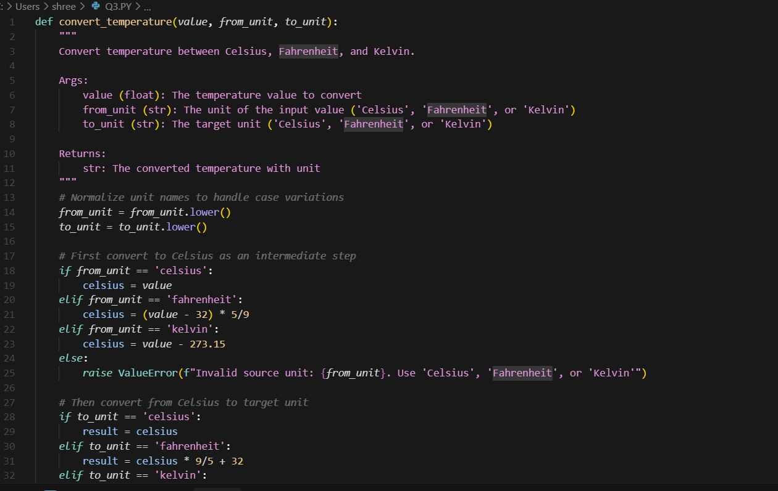

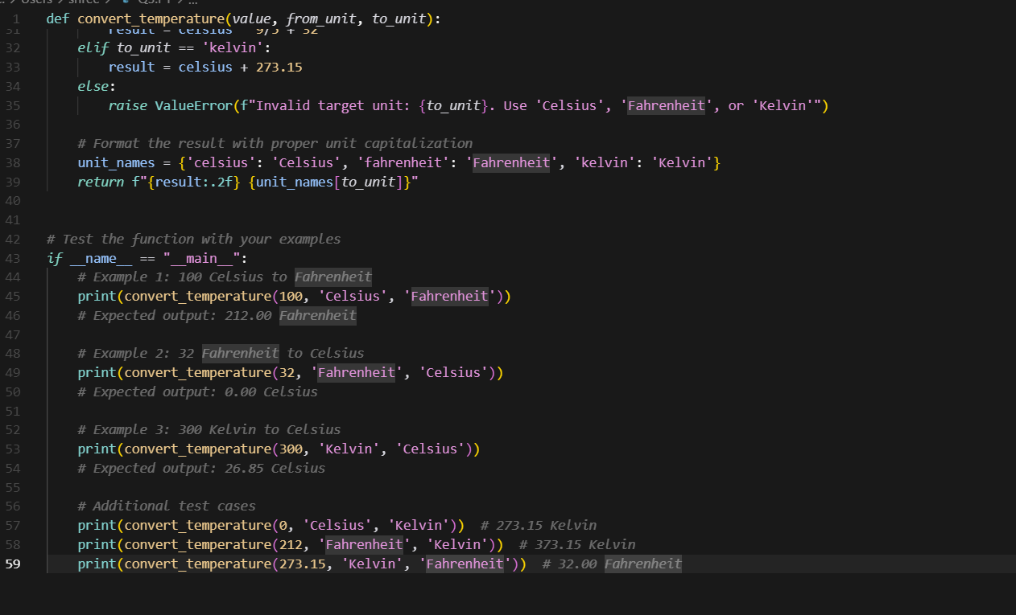

**Output:**

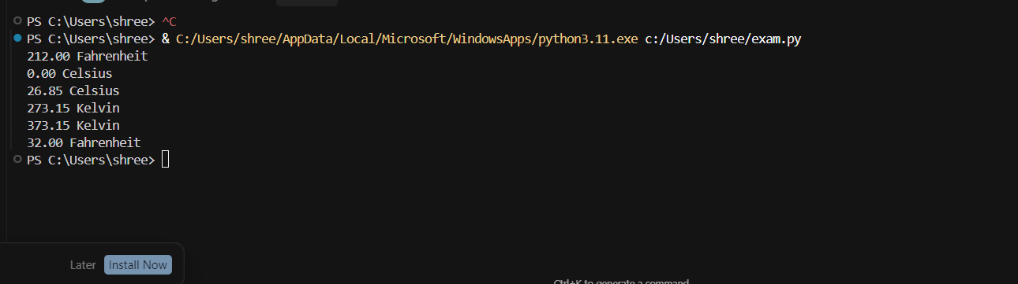

**Q4)**Write a python function to remove punctuation,convert to lower case,and remove stop words from a given text.Use cursor AI tool.Use zero short prompting

**PROMPT:**

Write a python function to remove punctuation,convert to lower case,and remove stop words from a given text by Using zero short prompting.

**CODE:**

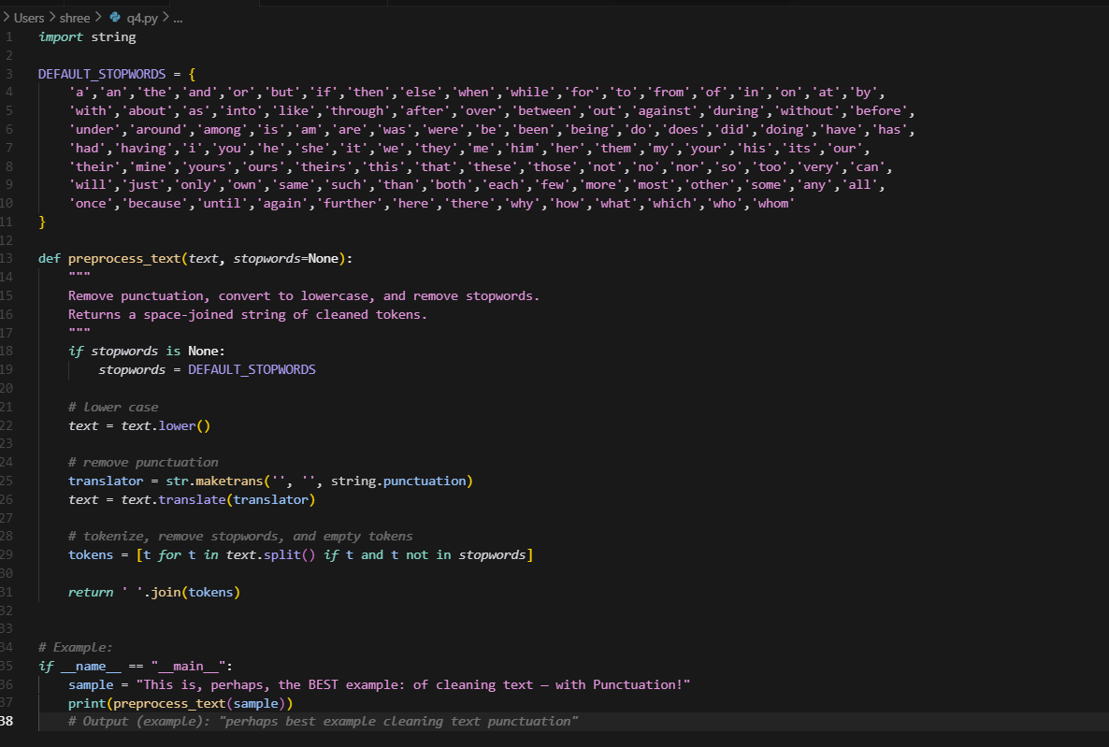

**OUTPUT:**

