AI ASSISTED CODING

ASSIGNMENT-4.5

2403A51260

Batch-11

M.Swapna

**Sample Data:**

1. "I did not get the invoice for my last purchase. Please send it again." — **Billing**
2. "My bill shows an extra charge that I don’t understand." — **Billing**
3. "I updated my card, but payment was still taken from my old account." — **Billing**
4. "The app crashes every time I try to log in." — **Technical Support**
5. "I forgot my password and the reset link is not working." — **Technical Support**
6. "The website is very slow and won’t load on my computer." — **Technical Support**
7. "I love the new update. The interface is much easier to use now." — **Feedback**
8. "Thank you for resolving my issue so quickly yesterday." — **Feedback**
9. "Can you tell me your office opening hours?" — **Others**
10. "Do you provide discounts for students or new users?" — **Others**

**Test Emails (for evaluation):**

1. "I was charged twice for the same subscription this month."
2. “The mobile app doesn’t let me reset my password."
3. "Your service is excellent, I am very satisfied with the support team."
4. "Could you tell me if you have a branch office in Hyderabad?"
5. "After the new update, my account takes longer to load the dashboard."

**Test Email-1:**

"I was charged twice for the same subscription this month."

* **Zero-shot Prompting:**

**Prompt**: Classify the following email into one of the following categories: Billing, Technical Support, Feedback, Others. Email: "I was charged twice for the same subscription this month."

**Response:**

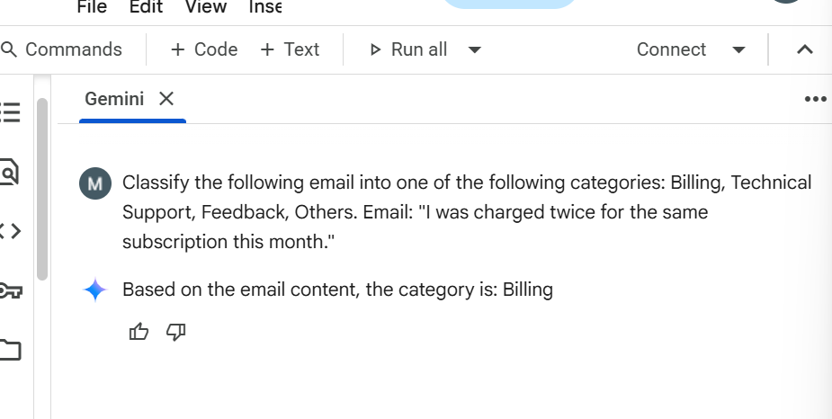

* **One-shot Prompting:**

**Prompt:** Example:"The app crashes every time I try to log in." — Technical Support. now classify this email:

Email: "I was charged twice for the same subscription this month."

**Response:**

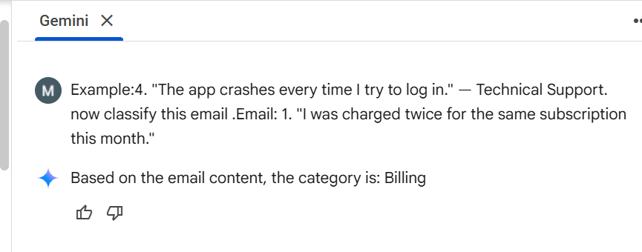

* **Few-shot Prompting:**

**Prompt:** Examples: Email: "I did not get the invoice for my last purchase. Please send it again." — Billing

Email: "The app crashes every time I try to log in." — Technical Support

Email: I love the new update. The interface is much easier to use now." — Feedback Email: C"an you tell me your office opening hours?" — Others .

Now classify this email:

Email:"I was charged twice for the same subscription this month."

**Response:**

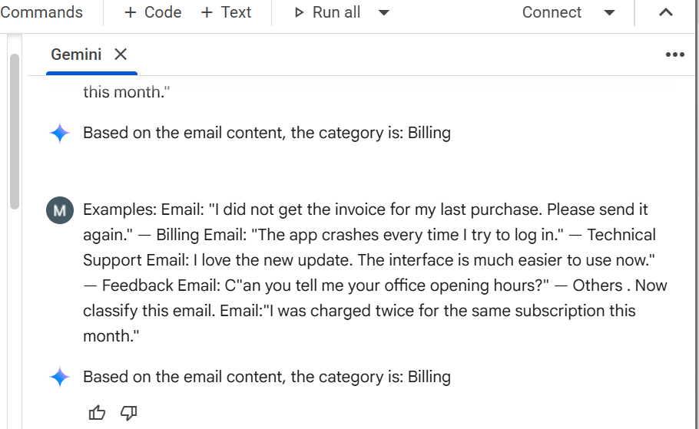

**Test Email-2:**

“The mobile app doesn’t let me reset my password."

* **Zero-shot Prompting:**

**Prompt:** Classify the following email into one of the following categories: Billing, Technical Support, Feedback, Others. Email: “The mobile app doesn’t let me reset my password."

**Response:**

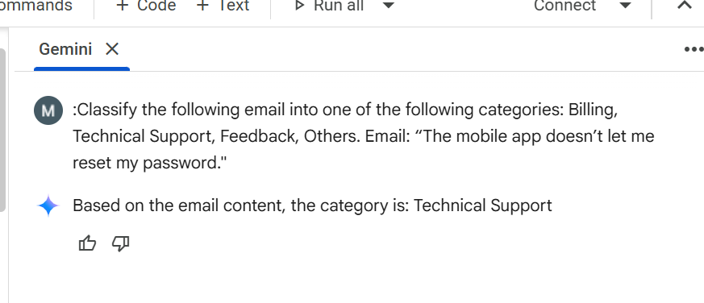

* **One-shot Prompting:**

**Prompt:** Example:"The app crashes every time I try to log in." — Technical Support. now classify this email:

Email:“The mobile app doesn’t let me reset my password."

**Response:**

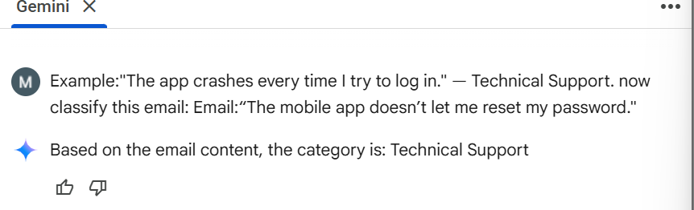

* **Few-shot Prompting:**

**Prompt:** Examples: Email: "I did not get the invoice for my last purchase. Please send it again." — Billing Email: "The app crashes every time I try to log in." — Technical Support Email: I love the new update. The interface is much easier to use now." — Feedback Email: C"an you tell me your office opening hours?" — Others .

Now classify this email:

Email:“The mobile app doesn’t let me reset my password.”

**Response:**

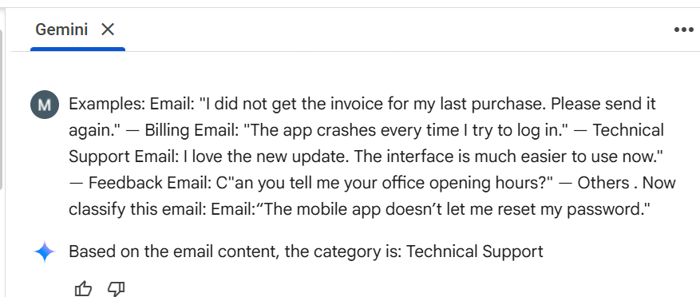

**Test Email-3:**

"Your service is excellent, I am very satisfied with the support team."

* **Zero-shot Prompting**:

**Prompt:** Classify the following email into one of the following categories: Billing, Technical Support, Feedback, Others. Email:"Your service is excellent, I am very satisfied with the support team."

**Response:**

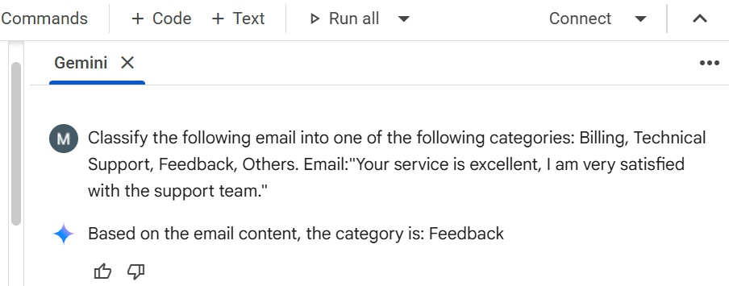

* **One-shot Prompting:**

**Prompt:** Example:"The app crashes every time I try to log in." — Technical Support. now classify this email:

Email:"Your service is excellent, I am very satisfied with the support team."

**Response:**

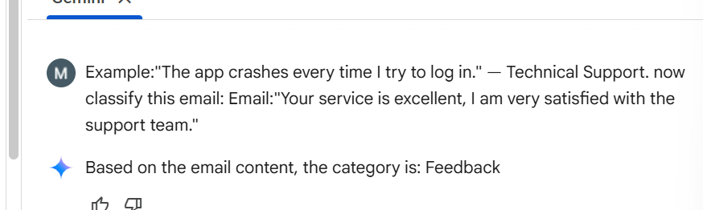

* **Few-shot Prompting:**

**Prompt:** Examples: Email: "I did not get the invoice for my last purchase. Please send it again." — Billing Email: "The app crashes every time I try to log in." — Technical Support Email: I love the new update. The interface is much easier to use now." — Feedback Email: C"an you tell me your office opening hours?" — Others .

Now classify this email:

Email:”Your service is excellent, I am very satisfied with the support team."

**Response:**

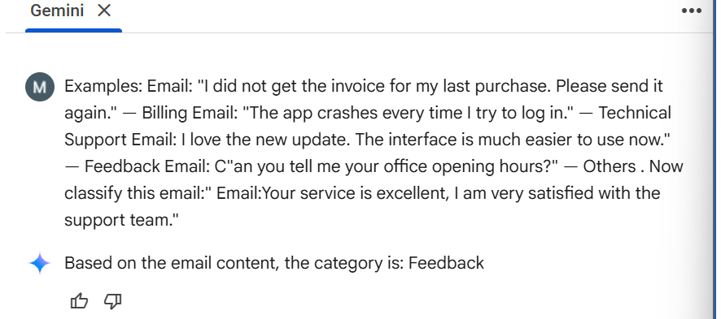

**Test Email-4:**

"Could you tell me if you have a branch office in Hyderabad?"

* **Zero-shot Prompting:**

**Prompt:** Classify the following email into one of the following categories: Billing, Technical Support, Feedback, Others. Email: "Could you tell me if you have a branch office in Hyderabad?"

**Response:**

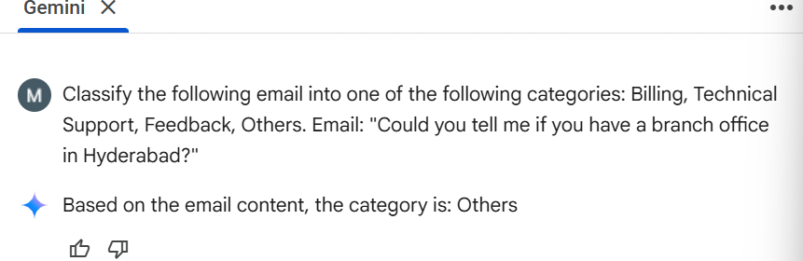

* **One-shot Prompting:**

**Prompt:** Example:"The app crashes every time I try to log in." — Technical Support. now classify this email:

Email: "Could you tell me if you have a branch office in Hyderabad?"

**Response:**

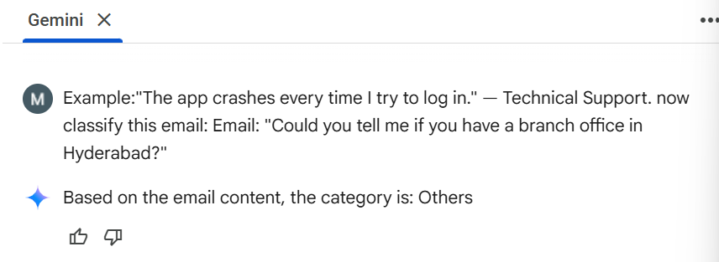

* **Few-shot Prompting:**

**Prompt:** Examples: Email: "I did not get the invoice for my last purchase. Please send it again." — Billing Email: "The app crashes every time I try to log in." — Technical Support Email: I love the new update. The interface is much easier to use now." — Feedback Email: C"an you tell me your office opening hours?" — Others .

Now classify this email:

Email:"Could you tell me if you have a branch office in Hyderabad?"

**Response:**

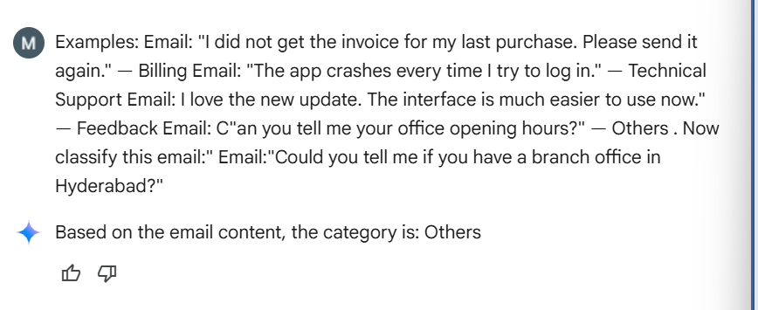

**Test Email-5:**

"After the new update, my account takes longer to load the dashboard."

* **Zero-shot Prompting**:

**Prompt:** Classify the following email into one of the following categories: Billing, Technical Support, Feedback, Others. Email:"After the new update, my account takes longer to load the dashboard."

**Response:**

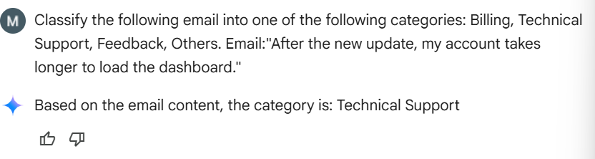

* **One-shot Prompting:**

**Prompt:** Example:"The app crashes every time I try to log in." — Technical Support. now classify this email:

Email:"After the new update, my account takes longer to load the dashboard."

**Response:**

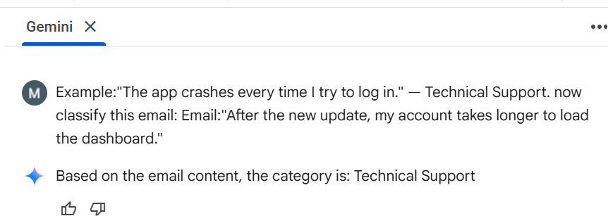

* **Few-shot Prompting:**

**Prompt:** Examples: Email: "I did not get the invoice for my last purchase. Please send it again." — Billing Email: "The app crashes every time I try to log in." — Technical Support Email: I love the new update. The interface is much easier to use now." — Feedback Email: C"an you tell me your office opening hours?" — Others .

Now classify this email:

Email:"After the new update, my account takes longer to load the dashboard."

**Response:**

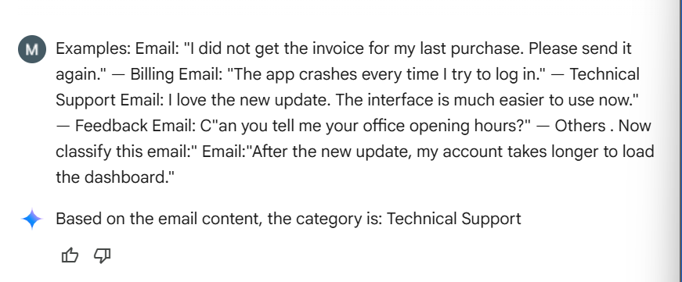

**Comparison Table:**

| **Test Email** | **Zero-shot Result** | **One-shot Result** | **Few-shot Result** | **Correct Category** |
| --- | --- | --- | --- | --- |
| 1. "I was charged twice for the same subscription this month." | Billing | Billing | Billing | Billing |
| 2. "The mobile app doesn’t let me reset my password." | Technical Support | Technical Support | Technical Support | Technical Support |
| 3. "Your service is excellent, I am very satisfied with the support team." | Feedback | Feedback | Feedback | Feedback |
| 4. "Could you tell me if you have a branch office in Hyderabad?" | Others | Others | Others | Others |
| 5. "After the new update, my account takes longer to load the dashboard." | Technical Support | Technical Support | Technical Support | Technical Support |

**Final Reflections:**

From the evaluation, all three prompting techniques—Zero-shot, One-shot, and Few-shot—were able to correctly classify all five test emails into their respective categories. This shows that the LLM already has strong contextual understanding for simple and well-defined tasks like email classification. However, while the accuracy was the same in this case, Few-shot prompting is generally more reliable in complex or ambiguous scenarios because it provides the model with clear examples across categories. Zero-shot prompting is the fastest and simplest method, but it may sometimes misclassify when the email wording is unclear. One-shot prompting offers a middle ground, giving the model a small hint.

In conclusion, **all methods worked equally well for this dataset**, but **Few-shot prompting remains the most robust approach for larger or more nuanced datasets**, while Zero-shot is sufficient for straightforward cases.