**AI ASSISTED CODING**

**ASSIGNMENT-1.4**

Name: M.SWAPNA

Hall Number:2403A51260

Batch:11

**Task-1:** A function in Python that returns the maximum of three numbers using GitHub Copilot. Use an appropriate comment as a prompt.  
**Expected Output -1:**• Python function that takes three inputs and returns the largest value. Include the code and output.

**Prompt:** Write a Python function that takes three numbers as input and returns the largest number among them. Include proper comments and an example usage.

**Code:**

**Output:**

**Task-2:** Use GitHub Copilot to create a recursive Python function that calculates the factorial of a  
number.  
**Expected Output -2:**• Python function for factorial using recursion with input and output examples

**Prompt:** Write a recursive Python function to calculate the factorial of a number. Include comments and an example showing input and output.

**Code:**

**Output:**

**Task-3:** Prompt GitHub Copilot to create a class named Student with attributes name, roll_no, and  
marks. Add a method to display student details.  
**Expected Output-3:**• Python class definition with an initializer and a display method. Include object creation and  
output.

**Prompt**: Create a Python class named Student with attributes name, roll_no, and marks. Add a method to display student details. Include example of object creation and output.

**Code:**

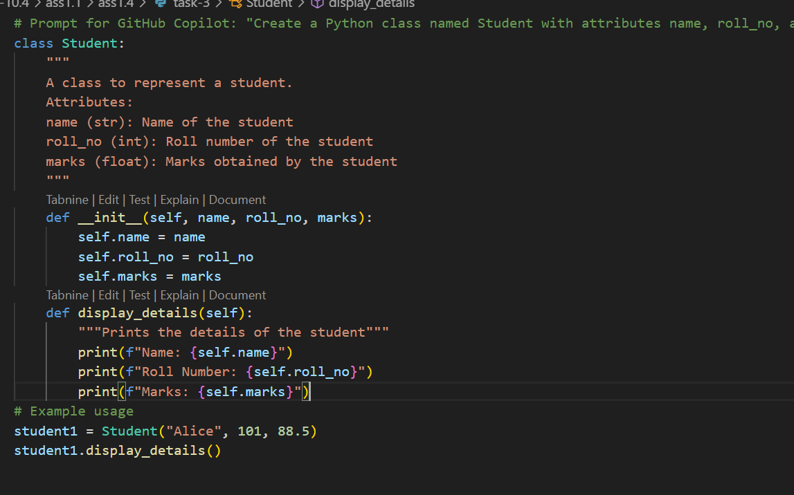

**Output:**

**Task-4:** Ask GitHub Copilot to generate a Python function that takes a string as input and returns the  
frequency of each word. **Expected Output-4:**• Python function that returns word frequency using a dictionary. Provide sample input and  
output.

**Prompt:** Write a Python function that takes a string as input and returns the frequency of each word using a dictionary. Include sample input and output.

**Code:**

**Output:**

